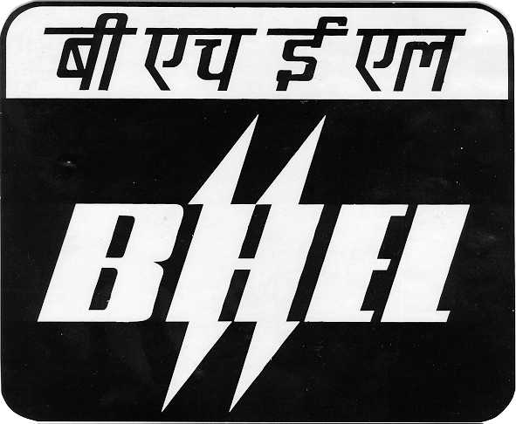
BHARAT HEAVY ELECTRICALS LIMITED

Heavy Power Equipment Plant, Ramachandrapuram, Hyderabad – 502 032. INDIA
Phones: Offl:[040-23182477
Fax No. 91-040 - 23020151, Telex: 0425-6212 6248-6777-6778, E-mail: raopn@bhelhyd.co.in

To

Sir,

Sub:- Arrangement of Snacks & Tea/coffee for our ERP Team for a period of 6 months (from Jan’09 to June’09), Request for Quotation – Reg.

For implementing ERP across all the products of BHEL-Hyd, an ERP Team has been formed comprising of around 120 executives (including BHEL and IP). All these officials are operating from HRDC of BHEL, Hyderabad and are likely to stay beyond 06.00 PM everyday. We propose to provide Snacks and Tea/Coffee in a hygienic way to all these officials on all the working days for the next 6 months (from Jan’09 to June’09).

Snacks Item | Specification | Rate per Plate
Samosa + Tea/Coffee | 2 Nos normal size + chutney & sauce
Idly + Tea/Cofee | 2 Nos normal size + chutneys
Cutlet + Tea/Cofee | 2 Nos normal size + sauce
Masala Vada + Tea/Coffee | 2 Nos normal size + chutneys
Veg Sandwich + Tea/Coffee | 3 Pieces normal size + sauce
Alu/ Arati Bajji + Tea/Coffee | 3 Nos-Alu or 2 Nos Arati – normal size + 2 chutneys
Mysore Bajji + Tea/Coffee | 3 Nos Normal size + 2 chutneys
Onion Bajji + Tea/Coffee | 2 Nos Normal size + 2 chutneys
Uttappam + Tea/Coffee | 1 No Normal size + 2 chutneys
Steam Dosa + Tea/Coffee | 1 No Normal size + 2 chutneys
Chappathi + Tea/Coffee | 2 Nos normal size + curry
Upma + Tea/Coffee | 1 plate + 2 chutneys

Terms and Conditions :
- The Snacks are to be served at 0530-0600PM on all the working days (Monday to Saturday) at the Lawns of HRDC, BHEL, Hyderabad.

- One day before, the Number of packs to be supplied on the next day will be informed to you, maximum number being 120 Nos.

- Snacks are to be made in hygienic conditions and they are to be served Hot and they are to be individually packed in Paper Cardboard Boxes. Tea/Coffee is to be brought in separate flasks and served Hot.

- Paper Napkins are to be provided by you.

- Waste Disposal :
You have to arrange a big plastic bag or such thing to collect the daily waste from the snacks service and disposal of this waste is to be taken care of by you.

- The snacks supply and service is required for a period of 6 months from Jan’09 to June’09. The present contract will be for a period of 3 months, from Jan’09 to March’09 and can be extended based on mutual agreement.

- BHEL reserves the right to cancel the order whenever it finds that the quality of supply and service is not upto the mark.

- Taxes :
Rate per plate is inclusive of all taxes.

- Payment :
You have to submit the delivery note for snacks & tea/coffee on daily basis to the ERP-Project Manager and raise a Consolidated Bill for the whole month. This Consolidated Bill has to be certified by the ERP-Project Manager and based on his endorsement, Payment will be made on monthly basis either through a cheque or Electronic Fund Transfer (EFT). You may please inform us about your bank account details, like, Name of Bank, Branch, A/C Number, MICR code etc.

You are requested to submit your quotation clearly specifying the normal size/weight for each of the snack items and meeting all the above terms and conditions immediately for our further consideration.

Thanking you,

Yours faithfully,
for Bharat Heavy Electricals Limited

(P. Narayana Rao)
AGM (IT)
Room No. 117, HRDC, BHEL,
Cell No. 9848842468

