BHARAT HEAVY ELECTRICALS LIMITED
(A Government of India Undertaking)
P.O. BHEL Jhansi 284120

Department:
FACTORY MAIN STORES

TENDER DOCUMENT
For

“Contract for (a) unloading and shifting of fresh materials and (b) Loading, Shifting and Unloading of Scrap materials.”

DUE DATE: 04.11.2016

Tender Enquiry No.
345 /TE/6/06/R00
Date 20.09.2016

Tender Documents

BHEL JHANSI
TENDER ENQUIRY NO: 345/TE/6/06/R00 DATE: 20.09.2016

DETAILS OF TENDER DOCUMENT

3 | 4 | 5 | T | E | 6 | 0 | 6 |  | R 0 0

nature of work: “Contract for (a) unloading and shifting of fresh materials and (b) Loading, Shifting and Unloading of Scrap materials.”

1. BHEL JHANSI is in the process of finalizing the works “Contract for (a) unloading and shifting of fresh materials and (b) Loading, Shifting and Unloading of Scrap materials.”

2. The tender document has been detailed as follows:
  - Notice Inviting Tender (Schedule A)
  - Work Specifications (Schedule e B)
  - Qualifying Requirements (Schedule C)
  - Instruction to Tenderers (Schedule D)
  - Tender Evaluation Criteria (Schedule E)
  - Contractor’s obligations (Schedule F)
  - Other General Terms and Conditions (Schedule G)
  - Criteria for measurement of work (Schedule H)
  - Technical Bid Application (Schedule I)
  - Price Bid (Schedule J)
The duly filled in Technical and Price / Rate bids (Schedule I and J, separately) along with the instructions to the tenders, Contractor’s Obligations, General Terms and Conditions with the signature of the tender on all the pages and complete in all respects super scribed as “Quotation for Tender No. 345/TE/6/06/r00 dated 20.09.2016” should reach us in a sealed cover on or before 04.11.2016 (13.15 hours) through Registered / Speed post or the same may be dropped in the tender box available at the following address:

CISF Control Room/Office
Administrative Building
Bharat Heavy Electricals Limited
Jhansi-284120
Note: 1) Dropping of tender in the Tender Box within scheduled time and date is the
responsibility of the bidder.

3) TECHNO-COMMERCICAL BID (COMPRISING SCHEDULES A TO SCHEDULE I, PAGES 1 TO 35) AND PRICE BID (COMPRISING SCHEDULE J ONLY, PAGES 36 to 40) SHOULD BE SUBMITTED IN SEPARATE SEALED ENVELOPES. IN CASE THE BIDS FOUNDS IN ONE SINGLE ENVELOPE THEN THE “BIDS” ARE LIABLE TO BE REJECTED.

Tender Documents

BHEL JHANSI
TENDER ENQUIRY NO: 345/TE/6/06/R00 DATE: 20.09.2016

CONTENTS

Sl. No. | Description | Schedule no. | No. of Pages
 | Notice Inviting Tender | A | 4 to 5
 | Work Specifications/ Scope of Work | B | 6 to 9
 | Qualifying Requirements | C | 10 to 11
 | Instructions to Bidders | D | 12 to13
 | Tender Evaluation Criteria | E | 14
 | Contractors obligations | F | 15 to 17
 | Other General Terms & Conditions | G | 18 to 31
 | Criteria for measurement of work | H | 32 to 33
 | Technical Bid | I | 34 & 35
 | Price Bid | J | 36 to 40

SCHEDULE ‘A’
BHEL- JHANSI Tender Documents
TENDER ENQUIRY NO: 345/TE/6/06/R00 DATE: 20.09.2016

NOTICE INVITING TENDER

- SCOPE OF WORK | : | Contract for (a) unloading and shifting of fresh materials and (b) Loading, Shifting and Unloading of Scrap materials.
- Tender Evaluation Criteria | : | As per Schedule – E
- Duration of the Contract | : | One year (However it can be extended for one more year based on satisfactory performance and mutual agreement).
- Other specific requirements | : | As per Tender
- Last date of receipt of the Tender | : | up to 1315 hours on 04.11.2016
- Date of opening of Techno Commercial Bid | : | 14.00 hours on 04.11.2016
- Address for receipt/issue of Tender Documents | : | Bharat Heavy Electricals Limited, Jhansi
- Earnest Money Deposit | : | Rs. 61,564/- (Sixty-One thousand five Hundred Sixty four Only)  (EMD shall be paid in the form of Demand Draft/Banker’s Cheque in favour of BHEL, Jhansi and copy of receipt may be enclosed along with Technical bid  OR  One time EMD of Rs.5Lakhs can also be deposited in above form and copy of receipt may be enclosed along with tender form  - In case of successful tenderer EMD will be converted and adjusted against the security deposit on request of bidder, however conversion from EMD to Security Deposit, Stamp Duty will have to be paid as per relevant clause in this document.  - In case of others the EMD shall be returned within 15 days of acceptance of award of work by the successful bidder.  SCHEDULE ‘A’
- Cost of Tender Document | : | Rs. 400/- + VAT (as applicable, current rate 15 %) = Total Rs. 460/-  (Rs. Four Hundred Sixty Only)  (In case the documents downloaded from website the cost may be paid by enclosing Demand Draft in favour of “BHEL, Jhansi” along with technical bid or cash may be deposited at BHEL Cash Office and receipt be enclosed with Technical Bid)
- Security Deposit | : | 5% of contract value.

NOTE:
1.THE BIDDER MAY VISIT THE WORK PLACE BEFORE QUOTING THEIR RATES.
2. FOR RELEVANT DETAILS PLEASE VISIT OUR WEBSITE “www.bhel.com”
& “www.bheljhs.co.in”

SCHEDULE ‘B’

BHEL- JHANSI Tender Documents
TENDER ENQUIRY NO: 345/TE/6/06/R00

WORK SPECIFICATION

Details of work

- Salient features & of scope of work.

- We at BHEL Jhansi Manufacturer Locomotive and Transformers.
For manufacture of Locomotive & Transformer, various raw materials, component comes to BHEL Jhansi from different parts of the country.
The store department of BHEL Jhansi unloads these materials on daily basis through the contractors on work measurement basis. After unloading of materials in CRX (Central Receiving Section) and clearance of same by QC, the material is shifted to various custody stores. These are then stacked in various bins. This is done through the contractor.
The stock verification is being done by counting the materials in various bin cards.
Various custody stores, the issue of materials to various user departments is being done through the contractors under the supervision of concerned store keeper
The scrap materials generated at various shops are being put in scrap bins located nearer to each shop. These scrap materials are being collected by the contractors on daily basis with the help of BHEL supplied tractors/ trolley / trailers and shift the same to scrap yard after doing weighment in weighing bridge. Thereafter, the scrap materials are unloaded and in kept in respective scrap locations.
Various materials are issued to various vendors / suppliers on free issue material/ job work basis. These materials are being loaded on the vehicle by the contractor with the help of cranes/ lifters.
In gas godown, the various gas cylinders are unloaded and kept in stacking condition. The empty gas cylinders are loaded on the vehicles for returning to the parties.
Some of the filled gas cylinders are issued to various shops and empty cylinders are collected from various shops.
Filled oxygen cylinders are connected to the oxygen battery and empty cylinders are removed from the battery and stacked. So also in case of LPG Gas cylinders.

SCHEDULE ‘B’
All the above works are done/completed through the contractor daily on works measurement basis.
During unloading of some of the vehicles, sometimes it may take time to decide the place of unloading. Also sometimes, due to engagement of cranes in some other work, it has to be waited for few hours. But work has to be completed on the same day. In rare cases, where it is not feasible to unload the material on the same day due to resource constraint or any other unavoidable reasons, the same can be done on the very next day irrespective of Sunday or non-gazzeted holiday.
- DETAILS OF WORK
Sl No. | Work description | Unit of measurement | Approximate quantity for one year
Sl No. | Work description | A | B
(A) Central Receiving (CRX)Area :-
1 | Unloading of materials from trucks/trailors/mini trucks etc.and shifting to identified place in CRX area and stacking using fork lifter and manual force. | Quintals | 112499
2 | Marking DRS on received materials. | Nos | 3185
3 | Opening of boxes counting of items, shifting them for inspection/testing. | Quintals | 1185
4 | Segregating, identifying, counting, fillling in boxes, carrying on fork lifter,unloading,stacking etc.at custody store. | Quintals | 10195
(B) GAS YARD AREA :-
5 | Unloading of filled cylinders | Nos | 30488
6 | Loading of empty cylinders | Nos | 30488
(C) CUSTODY STORES :-
7 | Assist the store keepers in the following activities of any or all of custody stores: a) Placement of incoming materials. b) Segregating & sorting. c) Taking out. d) Counting / weighment etc. e) Shifting using fork lifters or manually. | Quintals | 20857
(D) SHIFTING OF HEAVY MATERIALS TO PRODUCTION SHOPS:-
8 | Slinging and assistance in lifting of heavy materials using crane and tractor-trollies, fork lifters etc. And unloading some materials in shops. | Quintals | 10389
(E) CYLINDERS OF GAS YARD:-
9 | Stacking , moving & shifting of gas cylinders both empty & filled. | Nos | 30498
(F) OUTWARD DESPATCH MATERIALS:-
10 | Loading of outward dispatch materials including rejected materials. | Quintals | 1990
(G) SCRAP COLLECTION & SCRAP YARD :-
11 | Collection & Loading of Scrap using fork lifters / manually into bins and / or trolly (ies) from all areas / departments / shops of the factory and unloading the same in scrap yard in designated storage areas including sorting, cleaning, segregating etc. Scrap may include (but not limited to): a) Metal pieces and offcuts. b) Insulation materials. c) Batteries. d) Oil & Oil drums e) Cable / hose offcuts. f) Wood g) Plastic Materials h) Components & spares etc. | Quintals | 13419
12 | Cleaning of bushes , grass , small unwanted growth / trees in and around scrap yard. | Sq.Meter | 2587

* 1 Quintal is equal to 100 KG.

SCHEDULE ‘B’

- SCOPE OF WORK:

As per the past experience and keeping in view of works ahead, on an average 16 man days are required on daily basis to complete the daily works smoothly with some of workers stretching beyond normal/general shift. Contract is for one year and can be further extended for 1 more year on satisfactory performance and mutual agreement.

I/We agree with the above
Signature of Contractor with Seal

SCHEDULE ‘C’
BHEL- JHANSI Tender Documents
TENDER ENQUIRY NO: 345/TE/6/06/R00

QUALIFYING REQUIREMENTS
Essential :
- Should have PAN/TAN number. Copy of PAN/TAN to be submitted.

- Should have Service Tax number (PAN based). Copy of Certificate issued by Excise Dept.

- Should have VAT/TIN No. if material is supplied/consumed. Certificate Issued by sale tax Dept. to be enclosed.

- Self-Declaration that he is not blacklisted/under hold/under temporary suspension from BHEL Jhansi or banned by any unit/region/office of BHEL.

- Self Declaration that he should not be guilty by a Court of Law in India for any offence involving fraud, dishonesty and moral turpitude.

6. Should have independent ESI Code number.
Blank Price Bid as per Schedule “J”

7. Average Financial Turnover: Average financial turnover during the last 3 years, ending 31st

March 2016 (year) should be at least Rs.9.23 lakhs. Duly audited Financial Statement / Balance sheet / Certificate form CA to be submitted as supporting document.
8. If all balance sheets are not available for all three years then the average shall be
Calculated by dividing the sum of turnover of submitted balance sheets by three

9. Experience of having successfully completed similar works (any work done under service /work contract) during last 7 years ending 30.09.2016 should be either of the following: -
- Three similar completed works each costing not less that the amount equal to 12.31 Lakhs.
Or
- Two similar completed works each costing not less than the amount equal to 15.39 Lakhs.
Or
- One similar completed work, each costing not less than the amount equal to 24.63 Lakhs

10. Documentary proof (Execution Certificate) for the experience to be submitted along-with Technical Bid. In case of experience in Private Sector relevant TDS Certificate must be attached as evidence.
11. Documentary proof in support of above eligibility criteria along with EMD shall be
submitted along with Techno Commercial Bid at Schedule I.

SCHEDULE ‘C’
QUALIFYING REQUIREMENTS
Desirable:

12. The documents required for legal entities under whose name and style
Contractor has participated in the tender are as follows:
(i) Partnership Firm: Partnership Deed registered at the office of Registrar of Firms.
(ii) Company: Certified copy Memorandum of Association, Article of Association
and Incorporation Certificate.

(iii) Society: Registration certificate issued by Registrar of societies.
- Sole Proprietor-ship Firm: Undertaking on oath (Rs. 100 stamp paper) that Proprietor is solely responsible for all rights and liabilities while working under the name and style of Sole Proprietorship firm namely (____________________________)
- The bidder should have an email identity & address. 2 Ids are preferable. These Ids have to be provided with techno-commercial bid, without any mistake. Mobile & landline numbers too have to be provided.

Sign & seal of Bidder.

SCHEDULE ‘D’
BHEL- JHANSI Tender Documents
TENDER ENQUIRY NO: 345/TE/6/06/R00 DATE:20.09.2016

INSTRUCTIONS TO BIDDERS

(For Two Part Bid System)

Above tender is in two Bid System (Techno Commercial Bid & Price/ Rate Bid).

- The tender is to be processed in two parts viz. (1) Techno-Commercial bid and (2) Price/rate bid.

(a) Techno Commercial Bid: The Technical Bid Application (Schedule - I) and its enclosures (along with the Contractor’s Obligations, General Terms & Conditions and copies of qualifying requirements) must be submitted in one sealed envelope super scribed as “Contract for (a) unloading and shifting of fresh materials and (b) Loading, Shifting and Unloading of Scrap materials- TECHNO-COMMERCIAL bid”. EMD/Cost of Tender Document or Documents required as per qualifying requirements must be enclosed.

(b) Price Bid: The second envelope duly sealed should contain the price bid (Schedule-J) only super scribed as “(Name of Work) “Contract for (a) unloading and shifting of fresh materials and (b) Loading, Shifting and Unloading of Scrap materials-PRICE BID”. any other enclosures, which the tenderer wishes to submit, must be enclosed with the Technical Bid only. The price bid envelope should contain the rates only. Offers not in line with the above procedure or quoted in any other format is liable to be rejected/by passed.

- Both the technical bid and price bid sealed envelopes must be again sent in a single envelope duly sealed and super scribed as “Contract for (a) unloading and shifting of fresh materials and (b) Loading, Shifting and Unloading of Scrap materials.” Due date of OPENING 10.16 The same should be dropped in the tender box kept in the CISF gate of Administrative Building, BHEL, Khailar, Jhansi, within the specified date and time by the representative of the bidder. It shall be the responsibility of bidder that the bid is dropped in tender box before the due date and time. BHEL shall not take any responsibility if the bid is not dropped in the tender box before due time and date.

- All bidders can witness the opening of the Techno-comml. Bid. After evaluation of the Technical Bid which may involve visit to the bidder’s place by authorised officials, price bids of only those bidders who are techno commercially found suitable will be opened on a subsequent date which will be informed to the concerned whose Techno commercial bid has been accepted, in advance for witnessing the Price Bid opening.
SCHEDULE ‘D’

- All entries in the tender document should be in one ink. Corrections, over writing, cuttings, etc. will not be permitted. All the columns in the tender form should be filled without leaving blank in any page of the tender and all the pages must be duly signed & stamped by the bidders before submission.

- Price quoted in Price Bid shall be inclusive of all taxes & duties, all statutory requirements/liabilities like PF/ESI/Bonus/Min. wages etc. However, service Tax shall be payable extra as applicable. The price / rate should be quoted in figures as well as in words. In case of discrepancy in figures and/or the decision shall be as per guide lines issued by BHEL Corporate MM.

- The rate quoted will be valid for the period of contract.

- The contract will commence on the date as applicable against the contract and shall be valid as per the validity period of the contract. The contract can be extended further on mutual agreement up to one year on same terms, conditions and rates.

- Suppliers / Contractors against whom action has been initiated for initiation of suspension of business dealings or Suppliers / Contractors who are under interim suspension as per guidelines of the Company shall not eligible to participate in this tender. Even if such Suppliers / Contractors participate in this tender, their bids shall be summarily rejected.

SCHEDULE ‘E’
BHEL- JHANSI Tender Documents

TENDER ENQUIRY NO: 345/TE/6/06/R00 DATE: 20.09.2016

TENDER EVALUATION CRITERIA

The evaluation of the Tender will be carried out as follows:

- BHEL officials may visit the tenderer’s office & their client’s place to evaluate the capability and assess the performance.

- Capability of the Contractor will be assessed on the basis of employees including supervisors on their rolls, machinery, equipments in its possession, previous track record, experience in other organizations, etc.

- Price Bids will be opened of only Techno-Commercially accepted bidders.

- The contractor shall be awarded the work on overall L-1 basis.

- In case of tie between two or more than two bidders for L1 price. Bids shall be called for discount on price offered in sealed envelope from all the L1 bidders. Even then if there is tie, the winner shall be decided by draw of lots.
- In case of discrepancy in words and figures offered in price bid the decision taken by BHEL shall be final & binding.
- In case where bidders have submitted ‘NIL’ charges/amount over and above the minimum wages as per standard document, the bid shall be termed unresponsive and will not be considered (in terms of provisions of Ministry of Finance, Dept. of expenditure no. 29(1)/2014-PPD dated 29/1/2014)

SCHEDULE ‘F’
BHEL- JHANSI Tender Documents

TENDER ENQUIRY NO: 345/TE/6/06/R00 DATE: 20.09.2016

CONTRACTOR’S OBLIGATIONS

- CONTRACTUAL

Towards selection, control, supervision and care/treatment of employees

  - Contractor shall decide the number of employees to be deployed for execution of the work awarded to him and he or his authorized representative will be solely entitled to instruct such workers about the manner of carrying out the work as per the prescribed specifications and quality plan.

  - Contractor shall supervise the work allotted to him and to be carried out by his employees.

  - ) Contractor will ensure that the job is executed through his employees on his rolls and under no circumstances the contractor will deploy any casual employee to carry out the job nor shall sub-contract the job without prior written permission.
  - Age of workers: The contractor shall not employ any person who has not completed his 18 years. Also age of worker deployed should not exceed 60 years.
  - Contractor to ensure that the employees deployed in the premises of BHEL are physically and mentally fit and do not have any criminal record. Such employees should possess requisite skill, proficiency, qualification, experience etc acceptable to concerned department/work.
  - Discipline: The Contractor shall be responsible for the discipline of his own employees deployed under the contract. In case of any loss to the BHEL Jhansi on account of indiscipline of employee then such loss shall be assessed and recovered from the running bills of the contractor or from the security deposit.
  - The contractor, on advice of authorized BHEL official, shall immediately remove any person employed by him, who may in the opinion of such authorized. BHEL official is involved in misconduct. Such person shall not be re-employed by the contractor without prior permission.
  - Contractor will keep watch on his employees and he will be liable for any pilferage / loss to BHEL due to acts of omission and commission by his
SCHEDULE ‘F’
employees. Similarly, liability for any compensation to outsiders on account of any act of omission and commission by the employees deployed by the contractor shall lie exclusively with him.
  - Contractor to ensure that all precautions are taken for safety of his employees and equipment.
  - Record Keeping: Contractor to maintain appropriate records of his employees deployed to carry out the job(s). Contractor shall maintain neatly written, complete and legible registers, records, reports and returns for inspection by various authorities at short notice.
  - Uniform: The contractor shall be responsible to provide to his workers uniform and safety gears such as shoes, helmet and PPE. The uniform should be dark blue trousers and light blue shirt for males and dark blue trousers/salwar and light blue kurta/ kameez /top for female.
The uniform should have logo of the contactor’s firm/ company which shall be
affixed by the contract labor on the left side of his pocket. The uniform shall be
kept in neat, tidy and wearable condition.

The stitching and logo charges should be borne by the contractor. Contractor shall ensure that the employees are in neat and tidy uniform and safety gear on duty.
Penalty of 5% of monthly bill may be imposed if the workers are not found in
prescribed uniform and safety gears.

  - Bus Pass: Contractor may apply for providing bus pass facility to his workmen. BHEL will consider such applications based on merits and availability of seats. Contractor would be responsible for depositing bus pass charges and penalties (if applied) of his/her workmen/staff etc. BHEL would have the right to deduct/recover the same in case of default by the contractor/supplier.
  - In the event of termination of contract for any reason whatsoever, the contractor shall withdraw all his employees from the establishment of BHEL. In case contractor decides to terminate services of his employees, he should settle all terminal dues required.
  - Tools, tackles and materials: Contractor shall provide to his employees all tools, tackles, material, equipment’s as specified in contract and maintain the same to carry out the job under the contract at his risk and cost. BHEL shall not have any liability for these tools, tackles, equipment or material.
SCHEDULE ‘F’
  - Care & Treatment: Contractor or his representative should be in regular touch with all his employees during all work timings. If any worker falls ill or suffers an accident/injury, the contractor/rep. shall immediately arrange to take him for proper medical care. Delay/ignoring will be treated as violation of contractual obligations.

B) Towards statutory liability

1. As mentioned in the ‘Terms & Conditions’ enclosed in Schedule ‘G’ of this
contract.

2 Contractor shall indemnify BHEL against all claims by statutory authorities and losses under various Labour Laws, statutes or any civil or criminal law in connection with employees deployed by him.

3 Contractor shall be responsible for making payment of wages before expiry of 7 days from the last day of wage period (wage period shall be from 1st day of the month to the last date of the month) and to ensure disbursement of wages in the presence of the authorities representative of contract operating division who shall record under his signature at the end of entries in the Register of wages.

C) Towards Finance

Contractor to arrange his own finance for carrying out the job including supply of
tools, tackles and equipment’s, if required, to his employees, materials, payment of wages to his employees etc. Rates to be as per price bid.

D) PENAL ACTION FOR VIOLATION
In case of violation of terms and conditions, suitable action can be taken like (a) Monetary recovery with administrative charges, (b) termination/suspension of contract, (c) banning of business dealings etc.

SCHEDULE ‘G’
BHEL- JHANSI Tender Documents

TENDER ENQUIRY NO: 345/TE/6/06/R00

GENERAL TERMS & CONDITIONS FOR CONTRACTORS FOR DEPLOYMENT OF CONTRACT LABOURS UNDER SERVICE / WORKS CONTRACT.

  - SECURITY DEPOSIT (SD)
  - The amount of “Security Deposit” shall be 5% of contract value. EMD of the successful tenderer shall be converted and adjusted towards the required amount of security deposit.
  - Modes of deposit:
The balance amount to make up the required security deposit of 5% of contract value may be accepted in the following forms:
- Cash (as permissible under the extant Income Tax Act)
- Local cheques of scheduled banks (subject to realization)/Pay order/Demand Draft/Electronic Fund Transfer in favour of BHEL.
- Bank Guarantee from scheduled Banks/Public Financial Institutions as defined in companies Act. The Bank Guarantee format should have the approval of BHEL.
- Fixed Deposit Receipt (FDR) issued by Scheduled Banks/Public Financial Institutions as defined in Company’s Act (FDR should be in the name of bidder; a/c BHEL JHANSI duly discharged on the back).
- Securities available from Indian Post Offices such as NSC, Kisan Vikas Patras etc. (Certificates to be held in the name of bidder furnishing the security and duly pledged in favor of BHEL and discharged on the back)
(Note: BHEL will not be liable or responsible in any manner for the collection of interest or renewal of the documents or in any other matter connected therewith).
1.3 Collection of security deposit:
- At least 50% of the SD (including the EMD) should be deposited before the start of work and balance 50% may be recovered from running bills.
- Balance of the SD can be collected by deducting 10% of the gross amount progressively from each of running bills of the contractor till the total amount of SD is collected.
SCHEDULE ‘G’
- If the value of work done at any time exceeds the contract value, the amount of SD shall be correspondingly enhanced and the additional SD shall be immediately deposited by the contractor or recovered from the payment/s due to the contractor.
  - Release of security deposit:
S D shall be released to the contractor after making recoveries if any after a period of 6 months from the date of completion of the contract.
The Security Deposit shall not carry any interest.
2. Stamp duty applicable as per Indian Stamp Act 1899 is as follows: -
Sl. no. | Performance Security Deposit | Stamp Duty Applicable
 | Pay order, Demand draft, Local Cheque of scheduled banks | Rs. 125/- per Rs. 1000/-
 | Securities available from Post Offices such as NSC, Kisan Vikas Patras etc. and Fixed Deposit Receipt (FDR) issued by Scheduled Banks/Public Financial Institutions. | Rs. 70/- per Rs. 1000/-
 | Bank Guarantee from scheduled Banks/Public Financial Institutions | Rs. 5/- per Rs. 1000/- limited to Rs. 10,000/-

3. LABOUR LICENCE AND OTHER REQUIREMENTS: -
(a) Labour License
i) Contractor shall within 5 days of commencement/completion of work-order submit
Form VI-A to RLC office. The first & final bill shall be processed only on clearance
regarding submission of Form VI-A by contractor.

ii) Contractor shall apply for Form V to BHEL for obtaining labour license (if the number of workers deployed is more than 19) from appropriate government (as on date Central Government) and submit the same with one month from the date of award of the contract. Contractor shall possess separate valid Labour license from appropriate government for each contract in line with CL(R&A) Act before deploying their employees.
iii) In case the number of employee desired to be deployed by the contractor against the contract during execution exceeds the number of employees allowed in the license then the contractor shall obtain prior amended valid labour license for the contract for the requisite number of employees.
(b) Personal Accident Insurance Policy:
i) Contractor shall buy Personal Accident Insurance (24x7) policy for all of his employees deployed under the contract before the start of work. No employee should enter the BHEL factory premises or working area without insurance cover as stated below.
SCHEDULE ‘G’
ii) The policy should cover the accidental death of workers for 24 Hrs for all the seven days of week.
iii) The policy should be purchased from Govt. under taking company.
iv) The coverage shall be of Rs. 5 lakhs per individual. The sum assured (Rs.5 lakhs) shall become payable to the nominee/legal heir in the even of death due to accident of insured person.
v) In the event of death of any contract worker deployed by the contractor without proper insurance cover, the contractor shall be liable to pay Rs 5 lakhs to the nominee/ legal heir of such deceased contract worker.
vi) In the event if injury/accident, the cont./rep. shall immediately attend the worker and provide him care & medical facility/treatment.
4. APPOINTMENT AND ENTRY IN FACTORY PREMISES:
4.1 The contractor shall submit the following to HR, contracting department and CISF
(a) The details of the worker proposed to be deployed.
(b) Character certificate issued by District Magistrate’s Office or Proof of remittance of fees for character certificate at District Magistrate Office. Further he should submit the character certificate within 60 days failing which he will be discontinued.
(c) Copy of employment card issued by contractor to his own worker. Schedule II
4.2 After submission of documents the contractor shall issue photo identity card to the employee and submit to HR department. This identity card shall be forwarded by HR department to CISF, which shall then authorize the employee to enter the factory premises initially for a period of one month.
4.3 The photo identity card shall have to be revalidated every month on last working day of the month or any other date fixed to do so. In absence of such revalidation, duly forwarded by HR department, CISF shall not allow any employee to enter the premises of BHEL Jhansi.
4.4 The contractor shall maintain a register of persons employed by him the format prescribed under Rule 75 of Contract Labour (R&A) Central Rules. A copy of this format is annexed as Schedule III.
5. ATTENDANCE AND PAYMENT OF WAGES:
a) Contractor should maintain attendance register by recording daily attendance duly signed by both contractor and contract worker.
b) Over and above the minimum wages (as applicable of the Appropriate Government from time to time) which has to be mandatorily paid to its labour, the contactor shall also pay additional wages of Rs.123.08 per day to its labour as per their skill category. However, these additional wages are subject to change during execution of the contract.
SCHEDULE ‘G’
c) The contractor shall issue pay slips to his workers, for the month deployed for undertaking activities under the contract, at least a day prior to disbursement of wages.
d) The contractor shall make payment to his own employees / Before the expiry of the 7th day after the last day of the wage period in respect of which the wages are payable, preferably through bank account. The payment of wages to the employees shall not be subject to payment against the bills by BHEL.
e) The contractor shall remit the cheques favouring RPFC and ESI, Kanpur with the appropriate banks with such period as stipulated under relevant provisions. Last date for remittance of PF is 15th and that in case of ESI is 21st of each month.
f) The contractor shall make payment of wages to his workers by the due date in presence of an authorized representative of contracting department. The authorized representative shall provide a signed and dated copy and retain a copy of wage payment sheet with him.
g) In cases where the payment to the contractor is due only after completion of work and the payment is not made monthly then the contractor shall have to produce documents as enumerated in respect of all workers deployed by him against the contract, for each month separately, along with final bills.
6 Payment of bills
The payment of bills shall be done as per contract on completion of work/stage and duly certified by agency as defined in contract. The contractor’s bills should be accompanied with the following.
a) Copy of Measurement Book entries/Statement of work done by the Contractor
b) Statement of Minimum Wages of employees deployed by him under the contract, PF/ESI no., statutory deductions etc., in the format as in Schedule IV annexed to these terms and conditions. (Form XVII of Contract Labour (R&A) Rules and ESI challans for previous month- separate for concerned contract. Print of online challan along with ECR/ Contribution History of contributing contract workers for PF/ESI duly certified by the contractor.
c) Wage payment sheet for the bill period as per Schedule IV.
d) Copy of Form-5 and Form-10 (PF monthly returns) submitted by contractor to RPFC for billing month.
e) Copy of Form 12A-regarding PF remittance.
f) List of CL covered under accident insurance policy.
g) Statement of material supplied by the contractor if any
h) Copy of Labour License if increase in no. of employee deployed against Work Order if applicable.
SCHEDULE ‘G’
i) Copy of Challan of previous service tax paid
j) Proof of Personal Accident Insurance Policy along with bill
The executing department shall pass the bills of the contractor, after thorough checking, along with requisite documents the bill in original and Service Tax Challan & documents as above forward them to Finance through HR department.
After checking the Labour Laws compliances with respect to the concerned contract, HR department after retaining copies of PF and ESI Challans and wage payment sheet pertaining to the relevant months, Schedule IV etc., will forward the bill along with requisite documents (the bill in original and Service Tax Challan) to finance department. Finance department shall on satisfactory compliances of stamp duty charges, service tax and security deposit amount, make payment as per contract.
Finance department shall, on satisfactory compliance, and after deduction account of Security deposit amount and TDS will make payment to the contractor.
7. PROVIDENT FUND
  - The contractor should get independent EPF code before deployment of his contract worker against work contract.
  - The Contractor should allot PF account number and get the nomination form, duly filled in, from each worker deployed by him at the time of joining.
  - In case the worker already has PF/pension account number, allotted to him, previously, then the contractor shall get the transfer form filled up at the time of joining and send to the office of concerned Regional Provident Fund Commissioner.
  - After termination of contract the contractor shall provide due assistance to the labour for withdrawal of PF/pension amount, when due.
  - The Contractor shall liaison with the PF officials to get the annual PF slips and distribute amongst his own workers. Security deposit shall be released only after submission of PF slips of workers.
7.1 PF CONTRIBUTION:
Employee’s Contribution Employer’s Contribution
12% of Normal wages paid PF Contribution 3.67%
(Wage ceiling Rs.15000/- p.m Insp/Admn Charges 0.85%(min. Rs.500/challn)
On Employee’s/ Employers Admn/Insp Charges 0.50%
Contribution at present). Pension Fund 8.33%
EDLI Charges 0.01%(min. Rs.200/challn)
Total 13.36%
7.2 The Contractor shall submit annual returns in Form-6A and Form 3A, prescribed under statutory EPF scheme, 1952, in respect of each worker deployed by him with a copy to HR.
SCHEDULE ‘G’
8 . EMPLOYEES STATE INSURANCE
  - The Contractor should allot ESI account number and get the nomination form, duly filled in, from each labour deployed by him at the time of joining.
  - At the time of joining the contractor shall get the self/family registration form filled by the workers and submit to the local ESI office.
  - The contractor shall facilitate collection of issued ESI cards by his worker.
  - As applicable by Government/ respective agency (existing wage limit for coverage under the Act is Rs. 15,000/- per month w.e.f. 01/05/2010).
8.1 ESI CONTRIBUTION: -
Employee’s Contribution Employer Contribution
1.75% of gross wages 4.75% of gross wages
8.2 The Contractor shall submit annual returns in Form-6 prescribed under ESI Act, deployed by him with a copy to HR and finance department
8.3 The Contractor shall produce the following Registers and forms as per Contract Labour (R & A) Rules 1971 for verification by the Executing Officer of the company :-
    - Form XIII - Register of Workmen employed by contractor (Rule 75)
    - Form XIV - Employment Card issued by contractor (Rule 76)
    - Form XVI - Muster Roll 78(1) (a) (i)
    - Form XVII - Register of Wages (Rule 78 (1) (a) (i)
    - Form XVIII - Register of wages-cum Muster Roll (in case of weekly Payment)
    - Form XIX - Wage Slip (Rule 78) (1) (b)
    - Form XX - Register of deduction for damages of loss (Rule (78) (1)(a)(ii)
    - Form XXI - Register of fines (Rule 78) (1) (a) (ii)
    - Form XXII - Register of advance (Rule 78) (1) (a) (ii)
    - Form XXIII - Register of overtime (Rule 78) (1) (a) (iii)
    - Form XXIV - Return to be sent by the contractor to licensing officer (Rule 82)
    - Form XII – Register of Adult Workers.
    - Form XIV – Leave with wage register.
    - Form XV – Leave book.
8.4 Contractor shall fully abide by the provisions of various applicable labour Act/ laws and all other enactments as applicable for such contracts.
SCHEDULE ‘G’

9 BONUS
The contractor shall be liable to pay statutory bonus under payment of Bonus Act, 1965 and submit proof of disbursement along with received copy of Form-D to L.E.O Office.
10 LEAVE WITH WAGES to their employees: -
10.1 Guidelines as per UP factories Rules 1950 should be strictly observed with regard to crediting / availing of leave of absence. Register as prescribed under the said rules should be maintained by the contractor.
10.2 The contractor will give three paid National Holidays to his employees.
11. INDEMNITY BOND/COMPLIANCE OF LEGAL PROVISION/ INTEGERITY PACT: -
  - BHEL Jhansi shall not be liable for any compensation whatsoever in the case of accident / injury to the person employed by the contractor coming in the premises of BHEL Jhansi. Contractor shall pay all claims / compensation / damages / penalty / fine or any amount payable to the individual / authorities payable due to accident / injury to the person employed by the Contractor.
  - That BHEL-Jhansi will not, in any manner be responsible for any act, omission or commission of the workers engaged by contractor and no claim in this respect will lie against BHEL-Jhansi. If any such claim is made against BHEL-Jhansi by any worker or his heirs engaged/employed by the contractor, which BHEL-Jhansi is obliged to discharge by virtue of any statue or any provision of law and rules due to mere fact of the workers of the contractor working at BHEL- Jhansi premises or otherwise, the contractor will be liable to indemnify/reimburse BHEL-Jhansi all the money paid in addition to the expenses incurred by him. The contractor must indemnify and keep indemnified BHEL- Jhansi against all losses and claims for injuries or damage to any person or property whatsoever which may arise of or in course of the operation of the contract and against all claims, demands, proceedings, damages, cost, charges and expenses whatsoever in respect of contingencies depicted herein shall be deemed as expected risk.

c. The Contractor has to make an agreement with BHEL in the format prescribed only on Rs. 100/- Non-Judicial Stamp Paper.
d. In case of contract estimate is equal to or more that Rs. 10 Core Integrity Pact to be signed and submitted by the bidder along with the tender documents by the bidder.

SCHEDULE ‘G’
12. OTHER GENERAL TERMS AND CONDITIONS: -

Legal compliance:

- The contractor will comply with all the provisions regarding licensing, welfare and health, procedures, maintenance of various records and registers etc., as provided under the contract Labour (Regulation & abolition) Act 1970, rules amendments, orders, notifications there under issued by the Appropriate Government from time to time. For non-compliance of any provisions, statutory compliance under law, the contractor shall be responsible for penalties levied by the appropriate authority under the Act. The contractor shall also be liable to comply with all other Labour and Industrial Laws and such other acts and Statutes (including Factories Act, Payment of Bonus Act, minimum wages Act, etc). Depositing of ESI, PF contribution as may be applicable is the responsibility of the contractor. For any default in compliance, the contractor shall be held responsible.

- The work shall be supervised by the contractor or through the authorized representatives on day to day basis.

- The Contractor shall compensate BHEL for any loss or damage to the plant/property, material of BHEL due to his workmen/representatives’ negligence or otherwise during execution of work.

- In the event of contractor abandoning the work or BHEL revoking the contract BHEL shall have a right to get incomplete work completed at contractor’s risk and cost. BHEL shall have a right to terminate the contract at any time without assigning any reason thereof. Moreover action can be initiated for banning of business dealings as per guidelines of BHEL.

- Security deposit will be released on submission of following certificates from departments mentioned as under: -

    - Completion of work and certification of payment of minimum wages to contract labours from contracting department.

    - Certificate of compliance of labour laws from contracting deptt. and HR department.

    - Certificate of payment of Bonus by Contracting Deptt. and verified by HR Department.

    - No dues certificate from contractor regarding Service Tax payment & any other dues liable to remitted by contractor under Financial Laws to Finance department.

    - In case of non-satisfactory performance of the contract, BHEL shall have a right of forfeiting the security deposit. In case of any dispute decision of concerned Head of the Department will be final

SCHEDULE ‘G’
13. Risk & Cost:- If the Contractor fails to perform/execute the work within time or fail to perform as per the specification prescribed in tender or acted in violation to prescribed terms and conditions, BHEL-Jhansi shall be entitled to terminate the Contract and take recourse to alternate source to get the work done at the risk and cost of the Contractor. In such case Contractor shall make good the loss to BHEL. BHEL shall be entitled to recover the difference in cost, if any incurred by BHEL due to getting the work done from alternate source. However, in such case Contractor shall not be entitled for any gain.
14. SETTLEMENT OF DISPUTE/JURISDICTION/ARBITRATION ETC.:-
BHEL Reserve the following rights to evaluate the bid as per BHEL policy and Govt. guidelines including CVC / Vigilance guidelines by the tender committee duly constituted by BHEL Management. The decision of BHEL, Jhansi Management or Tender committee duly approved by competent authority shall be final and binding to bidder.
15. CONFIDENTIALITY: -
The parties agree & acknowledge that in the course of their discussions and interaction, BHEL may disclose information of confidential proprietary nature relating to its business, products, know-how, technology, customers, employees and financial to the contractor. Such information shall be considered as confidential. The contract agrees to keep it confidential & secret at all times and not directly or indirectly disclose to any party other than its employees and authorised personnel’s strictly on a need know basis, without the prior written permission of BHEL.
16. TERMINATION: -
BHEL reserves the right to terminate contract awarded for any contravention of statutory provision or any other reasons without assigning any explanation or notice to the contractor. BHEL also reserves the right to initiate proceedings for for banning of business dealings as per guidelines of BHEL.
17. SUSPENSION: -
BHEL reserves the right to suspend performance of any or all of its obligations under the contract. Such notice shall specify the obligation of which performance is to be suspended, the effective date of the suspension and the reasons therefore. The Contractor shall thereupon suspend performance of such obligations until ordered in writing to resume such performance by the same authority that ordered for suspension.
18. JURISDICTION
Any matter of dispute arising out of or in connection with this contract shall be under jurisdiction of Jhansi Court only.

SCHEDULE ‘G’
19. Fast Communication email & phones: -
Bidder has to provide at least one authorised email ID for fast communications.2 emails are desirable. All official communications shall be sent the on email / IDs and hard copies need not be sent. Such communication shall be deemed as delivered and final. Bidder has to regularly view his email box and also remain in touch with the department to remain updated. Non viewing of mail box or non functioning of Internet & PC will not be entertained as a reason for no–response to any official communication. Mobile phones may also be provided for communication / reminding. Such phones should be promptly attended. If due to any reason, bidder / authorised representative is unable to attend a call, he should revert back to Main Stores officials as soon as possible same day or at the maximum next working day. Any change in Id should be properly communicated in person, e-mail & hard copy. Non response to a communication calling for action, shall be deemed to be a deliberate violation of contract condition and may invite suitable penal action for which contractor shall be solely responsible.
20. ARBITRATION: -
All disputes arising in connection with the contract shall be settled by mutual consultation. If no agreement is reached the dispute shall be settled in accordance with Arbitration and conciliation Act, 1996 and the rules made there under. The dispute shall be referred for arbitration to any arbitrator to be appointed by the Head of the unit (BHEL Jhansi).
The award of the arbitrator shall be final and binding on both the parties. The venue of the Arbitration shall be at Jhansi in India. The Award to be given by the Arbitration shall be a speaking award. All questions, disputes, differences arising under, out of or in connection with this contract shall be to the exclusive jurisdiction of Jhansi court.

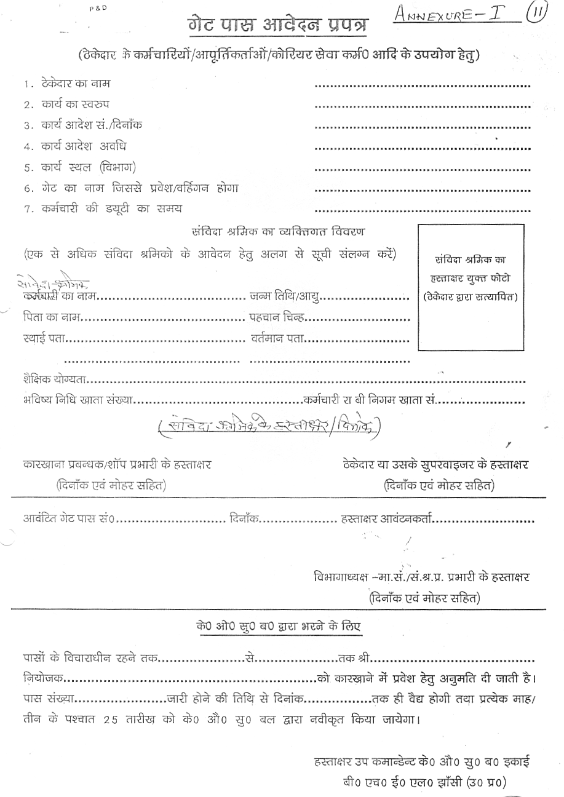
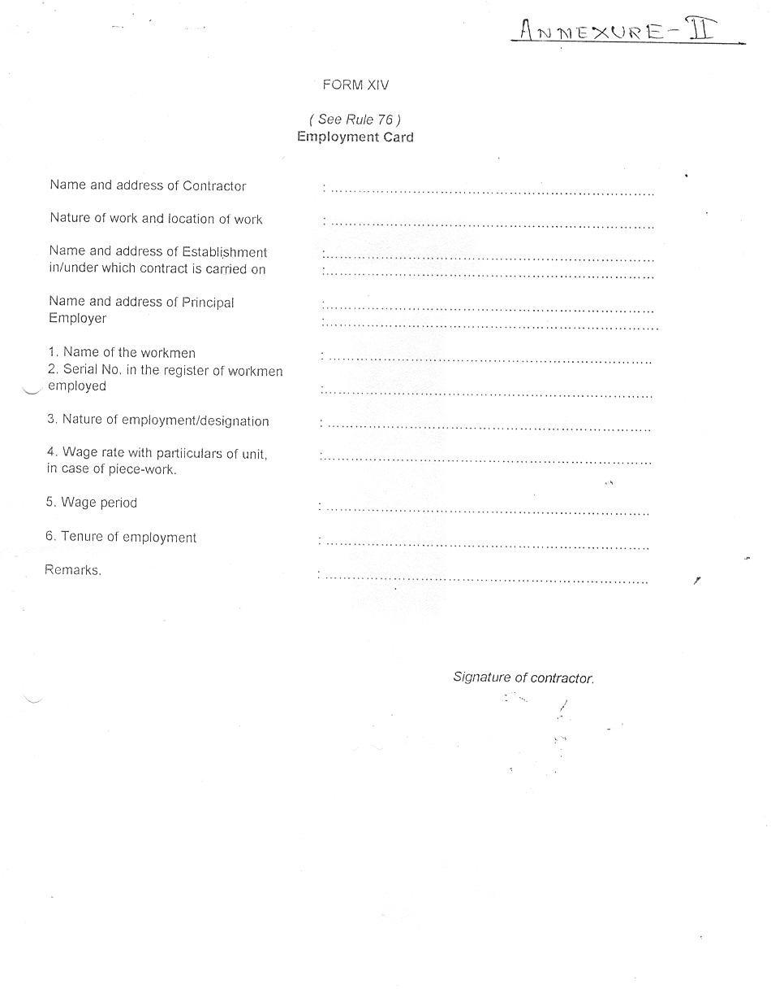
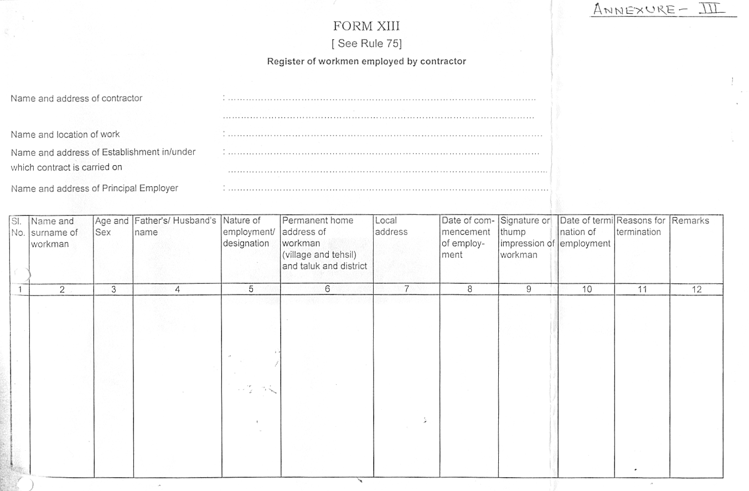

SCHEDULE-IV

TENDER ENQUIRY NO: 345/TE/6/06/R00 DATE: 20.09.2016

STATEMENT OF THE CONTRACTOR FOR THE MONTH OF ___________20____

WORK ORDER NO : ___________________
CONTRACTING DEPARTMENT : ___________________
CONTRACTOR NAME : ___________________

S.NO | NAME OF WORKER | CAT. | NORMAL  DAYS | OT  DAYS | GROSS  WAGES | EMPLOYEES CONTRIBUTION DEDUCTION |  | OTHER  DEDUCTION | TOTAL RECOVERY | NET PAYABLE | EMPLOYER'S CONTRIBUTION
 |  |  |  |  |  | PF 12% | ESI 1.75% | OTHER  DEDUCTION | TOTAL RECOVERY | NET PAYABLE | PF 13.61% | ESI 4.75%
 |  |  |  |  |  |  |  |  |  |  |  | \

SIGNATURE OF THE CONTRACTOR
SCHEDULE ‘H’
BHEL- JHANSI Tender Documents

TENDER ENQUIRY NO: 345/TE/6/06/R00 DATE: 20.09.2016

MEASUREMENT OF WORK AND PAYMENTS THEREOF.

- The designated officer of the Unit will periodically inspect the Work being provided by the contractor and find out deficiencies. The contractor shall rectify the same immediately to the satisfaction of the designated officer.

- Payment towards work satisfactorily executed will be made to the contractor on the basis of following: -

Sl No. | Work description |  | Unit of measurement |  |  | Approximate quantity for one year
 |  |  | A |  |  | B
(A) Central Receiving (CRX)Area :-
1 |  | Unloading of materials from trucks/trailors/mini trucks etc.and shifting to identified place in CRX area and stacking using fork lifter and manual force. |  | Quintals | 12499
2 |  | Marking DRS on received materials. |  | Nos | 3185
3 |  | Opening of boxes counting of items, shifting them for inspection/testing. |  | Quintals | 1185
4 |  | Segregating, identifying, counting, filling in boxes, carrying on fork lifter , unloading , stacking etc at custody store. |  | Quintals | 10195
(B) GAS YARD AREA :-
5 |  | Unloading of filled cylinders |  | Nos | 30488
6 |  | Loading of empty cylinders |  | Nos | 30488
(C) CUSTODY STORES :-
7 |  | Assist the store keepers in the following activities of any or all of custody stores: a) Placement of incoming materials. b) Segregating & sorting. c) Taking out. d) Counting / weighment etc. e) Shifting using fork lifters or manually. |  | Quintals | 20857
(D) SHIFTING OF HEAVY MATERIALS TO PRODUCTION SHOPS:-
8 |  | Slinging and assistance in lifting of heavy materials using crane and tractor-trollies, fork lifters etc. and unloading some materials in shops. |  | Quintals | 10389
(E) CYLINDERS OF GAS YARD:-
9 |  | Stacking , moving & shifting of gas cylinders both empty & filled. |  | Nos | 30489
(F) OUTWARD DESPATCH MATERIALS:-
10 |  | Loading of outward dispatch materials including rejected materials. |  | Quintals | 1990
(G) SCRAP COLLECTION & SCRAP YARD :-
11 |  | Collection & Loading of Scrap using fork lifters / manually into bins and / or trolly (ies) from all areas / departments / shops of the factory and unloading the same in scrap yard in designated storage areas including sorting, cleaning, segregating etc. Scrap may include (but not limited to): a) Metal pieces and offcuts. b) Insulation materials. c) Batteries. d) Oil & Oil drums e) Cable / hose offcuts. f) Wood g) Plastic Materials h) Components & spares etc. |  | Quintals | 13419
12 |  | Cleaning of bushes , grass , small unwanted growth / trees in and around scrap yard. |  | Sq. Meter | 2587

* 1 Quintal is equal to 100 KG.

SCHEDULE ‘I’
BHEL- JHANSI Tender Documents

TENDER ENQUIRY NO: 345/TE/6/06/R00

PROFORMA FOR SUBMITTING TECHNICAL BID FOR: “Contract for (a) unloading and shifting of fresh materials and (b) Loading, Shifting and Unloading of Scrap materials.”
(A) Essential Documents required

- Name of the firm  (Document as per clause 12 of Schedule C to be attached ) |  |  |  |  | : | __________________________________
- Name of the Proprietor/Partners |  |  |  |  | : | __________________________________
- Address and Contact Numbers |  |  |  |  | : | __________________________________
- ESI Code Number  (Copy of the Certificate) |  |  |  |  | : | __________________________________  Enclosed / Not Enclosed
- PAN/TAN Number |  |  |  |  | : | __________________________________
- Service Tax Number (PAN Based) |  |  |  |  | : | __________________________________
- VAT/TIN Number (Copy of certificate)  (To be submitted only in case where material transaction is involved) |  |  |  |  | : | __________________________________  Enclosed / Not Enclosed
- Audit financial statement/CA Certificate as per tender : |  |  |  |  | : | __________________________________  Enclosed / Not Enclosed
- Experience Certificate ( Along with necessary enclosures as per tender to be submitted) |  |  |  |  | : | Enclosed / Not Enclosed
- No. of Workers including Supervisors on the rolls of the firm. | : |  | ___________________________________
- Earnest Money Deposit  a) D.D Number & Date  b) Drawn on (Bank) |  | :  :  : |  | Rs …………………..  ____________________Date ________  _______________________
- Any other relevant information |  | : |  | _________________________________
 |  | : |  | _________________________________  SCHEDULE ‘I’
- Tender Cost  D.D. no. /Receipt No |  | :  : |  | Rs: ____________.  _____________
- Validity of offer  (At least 90 days from the date of tender Opening)  - Blank Price bid format  - E-mail Id & Mobile No |  | :  :  :  : |  | 90 days from the date of tender opening.  Enclosed / Not Enclosed  Enclosed / Not Enclosed  …………………………………………………
DESIRABLE
- PF Code Number  (Copy of the Certificate ) |  | : |  | __________________________________
- Income tax return last 3 yrs |  | : |  | Enclosed / Not Enclosed

We will fulfill all the obligations of the contractor and abide by the Terms & Conditions mentioned in the Tender.

Date: Contractor Signature with Name
& Office Seal

NOTE (1) TECHNO-COMML BID AND PRICE BID SHOULD BE SUBMITTED IN SEPARATE SEALED ENVELOPS. IN CASE THE BIDS ARE FOUND IN ONE SINGLE ENVELOPE THEN THE “BIDS” ARE LIABLE TO BE REJECTED.
.

No Reverse Auction shall be conducted in above Tender.

Please give e-mail address & mobile no. positively for fast communication.

SCHEDULE ‘J’

BHEL- JHANSI Tender Documents

TENDER ENQUIRY NO: 345/TE/6/06/R00 DATE: 06.10.2016
name of WORK: Contract for (a) unloading and shifting of fresh materials and (b) Loading, Shifting and Unloading of Scrap materials.”

PRICE BID (in separate sealed envelope)
TERMS AND CONDITIONS FOR PRICE BID ‘J’ (a) & ‘J’ (b)

- Pages 36 to 40 constitute the PRICE BID SCHEDULE ‘J’ and have to be kept in a separate sealed envelope, super-scribing the name of the work and due date of opening.
- The bidders are required to fill the % Contractor Commission in Row no.16 of PRICE BID schedule ‘J’ (a) page no.38 and its value in Rupees. Subsequently values at row nos. 18,19 & 20 have to be calculated & filled up. No other data and figures are to be filled by the contractor. The statutory requirements under minimum wages, PF ESI etc. are already fed in the corresponding rows of Price bid. Bidders are also required to fill up the value arrived at row no. 18, also on Price bid ‘J’ (b) page no. 40, in figures and words. The value at row 18 of page 38 should be exactly same as at page 40.
- Bidder are not allowed to offer negative (-) commission & zero (0) commission; such offers shall be summarily rejected.
- There is a special provision for payment of additional wages by BHEL in row no.3 (ii). This is purely a discretionary matter of BHEL Management and Contractor or his workers will have no claim on this amount.
- The provisions for reimbursement of charges for uniform, helmet, shoes etc. have been built into the price bid and shall be payable to the contractor on producing proof of procurement, distribution & use by the deployed workers. Mere documentary proof will not be sufficient to entertain claim for reimbursement. The mentioned amount is the upper limit and the reimbursement shall be limited to actual expenses.
- Provision has been kept in the Price Bid for escalation of minimum wages of workers which will become payable only on actual revision and proof of payment.
- The bill of quantities (BOQ) is on pages 39 & 40 (PRICE BID). This BOQ also provides the scope of work of the contract, the items, their description & quantities. The estimated rates of these items are also provided. These rates are calculated assuming contractor commission of 6%, reimbursement of Uniform (etc.), additional wages, Bonus, escalation etc. Bidders are also required to fill up the value arrived at row no. 18, also on Price bid ‘J’ (b) page no. 40, in figures and words. The value at row 18 of page 38 should be exactly same as at page 40.
- The rates for the BOQ items shall be derived by BHEL based on the Commission % quoted by the contractor and will be deemed to be the Contract rates for the contract. Billing will have to be done at these rates which will be communicated to the successful bidder in the LOI.
PRICE BID (in separate sealed envelope)
TERMS AND CONDITIONS FOR PRICE BID ‘J’ (a) & ‘J’ (b)

- The contractor will have to ensure that his workers complete the quantum of work expected from them each day so that both the requirements of quantity of items and minimum wages are fulfilled.

- Contractor will have to submit, at the end of each wage period (month), a table showing the detailed break-up of the claim under various heads like minimum wages, PF, ESI, Uniform, bonus, commission etc. based on monthly attendance of each worker. The monthly bill of the contractor (based on quantities of items executed) shall be accompanied with this tabular sheet, without which bill shall not be entertained. This should be kept in mind while filling this Price Bid.
- In case of non-fulfilment/ non-applicability of any of Uniform, additional wages, bonus, escalation etc. suitable deduction shall be made from the bill(s) and contractor will not have any claim on it based on the quantity of item completed and contract rates. While making the lump-sum deduction from the bill(s) if necessary, individual item rates (contract rates) will not be altered.
SCHEDULE ‘J’
BHEL- JHANSI Tender Documents

TENDER ENQUIRY NO: 345/TE/6/06/R00 DATE: 06.10.2016

PRICE BID (in separate sealed envelope)

Schedule “J”(a)

Name of Work: Contract for (a) unloading and shifting of fresh materials and (b) Loading, Shifting and Unloading of Scrap materials.
1 | Technological Man Hours required | Hrs. | 40350.00
2 | Technological Man Days required ( SL NO 1 /8) ( Figure of Sl no. 1 divided by 8 ) | day | 5043.75
3.(i) | Minimum applicable wage / day of Appropriate Government as on date - subject to change | Rs | 296.60
 | as applicable at present Rs. 296.60
3.(ii) | Additional Amount / day (76.92+ 46.16) - subject to change | Rs | 123.08
4 | Total Wages per day (Sl no.3(i) + 3(ii) | Rs | 419.68
5 | Total Wages (sl no.2*4) | Rs | 2116761.00
6 | Provision for extra wages @5% of Sl.no .5 | Rs | 105838.05
7 | Contingency @ 6% of Sl no. 5 due to revision of DA Rates and increase in minimum wages accordingly. | Rs | 127005.66
8 | Contingency @ 6% of Sl no. 6 due to revision of DA Rates and increase in minimum wages accordingly. | Rs | 6350.28
9 | Total contingency (sl.no 7+8) | Rs | 133355.94
10 | PF/EDLI/Pension Employer's contribution @13.36%(Calculated on Amt. of sl no.5&7) | Rs | 299767.23
11 | ESI Employer’s contribution @4.75%(Calculated on Amount. of sl no.5,6 & 9) | Rs | 111907.86
12 | Provision for uniforms ,uniform stitching charges, shoes, helmet @of Rs1175/- ( sl no 2/310 X Rs.1175/-) | Rs | 19117.44
13 | Provision of personal Accident insurance (24X7) @Rs 500/-, ( sl no 2 /310XRs 500) | Rs | 8135.08
14 | Contingency @20% of sl no 13 |  | 1627.02
15 | Total (sl.no 5+6+9+10+11+12+13+14) | Rs | 2796509.62
16 | Contractors Commission ………………... % of total of sl. no. 15. Bidders to quote here. | Rs | ………………..
17 | Statutory minimum Bonus @7000 /- (per labour) i.e (sl no 2 /310 X 7000)X16 persons for one year | Rs | 113891.13
18 | Total Value of the Contract payable to the bidders/price bid(excluding Service Tax and including Statutory bonus amount ) amount at (sl.no 15+16+17) | Rs | ………………..
19 | Service Tax @ of 15% of Sl. No.18 | Rs | ………………..
20 | Total Value of Contract (18+19) | Rs | …………………

SCHEDULE ‘J’
BHEL- JHANSI Tender Documents

TENDER ENQUIRY NO: 345/TE/6/06/R00 DATE: 06.10.2016

Schedule “J” (b)
PRICE BID (in separate sealed envelope)

BILL OF QUANTITIES (BOQ)
Name of Work: Contract for (a) unloading and shifting of fresh materials and (b) Loading, Shifting and Unloading of Scrap materials. ”
Sl No. | Work description |  | Unit of measurement |  | Approximate quantity for one year |  | Estimated Rate  (Rs) | Estimated  Amount (Rs)
Sl No. |  |  | A |  | B |  | C | D = BXC
(A) CENTRAL RECEIVING (CRX) AREA:-
1 | Unloading of materials from trucks/trailors/ mini trucks etc. and shifting to identified place in CRX area and stacking using fork lifter and manual force. |  | Quintals |  | 112499 |  | 13.00 | 1462487.00
2 | Marking DRS on received materials. |  | Nos |  | 3185 |  | 4.00 | 12740.00
3 | Opening of boxes counting of items, shifting them for inspection/testing. |  | Quintals |  | 1185 |  | 2.00 | 2370.00
4 | Segregating, identifying, counting, filling in boxes, carrying on fork lifter, unloading, stacking etc. at custody store. |  | Quintals |  | 10195 |  | 4.00 | 40780.00
(B) GAS YARD AREA:-
5 | Unloading of filled cylinders |  | Nos |  | 30488 |  | 6.00 | 182928.00
6 | Loading of empty cylinders |  | Nos |  | 30488 |  | 6.00 | 182928.00
( C ) CUSTODY STORES:-
7 | Assist the store keepers in the following activities of any or all of custody stores: |  | Quintals |  | 20857 |  | 20.00 | 417140.00
7 | a) Placement of incoming materials.
7 | b) Segregating & sorting.
7 | c) Taking out.
7 | d) Counting / weighment etc.
7 | e) Shifting using fork lifters or manually.
(D) SHIFTING OF HEAVY MATERIALS TO PRODUCTION SHOPS:-
8 | Slinging and assistance in lifting of heavy materials using crane and tractor trollies, fork lifters etc. and unloading some materials in shops. |  | Quintals |  | 10389 |  | 4.00 | 41556.00
(E) CYLINDERS OF GAS YARD:-
9 | Stacking, moving & shifting of gas cylinders both empty & filled. |  | Nos |  | 30498 |  | 6.00 | 182988.00
(F) OUTWARD DESPATCH PATERIALS:-
10 |  | Loading of outward dispatch materials including rejected materials |  | Quintals |  | 1990 | 4.00 | 7960.00
PRICE BID (in separate sealed envelope)

Schedule “J” (b)
(G) SCRAP COLLECTION & SCRAP YARD:-
11 | Collection & Loading of Scrap using fork lifters / manually into bins and / or trolley (ies) from all areas / departments / shops of the factory and unloading the same in scrap yard in designated storage areas including sorting, cleaning, segregating etc. Scrap may include (but not limited to): | Quintals | 13419 | 40.00 | 536760.00
11 | a) Metal pieces and offcuts.
11 | b) Insulation materials.
11 | c) Batteries.
11 | d) Oil & Oil drums.
11 | e) Cable / hose offcuts.
11 | f) Wood.
11 | g) Plastic Materials.
11 | h) Components & spares etc.
12 | Cleaning of bushes, grass, small unwanted growth / trees in and around scrap yard. | Sq. Meter | 2587 | 2.92 | 7554.04
 |  | ESTIMATED TOTAL |  | Rs. 3078191.04
IN WORDS: Thirty Lakh Seventy-Eight Thousand One Hundred Ninety-One and Zero Four Paisa
Only.
Service tax extra as applicable
TO BE FILLED BY THE BIDDER
Total Value of the Contract payable to the bidder/price bid (excluding Service Tax and including Statutory bonus amount), amount at sl.no.18 of Price Bid Schedule “J” (a)= Rs.……………………
Amount in words= Rs…………………………………………………………………………………………
………………………………………………………………….
Service tax extra as applicable

I/we agree with the above.
Signature of contractor or with seal / date Executive In-Charge

