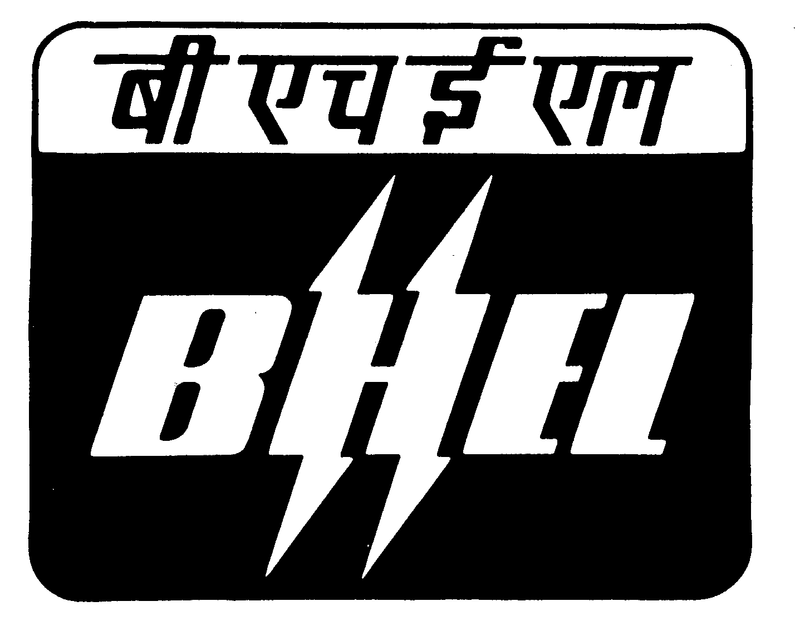
BHARAT HEAVY ELECTRICALS LIMITED
Ramachandrapuram, Hyderabad - 502 032
Phones : 040 - 23185227

FACTORY CIVIL AND PROJECTS DEPARTMENT

CORRIGENDUM - I

Ref : Tender Notice No: HY/FCD/OT-20/2021-22, Dt: 20.01.2022

The last date for sale and receipt of tenders for the work are given below.

Item No. | Name of work
1 | Provision of new toilet in CCSM bay of 04 shop

Tender Notice No. HY/FCD/0T-20/2021-22 DATED: 20.01.2022 for the above work is extended up to 11.00 hrs on 17.02.2022 (receipt). The tender box for receipt of tenders is kept at vendor complex. The tenders (Technical bids) will be opened on the same day at 13.15 hrs in vendor complex behind Admn. building. The other terms and conditions remains same. For full details and tender documents please visit our website https://www.bhel.com vide NIT No.: 62650 on or before the above mentioned dates.

Sd/-
AGM
Factory Civil & Projects

