
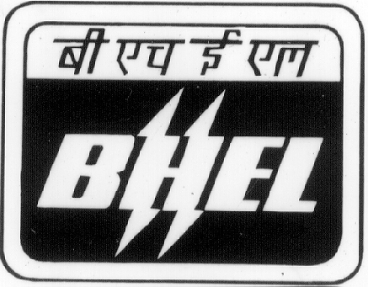 | BHARAT HEAVY ELECTRICALS LIMITED  RAMACHANDRAPURAM, HYDERABAD-502 032 (A.P)  Phone: 040-23182465; 23021869 Cell No. : 9490492143; e-mail: jsr@bhelhyd.co.in  Fax: 040-23020085 / 23020102
(STORES DEPARTMENT-CMM / COLLECTION CELL)

CORRIGENDUM (NIT_7728)
Tender Notice No. HY/CMM-STORES/CC/024/2010-12, Dt.02.11.2009

With reference to NIT No.7489 Dated:13.11.2009 ie., ALL INDIA TRANSPORT CONTRACT 2010 – 12, the tender due date was extended upto 25.02.2010, 14.00 Hrs. Details as follows :-
Closing date for Sale of Tender documents | : | 24.02.2010 at 14.00 Hrs
Last date for submission of Tender documents | : | 25.02.2010 at 14.00 Hrs.
Date of opening of Technical Bids | : | 26.02.2010 at 13.00 Hrs.

SR.MANAGER/STORES (CMM)

