- After login show user id name on top (30-10-2020 – point 1) - DONE (Attached Screenshort) -Not Done- first name and last name shown. DONE Ornate Done

- After unsuccessful 5 attempts id block but under admin it show ACTIVE. ### Ans : We disscussed this last time that status in admin will not changed to block as this status is not related to wrong password Ornate – But that time how we identify the blocked user. Due to Block user tab not shown the userid for the same person.

Amit : Tried unsuccessful 5 attempts with 3 different users and all are showing in block list

Ornate Done
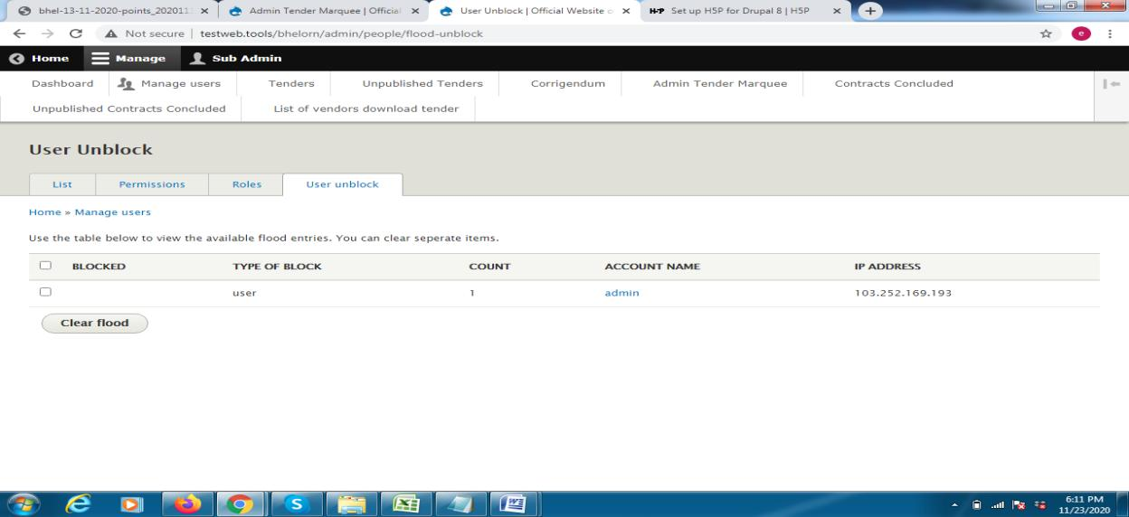

- Tender slider not edit and not proper view on website - Please explain this in details == Ornate-Wrongly write as tender slider – it is tender marquee which show on top of tender page. Please check the screen short - DONE screen short attached Not Done
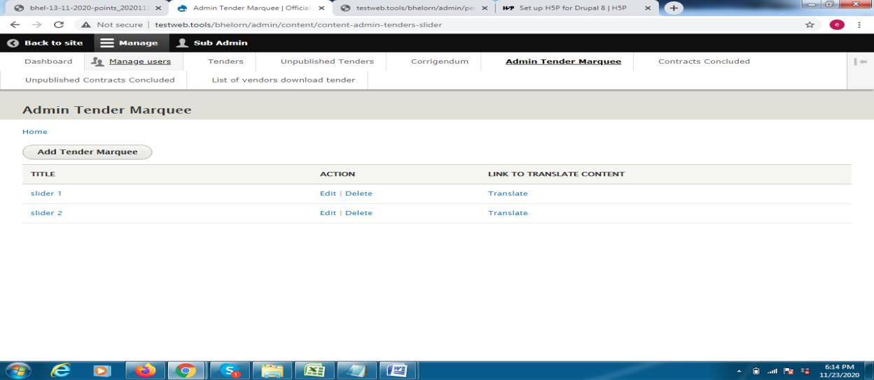
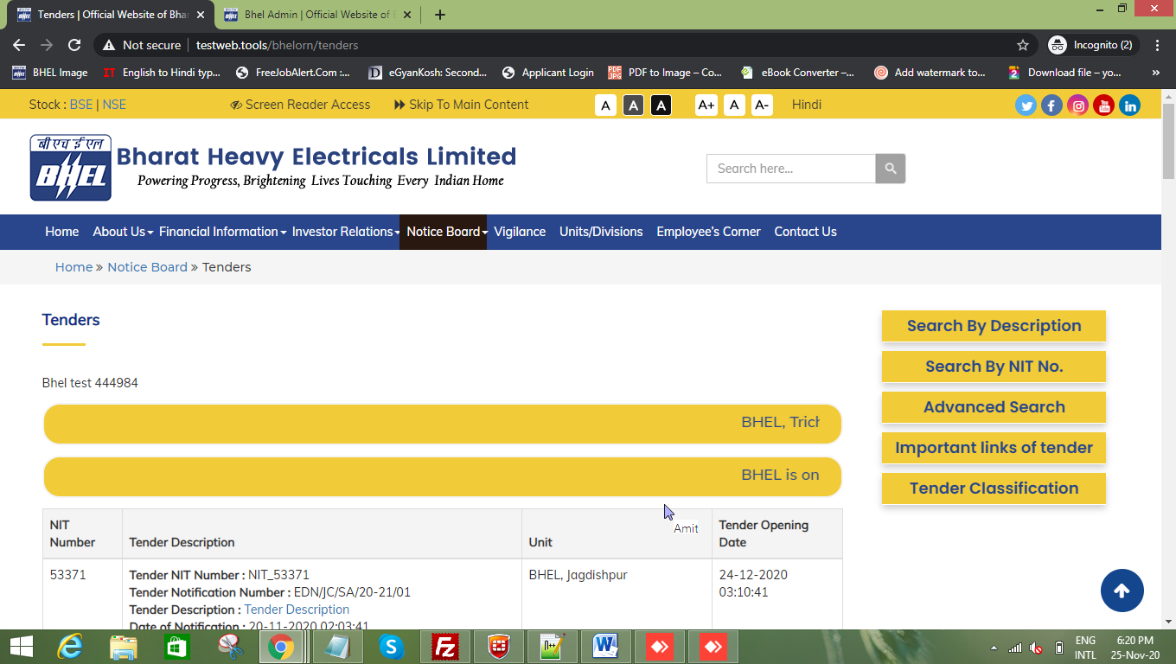

1.Corrigendum document not download.(NIT no. 53368) DONE Ornate Done

- In Advanced search some filed missing and captcha There is no need of captcha in search , captcha use only in form to stop spam

5. Corrigendum view not show correct corrigendum description DONE Not Done

Change the text CORRIGENDUM BRIEF DESCRIPTION As per old website

3.Search By Description and Advanced search not work DONE In Advanced search some not work

Reference Number- “u BHEL_30-10-2020/1 p” , Email ID, Contact No. and Notification Date

- While downloading the status of Vendor download document. If not shown. Only one shown - Please explain this in details == Ornate –We have uploaded a tender and download it with particular tender with differnet ids. But when we checked the download status it show only first time downloader details.

Amit : Didn't find any issue, I checked with three tester and all downloded user data is there all tester dowloaded data 2 -3 times , and also there is no ip validation Ornate Done

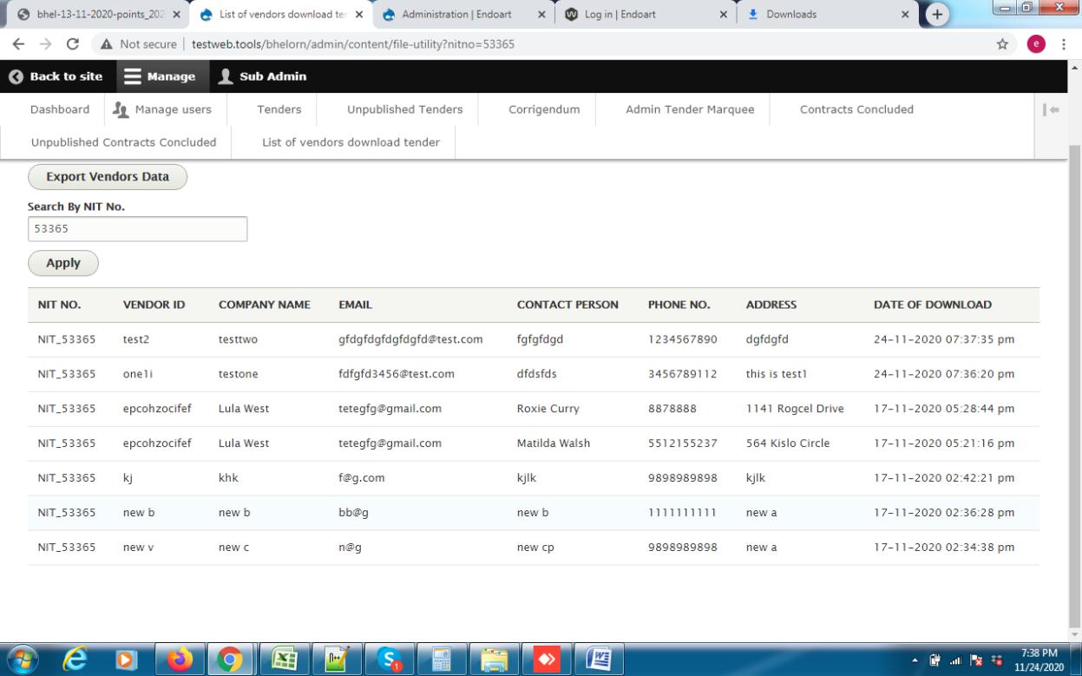

27-10-2020
- Tender upload by previous date by keyboard 53361 Not Done Re-Open(53371)

1.search by Nit no. so not show all tender only view corrigendum .

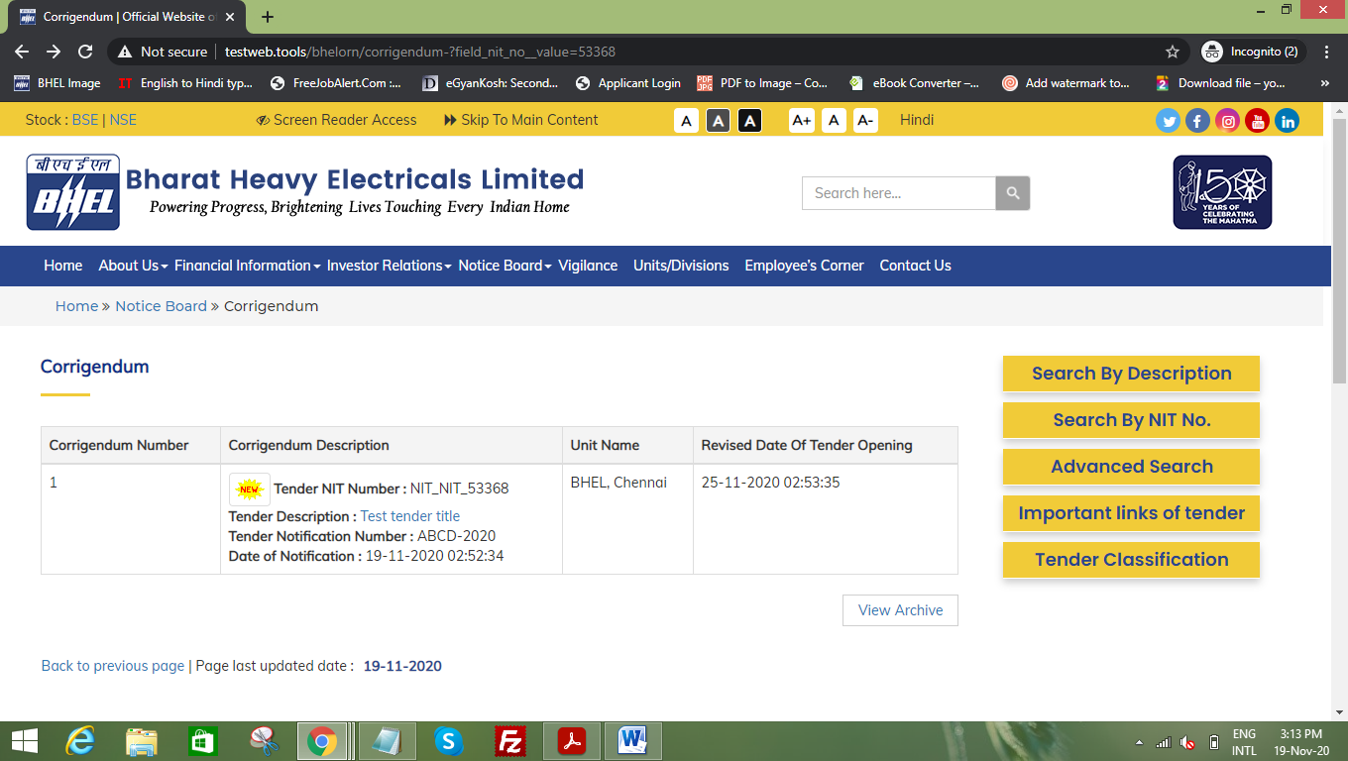

2.In Edit corrigendum not show previous uploaded document.(53370), if a user wants to edit corrigendum document –no document shown
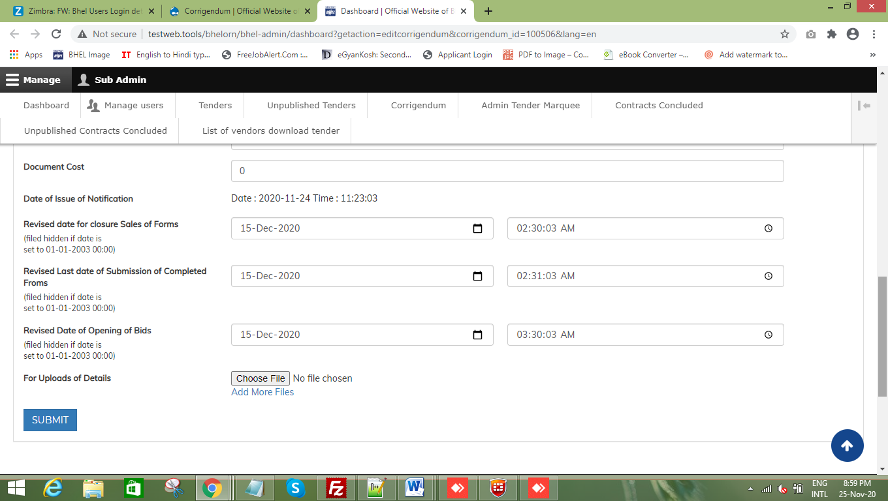
3.Download full detail title so long- as per old site it show download with pdf icon

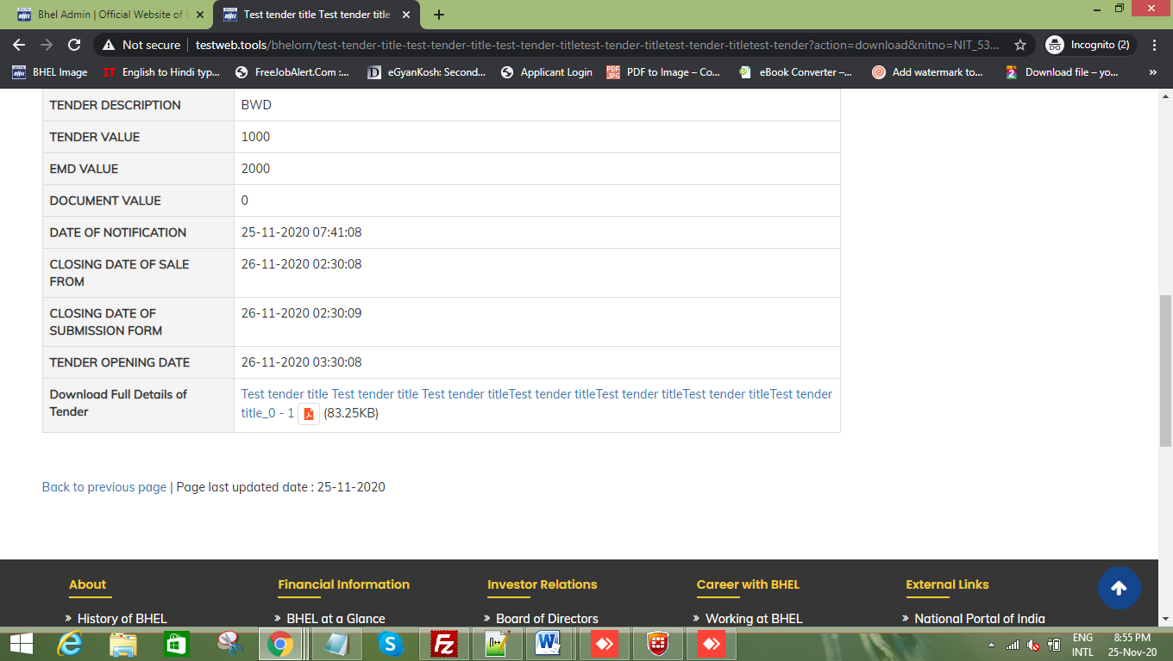

4.Tender title show two times

