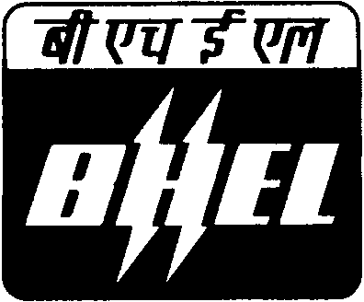 | BHARAT HEAVY ELECTRICALS LIMITED  INDUSTRIAL VALVES PLANT  433, INDUSTRIAL COMPLEX  GOINDWAL SAHIB  DISTT. TARN TARAN- PUNJAB |  |  |  | No. BHE:IVP:VR:  2010-11/03
NOTICE INVITING EXPRESSION OF INTEREST FOR SUPPLY OF VARIOUS GASES
BHARAT HEAVY ELECTRICALS LIMITED [BHEL] is manufacturing Industrial Valves and other Boiler accessories at its Industrial Valves Plant, Goindwal Sahib unit. The plant is heading towards increasing its volume as well as range of items. For an annual turnover to the tune of ` 200 Cr., BHEL has to procure various types of gases.

The various gases which are to be procured are listed below:
Argon Gas |  | High Purity Argon Gas-GR:1, satisfying to IS 5760/1998(II-REV) for welding use in supplier own cylinders along with Product Data Sheet (PDS), Material Safety Data Sheet (MSDS) and Test Certificate (TC) by conforming to IS 5760/1998(II-REV) specifications for each cylinder/lot supplies. Maximum permissible level of impurities: Water Vapour = 4ppm, Oxygen = 4ppm.  Total Annual Requirement ~ 4000 CM
Oxygen Gas |  | Compressed Oxygen Gas for Industrial use as per IS:309/2005 (With latest revision /amendment).  Total Annual Requirement ~ 8000 CM
Dissolved Acetylene Gas |  | Dissolved Acetylene Gas for Industrial use as per IS:308/1988 (With latest revision /amendment).  Total Annual Requirement ~ 6000 CM
BHEL is also looking for the vendors for procurement of empty cylinders for all the above mentioned three gases.
The capacity of each cylinder = 7 CM.
BHEL is looking for prospective gas manufacturers and suppliers who have well-established and sound organizational infrastructure and quality systems to work with. The manufacturer/supplier is to be ready for supply of gases in their own cylinders
BHEL invites such vendors to visit its above located plant on any working day from Monday to Saturday between 0900 Hrs to 1600 Hrs and contact undersigned for any clarification regarding:
Items details and requirement |  |  |  | Vendor registration form/procedure
Gurbax Singh Sokhal  Manager(MM, P&D) |  |  | Ankur Bansal  Engineer(MM) | Vishal Devgon  Dy. Manager(IT, SD & HSE)
Phone: 01859-224615 |  |  | 01859-224616 | 01859-224623
Mobile: 088729 77877 |  |  | 088725 66150 | 092163 49001
E-mail: gss@ivp.bhel.in |  |  | ab@ivp.bhel.in | vishal@ivp.bhel.in
Fax: 01859-222061
BHARAT HEAVY ELECTRICALS LIMITED
INDUSTRIAL VALVES PLANT
433, INDUSTRIAL COMPLEX
GOINDWAL SAHIB, DISTT. TARN TARAN

