

BHARAT HEAVY ELECTRICALS LIMITED,JHANSI
(A GOVT. OF INDIA UNDERTAKING)

TENDER ENQUIRY NO: FBM/TE/1/07 DATE: 25/03/2012

nature of work: Works Contract for “Manufacturing of Shell of ACEMU Coach” in Fabrication Shop of BHEL Jhansi.

- BHEL Jhansi is in the process of finalizing the Works Contract for “Manufacturing of Shell of ACEMU Coach” in Fabrication Shop of BHEL Jhansi.
2. The tender document has been detailed as follows:

  - Notice Inviting Tender (Annexure A)
  - Work Specifications (Annexure B)
  - Qualifying Requirements (Annexure C)
  - Instruction to Tenderers (Annexure D)
  - Tender Evaluation Criteria (Annexure E)
  - Contractor’s obligations (Annexure F)
  - Other General Terms and Conditions (Annexure G)
  - Criteria for measurement of work (Annexure H)
  - Technical Bid Application (Annexure I)
  - Price Bid ( Annexure J)

The duly filled in Technical bid and Price bid (Annexure I and J, separately) along with the instructions to the bidder, Contractor’s Obligations, General Terms and Conditions with the signature of the bidder on all the pages and complete in all respects super scribed as “Quotation for Tender No. FBM/TE/1/07 dated 25/03/2012” should reach us in a sealed cover on or before DUE DATE 22/05/2012 (13:15 hours) through registered / speed post / courier or the same may be dropped in the tender box available at the following address:

CISF Control Room/Office
Administrative Building
Bharat Heavy Electricals Limited
Jhansi-284 129

TENDER ENQUIRY NO: FBM/TE/1/07 DATE: 25/03/2012

CONTENTS

Sl. No. | Description | Annexure No. | No. of Pages
01. | Notice Inviting Tender | A | 2
02. | Work Specifications | B | 2
03. | Qualifying Requirements | C | 2
04 | Instructions to bidder | D | 2
05. | Tender Evaluation Criteria | E | 1
06. | Contractors obligations | F | 2
07. | Other General Terms & Conditions with annexure | G | 10
08. | Criteria for measurement of work | H | 1
09. | Technical Bid format | I | 2
10. | Price Bid | J | 1

NOTE:
- Technical bid and price bid should be submitted in separate sealed envelopes and both the technical bid and price bid sealed envelopes must be again put in a single envelope duly sealed and super scribed as “Tender for Tender No. FBM/TE/1/07 dated 25/03/2012 due on 22/05/2012 (date of opening).

- EMD and dd for tender cost must be kept with technical bid. If they are kept in price bid envelope then offer will be liable for rejection.

Annexure ‘A’

NOTICE INVITING TENDER

TENDER ENQUIRY NO: FBM/tE/1/07 DATE: 25/03/2012

- SCOPE OF WORK: Works Contract of “Manufacturing of Shell of ACEMU Coach” in Fabrication Shop of BHEL Jhansi.
- Duration of the Contract: One year from award of contract or completion of works whichever is earlier.
- Last date of receipt of the Tender: Up to 13:15 hours on 22/05/2012

4. Date of opening of Techno - : 14:00 hours on 22/05/2012 at ADM Building
Commercial Bid of BHEL Jhansi

5. Address for receipt / issue of Tender: AGM (FBM), Bharat Heavy Electricals
Documents Limited Jhansi, PIN-284129

6. Earnest Money Deposit: Rs.1, 50,000/- (One Lakh Fifty Thousand only) Payable in the form of Demand Draft / Pay order in favour of BHEL, Jhansi.
or
One time EMD of Rs. 2.0 Lakh can also be deposited in
above form and copy of receipt may be enclosed along with
tender form.

6. (a) In case of successful bidder, EMD will be converted and adjusted against the Security deposit.

6. (b) EMD will be forfeited in following cases :
- After opening the tender, the bidder revokes his tender within the validity period or increases his earlier quoted rate.
ii) The bidder does not commence the work within the period as per LOI / Contract. Incase the LOI / contract is silent in the regard then within 15 days after award of contract.
6. (c) EMD given by all unsuccessful tenderers shall be refunded normally within 15 days of acceptance of award of work by the successful tenderer.
6. (d) EMD shall not carry any interest.
7. Cost of Tender Document: Rs.1000.00 + 13.5% VAT = Total Rs. 1135 /- (Rs. One thousand one hundred thirty five only)
(Payable through a Separate Demand Draft in favour of
“BHEL, Jhansi” along with technical bid, in case the
documents downloaded from website)

8. Security Deposit : Security deposit shall be Rs.4.00 Lakhs + 5% amount exceeding amount Rs.50 lakhs as per our work policy Para, 8 (refer website
www.bhel.com) and shall be deposited before start of work. The EMD
shall be adjusted with the actual amount of security deposit which shall
be given in work order.

9. All the documents required for this tender should be submitted at the time of opening of
Bids only.

11. Delivery period: On an average it is expected that 1 No. Shell of ACEMU Coach
shall be completed per month.

12. Period of contract: The contract shall be valid for the period of One year from date of
award of the completion of works whichever is earlier.
13. LD Clause: For late completion of work, BHEL standard LD clause shall be applicable
which is 0.5% per week for unexecuted portion of work subject to maximum 10% of
contract value.
14. Payments will be made to the contractor on the basis of work carried out by him on a
monthly basis after completion of fabrication of Shell of ACEMU Coach duly cleared by
BHEL–QC/RDSO.

15. BHEL reserves the right to accept or reject any of the bid / all bids or cancel / withdraw
The invitation for bid without assigning any reason whatsoever and in such case no
bidder/intending bidders shall have any claim arising out of such action by BHEL.

16. BHEL can accept / reject any or all tenders fully or partly, reduce / increase business
Volume without assigning any reasons thereof.

17. The price bids of only the technically & commercially qualified bidders shall be opened
who confirm compliance to all terms & conditions.

18. In Price Bid format only price quoted in figure & word, (without overwriting) will be allowed. If any other addition is made or any condition is added by the bidder in the price bid format and / or techno-commercial bid, then the offer shall be by-passed.

NOTE:

1. THE CONTRACTORS MAY PERSONALLY VISIT THE WORK PLACE BEFORE SUBMITTING THEIR BIDS.

2. FOR RELEVANT DETAILS PLEASE VISIT OUR WEBSITE “www.bhel.com”.

I / We agree with the above

Signature of Contractor with Seal Executive Incharge

Annexure ‘B’

TENDER ENQUIRY NO: FBM/TE/1/07 DATE: 25/03/2012

WORK SPECIFICATION

DETAILS OF WORK

- Scope of work of the contractor shall be as following:-

1) The contractor shall be responsible for “Manufacturing of Shell of ACEMU Coach” in Fabrication Shop of BHEL Jhansi.
2) Only material, electricity, compressed air, consumables, like electrodes, grinding wheels & discs etc.; available with BHEL shall be provided by BHEL free of cost. Vendor to arrange for tooling other than welding fixtures, which will be provided by BHEL. Machines / equipments such as welding machine, grinding machines, tools etc. required shall be arranged by vendor. Number of machine, Make, Model and Year of manufacturing of machine to be provided by bidder in technical bid.
3) EOT crane shall be provided by BHEL free of cost; however, the assistance in operation of the same shall be the responsibility of contractor. In contingency, in order to meet the job requirement, any additional resources if required shall be arranged by the contractor at their cost.
4) Inspection at various stages shall be done by BHEL - QC / RDSO and proper record by vendor shall be maintained. Inspection / clearance by BHEL QC / RDSO shall be vendor’s responsibility.
5) Vendor shall have at least 3 year of experience of similar sheet metal fabrication, preferably Indian Railways coach factory / coach repair shop. The vendor shall employ workers having experience and knowledge of concerned work. Vendor to post an experienced and qualified (Minimum Diploma) Supervisor for the complete period of contract.
6) The Contractor shall be responsible for complying with all the applicable statutory acts & law.
7) Contractor may be required to work in 3 - Shifts. Contractor shall appoint supervisors (Minimum Diploma) for A / B / C Shifts for coordination with various departments BHEL. Vendor to organize adequate work force of qualified and experienced welders and fitters to take up parallel working on underframe, side walls & roof of Shell of ACEMU coach.
8) Contractor is advised to visit the work place to know the work content before submission of quotation.
9) Contactor shall give undertaking for providing skilled & un-skilled manpower as per
requirement of BHEL during execution of contract.

10) Tenderer should confirm the following work related requirement:
- The workers to be deployed shall be decided by contracting department as per requirement of job.
- The personal protective equipment, helmets, shoes, tools and tackles etc., Group insurance shall be provided by the contractor from the commencement of the contract for the entire contract period. No separate reimbursement shall be made to this account. Payment shall be made as per rates quoted by the contractor.
- In case any worker leaves the job or fresh worker is deployed then also providing helmets, shoes, tools and tackles group insurance etc. to the fresh worker shall be in contractors scope and no extra amount shall be payable to this account.

- Measurement of work & Payment–
  - The work shall be measured in terms of weight (Kilogram).
  - The payment shall be made after completion of Shell of ACEMU Coach by QC (BHEL) / RDSO.
  - All the payments will be subject to deduction of tax at source applicable as per law.
  - Estimated Quantum of Work : 252,000 Kg.

I / We agree with the above

Signature of Contractor with Seal Executive Incharge
Annexure ‘C’

TENDER ENQUIRY NO: FBM/TE/1/07 DATE: 25/03/2012

QUALIFYING REQUIREMENTS

Sl. No. | Description of Qualifying requirement | Copy enclosed
1. | Contractor should have independent ESI Code number. | Yes/No
2. | Contractor should have PAN / TAN number. | Yes/No
3. | Contractor should have Service Tax number (PAN based). | Yes/No
4. | Self Certificate / Declaration that the bidder is not blacklisted / under hold / banned or delisted by BHEL Jhansi or any unit / region / office of BHEL on the date of tender. | Yes/No
5. | Self Declaration that he is not guilty by a Court of Law in India for any offence involving fraud, dishonesty and moral turpitude. | Yes/No
6. | Contractor should have minimum 05 nos. qualified welders for ASME section IX / AWS D 1.1 (Certificates to be enclosed). | Yes/No
7. | Vendor shall have at least 3 year of experience of similar sheet metal fabrication, preferably Indian Railways coach factory / coach repair shop. Copy of orders and performance report issued by customer for successful execution of the order is to be submitted along with TDS certificate (if applicable). | Yes/No
8. | The vendor should have workers having experience and knowledge of concerned work. Vendor should have an experienced and qualified (Minimum Diploma) Supervisor for the complete period of contract. List of qualified and experienced welders and fitters (preferably ITI) with supervisor (Minimum Diploma), adequate enough work force to take up parallel working on underframe, side walls & roof of Shell of ACEMU Coach; to be enclosed. | Yes/No
9. | Contractor should give confirmation for the following work related requirement:  - The workers to be deployed shall be decided by contracting department as per requirement of job.  - The personal protective equipment, helmets, shoes, tools and tackles etc., Group insurance shall be provided by the contractor from the commencement of the contract for the entire contract period. No separate reimbursement shall be made to this account. Payment shall be made as per rates quoted by the contractor.  - In case any worker leaves the job or fresh worker is deployed then also providing helmets, shoes, tools and tackles group insurance etc. to the fresh worker shall be in contractors scope and no extra amount shall be payable to this account. | Yes/No
10. | Vendor to arrange for tooling other than welding fixtures, which will be provided by BHEL. Machines / equipments such as welding machines, grinding machines, tools etc. required shall be arranged by vendor. List of number of machines, Make, Model and Year of manufacturing of machine to be provided by bidder in technical bid. | Yes/No
11. | Tender cost for Rs. 1135/- (Rs. One thousand one hundred thirty  five only). Payable through a Demand Draft in favour of “BHEL,  Jhansi. | Yes/No
12. | EMD for Rs 1, 50,000/- (One Lakh Fifty Thousand only) Payable in the form of Demand Draft / Pay order in favour of BHEL Jhansi. | Yes/No
13. | Documentary proof in support of this eligibility criterion shall be submitted along with Techno Commercial Bid at Annexure I. | Yes/No
14. | Blank Price bid | Yes/No

I / We agree with the above

Signature of Contractor with Seal Executive Incharge

Annexure’D’

TENDER ENQUIRY NO: FBM/TE/1/07 DATE: 25/03/2012

INSTRUCTIONS TO TENDERERS

* Above tender is in Two Bid System (Techno Commercial Bid & Price/Rate Bid).

1. The tender is to be processed in two parts viz. 1) Techno Commercial bid 2) and Price/Rate bid. The Technical Bid Application (Annexure - I) and its enclosures (along with the Contractor’s Obligations, General Terms & Conditions and copies of qualifying requirements ) must be submitted in one sealed envelope super scribed as “Tender for -------------------------------TECHNOCOMMERCIAL bid”. EMD/Cost of Tender Document or Documents required as per qualifying requirements must be enclosed. The second envelope duly sealed should contain the Price bid (Annexure-J) only super scribed as “(Name of Work) ---------------------------------PRICE bid”. Any other enclosures, which the tenderer wishes to submit, must be enclosed with the Technical Bid only. The price bid envelope should contain the rates only. Offers not in line with the above procedure or quoted in any other format is liable to be Rejected / By passed.

2. Both the technical bid and price bid sealed envelopes must be again sent in a single envelope duly sealed and super scribed as “TENDER FOR TENDER NO --------------------------- Due date of OPENING -----------“The same should be dropped in the tender box kept in the CISF gate of Administrative Building, BHEL, Khailar, Jhansi, within the specified date and time by the representative of the tenderer.

3. All tenderers can witness the opening of the Technical Bid. After evaluation of the Technical Bid which may involve visit to the tenderer’s / clients place by authorised officials, price bids of only those tenderers who are technically found suitable will be opened on a subsequent date which will be informed to the concerned whose technical bid has been accepted, in advance for witnessing the Price Bid opening.

4. All entries in the tender document should be in one ink. Corrections, over writing, cuttings, etc. will not be permitted. All the columns in the tender form should be filled without leaving blank in any page of the tender and all the pages must be duly signed & stamped by the tenderer before submission.

5. The Price / Rate should be quoted in figures as well as in words. Price quoted in Price Bid shall be inclusive of all taxes & duties, all statutory requirements / liabilities like PF/ESI/Bonus/Min.Wages etc. However service Tax shall be payable extra as applicable.

6. The rate quoted will be valid for the period of contract.

7. The contract will commence on the date as applicable against the contract and shall be valid as per the validity period of the contract. The contract can be extended further on mutually agreed terms and conditions.

I / We agree with the above

Signature of Contractor with Seal Executive Incharge

Annexure ‘E’

TENDER ENQUIRY NO: FBM/TE/1/07 DATE: 25/03/2012

TENDER EVALUATION CRITERIA

The evaluation of the Tender will be carried out as follows:

- BHEL officials may visit the bidder’s office & their client’s place to evaluate the capability and assess the performance. Capability of the Contractor will be assessed on the basis of employees including supervisors on their rolls, machinery, equipments in its possession, previous track record, experience in other organizations, etc.

- Successful techno commercial qualified bidder after the above process only will be invited for opening of the price bid.

- The contractor shall be awarded the work on over all L-1 basis (net cost to BHEL).

I / We agree with the above

Signature of Contractor with Seal Executive Incharge

Annexure’F’

TENDER ENQUIRY NO: FBM/TE/1/07 DATE: 25/03/2012

CONTRACTOR’S OBLIGATIONS

- CONTRACTUAL

Towards selection, control and supervision of employees

  - Contractor shall decide the number of employees to be deployed for execution of the work awarded to him and he or his authorized representative will be solely entitled to instruct such workers about the manner of carrying out the work as per the prescribed specifications and quality plan.

  - Contractor shall supervise the work allotted to him and to be carried out by his employees.

  - Contractor to ensure that the employees deployed in the premises of BHEL are physically and mentally fit and do not have any criminal record. Such employees should possess requisite skill, proficiency, qualification, experience etc. Contactor shall give undertaking for providing skilled & un skilled manpower as per requirement of BHEL during execution of contract.

d) Contractor to maintain appropriate records of his employees deployed to carry out the job(s).

e) Contractor shall ensure Group Insurance Policy for his workers. The coverage shall be of minimum Rs 3 Lakhs per individual.

f) Contractor will ensure that the job is executed through his employees on his rolls and under no circumstances the contractor will deploy any casual employee to carry out the job nor shall sub-contract the job without prior written permission.

g) Contractor will keep watch on his employees and he will be liable for any pilferage/loss to BHEL due to acts of omission and commission by his employees. Similarly, liability for any compensation to outsiders on account of any act of omission and commission by the employees deployed by the contractor shall lie exclusively with him.

h) The contractor has to provide to his workers uniform (lower- dark blue & upper- light blue) along with badges bearing logo of his establishment, which shall be affixed by the contract labour on the left side of his pocket.

i) Contractor to ensure that all precautions are taken for safety of his employees and equipments.

J) In the event of termination of contract for any reason whatsoever, the contractor shall withdraw all his employees from the establishment of BHEL. In case contractor decides to terminate services of his employees, he should settle all terminal dues required.

B) Towards supply of tools, tackles and materials

a) Contractor shall provide to his employees all tools, tackles, material, equipments as specified in contract and maintain the same to carry out the job under the contract at his cost and if necessary may take insurance policy of his worker, material, equipments & tools & tackles.

b) Contractor shall provide shoe, helmet, gloves, personal protective equipment & maintain the same at his own cost which may be required.

c) Contractor shall ensure that his workers wear uniform, shoes, helmet and other required safety appliances, apparels / equipments inside factory.

C) Towards statutory liability

a) As mentioned in the terms and conditions enclosed as Annexure ‘G’ of this contract.

b) Contractor shall indemnify BHEL against all claims by statutory authorities and losses under various Labour Laws, statutes or any civil or criminal law in connection with employees deployed by him.

c) Contractor shall be responsible for making payment of wages before expiry of 7 days from the last day of wage period (wage period shall be from 1st day of the month to the last date of the month) and to ensure disbursement of wages in the presence of the authorities representative of contract operating division who shall record under his signature at the end of entries in the Register of wages.

d) Contractor to obtain license under the provisions of CL(R&A) Act.

D) Towards Finance

Contractor to arrange his own finance for carrying out the job including supply of tools, tackles and equipments, if required, to his employees, materials, payment of wages to his employees etc.Rates to be as per price bid

I / We agree with the above

Signature of Contractor with Seal Executive Incharge

Annexure ‘G’

TENDER ENQUIRY NO: FBM/TE/1/07 DATE: 25/03/2012

GENERAL TERMS & CONDITIONS FOR CONTRACTORS FOR DEPLOYMENT OF CONTRACT LABOURS UNDER SERVICE / WORKS CONTRACT.

1 LABOUR LICENCE AND OTHER REQUIREMENTS:-

1.0 Contractor should possess Labour licence in case of contractors working in BHEL, Jhansi and deploying 20 or more labours on any day, from the Appropriate Government (Central Govt.) for carrying out the various activities mentioned in the contract document.

1.1 The contractor shall deploy such number of workers in the premises of BHEL, Jhansi, as required for completion of the contract. The workers such deployed shall be his own workers.

1.2 In case the number of labour deployed by the contractor in premises of BHEL Jhansi exceeds the number of labour allowed in the licence then the contractor shall immediately inform the HR and concerned department. The contractor shall also apply to the licensing officer in the region for amendment in the licence within 7 days of exceeding the number of labours mentioned in the licence.

1.3 Labour licence and other requirement in case of contractors NOT working in BHEL, Jhansi or has less than 20 workers on his rolls.

1.3. A The contractor should possess valid labour licence issued by any licensing authority if he has deployed 20 or more workers in any organization.

1.3. B After being eligible to apply as above, if the contractor is awarded the contract then he should apply for Form-V from BHEL to obtain Labour Licence from Appropriate Government and submit the same within one month from the date of award of contract. Till then award will be treated as PROVISIONAL.

1.4 The contractor shall also have to submit copy of PAN card and latest IT return.

1.5 The contractor must possess Service Tax Registration number under relevant code head.

1.6 The contractor should possess VAT/TIN Number if material is supplied/consumed. The contractor should not be disqualified from bidding in case the contractor does not have TIN No. However, he shall have to produce TIN No. before opening of Price bid.

1.7 Stamp Duty: Contractor should deposit stamp duty, before start of the contract, on security deposit as per Stamp Duty Act

2.0 APPOINTMENT AND ENTRY IN FACTORY PREMISES :

2.1 The contractor shall submit the following to HR, contracting department and CISF.

- The details of the worker proposed to be deployed in Annexure-I.

- Character certificate issued by District Magistrate’s Office or Proof of remittance of fees for character certificate at District Magistrate’s Office. Further he should submit the character certificate within 60 days failing which he will be discontinued.

(c) Copy of employment card issued by contractor to his own worker. – Annexure II

2.2 After submission of documents as in Para 2.3, the contractor shall issue photo identity card to the labour and submit to HR department. This identity card shall be forwarded by HR department to CISF, which shall then authorize the labour to enter the factory premises initially for a period of one month.

2.3 The photo identity card shall have to be revalidated in every three month on last working day of the month or any other date fixed to do so. In absence of such revalidation, duly forwarded by HR department, CISF shall not allow any labour to enter the premises of BHEL Jhansi.

2.4 The contractor shall maintain a register of persons employed by him in the format prescribed under Rule 75 of Contract Labour (R&A) Central Rules. A copy of this format is annexed as annexure III.

  - BILLS PAYMENT , ATTENDANCE AND PAYMENT OF WAGES

3.1 The contractor shall pay minimum wages as applicable of the Appropriate Government and in addition to minimum wage Rs. 76.92 per day shall also paid to the contract workers. This additional amount will also attract all statutory deduction and payments.
3.2 The contractor shall submit bills to the contracting department on 8th of each month.

3.3 The contractor’s bills should be accompanied with the following.

- Copy of Measurement Book entries / Statement of work done by the
Contractor
b) Statement of Minimum Wages of labours deployed by him under the Service contract, PF/ESI no., statutory deductions etc., in the format as in Annexure IV annexed to these terms and conditions. (Form XVII of Contract Labour (R&A) Rules
c) PF and ESI challans for previous month-separate for concerned Service contract. Print of online challan alongwith list of contributing contract workers for ESI duly certified by the contractor.
d) Wage payment sheet for the bill period as per annexure IV.
e) Copy of Form-5 and Form-10 (PF monthly returns) submitted by contractor to
RPFC for billing month.
f) Copy of Form 12A-regarding PF remittance
g) List of CL covered under accident insurance policy
h) Statement of material supplied by the contractor if any
i) Copy of Labour Licence if increase in no. of labours deployed against Work Order if applicable.
j) Copy of Challan of previous service tax paid

3.4 The executing department shall pass the bills of the contractor, by 9th of each month, and after checking the documents as in Para 3.3 above forward them to Finance through HR department.

3.5 After checking the Labour Laws compliances with respect to the concerned service contract HR department and after retaining copies of PF and ESI Challans and wage payment sheet pertaining to current month, annexure IV etc. will forward the bill alongwith requisite documents (the bill in original and service tax challan) to finance department. Finance department shall on satisfactory compliances of stamp duty charges, service tax and security deposit amount, make payment as per contract.

3.6 Finance department shall, on satisfactory compliance, and after deduction on account of Security deposit amount and TDS will make payment to the contractor within 10 days of submission of clean bill by the contractor.

3.7 The contractor shall issue pay slips to his workers, for the month deployed for undertaking activities under the Service contract, at least a day prior to disbursement of wages.

3.8 The contractor shall make payment to the his own labours / contract workers before the expiry of the 7th day after the last day of the wage period in respect of which the wages are payable. The payment of wages to the workers shall not be subject to payment against the bills by BHEL.

3.9 The contractor shall remit the cheques favouring RPFC and ESI Kanpur with the appropriate banks with such period as stipulated under relevant provisions. Last date for remittance of PF is 15th and that in case of ESI is 21st of each month.

3.10 The contractor shall make payment of wages to his workers on due date in presence of an authorized representative of contracting department. The authorized representative shall retain a copy of wage payment sheet with him.

3.11 In cases where the payment to the contractor is due only after completion of work and the payment is not made monthly then the contractor shall have to produce documents as enumerated in Para 3.3 above, in respect of all workers deployed by him against the contract, for each month separately, alongwith final bills.

4.0 Provident Fund

4.1 The contractor should get independent EPF code before deployment of his contract worker against work contract.

4-2 The Contractor should allot PF account number and get the nomination form, duly filled in, from each worker deployed by him at the time of joining.

4-3 In case the worker already has PF/pension account number, allotted to him, previously, then the contractor shall get the transfer form filled up at the time of joining and send to the office of concerned Regional Provident Fund Commissioner.

4-4 After termination of contract the contractor shall provide due assistance to the labour for withdrawal of PF/pension amount, when due.

4.5 The Contractor shall liaison with the PF officials to get the annual PF slips and distribute amongst his own workers. Security deposit shall be released only after submission of PF slips of workers.

4.6 PF CONTRIBUTION:

Employee’s Contribution Employer’s Contribution

12% of Normal wages paid PF Contribution 3.67%
Insp. / Admn. Charges 1.10%
Admn. / Insp Charges 0.01%
Pension Fund 8.33%
EDLI Charges 0.5%
Total 13.61%

4.7 The Contractor shall submit annual returns in Form-6A and Form 3A, prescribed under statutory EPF scheme, 1952, in respect of each worker deployed by him with a copy to HR.

5.0 Employees State Insurance

  - The Contractor should allot ESI account number and get the nomination form, duly filled in, from each labour deployed by him at the time of joining.

  - At the time of joining the contractor shall get the self/family registration form filled by the workers and submit to the local ESI office.

  - The contractor shall facilitate collection of issued ESI cards by his worker.

  - ESI CONTRIBUTION :-

Employee’s Contribution Employer Contribution
1.75% of gross wages 4.75% of gross wages

5.5 The Contractor shall submit annual returns in Form-6 prescribed under ESI Act, deployed by him with a copy to HR and finance department

5.6 The Contractor shall produce the following Registers and forms as per Contract Labour (R & A) Rules 1971 for verification by the Executing Officer of the company :-

(a) Form XII - Register of contractors (Rule74)
(b) Form XIII - Register of Workmen employed by contractor (Rule 75)
(c) Form XIV - Employment Card issued by contractor (Rule 76)
(d) Form XVI - Muster Roll 78(1) (a) (i)
(e) Form XVII - Register of Wages (Rule 78 (1) (a) (i)
(f) Form XVIII - Register of wages-cum Muster Roll (in case of weekly Payment)
(g) Form XIX - Wage Slip (Rule 78)(1) (b)
(h) Form XX - Register of deduction for damages of loss (Rule (78)( 1) (a) (ii)
(i) Form XXI - Register of fines (Rule 78) (1) (a) (ii)
(j) Form XXII - Register of advance (Rule 78) (1) (a) (ii)
(k) Form XXIII - Register of overtime (Rule 78) (1) (a) (iii)
(l) Form XXIV - Return to be sent by the contractor to licensing officer (Rule 82)

6.0 Bonus

The contractor shall be liable to pay statutory bonus under payment of Bonus Act, 1965

7.0 Discipline

7.1 The Contractor shall be responsible for the discipline of his own labours deployed under the service contract. In case of any loss to the BHEL Jhansi on account of indiscipline of contract labour then such loss shall be assessed and recovered from the running bills of the contractor or from the security deposit.

7.2 The contractor shall not employ any person who has not completed his 18 years of age and person who has attained 60 years of age.

7.3 The contractor, on advice of authorized BHEL official, shall immediately remove any person employed by him, who may in the opinion of such authorized BHEL official is involved in misconduct. Such person shall not be re-employed by the contractor without prior permission.
8.0 LEAVE WITH WAGES TO CONTRACT LABOUR :-

Guidelines as per UP factories Rules 1950 should be strictly observed with regard to crediting / availment of leave. Register as prescribed under the said Rules should be maintained by the contractor.

9.0 INDEMNITY BOND/COMPLIANCE OF LEGAL PROVISION

9.1 That BHEL-Jhansi will not, in any manner be responsible for any act, omission or commission of the workers engaged by contractor and no claim in this respect will lie against BHEL-Jhansi. If any such claim is made against BHEL-Jhansi by any worker or his heirs engaged/employed by the contractor, which BHEL-Jhansi is obliged to discharge by virtue of any statue or any provision of law and rules due to mere fact of the workers of the contractor working at BHEL- Jhansi premises or otherwise, the contractor will be liable to indemnify/reimburse BHEL-Jhansi all the money paid in addition to the expenses incurred by him. The contractor must indemnify and keep indemnified BHEL- Jhansi against all losses and claims for injuries or damage to any person or property whatsoever which may arise of or in course of the operation of the contract and against all claims, demands, proceedings, damages, cost, charges and expenses whatsoever in respect of contingencies depicted herein shall be deemed as expected risk.

9.2 The Contractor has to make an agreement with BHEL in the format prescribed only on Rs. 100/- Non-Judicial Stamp Paper.

10.0 OTHER GENERAL TERMS AND CONDITIONS :-

10.1 Legal compliance
The contractor will comply with all the provisions regarding licensing, welfare and health, procedures, maintenance of various records and registers etc., as provided under the contract Labour (Regulation & abolition) Act 1970, rules amendments, orders, notifications there under issued by the Appropriate Government from time to time. For non-compliance of any provisions, statutory compliance under law, the contractor shall be responsible for penalties levied by the appropriate authority under the Act. The contractor shall also be liable to comply with all other Labour and Industrial Laws and such other acts and Statutes (including Factories Act, Payment of Bonus Act, minimum wages Act, etc.,). Depositing of ESI, PF contribution as may be applicable is the responsibility of the contractor. For any default in compliance, the contractor shall be held responsible.

10.2 The work shall be supervised by the contractor or through the authorized representatives on day to day basis.

10.3 The Contractor shall compensate BHEL for any loss or damage to the Plant / property, material of BHEL due to his workmen / representatives’ negligence or otherwise during execution of work.

10.4 In the event of contractor abandoning the work or BHEL revoking the contract BHEL shall have a right to get incomplete work completed at contractor’s risk and cost. BHEL shall have a right to terminate the contract at any time without assigning any reason thereof.

10.5 Security deposit will be released on submission of following certificates from
departments mentioned as under:-

a. Completion of work and certification of payment of minimum wages to contract labours from contracting department.

b. Certificate of compliance of labour laws from HR department.

c. Certificate of payment of Bonus by Contracting and HR Department

  - No-dues certificate regarding service tax payment, and any other dues liable to be remitted by contractor under financial laws, to Finance department.

  - In case of non satisfactory performance of the contract, BHEL shall have a right of forfeiting the security deposit. In case of any dispute decision of concerned Head of the Department will be final

11.0 SETTLEMENT OF DISPUTE/JURISDICTION/ARBITRATION ETC. :-

BHEL Reserve the following rights:-
To evaluate the bid as per BHEL policy and Govt. guidelines including CVC / Vigilance guidelines by the tender committee duly constituted by BHEL Management. The decision of BHEL, Jhansi Management or Tender committee duly approved by competent authority shall be final and binding to bidder.
Accept / Reject any or all tender fully or partly without valid reasons.

11.1 CONFIDENTIALITY

The parties agree & acknowledge that in the course of their discussions and interaction, BHEL may disclose information of confidential proprietary nature relating to its business, products, know-how, technology, customers, employees and financial to the contractor. Such information shall be considered as confidential. The contract agrees to keep it confidential & secret at all times and not directly or indirectly disclose to any party other than its employees and authorized personnel’s strictly on a need know basis, without the prior written permission of BHEL.

11.2 SUSPENSION

BHEL reserves the right to suspend performance of any or all of its obligations under the contract. Such notice shall specify the obligation of which performance is to be suspended, the effective date of the suspension and the reasons therefore. The Contractor shall thereupon suspend performance of such obligations until ordered in writing to resume such performance by the same authority that ordered for suspension.

11.3 JURISDICTION

Any matter of dispute arising out of or in connection with this contract shall be under jurisdiction of Jhansi Court only.

11.4 ARBITRATION

All disputes arising in connection with the contract shall be settled by mutual consultation. If no agreement is reached the dispute shall be settled in accordance with Arbitration and conciliation Act, 1996 and the rules made there under. The dispute shall be referred for arbitration to any arbitrator to be appointed by the Head of the unit.

The award of the arbitrator shall be final and binding on both the parties. The venue of the Arbitration shall be at Jhansi in India. The Award to be given by the Arbitration shall be a speaking award. All questions, disputes, differences arising under, out of or in connection with this contract shall be to the exclusive jurisdiction of Jhansi court.

I / We agree with the above

Signature of Contractor with Seal Executive Incharge

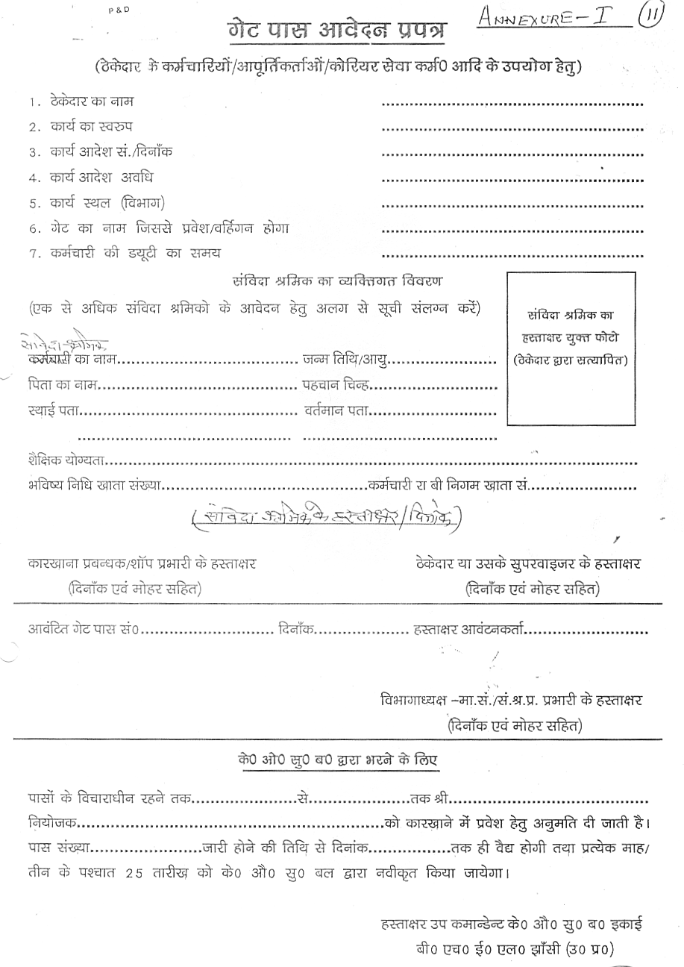
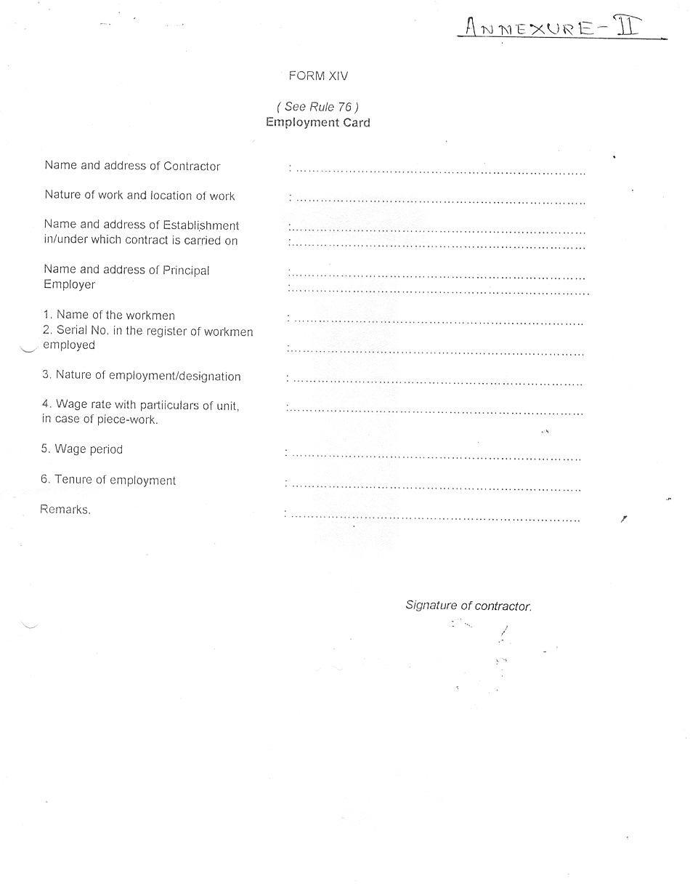

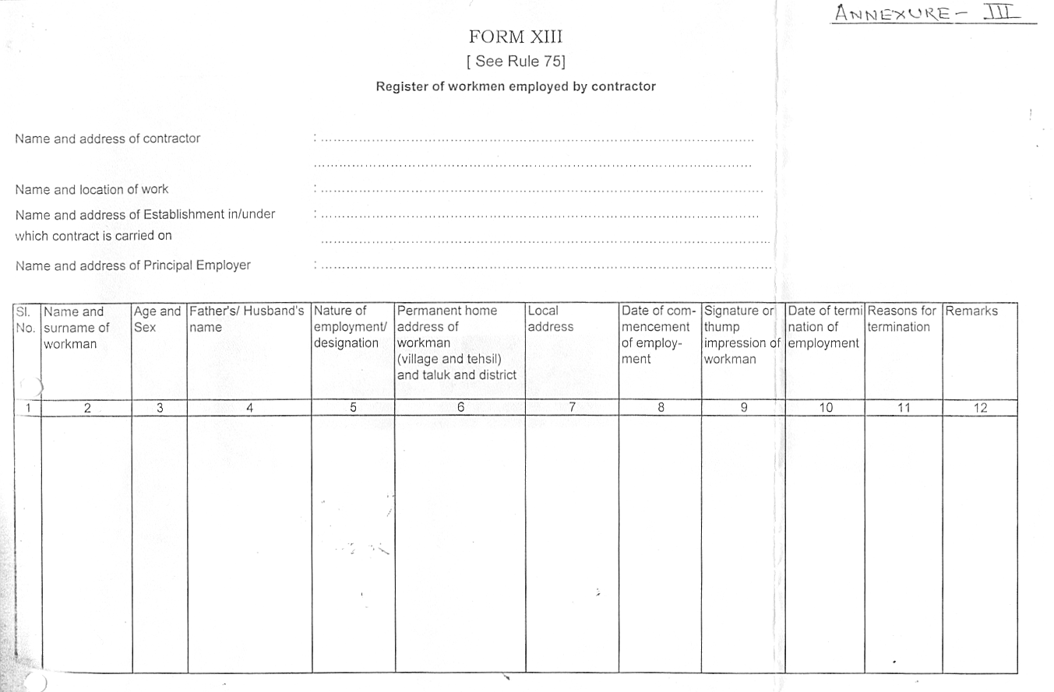

ANNEXURE-IV

TENDER ENQUIRY NO: ------------------------------- DATE:

STATEMENT OF THE CONTRACTOR FOR THE MONTH OF ____________20____

WORK ORDER NO-------------------------------
CONTRACTING DEPARTMENT----------------------
CONTRACTOR NAME----------------------------------

S.NO | NAME OF WORKER | CAT. | NORMAL  DAYS | OT  DAYS | GROSS  WAGES | EMPLOYEES CONTRIBUTION DEDUCTION |  | OTHER  DEDUCTION | TOTAL RECOVERY | NET PAYABLE | EMPLOYER'S CONTRIBUTION
 |  |  |  |  |  | PF 12% | ESI 1.75% | OTHER  DEDUCTION | TOTAL RECOVERY | NET PAYABLE | PF 13.61% | ESI 4.75%
 |  |  |  |  |  |  |  |  |  |  |  | \

SIGNATURE OF THE CONTRACTOR

Annexure ’H’

TENDER ENQUIRY NO: FBM/TE/1/07 DATE: 25/03/2012

MEASUREMENT OF WORK AND PAYMENTS THEREOF.

1) The designated officer of BHEL Jhansi Unit will periodically inspect the Work being provided by the contractor and find out deficiencies. The contractor shall rectify the same immediately to the satisfaction of the designated officer.

2) Payment towards work satisfactorily executed will be made to the contractor on the basis of following: -

Sl. No | JOB / ACTIVITY | UNIT OF MEASUREMENT  (Kg) | QUANTUM OF WORK
1 | Manufacturing of Shell of ACEMU Coach | Kg | Completion of fabrication in Kg.

3) Payments will be made to the contractor on the basis of work carried out by him on a monthly basis after completion of fabrication of Job duly cleared by BHEL - QC / RDSO.

        - All payments will be subject to deduction of income tax at source as per Income Tax as per the applicable Rules.

        - Measurement Book to be maintained for the work carried out daily / weekly / monthly by the contractor & the same shall be verified by BHEL official, nominated for the same.

I / We agree with the above

Signature of Contractor with Seal Executive Incharge

Annexure ’ I’

TENDER ENQUIRY NO: ------------------------------- DATE: --------------

PROFORMA FOR SUBMITTING TECHNICAL BID FOR ------------------------------

1. Name of the firm : _______________________

      - Name of the Proprietor : _______________________

      - Address and Contact Numbers : ________________________

      - Registration Number : ________________________

Copy of the Certificate : Enclosed / Not Enclosed

      - Labour Licence Number : _________________________

Copy of the Licence : Enclosed / Not Enclosed

      - PF Code Number : _________________________

Copy of the Certificate : Enclosed / Not Enclosed

      - ESI Code Number : _________________________

Copy of the Certificate : Enclosed / Not Enclosed

      - (1) PAN/TAN Number : _________________________

(2) Income Tax return last 3 yrs. : Enclosed / Not Enclosed

      - Service Tax Number (PAN Based) :__________________________

      - Machines & equipments details such as welding machines, grinder, measuring equipment. Contractor shall have machines and equipment for carrying out the fabrication work of 2 Nos. Shell of ACEMU Coach per month at BHEL works.

Sl. No. | Equipment Name | Model | Make | Year of Mfg. | Qty.

      - No. of Workers including Supervisors : _______________________
on the rolls of the firm.

12. Earnest Money Deposit : Rs. -----------------------------

a) D.D. Number & Date : -------------------Date-------------
b) Drawn on (Bank) : --------------------------------------

13. Any other relevant information : ---------------------------------------

14. Tender Cost : Rs. --------------------
D.D.No. : -------------------------

15. Validity of offer : 120 days from the date of tender Opening.

16. Blank Price bid : Enclosed / Not Enclosed
(Price bid format without prices)

I / We will fulfill all the obligations of the contractor and abide by the Terms & Conditions mentioned in the enquiry.

Date: Signature with Name
& Office Seal

NOTE : TECHNICAL BID AND PRICE BID SHOULD BE SUBMITTED IN SEPARATE SEALED ENVELOPS. IN CASE THE BIDS ARE FOUND IN ONE SINGAL ENVELOPE THEN THE “BIDS” ARE LIABLE TO BE REJECTED.

I / We agree with the above

Signature of Contractor with Seal Executive Incharge

Annexure “J”

TENDER ENQUIRY NO: ------------------------------- DATE: --------------

PRICE BID

TENDER NO: -------------------------------- Date: -------------
a. Name of the firm :

b. Name of the proprietor/partners :

c. Address and contact nos :

d. Price offer on work measurement basis:

Sl. No | JOB/ACTIVITY | UNIT OF MEASURE-MENT | QUANTUM OF WORK ANNUAL | RATE QUOTED  Rs. Per Kg. | TOTAL VALUE (E=C*D)
 | A | B | C | D | E
1 | Manufacturing of Shell of ACEMU Coach | Kg. | 2,52,000.00
Note: Service Tax extra

Date: Signature with Name
& Office Seal

I / We agree with above and all other terms & conditions of the contract.

Signature & Name of Contractor with Seal Executive Incharge

