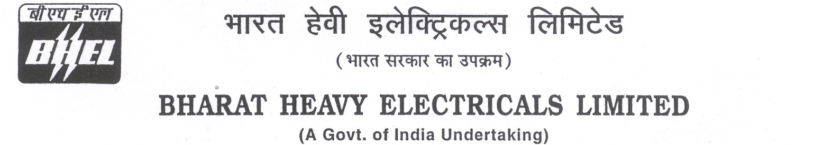

Date: 07/08/2025

TENDER CANCELLATION FORM

1 | NIT No. | GEM/2025/B/6080273 Dated 24-03-2025..
2 | Notification No./Tender No. | GEM/2025/B/6080273 Dated 24-03-2025.
3 | Tender Title | SUPPLY OF PORTLAND POZZOLANA CEMENT (1650MT) AS PER IS 1489 (PART-1):2015 AT 3x660 MW NORTH KARANPURA STPP FGD PROJECT, JHARKHAND.
4 | Reason for Cancellation
5 | Date of tender cancellation | 07/08/2025
6 | Approving Authority | GM ( SCT, PUR, COC, COMMERCIAL)

This bears the approval of competent authority.

Thanking you,

Yours faithfully,
for BHARAT HEAVY ELECTRICALS LTD

MANAGER (PURCHASE)

