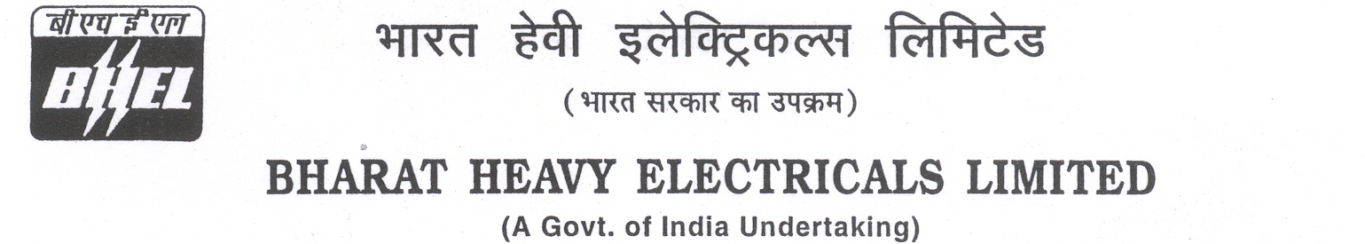

Date: 17/05/2025

TENDER CANCELLATION FORM

1 | NIT No. | GEM/2025/B/6053846 DTD 13-03-2025.
2 | Notification No./Tender No. | GEM/2025/B/6053846 DTD 13-03-2025.
3 | Tender Title | SUPPLY & INSTALLATION OF OFFICE FURNITURES FOR 2X800 MW LARA THERMAL POWER PROJECT SITE, RAIGARH, CHHATTISGARH.
4 | Reason for Cancellation
5 | Date of tender cancellation | 17/05/2025
6 | Approving Authority | GM (SCT, Purchase, COC & Commercial)

This bears the approval of competent authority.

Thanking you,

Yours faithfully,
for BHARAT HEAVY ELECTRICALS LTD

MANAGER (PURCHASE)

