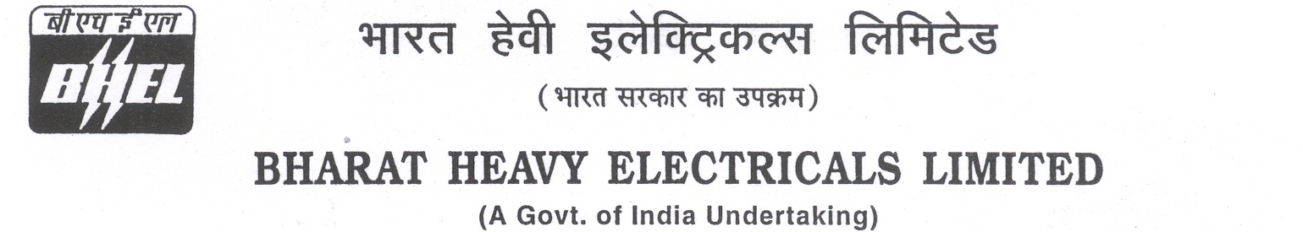

Date: 19/04/2025

TENDER CANCELLATION FORM

1 | NIT No. | GEM/2025/B/5813643 Dated 13-01-2025.
2 | Notification No./Tender No. | GEM/2025/B/5813643 Dated 13-01-2025
3 | Tender Title | SUPPLY OF 5000 MT PORTLAND POZZOLANA CEMENT (PPC) AS PER IS:1489 (PART 1) :2015 AT 2 X 800 MW DVC KODERMA TPS, PH-II, JHARKHAND
4 | Reason for Cancellation
5 | Date of tender cancellation | 19/04/2025
6 | Approving Authority | GM (SCT, Purchase, COC & Commercial)

This bears the approval of competent authority.

Thanking you,

Yours faithfully,
for BHARAT HEAVY ELECTRICALS LTD

MANAGER (PURCHASE)

