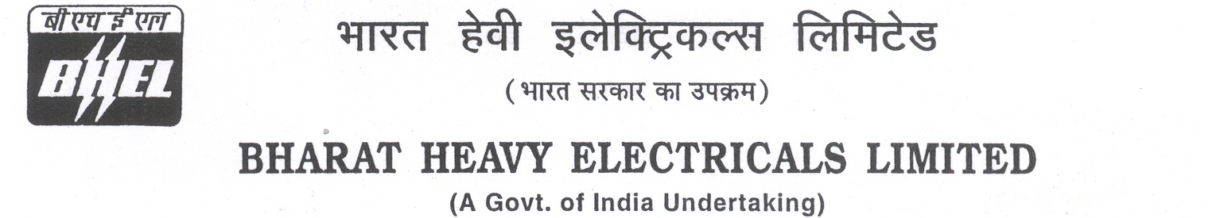

Date: 18/04/2025

TENDER CANCELLATION FORM

1 | NIT No. | PSER:PUR:HR:121(VI):080:(ENQ:24:PP:0015:PUR:79) Date 10/02/2025, TCN-01 dtd. 20/02/2025 & TCN-02 dtd. 28/03/2025.
2 | Notification No./Tender No. | PSER:PUR:HR:121(VI):080:(ENQ:24:PP:0015:PUR:79) Date 10/02/2025, TCN-01 dtd. 20/02/2025 & TCN-02 dtd. 28/03/2025.
3 | Tender Title | “RUNNING AND MAINTENANCE OF THREE NUMBER BHEL TRANSIT FLATS AT GOLF GREEN MULTISTORIED APARTMENT ASSOCIATION, KOLKATA-700095 FOR TWO YEARS”.
4 | Reason for Cancellation
5 | Date of tender cancellation | 18/04/2025
6 | Approving Authority | GM (SCT, Purchase, COC & Commercial)

This bears the approval of competent authority.

Thanking you,

Yours faithfully,
for BHARAT HEAVY ELECTRICALS LTD

ENGINEER (PURCHASE)

