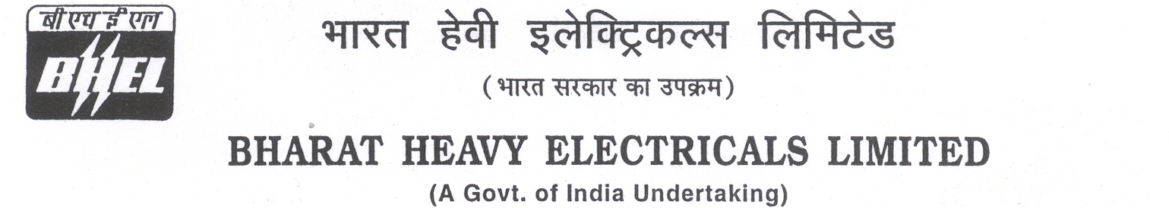

Date: 05/07/2024

TENDER CANCELLATION FORM

1 | NIT No. | GEM/2024/B/5068169 date 22-06-2024
2 | Notification No./Tender No. | GEM/2024/B/5068169 date 22-06-2024
3 | Tender Title | SUPPLY OF 01 NO DRONE - UNMANNED AERIAL VEHICLE & PAYLOAD SYSTEMS FOR SURVEILLANCE FOR 2X800MW LARA SUPER THERMAL POWER STATION, STAGE-II.
4 | Reason for Cancellation
5 | Date of tender cancellation | 05/07/2024
6 | Approving Authority | SDGM (HOS/ PUR)

This bears the approval of competent authority.

Thanking you,

Yours faithfully,
for BHARAT HEAVY ELECTRICALS LTD

Sr. ENGINEER (PURCHASE)

