BHARAT HEAVY ELECTRICALS LIMITED
(A Govt. of India Undertaking)
P.O. BHEL, JHANSI - 284 129
(Communication & Public Relations Department)
Phone: 0510-2412211; Fax: 0510-2770011

Ref: CPR/WC/CS/01 Date: 05.03.2009

TENDER NOTICE

Sealed tenders, in two bids system are invited from the registered contractors for "Guarding of Bicycles, Scooters, Motor- Cycles & Cars kept at the Stands located at Main Gate & Material Gate of BHEL, Jhansi" on service contract basis. Detailed tender document may be obtained from C&PR Department.

EMD : Rs.20,000/- (Rs. Twenty Thousand only) through DD/ Banker Cheque in favour of BHEL, Jhansi

Cost of tender document : Rs.200/-

Last date & Time of sale of
tender document : 19.03.2009.... upto 16.45 hrs.

Due date & Time submission of
tender document : 20.03.2009.... upto 13.15 hrs.

Date & Time of opening of
technical bid : 20.03.2009 .... at 14.00 hrs.

Fully completed forms/bids should be sent by Registered/Speed Post to the undersigned or dropped in the tender box available at the entrance gate of Admn. Building, BHEL, Jhansi on or before due date as mentioned above.

Sr. Manager (C&PR)

Tender Documents

DETAILS OF TENDER DOCUMENT

TENDER NO: CPR/WC/CS/01 DATE: 05.03.2009

NATURE OF WORK : GUARDING OF BICYCLES, SCOOTERS, MOTOR- CYCLES & CARS KEPT AT THE STANDS LOCATED AT MAIN GATE & MATERIAL GATE OF BHEL, JHANSI

1. BHEL JHANSI is in the process of finalising the Service Contract for the
aforesaid works at its Stands.

2. The tender document has been detailed as follows:

a) Notice Inviting Tender (Annexure A)
b) Work Specifications (Annexure B)
c) Qualifying Requirements (Annexure C)
d) Instruction to Tenderers (Annexure D)
e) Tender Evaluation Criteria (Annexure E)
- Contractor’s obligations (Annexure F)
g) Other General Terms and Conditions (Annexure G)
h) Criteria for measurement of work (Annexure H)
i) Technical Bid Application (Annexure I)
- Price/Rate Bid ( Annexure J)

3. The duly filled in Technical and Price/Rate bids (Annexure I and J, separately) along with the instructions to the tenderers, Contractor’s Obligations, General Terms and Conditions with the signature of the tenderer on all the pages and complete in all respects superscribed as Quotation for Tender No. CPR/WC/CS/01 for "Guarding of Bicycles, Scooters, Motor- Cycles & Cars kept at the Stands located at Main Gate & Material Gate of BHEL, Jhansi"should reach us in a sealed cover on or before 20.03.09...13.15 hours) through Registered/Speed Post or the same should be dropped in the tender box available at the entrance gate of Admn. Bldg.

NOTE : TECHNCAL BID AND PRICE/RATE BID SHOULD BE SUBMITTED IN SEPARATE SEALED ENVELOPES. IN CASE THE BIDS ARE FOUND IN ONE SINGLE ENVELOPE THEN THE “BIDS” ARE LIABLE TO BE REJECTED.

BHEL, JHANSI Tender Document

CONTENTS

Sl. No. | Description | ANNEXURE NO. | Page No.
01. | Notice Inviting Tender | A | 4-5
02. | Work Specifications | B | 6
03. | Qualifying Requirements | C | 7
04 | Instructions to Tenderers | D | 8
05. | Tender Evaluation Criteria | E | 9
06. | Contractor's obligations | F | 10-13
07. | Other General Terms & Conditions | G | 14-28
09. | Measurement of work and payment thereof | H | 29
10. | Technical Bid | I | 30-31
11. | Price/Rate Bid (One blank Price Bid format duly signed to be sent along with Technical Offer) | J | 32
12. | Basis of Offer | - | 33-34

Annexure ‘A’

BHEL – JHANSI

Tender Documents

NOTICE INVITING TENDER

TENDER NO: CPR/WC/CS/01 DATE: 05.03.2009

1. Scope of work : GUARDING OF BICYCLES, SCOOTERS, MOTOR- CYCLES & CARS KEPT AT THE STANDS LOCATED AT MAIN GATE & MATERIAL GATE OF BHEL, JHANSI

2. Tender Evaluation Criteria : As per Annexure –E

3. Duration of the Contract :One year from the date of award of the contract
4. Other specific requirements :

5. Last date of receipt of the Tender :13.15 hours on -20.03.2009--

6. Date of opening of Technical Bid :14.00 hours on -20.03.2009--

7. Address for receipt/issue of Tender : Sr. Manager (C&PR)
Document Bharat Heavy Electricals Limited
Khailar,Jhansi-284 129

8. Earnest Money Deposit : Rs.20,000/- (Rs. Twenty Thousand only)
Payable in the form of Banker’s Cheque/ Demand Draft favoring BHELJhansi alongwith technical bid.
(1.Incase of successful tenderer EMD shall be converted and adjusted against the security deposit.
2 In case of others, the EMD shall be returned within 15 days of acceptance of award of work by the successful tenderer). OR
One Time EMD of Rs.2,00,000/- may be deposited to BHEL Cash Office also.
9. Cost of Tender Document : Rs.200/- (Rupees Two Hundred only).

NOTE :

1. TECHNICAL BID AND PRICE/RATE BID SHOULD BE SUBMITTED IN SEPARATE SEALED ENVELOPES. IN CASE THE BIDS ARE FOUND IN ONE SINGLE ENVELOPE THEN THE “BIDS” ARE LIABLE TO BE REJECTED. THESE TWO ENVELOPES SHOULD CLEARLY BE MARKED AS "TECHNICAL BID" OR "PRICE/RATE BID" ON THE TOP POSITION OF THE ENVELOPE (AS THE CASE MAY BE). THESE TWO ENVELOPES SHOULD BE SEALED AND BE PUT IN THE THIRD ENVELOPE WHICH SHOULD BEAR THE ENQUIRY NO. AND DUE DATE ONLY.

2. THE CONTRACTORS MAY PHYSICALLY VISIT THE WORK PLACE BEFORE QUOTING THEIR RATES.

I/We agree with the above

Signature of Contractor with Seal Executive Incharge
Annexure’B’

BHEL – JHANSI

Tender Documents

TENDER NO: CPR/WC/CS/01 DATE: 05.03.2009.....

WORK SPECIFICATIONS

Sl.No. | Service/Activity | Unit | Approx. qty.
1. | Stand No.1: At the Northern Side of Main Gate in all the 3 shifts on all the 7 days in a week  (1 Stand, 3 Shifts, 12 Months, hence 1 x 3 x 12 = 36) | Per Stand  Per Shift  Per month | 36
2. | Stand No.2: At the Northern Side of Main Gate in all the 3 shifts on all the 7 days in a week  (1 Stand, 3 Shifts, 12 Months, hence 1 x 3 x 12 = 36) | Per Stand  Per Shift  Per month | 36
3. | Stand No.3: At the Southern Side of Main Gate in 2 shifts on 6 days in a week  (1 Stand, 2 Shifts, 12 Months, hence 1 x 2 x 12 = 24) | Per Stand  Per Shift  Per month | 24
4. | Stand No.4: At the Nothern Side of Material Gate in 2 shifts on 6 days in a week  (1 Stand, 2 Shifts, 12 Months, hence 1 x 2 x 12 = 24) | Per Stand  Per Shift  Per month. | 24
5. | Stand No.4: At the Southern Side of Material Gate in 2 shifts on 6 days in a week  (1 Stand, 2 Shifts, 12 Months, hence 1 x 2 x 12 = 24) | Per Stand  Per Shift  Per month | 24

I/We agree with the above

Signature of Contractor with Seal Executive Incharge

Annexure’C’

BHEL – JHANSI

Tender Documents

QUALIFYING REQUIREMENTS

1. The contractor should be a reputed agency for providing the services for the work called in tender.

2. Labour contractors presently working in BHEL, Jhansi and deploying 20 or more labours should have labour licence from the licensing officer of Jhansi Region. For others, refer clause 1.A.2 of Annexure G.

3. Should have independent ESI Code number

4. Should have independent PF Code number

5. Should have PAN

6. Should have Income Tax Return for the last three years

7. Should have Service Tax number

8. Self certificate that he is not blacklisted/banned/delisted on the date of tender.

9. Declaration that he is not guilty by a Court of Law in India for any offence involving fraud, dishonesty and moral turpitude.

Documentary proof in support of above eligibility criteria shall be submitted alongwith Technical Bid at Annexure I.

I/We agree with the above

Signature of Contractor with Seal Executive Incharge

Annexure’D’

BHEL – JHANSI Tender Documents

INSTRUCTIONS TO TENDERERS
- Above tender is in two Bid System (Technical Bid & Price/Rate Bid)
1. The tender is to be processed in two parts viz. Technical bid and price/rate bid. The Technical Bid Application (Annexure - I) and its enclosures (along with the Contractor’s Obligations, General Terms & Conditions and copies of qualifying requirements) must be submitted in one sealed envelope superscribed as “Tender for: Guarding of Bicycles, Scooters, Motor- Cycles & Cars kept at the Stands located at Main Gate & Material Gate of BHEL, Jhansi- technical bid”. EMD/Cost of Tender Document or Documents required as per qualifying requirements must be enclosed. The second envelope duly sealed should contain the price/rate bid (Annexure-J) only superscribed as “Tender for: Guarding of Bicycles, Scooters, Motor-Cycles & Cars kept at the Stands located at Main Gate & Material Gate of BHEL, Jhansi- PRICE/RATE bid”. Any other enclosures, which the tenderer wishes to submit, must be enclosed with the Technical Bid only. The price bid envelope should contain the rates only. Offers not in line with the above procedure or quoted in any other format will be rejected/by passed.

2. Both the technical bid and price bid sealed envelopes must be again sent in a single envelope duly sealed and superscribed as “TENDER FOR TENDER NO CPR/WC/CS/01 Due date of opening -20.03.2009--” The same should be dropped in the tender box available at the entrance gate of Administrative Building, BHEL Jhansi or sent to Sr. Manager (CPR) by Registered Post/Speed Post, within the specified date and time by the tenderer or his representative.

3. All tenderers can witness the opening of the Technical Bid. After evaluation of the Technical Bid which may involve visit to the tenderer’s/client's place by authorised officials, price bids of only those tenderers who are technically found suitable will be opened on a subsequent date which will be informed to the concerned whose technical bid has been accepted, in advance for witnessing the Price/Rate Bid opening.

4. All entries in the tender document should be in one ink. Corrections, over writing, cuttings etc. will not be permitted. All the columns in the tender form should be filled without leaving blank in any page of the tender document and all the pages must be duly signed & stamped by the tenderer before submission.

- The price/rate should be quoted in figures as well as in words strictly.

I/We agree with the above

Signature of Contractor with Seal Executive Incharge

Annexure’E’

BHEL – JHANSI

Tender Documents

TENDER EVALUATION CRITERIA

The evaluation of the Tender will be carried out as follows:

- The bidders meeting qualifying requirements as given in Annexure 'C' shall be evaluated for technical suitability.

- BHEL officials may visit the tenderer’s office & their client’s place to evaluate the capability and assess the performance.

- Capability of the Contractor will be assessed on the basis of employees including supervisors on their rolls, machinery, equipments in its possession, previous track record, experience in other organizations, etc.

- Successful technically qualified tenderers after the above process only will be invited for opening of the rate / price bid.

- The complete work shall be awarded to one contractor only, on lowest (L-1) basis.

- The sum-total of all items shall be considered for evaluating the lowest (L-1) bidder.

I/We agree with the above

Signature of Contractor with Seal Executive Incharge

BHEL – JHANSI Annexure’F’

Tender DocumentsCONTRACTOR’S OBLIGATIONS

CONTRACTUAL

A) Towards selection, control and supervision of employees

  - Contractor shall decide the number of employees to be deployed for execution of the work awarded to him and he or his authorized representative will be solely entitled to instruct such workers about the manner of carrying out the work as per the prescribed specifications and quality plan.

b) Contractor shall supervise the work allotted to him and to be carried out by his employees.

c) Contractor to ensure that the employees deployed in the premises of BHEL are physically and mentally fit and do not have any criminal record. Such employees should possess requisite skill, proficiency, qualification, experience of relevant field.

d) Contractor to maintain appropriate records of his employees deployed to carry out the job(s). The contractor shall maintain the attendance register of his employees on regular basis and the same shall be inspected & certified by the BHEL officials from time to time.

e) Contractor should issue appropriate appointment letters to his employees.

f) Contractor will ensure that the job is executed through his employees on his rolls and under no circumstances the contractor will deploy any casual employee to carry out the job nor shall sub-contract the job without prior written permission.

g) Contractor will keep watch on his employees and he will be liable for any pilferage/loss to BHEL due to acts of omission and commission by his employees. Similarly, liability for any compensation to outsiders on account of any act of omission and commission by the employees deployed by the contractor shall lie exclusively with him.

h) The contractor has to provide badges bearing logo of his establishment, which shall be affixed by the contract labour on the left side of his pocket.

i) Contractor to ensure that all precautions are taken for safety of his employees and equipments.

J) In the event of termination of contract for any reason whatsoever, the contractor shall withdraw all his employees from the establishment of BHEL. In case contractor decides to terminate services of his employees, he should settle all terminal dues.

k) The contractor has to deploy his workers in appropriate number of shifts as mentioned in the Price Bid. The shift timings of BHEL Jhansi are as follows:
1st Shift : 07.00 hrs. to 15.45 hrs.
2nd Shift : 15.45 hrs. to 00.30 hrs.
3rd Shift : 23.00 hrs. to 07.00 hrs.

For Stands having 3 shifts operations, 24 hrs. guarding should be ensured without any break.

l) On Sundays & Holidays, workers are to be deployed in all the 3 shifts from 06.45 hrs. to 07.15 hrs. the next day for guarding of bicycles, scooters, motor-cycles & cars kept at the Stand of Main Gate.

Guarding should be done 15 minutes before start of shift and 30 minutes after the end of 2nd shift at all the Stands.

m) The contractor shall be fully responsible for the safety of vehicles kept at these Stands. In case of any damage/pilferage, a penalty of Rs.10,000/- (Rupees Ten Thousand only) shall be imposed on the contractor and the same shall be recovered from his Bills.

n) The duration of the contract shall be for one year. During this period, in the event of any problem being created by the contractor, the contract shall be cancelled without assigning any reason.
o) The contractor has no right to sub-contract this contract to any other contractor and he may have to implement the token system at the Stands.
p) The workers deployed at the Stands will have to inform about their presence on all working days at 08.15 hrs. & 15.45 hrs. on Telephone No.2223 of C&PR Deptt. Besides this, the workers have to mark their presence in the register made available by the contractor at the Stands.

q) In case the workers report for duty late at the Stands, fine shall be levied as under:
Upto 01 hour : Rs.10/-

More than 1 hour : Rs.100/-

If the workers continue to come late, then the contract may be cancelled or the contractor will have to replace the workers.

r) No unauthorised person is allowed to keep his vehicle at the Stand. In case it is found so, the contractor himself shall be responsible for the same.

s) In the event of any worker being absent, the contractor will have to depute another worker in his place failing which a fine of Rs.100/- shall be levied. This provision is valid for a week only beyond which the management reserves the right to cancel the contract.

t) The workers performing the duty of guards at the Stands will have to be in black uniform which consists of black shirt, black pant, black hat (cap), black shoes and must have a Laathi & a whistle with them. During the inspection, in case any guard is found without uniform, a fine of Rs.10/- may be levied for every such lapse for one guard for one shift for one day.

In case the contractor fails to provide uniforms to guards within a month from the date of start of the contract, Rs.500/- per guard would be deducted from his bill. While quoting the rates, the contractors must keep this factor in their minds.

u) The contractor or his supervisor has to come and meet representative of C&PR Deptt. everyday and give feedback regarding functioning of the Stands. In case he fails to report continuously for 15 days, a penalty of Rs.200/- shall be imposed. Also the contractor or his supervisor must meet Head of C&PR Deptt. once in six months and give feedback regarding functioning of Stands. Failing to do so, a penalty of Rs.500/- shall be imposed.

v) During the lunch hours, guards shall remain at the Stands and they shall take their lunch at the Stands itself so that there is no disruption in the smooth functioning of the Stands.

w) The physical & educational requirements of the guards are as under:

Age : Minimum 20 years but not more than 50 years of age
Height : Minimum 5'4"
Weight : Minimum 60 Kgs.
Education: Minimum 8th Standard passed

x) The contractor shall instruct his guards not to consume alcohol while on duty. They will be patrolling continuously and whistle from time to time so that it is exhibited that guards are on duty.

B) Towards supply of tools, tackles and materials

a) Contractor shall provide to his employees all tools, tackles and equipments and maintain the same to carry out the job under the contract at his cost and if necessary contractor may take insurance policy of his men, material, equipments and tools and tackles.

b) Contractor shall provide safety appliances and maintain the same at his own cost which may be required under the statute or otherwise.

c) Contractor shall provide material at his cost as mentioned in the contract to his employees for carrying out the job.

C) Towards statutory liability

a) As mentioned in the terms and conditions enclosed as Annexure ‘G’ of this contract.

b) Contractor shall indemnify BHEL against all claims by statutory authorities and loses under various Labour Laws, statutes or any civil or criminal law in connection with employees deployed by him.

c) In case a contractor employs women as employee he will discharge his obligation under law in respect of such women workers such prohibition of engaging them during night-hours, prohibition of employing them for more than 9 hours per day, provision of crèche facility, grant of maternity leave as per rules etc.

d) Contractor shall be responsible for making payment of wages before expiry of 10 days from the last day of wage period and to ensure disbursement of wages in the presence of the authorities representative of contract operating division who shall record under his signature at the end of entries in the Register of wages.

e) Contractor to obtain license under CL(R&A) Act, 1970.

D) Towards Finance

Contractor to arrange his own finance for carrying out the job including supply of tools, tackles and equipments to his employees, materials, payment of wages to his employees etc. Rates quoted shall be net and inclusive of all the capital cost, material cost, taxes and levies which might be applicable to this type of job. Service Tax & Bonus shall be extra.

I/We agree with the above
Signature of Contractor with Seal Executive Incharge

Annexure ‘G’

BHEL – JHANSI

Tender Documents

OTHER GENERAL TERMS & CONDITIONS FOR CONTRACTORS FOR DEPLOYMENT OF CONTRACT LABOURS UNDER SERVICE CONTRACT.

Service contracts shall only be awarded for the works on the following terms and conditions.

1. 0 LABOUR LICENCE AND OTHER REQUIREMENTS:-

1.1 Labour licence and other requirements in case of contractors working in BHEL, Jhansi and deploying 20 or more labours.

  - Contractor should possess valid labour licence for the maximum number of contract labours deployed on any day from the competent authority for carrying out the various activities mentioned in the contract document.

  - No. of labours mentioned in estimate/price bid should ordinarily not exceed. However, in view of exigencies/increased activities, the nos. to be deployed can vary but in no case estimated value will be changed. If enhancement of value is also required then prior approval Unit Head must be obtained by giving reason for the same.

  - The contractor shall deploy such number of labours in the premises of BHEL, Jhansi, as required for completion of the contract. The labours such deployed shall be his own labours.

  - In case the number of labour deployed by the contractor in premises of BHEL Jhansi exceeds the number of labour allowed in the licence then the contractor shall immediately inform the HR and concerned department. The contractor shall also apply to the licensing officer in the region for amendment in the licence within 7 days of exceeding the number of labours mentioned in the licence.

1.6 The contractor shall also have to submit copy of PAN card and latest IT return.

1.7 The contractor must possess Service Tax Registration number under relevant code head.

1.8 The contractor should possess VAT/TIN Number if material is supplied/consumed. The contractor should not be disqualified from bidding in case the contractor does not have TIN No. However, he shall have to produce TIN No. before opening of Price bid.

1.9 Stamp Duty : Contractor should deposit stamp duty on security deposit as per Stamp Duty Act.

1.A Labour licence and other requirement in case of contractors NOT working in BHEL, Jhansi or has less than 20 workers on his rolls.

1.A.1. The contractor should possess valid labour licence issued by licensing authority in case he has worked within or outside Jhansi Region and has deployed 20 or more workers in any Organization.

1.A.2. After being eligible to apply as per para 1.A.1, if the contractor is awarded the contract then he should apply for Form-V from the BHEL to obtain Labour Licence from Dy.Labour Commissioner, Jhansi and submit the same within one month from the date of award of contract. Till then award will be treated as PROVISIONAL.

- APPOINTMENT AND ENTRY IN FACTORY PREMISES :

  - The contractor shall deploy his own labours for carrying out the works contract awarded to him. At the time of appointment the contractor shall issue appointment letter alongwith terms and conditions of employment to his own labours.
  - The labours deployed in the manner as in 2.1 shall be allowed to enter the premises of the factory only if the terms and conditions of employment is acceptable to them.
  - The contractor shall submit the following to HR, contracting department and CISF

- The details of the labour proposed to be deployed in annexure I.
- Character certificate issued by District Magistrate’s Office or Proof of remittance of fees for character certificate at District Magistrate’s Office.
- Copy of employment card issued by contractor to his own labour.

  - After submission of documents as in para 2.3, the contractor shall issue photo identity card to the labour and submit to HR department. This identity card shall be forwarded by HR department to CISF, which shall then authorize the labour to enter the factory premises initially for a period of one month.

  - The photo identity card shall have to be revalidated every month on 25th or any other date fixed to do so. In absence of such revalidation, duly forwarded by HR department, CISF shall not allow any labour to enter the premises of BHEL Jhansi.

  - The contractor, besides the photo identity card shall also issue employment card to his own labours, at his own cost within a period of three days from beginning of employment in the format prescribed under Rule 76 of UP Contract Labour Rules. A copy of this format is annexed as annexure II, to these terms and conditions. A copy of this format shall have to be submitted by the contractor to the contracting department, HR department and CISF, as mentioned in para 2.3.

  - The contractor shall maintain a register of persons employed by him in the format prescribed under Rule 75 of UP Contract Labour Rules, 1975. A copy of this format is annexed as annexure III.

- BILLS PAYMENT, ATTENDANCE AND PAYMENT OF WAGES

  - The contractor shall compile attendance everyday in respect of the labours deployed by him under the Service/job contract.

  - The contractor shall maintain an attendance card in respect of every labour deployed by him.

  - The contractor shall generate a daily statement in the prescribed format, as in annexure IV, annexed to these terms and conditions of deployment. This statement shall be prepared by the contractor in three copies. One copy shall be forwarded to the department and another copy shall be forwarded to HR department. The third copy shall be retained by the contractor.

  - The contractor shall submit bills to the contracting department on 2nd of each month.

  - The contractors bills should be accompanied with

a) Copy of Measurement Book entries/Statement of work done by the Contractor
b) Statement of Minimum Wages of labours deployed him under the Service contract, PF/ESI no., statutory deductions etc., in the format as in Annexure V annexed to these terms and conditions.
c) PF and ESI challans for previous month- separate for concerned Service contract
d) Wage payment sheet for the previous month
e) Copy of Form-5 and Form-10 (PF monthly returns) submitted by contractor to RPFC for billing month.
f) Copy of Form 12A-regarding PF remittance
g) List of CL covered under accident insurance policy
h) Statement of material supplied by the contractor
i) Copy of Labour Licence
j) Challan of service tax payment (separate in respect of each service contract).

  - The executing department shall pass the bills of the contractor, on 3rd day of each month, after checking the documents as in para 3.5, above and forward them to HR department alongwith its statement as in Annexure VI, annexed to these terms and conditions. In case any discrepancy/non-compliance is detected then the contractor has to clarify the query within two days of intimation such discrepancy. In such cases bills shall be passed by the contracting department, within two days of receiving such clarification.

  - After Checking the Labour Laws Compliances with respect to the concerned service contract HR department after retaining copies of PF and ESI Challans and wage payment sheet pertaining to previous month, Annexure V etc. will forward the bill alongwith requisite documents ( the bill in original and service tax challan) to finance department. Finance department shall, on satisfactory compliances, on account of stamp duty charges and security deposit amount, make payment as per Contract.

  - Finance department shall, on satisfactory compliance, and after deduction on account of Security deposit amount and TDS shall make consolidated payment on 10th of each month.

  - The contractor shall issue pay slips to his labours, deployed for undertaking activities under the Service contract, on 7th/8th of each month.

  - The contractor shall make payment to the his own labours/contract workers on 10th of each month. The payment of wages to the labours shall not be subject to payment against the bills.

  - The contractor shall remit the cheques favouring RPFC and ESI Kanpur with the appropriate banks with such period as stipulated under relevant provisions. Last date for remittance of PF is 15th and that in case of ESI is 21st of each month.

  - The contractor shall make payment of wages to his labours on due date in presence of an authorized representative of contracting department. The authorized representative shall retain a copy of wage payment sheet with him.
  - In cases where the payment to the contractor is due only after completion of work and the payment is not made monthly then the contractor shall have to produce documents as enumerated in para 3.5 above, in respect of all labours deployed by him against the contract, for each month, separately, alongwith final bill(s). Para 3.7 shall not be applicable in such cases. The contractor shall be paid through cheque in his/firm’s favour.
- Provident Fund
  - The Contractor should allot PF account number and get the nomination form, duly filled in, from each labour deployed by him at the time of joining.
  - In case the labour already has PF/pension account number, allotted to him, previously, then the contractor shall get the transfer form filled up at the time of joining and send to the office of concerned Regional Provident Fund Commissioner.
  - After termination of contract the contractor shall provide due assistance to the labour for withdrawal of PF/pension amount, when due.
  - The Contractor shall liaise with the PF officials to get the annual PF slips and distribute amongst his own labours.
  - PF CONTRIBUTION :

Employee’s Contribution Employer’s Contribution
12% of Normal waged paid PF Contribution 3.67%
Insp/Admn Charages 1.10%
Admn/Insp Charges 0.01%
Pension Fund 8.33%
EDLI Charges 0.5%

  - The Contractor shall submit annual returns in Form-6A and Form 3A, prescribed under statutory EPF scheme, 1952, in respect of each labour deployed by him with a copy to HR and finance department.

5.0 Employees State Insurance

5.1 The Contractor should allot ESI account number and get the nomination form, duly filled in, from each labour deployed by him at the time of joining.
5.2 At the time of joining the contractor shall get the self/family registration form filled by the labour and submit to the local ESI office.
5.3 The contractor shall collect the identity card issued after submission of registration form, from ESI office and hand over the card to the concerned labour.

5.4 ESI CONTRIBUTION :-
Employee’s Contribution Employer Contribution
1.75% of gross wages 4.75% of gross wages

  - The Contractor shall submit annual returns in Form-6 prescribed under ESI Act, deployed by him with a copy to HR and finance department

- Bonus
The contractor shall be liable to pay statutory bonus under Payment of Bonus Act, 1965. However, BHEL shall be liable to pay to the contractor only an amount equivalent to the minimum statutory rate existing for the period under consideration. The contractor shall distribute the bonus for full contract period immediately after completion of contract. This amount will be reimbursed to him subject to production of proof thereof and his security deposit will be released subsequently.

- Discipline
7.1 The Contractor shall be responsible for the discipline of his own labours deployed under the works contract. In case of any loss to BHEL Jhansi on account of indiscipline of contract labour then such loss shall be assessed and recovered from the running bills of the contractor or from the security deposit.
  - The contractor shall not employ any person who has not completed his 18 years of age.
7.3 The contractor shall not employ any person who has attained 55 years of age & above
7.4 The contractor, on advice of authorized BHEL official, shall immediately remove any person employed by him, who may in the opinion of such authorized BHEL official is involved in misconduct. Such person shall not be employed by the contractor without prior permission.

8.0 LEAVE WITH WAGES TO CONTRACT LABOUR :-
Guidelines as per UP Factories Rules 1950 should be strictly observed with regard to crediting/availment of leave. Register as prescribed under the said rules should be maintained by the contractor

- INDEMNITY BOND/COMPLIANCE OF LEGAL PROVISION

  - The contractor shall at all times indemnify the company/corporation against all claims, loss, damage occurred, or caused due to wilful acts or omissions or carelessness or negligence of the security guards employed while on duty or compensation under the provision of Factories Act- 1948. Contract Labour (R&A) Act-1970, Payment of Wages Act 1936, Minimum Wages Act- 1948, Payment of Bonus Act-1965, Employees Provident Fund and Misc, Act-1952, Employees State Insurance Act-1948, Employer’s Liability Act-1938, Workman’s Compensation Act-1923, Industrial Dispute Act- 1947, Maternity Benefit Act- 1961, Inter State Migrant Workmen Act-1979, Payment of Gratuity Act-1992 or any modification therof or any other law relating thereto and rules made thereunder from time to time or as consequence of any accident or injury to any workman or other persons in or about the work whether in the employment of contract or not, save the except whether such accident or injury has resulted from any Act of the Company/Corporation, its agents, or servants, and also against all costs/charges and expenses of any suit, action or proceeding paid to compromise or settle any such claims.

9.2 The Contractor has to make an agreement with BHEL in the format prescribed only on Rs. 100/- Non-Judicial Stamp Paper.

- OTHER GENERAL TERMS AND CONDITIONS :-

  - In case of non satisfactory performance of the contract, BHEL shall have a right of forfeiting the security deposit. In case of any dispute, decision of concerned Head of the Department will be final.

  - The work shall be supervised by the contractor or through the authorized representatives on day to day basis.

  - The Contractor shall compensate BHEL for any loss or damage to the plant/property, material of BHEL due to his workmen/representatives’ negligence or otherwise during execution of work.

  - In the event of contractor abandoning the work or BHEL revoking the contract, BHEL shall have a right to get incomplete work completed at contractor’s risk and cost. BHEL shall have a right to terminate the contract at any time without assigning any reason thereof.

  - The Contractor shall get the character & antecedents of his own labours verified from District Magistrate’s office and intimate the same to the management. before deploying them to work.

  - The contractor shall deposit an amount of Rs.55,000/- as security deposit in the manner as prescribed under Clause 8.2 of Works Policy of BHEL. This security deposit shall be liable to be returned to contractor after termination of contract and fulfilment of contract and statutory obligations.

  - Security deposit will be released on submission of following certificates from departments mentioned as under:-

a. Completion of work and certification of payment of minimum wages to contract labours from contracting department.

b. Certificate of compliance of labour laws from HR department.

c. Certificate of payment of bonus from HR Department/Contracting Department.

d. No-dues certificate regarding service tax payment, and any other dues liable to be remitted by contractor under financial laws, to Finance Department

  - The contractor shall provide required safety equipments to the labours engaged by him.

  - The contractor shall indemnify BHEL Jhansi against any claim, loss, damage occurred or caused to the contract labour due to wilful acts or omissions or carelessness or negligence of the contract labour employed by the contractor while on duty.

  - Notwithstanding anything contained in this Agreement, the contract may be terminated by BHEL without assigning any reason thereof by giving a notice of 15 days to the contractor.

  - The contract will commence on 01.4.09(date) and will remain valid for a period of one year i.e. till 31.03.2010 (date). The parties reserve the right to extend the contract on mutually agreed terms and conditions.

11. CONTRACTOR’S COMMISSION :-

If there is any change in Minimum Wages, Statutory contribution/Taxes/Duties (i.e. PF/EDLI, ESI, etc.) the same will be borne by the contractor and there will not be any change in the %age of contractor commission quoted.

12.0 SETTLEMENT OF DISPUTE/JURISDICTION/ARBITRATION ETC. :-

12.1 BHEL RESERVE THE FOLLOWING RIGHTS:
-To evaluate the bid as per BHEL policy and Govt. guidelines including CVC/Vigilance guidelines by the tender committee duly constituted by BHEL Management. The decision of BHEL, Jhansi Management or Tender committee duly approved by competent authority shall be final and binding to bidder.
-To accept/Reject any or all tender fully or partly without assigning any reason thereof.
-Contractor should not have been blacklisted and/or suspended from business by any BHEL Unit/region continuously for one year or more. The contractor whose suspension from business or delisting from contractor’s list has been removed/withdrawn by the concerned BHEL Unit on or earlier to tender due date, shall become eligible to qualify for this tender. Black-listed contractor may become eligible only after expiry of black-listing period on tender due date if black-listing is not permanent. Tenderer has to give self-declaration or certificate from BHEL sister units in this regard. Any declaration/certificate found/detected to be false at a later date shall lead to cancellation of the contract forthwith apart from other penal action that BHEL may impose.
-The tenderer should not have been held guilty by a Court of Law in India for any offence involving fraud, dishonesty and moral turpitude. Declaration to that effect must be submitted alongwith the offer.

12.2 CONFIDENTIALITY
The parties agree & acknowledge that in the course of their discussions and interaction, BHEL may disclose information of confidential proprietary nature relating to its business, products, know-how, technology, customers, employees and financial to the contractor. Such information shall be considered as confidential. The contractor agrees to keep it confidential & secret at all times and not directly or indirectly disclose to any party other than its employees and authorised personnel strictly on a need know basis, without the prior written permission of BHEL.

12.3 SUSPENSION
BHEL reserves the right to suspend performance of any or all of its obligations under the contract. Such notice shall specify the obligation of which performance is to be suspended, the effective date of the suspension and the reasons therefor. The Contractor shall thereupon suspend performance of such obligations until ordered in writing to resume such performance by the same authority that ordered for suspension.

  - TERMINATION OF CONTRACT
BHEL reserves the right to terminate the contract at any time during the validity period on account of non fulfilment of contract condition, adverse feedback regarding quality of services rendered, indulgence in unethical practices or questionable integrity.

  - JURISDICTION
Any matter of dispute arising out of or in connection with this contract shall be under jurisdiction of Jhansi Court only.

  - ARBITRATION
Any dispute(s) or difference(s) arising out of or in connection with the contract shall, to the extent possible in the first instance be resolved amicably between the contractor and BHEL.

In case dispute is not resolved, the same shall be referred for conciliation by an officer of BHEL. In case, it still remains unresolved, the dispute will be referred for arbitration by an officer of BHEL. (In case arbitration by an officer of BHEL’s is not acceptable, the same could be entrusted to any mutually of Jhansi shall have exclusive jurisdiction. agreeable common functionary or an independent person). The arbitrator will give his award within the shortest period. The award of the arbitrator shall be final, conclusive and binding on both parties.

The arbitration proceeds shall be conducted in accordance with “Indian Arbitration and Conciliation Act 1996 or any statutory modification thereof. Language of the Arbitration proceedings shall be in English. The venue of Arbitration shall be Jhansi, India. The court of Jhansi shall have exclusive jurisdiction.
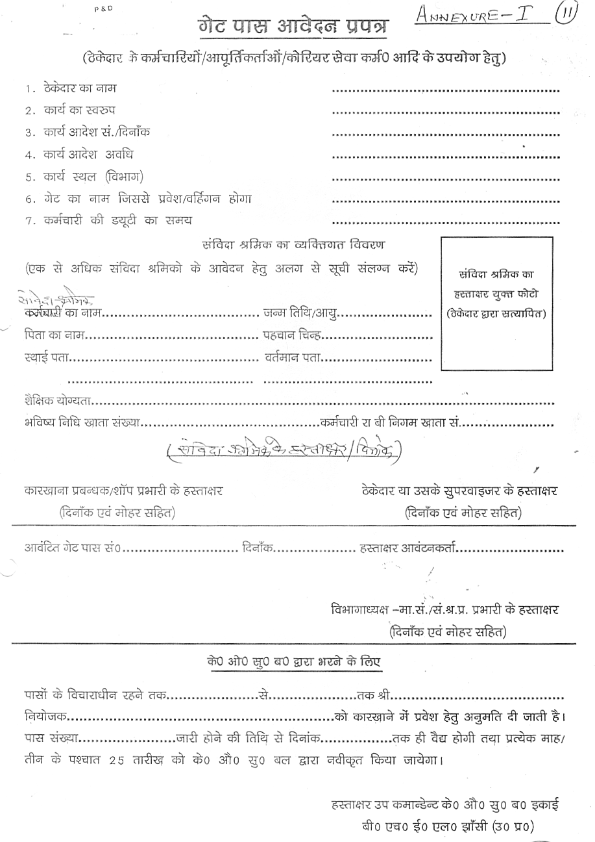

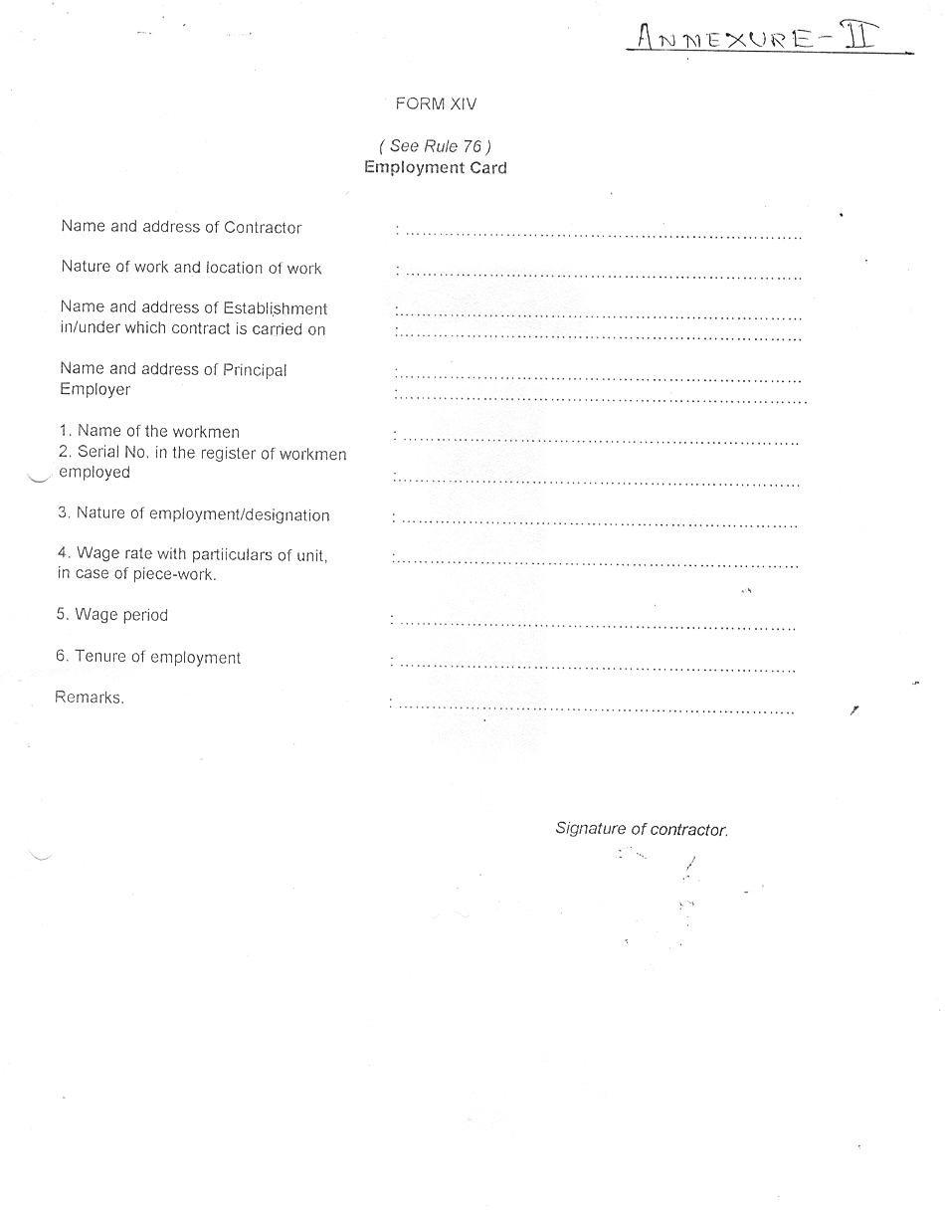

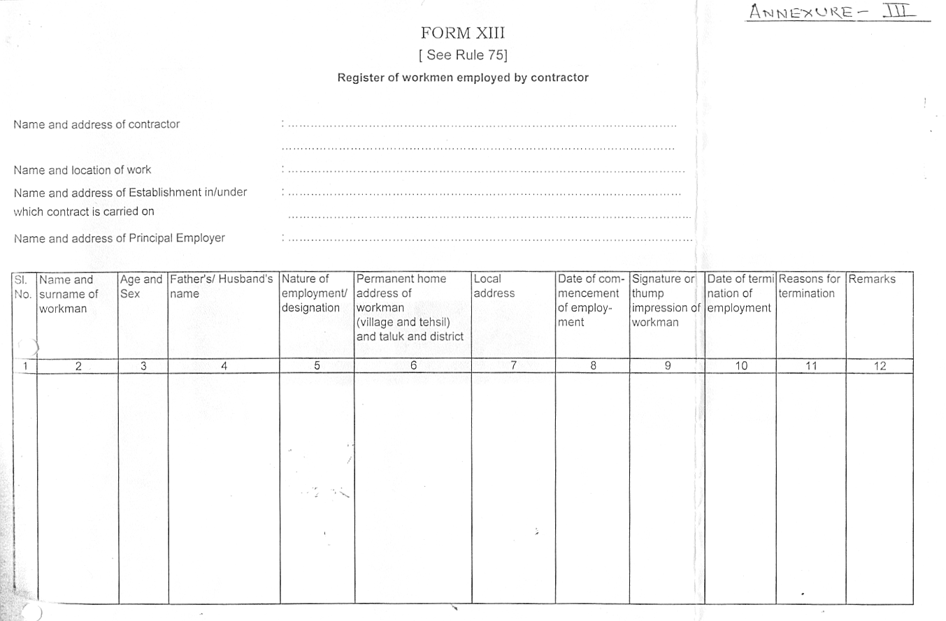


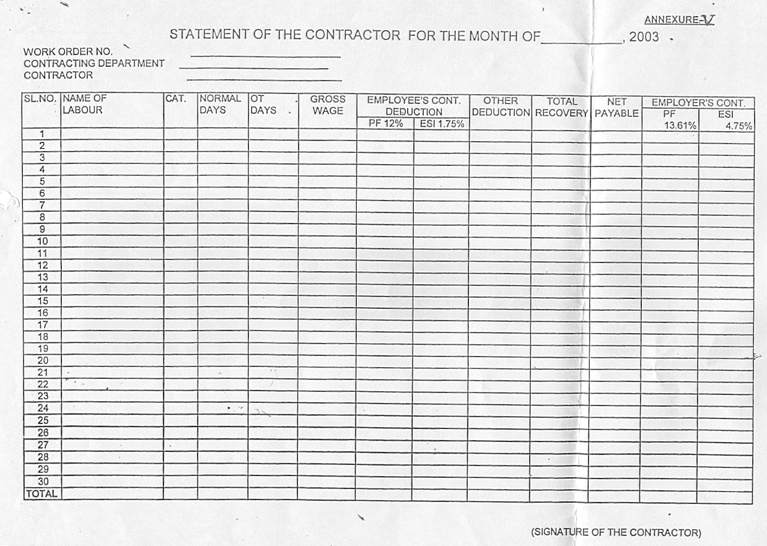

 |  |  |  | ANNEXURE - VI
SUMMARY SHEET FOR THE MONTH OF , 200----
( TO BE FILLED BY THE CONTRACTING DEPARTMENT )
01 | SERVICE CONTRACT NO. DATE :
02 | PERIOD OF CONTRACT : FROM : TO :
03 | NAME OF THE CONTRACTOR : M/s.
04 | NO.OF CONTRACT LABOUR DEPLOYED DURING THE MONTH |  | CATEGORY | NOS. |  | CAT.WISE TOTAL DAYS
 |  |  | USW
 |  |  | SSW
 |  |  | SW
05 | TOTAL PAYMENT AGAINST WAGES PAYABLE TO ALL ABOVE CONTRACT WORKERS b = a - (6b + 7b) |  | a.GROSS AMOUNT RS =
05 |  |  | b.NET AMOUNT RS.=
06 | PF/EPF/EDLI CONTRIBUTION DUE |  | a. EMPLOYER @ 13.61% =
06 |  |  | b. EMPLOYEE @ 12.00% =
06 |  |  | c. TOTAL (a+b) (Rs.) =
07 | ESI CONTRIBUTION DUE |  | a. EMPLOYER @ 4.75% =
07 |  |  | b. EMPLOYEE @ 1.75% =
07 |  |  | c. TOTAL (a+b) (Rs.) =
08 | AMOUNT PAYABLE TO CONTRACTOR (5+6(a)+7(a ) |  | a. GROSS WAGE AMOUNT RS. =
08 |  |  | b. PF CONT. @ 13.61% =
08 |  |  | c. ESI CONT. @ 4.75% =
08 |  |  | d. CONT.COMMI.@ ----% =
08 |  |  | e. SERVICE TAX @ 12.36% =
08 |  |  | (ON TOTAL AMOUNT OF a TO d)
08 |  |  | TOTAL ( a TO e ) = RS.
( COUNTERSIGNED BY HOD) ( SIG. & SEAL OF SHOP INCHARGE )
I/We agree with the above
Signature of Contractor with Seal Executive Incharge

Annexure’H’

BHEL – JHANSI

Tender Documents

MEASUREMENT OF WORK AND PAYMENTS THEREOF.

1. The designated officer of the Unit will periodically inspect the Data Punching and Miscellaneous services being provided by the contractor and find out deficiencies. The contractor shall rectify the same immediately to the satisfaction of the designated officer.

2. Payment towards work satisfactorily executed will be made to the contractor on the basis of following: -

Sl.No. | Service/Activity | Measurement criteria (Unit) | Approx. qty.(in one year)
1. | Stand No.1: At the Northern Side of Main Gate in all the 3 shifts on all the 7 days in a week  (1 Stand, 3 Shifts, 12 Months, hence 1 x 3 x 12 = 36) | Per Stand  Per Shift  Per month | 36
2. | Stand No.2: At the Northern Side of Main Gate in all the 3 shifts on all the 7 days in a week  (1 Stand, 3 Shifts, 12 Months, hence 1 x 3 x 12 = 36) | Per Stand  Per Shift  Per month | 36
3. | Stand No.3: At the Southern Side of Main Gate in 2 shifts on 6 days in a week  (1 Stand, 2 Shifts, 12 Months, hence 1 x 2 x 12 = 24) | Per Stand  Per Shift  Per month | 24
4. | Stand No.4: At the Nothern Side of Material Gate in 2 shifts on 6 days in a week  (1 Stand, 2 Shifts, 12 Months, hence 1 x 2 x 12 = 24) | Per Stand  Per Shift  Per month | 24
5. | Stand No.5: At the Southern Side of Material Gate in 2 shifts on 6 days in a week  (1 Stand, 2 Shifts, 12 Months, hence 1 x 2 x 12 = 24) | Per Stand  Per Shift  Per month | 24

3) Payments will be made to the contractor on the basis of work carried out by him on a monthly basis.

4) All payments will be subject to deduction of income tax at source as per Income Tax applicable Rules.

5) Log book to be maintained for the work carried out daily/weekly/monthly to be certified by the contractor’s representative and BHEL official, nominated for the same.
I/We agree with the above

Signature of Contractor
with Seal Signature of Officials of Executing Deptt.

Annexure’I’

BHEL – JHANSI

Tender Documents

Ref: Your Enquiry No. CPR/WC/CS/01 Dated. 05.03.2009..

TECHNICAL BID
FOR GUARDING OF BICYCLES, SCOOTERS, MOTOR- CYCLES & CARS KEPT AT THE STANDS LOCATED AT MAIN GATE & MATERIAL GATE OF BHEL,JHANSI

1.Name of the firm :

2.Name of the Proprietor :

3.Address and Contact Numbers :

4.Registration Number :

Copy of the Certificate : Enclosed / Not Enclosed

5.Labour Licence Number :

Copy of the Licence : Enclosed / Not Enclosed

6.PF Code Number :

Copy of the Certificate : Enclosed / Not Enclosed

7.ESI Code Number :

Copy of the Certificate : Enclosed / Not Enclosed

8.PAN Number :

9.Income Tax Returns for last 3 years : Enclosed / Not Enclosed

10.Service Tax Number : Enclosed / Not Enclosed
11.VAT/TIN Number : Enclosed / Not Enclosed
(To be submitted only in case
where material transaction is
involved)
12. Blank Price Bid format : Enclosed / Not Enclosed

13 No.of Workers including Supervisors :
on the rolls of the firm

14. Earnest Money Deposit : Rs. ---------------------

a) D.D. Number & Date : ----------------------------
b) Drawn on (Bank) : ----------------------------

15. Any other relevant information :

16. Tender Cost : Rs. --------------------
D.D.No. : -------------------------

17. Validity of offer : 90 days from the date of tender
Opening.
18. Blank Price Bid Format

We will fulfil all the obligations of the contractor and abide by the Terms & Conditions mentioned in the enquiry.

Signature with Name
& Office Seal
Date:

NOTE : TECHNICAL BID AND PRICE/RATE BID SHOULD BE SUBMITTED IN SEPARATE SEALED ENVELOPES. IN CASE THE BIDS ARE FOUND IN ONE SINGLE ENVELOPE THEN THE “BIDS” ARE LIABLE TO BE REJECTED.

I/We agree with the above
Signature of Contractor with Seal Executive Incharge

BHEL, JHANSI Annexure “J”

ENQUIRY NO. CPR/WC/CS/01 DATED: 05.03.2009....

PRICE/RATE BID
for GUARDING OF BICYCLES, SCOOTERS, MOTOR-CYCLES & CARS KEPT AT THE STANDS LOCATED AT MAIN GATE & MATL GATE OF BHEL, JHANSI

a. Name of the firm :
b. Name of the proprietor/partners :
c. Address and contact nos :
d. Price offer on work measurement basis :
SL.NO | Service/Activity | Measure-ment criteria  (Unit) | Approx. qty.  (in one year) | Rate per unit | Total value  F = D x E
(A) | (B) | (C ) | (D) | (E) | (F)
1. | Stand No.1: At the Northern Side of Main Gate in all the 3 shifts on all the 7 days in a week  (1 Stand, 3 Shifts, 12 Months, hence 1 x 3 x 12 = 36) | Per Stand  Per Shift  Per month | 36
2. | Stand No.2: At the Northern Side of Main Gate in all the 3 shifts on all the 7 days in a week  (1 Stand, 3 Shifts, 12 Months, hence 1 x 3 x 12 = 36) | Per Stand  Per Shift  Per month | 36
3. | Stand No.3: At the Southern Side of Main Gate in 2 shifts on 6 days in a week  (1 Stand, 2 Shifts, 12 Months, hence 1 x 2 x 12 = 24) | Per Stand  Per Shift  Per month | 24
4. | Stand No.4: At the Nothern Side of Material Gate in 2 shifts on 6 days in a week  (1 Stand, 2 Shifts, 12 Months, hence 1 x 2 x 12 = 24) | Per Stand  Per Shift  Per month | 24
5. | Stand No.5: At the Southern Side of Material Gate in 2 shifts on 6 days in a week  (1 Stand, 2 Shifts, 12 Months, hence 1 x 2 x 12 = 24) | Per Stand  Per Shift  Per month | 24
6. | Total |  | 144

Date: Signature with Name & Office Seal

NOTE: TECHNICAL BID AND PRICE/RATE BID SHOULD BE SUBMITTED IN SEPARATE SEALED ENVELOPES. IN CASE THE BIDS ARE FOUND IN ONE SINGLE ENVELOPE, THE "BIDS" ARE LIABLE TO BE REJECTED.

BASIS OF OFFER

UNIT USW

1. Category wise No.of Contract Labours 07
2. Category wise Min.wages per day/Labour (Rs.) 153/-
3. Category wise No.of days expected for (Days) 300
fulfillment of contract
4. Category wise total of normal wage (Rs.) 321300/-
(Sl.No. 1X2X3)
------------------------------------------------------------------------------------------------------
5. Total Minimum Wages (Rs.) 321300/-
6. O.T. @ 10% of Minimum Wages (Rs.) 32130/-
7. Contingency @ 6% of Sl.No.5 due to (Rs.) 19278/-
revision of DA Rates and increase in
minimum wages accordingly.
8. Contingency @ 6% of Sl.No.6 due to (Rs.) 1928/-
revision of DA Rates and increase in
minimum wages accordingly.
9. Total contingency (sl.no.7+8) (Rs.) 21206/-
10. PF/EDLI/Pension (Rs.) 46353/-
Employer’s contribution @ 13.61%
(Calculated on Amt.of sl.no. 5&7
i.e. Rs. ……………….)
11. ESI Employer’s Contribution @ 4.75% 17795/-
(Calculated on Amt.of sl.no. 5,6&9
i.e. Rs. ……………….)
12. Grand Total (Sl.no.5+6+9+10+11) Total (Rs.) 438784/-
13. Contractors Commission for fulfillment of work
described above and to meet incidental charges
including supervision, financing cost,stamp duty
charges, safety equipment for labours,wages for
leave period as per UP Factories Rules,etc.= -- % of total of .no.12
= Rs.------------------------
14.Total Value of the Contract payable to the = amount at sl..no.12+sl.no.13
bidder/price offer (excluding Service Tax = Rs.-------------------- and Statutory bonus amount)

REMARKS :

i) Service tax shall be payable extra over and above the value of the offer price quoted above at sl.no.14 at the rates applicable (presently 12.36%)
ii) Payment of statutory bonus @8.33% (At present Max. Rs. 3500/- per labour per year) extra will be reimbursed by BHEL as per clause no. 6.0 of General Terms & Conditions at Annexure ‘G’.

Signature of the Contractor

NOTE/CONDITIONS FOR PRICE BID

1. TECHNICAL BID AND PRICE BID SHOULD BE SUBMITTED IN SEPARATE SEALED ENVELOPES. IN CASE THE BIDS ARE FOUND IN ONE SINGLE ENVELOPE THEN THE SAME ARE LIABLE TO BE REJECTED.
2. ALL THE BLANK SPACES AT SL.NO. d OF ANNEXURE 'J' OF PRICE BID & AT SL.NO.14 OF BASIS OF OFFER FORMATS SHOULD BE FILLED BY THE CONTRACTOR. IF ANY FIXED FIGURE IN THE PRICE BID FORMAT IS CHANGED THEN THE BID SHALL BE SUMMARRIRILY BY-PASSED.
3. THE FIGURE AT SL.NO. d OF PRICE BID OF ANNEXURE 'J' SHOULD MATCH/TALLY WITH FIGURE AT SL.NO. 14 OF BASIS OF OFFER. IF THESE TWO VALUES ARE DIFFERENT THEN THE OFFER SHALL BE BY-PASSED.
4. TOTAL CONTINGENCY OF 6% INDICATED AT SL. NO. 9 OF BASIS OF OFFER ABOVE IS NOTIONAL. PAYMENT WILL BE MADE ON ACTUAL BASIS DEPENDING UPON MINIMUM WAGES DECLARED BY THE GOVT. OF UP FROM TIME TO TIME.
5. IF ANY OTHER ADDITION IS MADE OR ANY CONDITION IS ADDED BY THE BIDDER IN THE PRICE BID FORMAT THEN THE OFFER SHALL BE BY-PASSED.
6. CONTRACTOR HAS TO COMPLY WITH PAYMENT OF MINIMUM WAGES AND OTHER STATUTORY LEVIES AS PER PROVISION OF THE RESPECTIVE ACTS.

I/We agree with above and all other terms & conditions of the contract .

Date : Name & Signature with Office Seal

I/We agree with the above
Signature of Contractor with Seal Officials Of Executing Department

