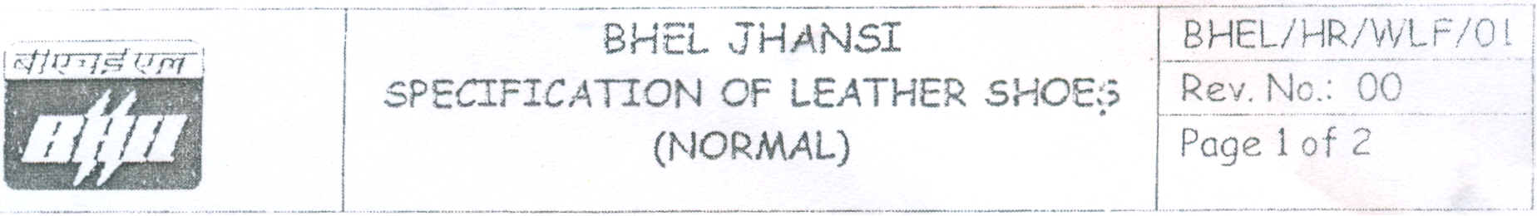

Black Leather Shoes/Sandal (Normal)

1.0 Scope
This standard covers the requirement of Leather shoe (Normal) wit h PU DIP/DPP sole for protection of feet.

2.0 Technical Requirement
- The shoe/sandal upper and bottom sole shall be joined together by direct injection process (DIP) or Direct pouring process (DPP).
- Upper leather shall be of good quality Cow/Buffalo softy leather in black colour.
- The shoe/sandal shall be provided with lasting inner sole.
- The Eye lets shall be of Brass/ Aluminum and shall be 4/5 pairs.
- The shoe/sandal is to be machine stitched and no nails shall be used.
- Total weight shall be approximately 900 Grams per pair.
- Laces shall be round in shape and slip knot Resistant.
- Shoe/sandal size shall be as per "BATA" standard.

3.0 Sample
Along with offer, sample and conformance certificate as per specification no. BHEL/HR/WLF/Ol, (Clause no-4.1) shall be submitted. Maximum three samples can be submitted along with offer by each bidder.

Each sample shall have a permanent non-removable hanging type tag of maximum size 2"X2" with the following details.
- Tender Enquiry No.:
- Article/ Model no.
- Name of tenderer.

- Signature along with name.

4. 0 Test Certificate
4.1 Supplier shall submit sample with conformance certificate along with the
offer as per the following technical parameters (clause no-4.1)
Test certificate shall be submitted along with bulk supply after carrying out test as per the following technical parameter on each lot of supply against BHEL order.

Technical Parameters

•...
Type of test |  |  | Required value
 | 1. | Shoe upper (Leather)
(a) Tear Strength Test |  |  | Minimum - 120 Newton
Based on IS 15298 (Part-2) 2002
(b) Bailey Flexing Test |  |  | No Damage/Crack till 1,00,000 Cycles.
Based on SA IRA TM 55
 |  |  |  | -j
 | 2. | Sole PU (DIP/DPP)
(a) Bennewart Flexing Test |  |  | Cut growth not more than 4 mm before
As per IS 15298 (Part-2) 2002 |  |  | 30,000 Cycles
(b) Aberration Resistance Test |  |  | Maximum 250 mm3' I
(c) Peel strength test between upper and |  |  | Minimum 4 Newton/mm
sole. Based on SATRA TM 411

5.0 Packing
Each pair of shoes shall be packed in a card board box and one' polythene carrying bag is required for each pair of shoe.

6.0 Marking
The shoe shall be marked with the following information
(a) Size of the shoe on sole and shoe socks.
(b) MRP on shoe socks.
(c) Suppliers identity
(d) Article no/Model no
(e) Month/Year of the manufacturing /Size on cardboard box.

7.0 BHEL Inspection
Final inspection will also be carried out at our works with reference to the approved sample and test report submitted along with supply and as per purchase order. BHEL Jhansi may inspect at manufacturer's work at its discretion with reference to the approved sample. Technical parameters and as per Purchase Order. The supplier shall give inspection call before dispatch of shoe.

8.0 Guarantee Certificate
Six months free replacement guarantee certificate shall be given for manufacturing defects along with its consignment from the date of receipt at BHEL.

4.2 Test Certificate submitted along with supply shall indicate the following.
(a) BHEL Purchase Order No. (b) Batch no & date
(c) Type of test, its required and observed values as per technical parameter (clause 4.1)

