REV. NO. 00 PAGE 1 OF 1
H Y D
TECHNICAL SPECIFICATIONS
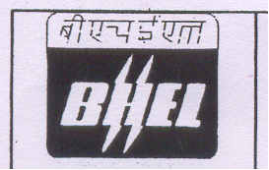
ENQUIRY SPECIFICATIONS FOR
EARTHING MATERIAL I Proj/001
General
1.0 This specification includes design, fabrication, supply and testing of
materials for earthing system in accordance with the applicable
Indian Standards & Indian Electricity Rules.
2.0 Galvanized Steel Strips
2.1 All steel strips shall be hot-dip galvanized according to IS;.
. 2629:1990 & IS-4759:1990. Galvanizing shall be done at a place
where galvanizing and testing facilities required as per above Indian
Standards exist.
''''"",,:!:
2.2 The thickness of galvanizing shall not be less than 75 microns;
2.3 The galvanizing shall be uniform, clean, smooth, continuous and free from acid spots. Should the galvanizing of the samples be found defective, the entire batch of steel will have to be re-galvanized at the vender's cost.
2.4 The amount of zinc deposited shall not be less than 610 grams per square meter of surface area and in addition the thickness of zinc deposit at any spot whatsoever, shall not be less than 75 microns. The purchaser reserves the right to measure the thickness of zinc deposit by Elkometer or any other instrument acceptable to purchaser and reject any component which shows thickness of zinc at any location to be less than 75 microns.
2.5- The GI Strips shall be supplied in mixed lengths of 6m to 12 m. ***

