THIS TENDER IS THROUGH E-PROCUREMENT MODE.
Online bids in two parts are invited for the “Supply of Welding Set 600 Amp along with spares”. The relevant documents can be downloaded from https://eprocurebhel.co.in.

Tender Enquiry No | 2021-012E
Enquiry date | 05-Jun-21
Last time and date of tender submission | 1400 Hrs 16-Jun-21
Tender opening time and date | 1530 Hrs 16-Jun-21
Quotation Parts | Two-part Bid
Item Description | Welding Set 600 Amp along with spares
Item Qty | 4 Nos (Sets)
Item Specification | As mentioned in Technical Specification (Annexure-B)
Validity of offer (In days) | 90 days

PRE-QUALIFICATION CRITERIA
As per Annexure-A & B attached.

SPECIAL TERMS

- Pre-dispatch inspection (PDI) to be carried out by the BHEL personnel at the vendor works. Vendor has to inform BHEL for inspection to get clearance for dispatch. The criteria for clearance at the time of PDI has been detailed as per annexure-1, parameter-wise. However final acceptance of the sets shall be based on equipment prove out at our works, before BHEL Engineers.
- Quantity indicated as '1 Set' comprises of 'One complete Welding set' and 'one complete set of nine mandatory spares' as mentioned in annexure -2. [1 Set = 1 welding set + 9 Spares]
- The evaluation criteria for L1 bidder should be based on '1 Set' basis as per detailed in above Point 2.
- Guarantee/Warranty for a minimum period of one year from the date of commissioning at our works, is applicable for complete '1 Set', which comprises of welding set as well as spares.
- Commissioning charges applicable @ 2.75 % of the total tender value. The successful bidder shall be responsible for completing the installation (including electrical setup) of the welding sets at BHEL, IVP, Goindwal works and demonstrate its operational features for all the procured sets.
- Details of any additional accessories supplied, which are not demanded in this enquiry, shall be notified separately.
- Delivery of first two welding sets should not be later than 60 days from date of release of PO/LOI. Delivery of second lot of two welding sets must be after 30.09.2021 and should not be later than 30.11.2021. In case the supplier delivers the second lot of two welding sets before stipulated date of 30.09.2021, the material receipt date of second lot for payment purposes will be considered 30.09.2021 only.
- No counter offer will be given for this tender enquiry to any bidder including MSE bidders.
- The requirement of calibration certificate and NABL laboratory certificate as per Annexure B must be produced along with the supply of welding sets.
CONTRACTOR / SUPPLIER NOT ELIGIBLE TO QUOTE IN THIS TENDER

M/s. Cruxweld Industrial Equipments PVT. LTD., address - 784, Raja garden, Old Faridabad, Haryana-121002 (PAN No. AAECK2005N) is not eligible to participate in this tender enquiry.

These Special terms & conditions and GCC collectively are the part of tender terms and conditions.

ANNEXURE-A : PRE-QUALIFYING CRITERIA FOR SUPPLY OF Welding Set 600 Amp along with spares

The bidder/vendor has to compulsorily meet the following requirement to get qualified for submitting an offer for the Welding Set 600 Amp along with spares as per tender terms & conditions:

S.No. | Pre-Qualification Criteria for the vendor | Document Copies to be furnished
1. | Bidder should have supplied, installed and commissioned IGBT welding set of 600 amp. or above in the past five years (on the date of opening of tender) - PO copy to be enclosed.
2. | For startups : The Purchase order criteria in pre-Qualification terms shall not be applicable to Start-Up Firms. These relaxations and exemptions are in line with D.O. No. 5(4)/2016-BE-I dated 15.02.2017. However for claiming the Start-Up exemption, the bidders have to submit documentary evidence or undertaking of following:  - The business being a start-up firm  - The capacity of the firm to supply a similar “Welding Set 600 Amp along with spares“ equipment i.e. IGBT welding set of 600 amp ( refer detailed technical specifications vide Annexure B ).

ANNEXURE- B
TECHNICAL SPECIFICATIONS OF Welding Set 600 Amp along with spares REQUIRED AT: BHARAT HEAVY ELECTRICALS LIMITED, INDUSTRIAL VALVES PLANT, GOINDWAL SAHIB, PUNJAB

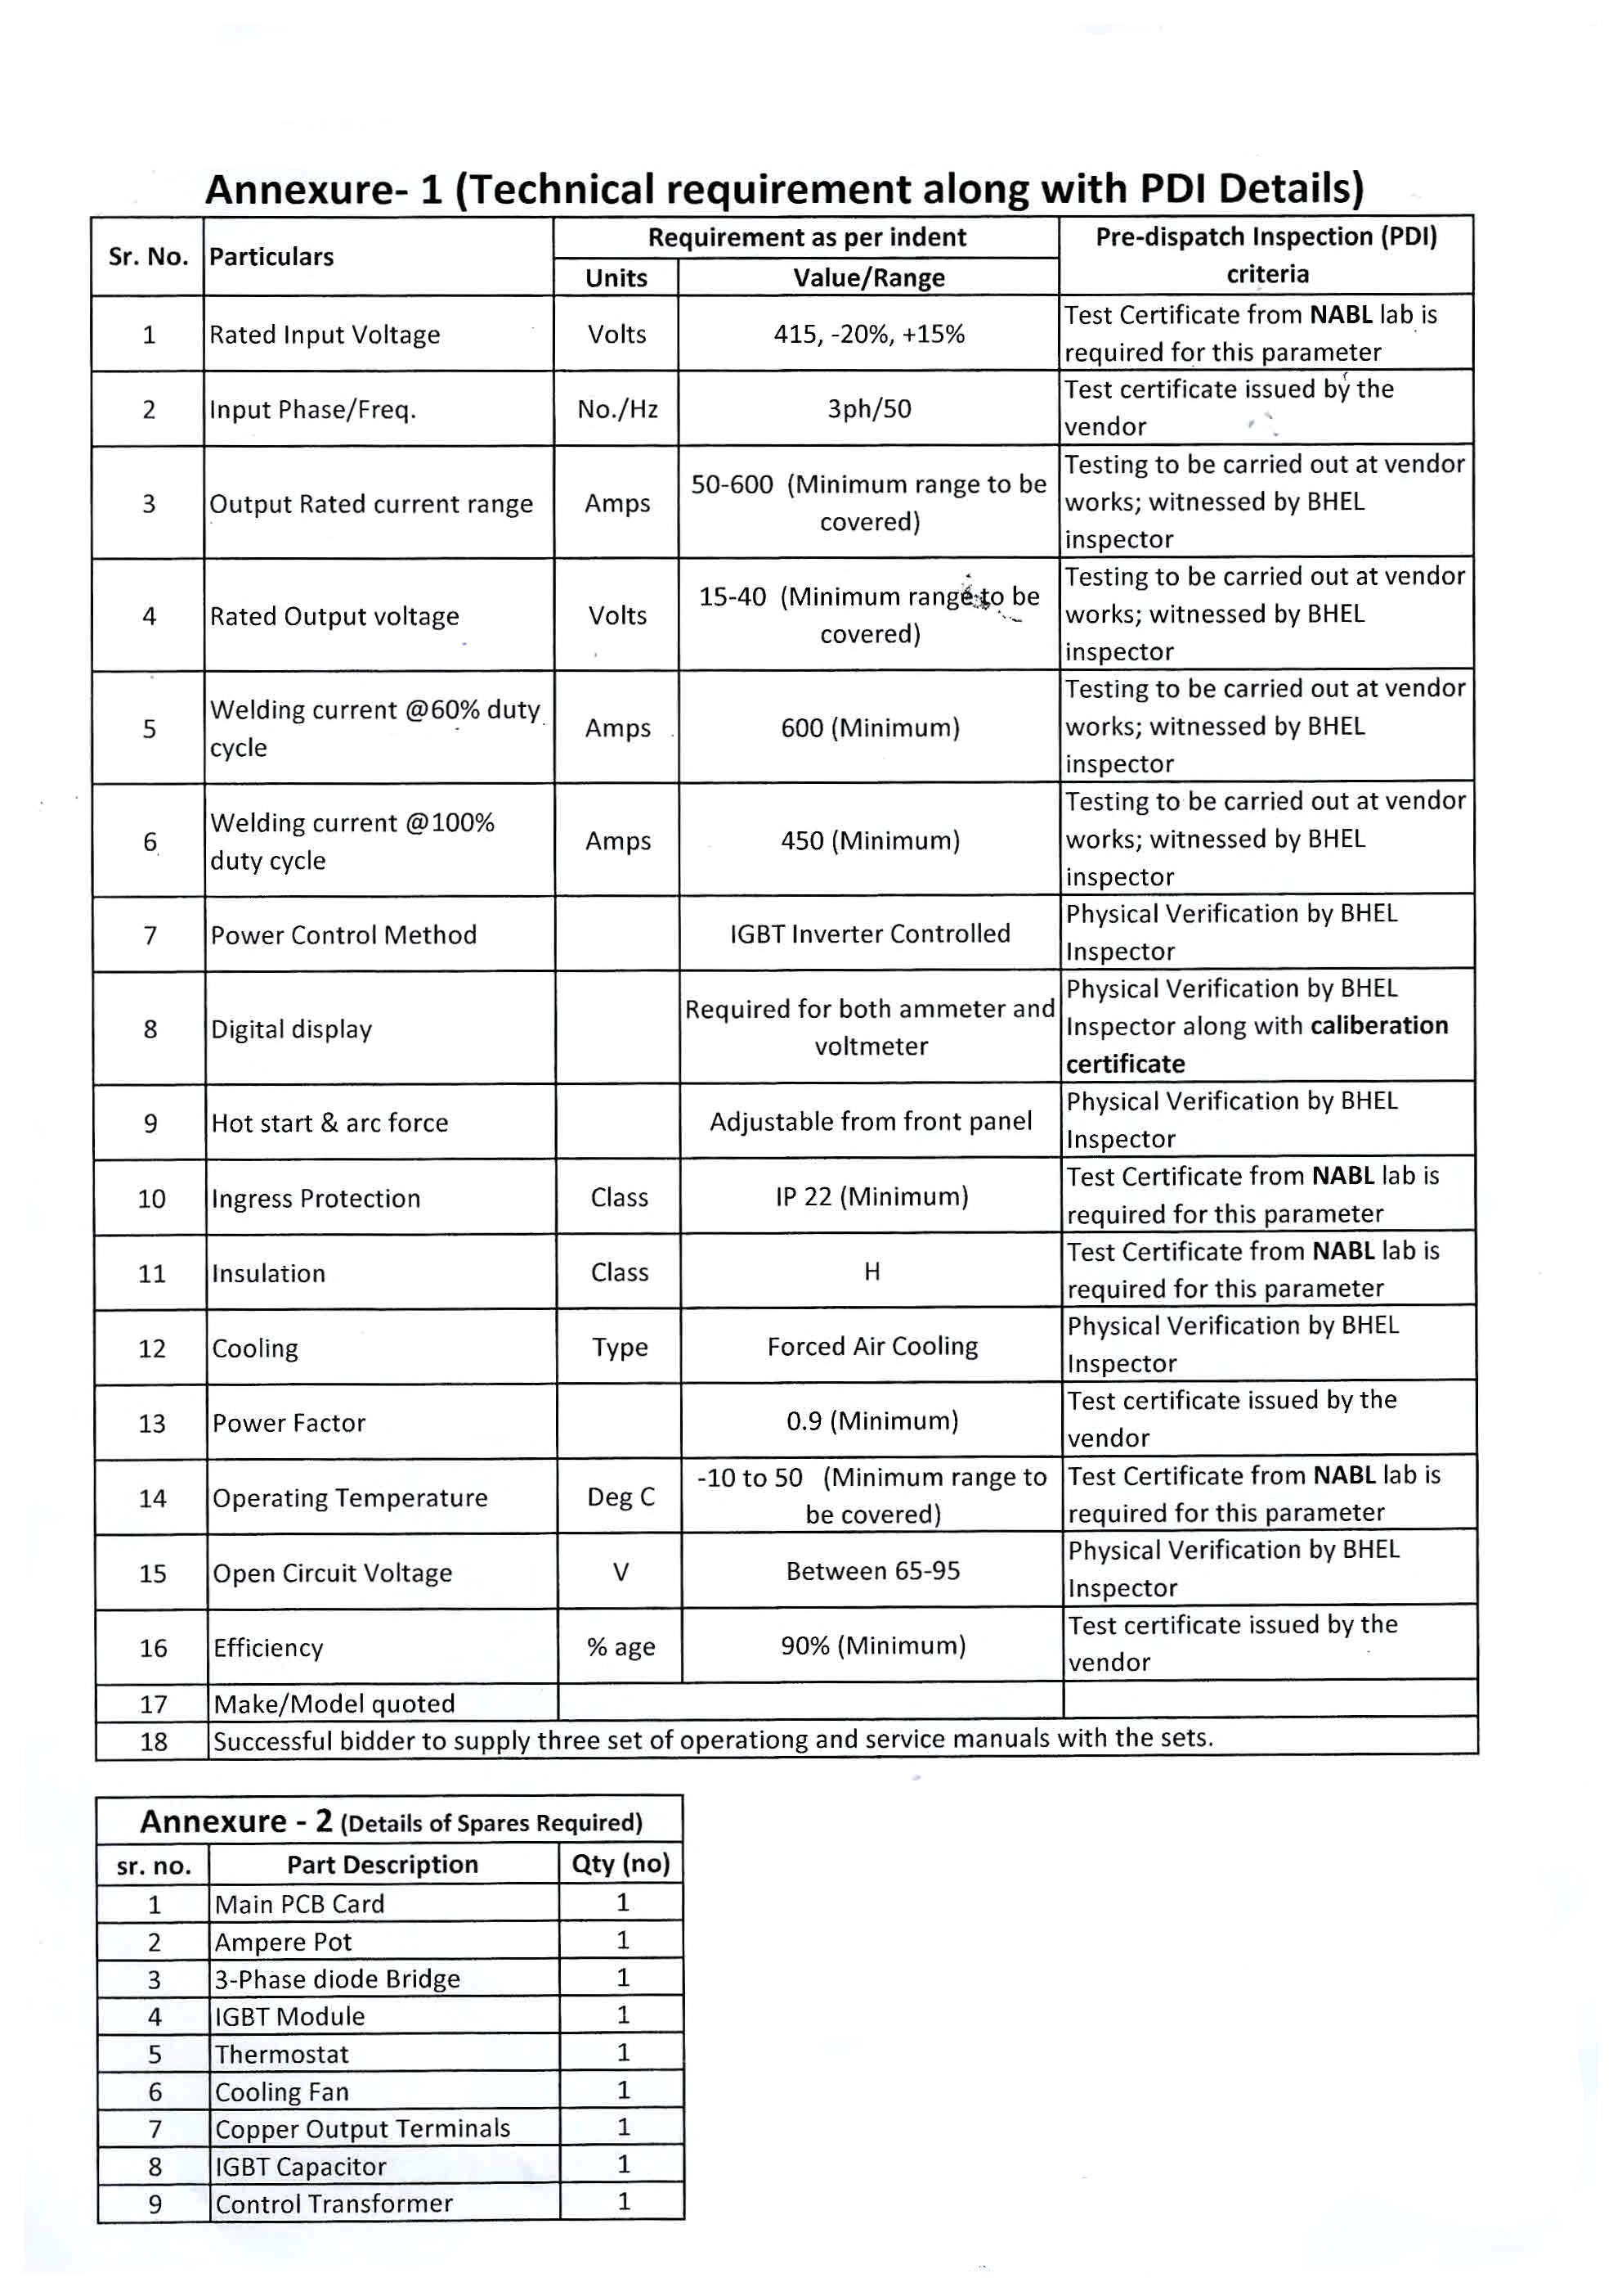
ANNEXURE-C
COMMERCIAL TERMS AND CONDITIONS CONFIRMATION SHEET

PLEASE NOTE THAT THE CONDITIONS INDICATED IN THE COMMERCIAL TERMS AND CONDITIONS APPLICABLE FOR THE TENDER ARE APPLICABLE ONLY TO THE EXTENT THEY ARE NOT SUPERSEDED BY THE FOLLOWING CONDITIONS

Description of the Equipment: Welding Set 600 Amp along with spares
BHEL Tender No. & Date: 2122-012E DATED 05-Jun-21
Sl. no. | Description | Vendor’s confirmation
1.0 | Price Bid:  Price Bid should contain the price particulars of items, co-related to the technical details provided in Part I. Techno-commercial bid alone without the Price Bid would be rejected. The prices contracted shall be firm till the execution of the contract in full and in all respects.  The bidder has to quote charges for ‘Supply’and ‘Erection & Commissioning’ separately. The evaluation of tender shall be on the basis of "NET CASH OUTFLOW VALUE (total cost to BHEL- refer Annexure - B).
2.0 | Validity:  Validity of the offer should be 90 days from the date of tender opening.
3.0 | Payment terms (for item sr. no. 1- ref annexure B)-  - 100% payment, within 45 to 90 days, After successful commissioning & acceptance of equipment at BHEL, Goindwal, Punjab.  or  - 80% payment of Supply value shall be made within 45 days from the date of receipt of material at BHEL. Balance 20% of Supply value plus 100% of the E&C portion of PO value will be paid against E&C certificate issued by BHEL and submission of Performance Bank Guarantee (PBG) valid for two months beyond the warranty period by Supplier from any of the Consortium Banks of BHEL for 10% of total PO Value in the prescribed Format.  NOTE: In case of any deviation from standard payment term mentioned above, BHEL at it’s discretion may load on the item price at Benchmark Prime Lending Rate (BPLR) of SBI as applicable on the scheduled date of tender opening (Part-I bid in case of two part bid) + 6%, for the amount & period of relaxation sought by bidder. | Vendor has to mention which payment term is accepted by him (a) or (b).
4.0 | Value for Erection & Commissioning (applicable as mentioned in scope of supply in annexure B) at BHEL:  Erection & Commissioning (E&C) value will include services to be rendered at BHEL like erection, commissioning, job proving, training to operators, supervising foundation work etc. (to be together called as E&C). E&C is in the scope of the supplier, and E&C value should be quoted separately by the bidders.  Only in case where quoted value is less than the minimum value indicated below or separate E&C values are not mentioned in the offer, value for E&C portion shall be deemed to be considered as the value indicated below and accordingly supply value will be adjusted from that quoted value and the balance will be released as E&C payment . The bidder, however, can choose to quote the E&C value higher than the below mentioned minimum E&C value (%) and suitably apportion the supply value.
5.0 | Currency of payment:  The currency shall be Indian Rupees.
6.0 | Taxes & Duties:  - Documents to be submitted (if applicable)  - Tax invoice (Invoice shall be GST compliant and should contains all the required information such as GST No, HSN code etc.)  - Transporter copy along with material/consignment.  - Material Test Certificates (MTC) and  - Compliance Certificate.  - GST registration number is to be submitted by qualified vendor as per GST law.  - It is mandatory to mention proper material codes in the invoices and separate invoices to be raised for different POs.  - BHEL releases payment through EFT mode ONLY. Necessary details may please be submitted by filling required format before release of payment.  - Conditions relating to release of GST portion:  Payment of GST portion will be released to vendor only upon completion of statutory requirement and further subject to following:  The reimbursement of GST portion of invoice shall be released only upon: -  - vendor declaring such invoice in his GSTR-1 and  - receipt of goods and Tax invoice by BHEL and  - Confirmation of payment of GST thereon by vendor on GSTN portal.  - Above is subject to receipt of goods/service and tax invoice thereof along with vendor declaring invoice in his return and paying GST within timeline prescribed for availing ITC by BHEL.  - In case GST credit is delayed/denied to BHEL due to non/delayed receipt of goods and/or tax invoice or expiry of timeline prescribed in GST law for availing such ITC, or any other reasons not attributable to BHEL, GST amount shall be recoverable from vendor along with interest levied / leviable on BHEL.  - In case vendor delays declaring such invoice in his return and GST credit availed by BHEL is denied or reversed subsequently as per GST law, GST amount paid by BHEL towards such lTC reversal as per GST law shall be recoverable from vendor/contractor alongwith interest levied / leviable on BHEL.
7.0 | Delivery Period:  Bidder should quote time period separately for ‘Supply’ and ‘E&C’ of equipment.
 | - Supply Period: – Bidders are requested to quote firm Time period required for delivery of the equipment, (FOR dispatching station). For Supply portion, delivery period shall be reckoned from the date of purchase order/LOI to dispatch from the vendor works.
 | DELIVERY PERIOD REQUIRED BY BHEL (SUPPLY PORTION) | As per annexure B
 | DELIVERY PERIOD OFFERED BY VENDOR (SUPPLY PORTION)
 | (b) E&C period: – Duration shall be counted from the date of intimation by BHEL to vendor for deputation of their Engineers for E&C.
 | E & C PERIOD REQUIRED BY BHEL (E & C PORTION) | 15
 | E & C PERIOD OFFERED BY VENDOR (E & C PORTION)
8.0 | LIQUIDATED DAMAGES (LD):  Delivery terms mentioned in the PO/LOI shall be adhered to. In case of approval of drawings or any other technical documents, a nominal period of 15 days shall be considered as included in the delivery period mentioned. If BHEL is taking more time in such approvals, delivery period can be extended accordingly. All such technical documents to be approved by BHEL shall be submitted within 10 days of release of PO/LOI. Delivery of the goods specified in the purchase order should be made within the time prescribed.  Penalty on delay in ‘Supply’ and/or ‘E&C’ will be applicable to the delays attributed to vendor. Penalty will be considered separately for ‘Supply’ and ‘E&C’.  The rate of penalty for delayed Supply shall be @ 0.5% per week of delay of total PO value (Supply + E&C) in supply subject to a maximum of 10% of total PO value (Supply + E&C).  The rate of penalty for delayed E&C shall be @ 0.5% per week of delay of total PO value (Supply + E&C) in E&C subject to a maximum of 10% of total PO value (Supply + E&C).  Maximum penalty for delay in Supply and E&C together shall be limited to 15% of total PO value (Supply + E&C).  If any vendor does not accept PLD ½% of the supply and E&C separately for each week of delay subject to a maximum of 5%, their offer is likely to be rejected by BHEL and the price bid shall not be opened. Bidders accepting for 10% PLD shall not be loaded on account of PLD. However, bidders who offer any other % PLD [between 5% to 10%] shall be loaded @ % deviation from 10% and their accepted %. e.g. If a bidder accepts for a max of 7% LD only, their offer would be loaded @ 3% (10 – 7 = 3). As regards LD, the delivery date (FOR dispatching station) shall be considered.  Supply period indicated by bidder should include reasonable time required for approval of drawings and other inputs from BHEL. In the Techno-Commercial Bid, the bidder shall submit milestones for various activities in co-relation with Supply and E&C period quoted by him.  For the purpose of penalty for delay E&C of the equipment the duration will be reckoned from the date of intimation by BHEL to vendor for readiness of site.
9.0 | SHORT SUPPLY / WARRANTY REPLACEMENT:  In case, any shortage is noticed viz-a-viz PO requirement in the main equipment / spares, such shortages shall be replenished by supplier on FOR destination basis without any cost implication to BHEL i.e. Custom Duty and freight charges etc. up to destination for such short supplies shall be borne by the supplier.
10.0 | Risk purchase:  If the supplier fails to deliver the goods within the delivery specified in the Purchase Order, BHEL will be entitled to terminate the contract and to purchase elsewhere at the risk and cost of the seller either the whole of the goods or any part which the supplier has failed to deliver or dispatch within the delivery period mentioned in the Purchase Order.  BHEL reserves the right not to consider offers from vendors not accepting the above Risk Purchase terms.
11.0 | Guarantee / Warranty:  Vendors shall provide a guarantee of machine performance as per technical terms – Annexure B, from the date of commissioning of the equipment at BHEL Goindwal and shall provide spares and services during warranty period to maintain the machine in working condition.  Offers from vendors not accepting to the requested guarantee period are liable for rejection.
12.0 | Performance Bank Guarantee [PBG]: Performance Bank Guarantee (PBG) for 10% of the total order value covering the agreed Guarantee period (with additional 2 months as claim period) has to be furnished. In case of indigenous bidder, the PBG shall be in the format enclosed and from one of the banks mentioned therein. In case of import, the foreign vendor shall arrange to give a counter guarantee to Punjab National Bank (PNB) Goindwal Sahib and PNB will provide the PBG to BHEL in the format enclosed. In case any bidder does not accept for submission of Performance Bank Guarantee (PBG), their offer is likely to be rejected and the technical bid not processed. All bank charges in India and outside India will be to the supplier’s account.
13.0 | Contacts:  Details of contact person’s name, designation, department with complete postal and email address along with phone and fax numbers to be mentioned
 | Name:
 | Designation:
 | Email ID:
 | Phone No.:
 | Mobile No.
 | Fax No.:
 | Address:
14.0 | Terms of Delivery:  FOR, BHEL, Stores  Industrial Valves Plant  433, Industrial Complex  Goindwal – 143 422  District: Tarn Taran (Punjab), India
15.0 | Weight:  Approximate Net weight of the total consignment  Approximate Gross weight of the total consignment

FORMAT FOR PERFORMANCE BANK GUARANTEE

Bank Guarantee No:
Date:
To
NAME
& ADDRESSES OF THE BENEFICIARY

Dear Sirs,
In consideration of Bharat Heavy Electricals Limited (hereinafter referred to as the 'Employer' which expression shall unless repugnant to the context or meaning thereof, include its successors and permitted assigns) incorporated under the Companies Act, 1956 and having its registered office at _______________________¹ through its Unit at…………………..(name of the Unit) having awarded to (Name of the Vendor / Contractor / Supplier) with its registered office at_________² hereinafter referred to as the 'Vendor / Contractor / Supplier', which expression shall unless repugnant to the context or meaning thereof, include its successors and permitted assigns), a contract Ref No……………………dated ………………………………….³ valued at Rs…………4 (Rupees ------------------------)/FC………………(in words………..) for …………………………5 (hereinafter called the 'Contract') and the Vendor / Contractor / Supplier having agreed to provide a Contract Performance Bank Guarantee, equivalent to ……% (…. Percent) of the said value of the Contract to the Employer for the faithful performance of the Contract,
we, …………………, (hereinafter referred to as the Bank), having registered/Head office at ……………. and inter alia a branch at ………… being the Guarantor under this Guarantee, hereby, irrevocably and unconditionally undertake to forthwith and immediately pay to the Employer any sum or sums upto a maximum amount of Rs -------------------- 6 ( Rupees ------------------------) without any demur, immediately on first demand from the Employer and without any reservation, protest, and recourse and without the Employer needing to prove or demonstrate reasons for its such demand.
Any such demand made on the Bank shall be conclusive as regards the amount due and payable by the Bank under this guarantee. However, our liability under this guarantee shall be restricted to an amount not exceeding Rs.------------------.
We undertake to pay to the Employer any money so demanded notwithstanding any dispute or disputes raised by the Vendor / Contractor / Supplier in any suit or proceeding pending before any Court or Tribunal, Arbitrator or any other authority, our liability under this present being absolute and unequivocal.
The payment so made by us under this Guarantee shall be a valid discharge of our liability for payment
thereunder and the Vendor / Contractor / Supplier shall have no claim against us for making such payment.

We the ……………………bank further agree that the guarantee herein contained shall remain in full force and effect during the period that would be taken for the performance of the said Contract / satisfactory completion of the performance guarantee period as per the terms of the Contract and that it shall continue to be enforceable till all the dues of the Employer under or by virtue of the said Contract have been fully paid and its claims satisfied or discharged.

We ……………..BANK further agree with the Employer that the Employer shall have the fullest liberty without our consent and without affecting in any manner our obligations hereunder to vary any of the terms and conditions of the said Contract or to extend time of performance by the said Vendor / Contractor / Supplier from time to time or to postpone for any time or from time to time any of the powers exercisable by the Employer against the said Vendor / Contractor / Supplier and to forbear or enforce any of the terms and conditions relating to the said Contract and we shall not be relieved from our liability by reason of any such variation, or extension being granted to the said Vendor / Contractor / Supplier or for any forbearance, act or omission on the part of the Employer or any indulgence by the Employer to the said Vendor / Contractor / Supplier or by any such matter or thing whatsoever which under the law relating to sureties would but for this provision have effect of so relieving us.
The Bank also agrees that the Employer at its option shall be entitled to enforce this Guarantee against the Bank as a principal debtor, in the first instance without proceeding against the Vendor / Contractor / Supplier and notwithstanding any security or other guarantee that the Employer may have in relation to the Vendor / Contractor / Supplier 's liabilities.
This Guarantee shall remain in force upto and including…………………………….. 7 and shall be extended from time to time for such period as may be desired by Employer.
This Guarantee shall not be determined or affected by liquidation or winding up, dissolution or change of constitution or insolvency of the Vendor / Contractor / Supplier but shall in all respects and for all purposes be binding and operative until payment of all money payable to the Employer in terms thereof.
Unless a demand or claim under this guarantee is made on us in writing on or before the ……………………………….8we shall be discharged from all liabilities under this guarantee thereafter.

We, ……………… BANK lastly undertake not to revoke this guarantee during its currency except with the previous consent of the Employer in writing.
Notwithstanding anything to the contrary contained hereinabove:
  - The liability of the Bank under this Guarantee shall not exceed………………………… 6
  - This Guarantee shall be valid up to ………………7
  - Unless the Bank is served a written claim or demand on or before _____________8 all rights under this guarantee shall be forfeited and the Bank shall be relieved and discharged from all liabilities under this guarantee irrespective of whether or not the original bank guarantee is returned to the Bank.
We, _____________ Bank, have power to issue this Guarantee under law and the undersigned as a duly authorized person has full powers to sign this Guarantee on behalf of the Bank.

For and on behalf of
(Name of the Bank)

Dated……………….
Place of Issue……………….

1 NAME AND ADDRESS OF EMPLOYER i.e. Bharat Heavy Electricals Limited
2 NAME AND ADDRESS OF THE VENDOR /CONTRACTOR / SUPPLIER.
3 DETAILS ABOUT THE NOTICE OF AWARD/CONTRACT REFERENCE
4 CONTRACT VALUE
5 PROJECT/SUPPLY DETAILS
6 BG AMOUNT IN FIGURES AND WORDS
7 VALIDITY DATE
8 DATE OF EXPIRY OF CLAIM PERIOD

Note:
The BG should be on Non-Judicial Stamp paper/e-stamp paper of appropriate value as per Stamp Act prevailing in the State(s) where the BG is submitted or is to be acted upon or the rate prevailing in the State where the BG was executed, whichever is higher. The Stamp Paper/e-stamp paper shall be purchased in the name of Vendor/Contractor/Supplier /Bank issuing the guarantee.

LIST OF CONSORTIUM OF BANKS

Bank guarantees should be got released from any of the below banks only.

Nationalised Banks:
- State Bank of India
- Allahabad Bank
- Andhra Bank
- Bank of Baroda
- Canara Bank
- Corporation bank
- Central Bank
- Indian Bank
- Oriental Oversea Bank
- Oriental bank of Commerce
- Punjab National Bank
- Punjab & Sindh Bank
- Syndicate Bank
- UCO Bank
- Union Bank of India
- United Bank of India
- Vijaya Bank

Public Sector Banks:
- IDBI

Private Banks:
- Axis Bank
- HDFC
- ICICI
- The Federal Bank Limited
- Kotak Mahindra Bank
- Indusind Bank
- YES Bank

Foreign Banks:
- CITI Bank N.A
- Deutsche Bank AG
- HSBC
- Standard Chartered Bank
- J P Morgan

