Total 28 pages

BHEL JHANSI Tender Documents
DETAILS OF TENDER DOCUMENT

Tender No. WEX/TE/2/18 DATE: 22.02.2013

NATURE OF WORK: Inspection /Testing of Pressure Vessels in BHEL Jhansi Plant.

1. BHEL JHANSI is in the process of finalizing the Service Contract for ----------------------------------------------------------------------------------------------------

2. The tender document has been detailed as follows:

  - Notice Inviting Tender (Annexure A)
  - Work Specifications (Annexure B)
  - Qualifying Requirements (Annexure C)
  - Instruction to Tenderers (Annexure D)
  - Tender Evaluation Criteria (Annexure E)
  - Contractor’s obligations (Annexure F)
  - Other General Terms and Conditions (Annexure G)
  - Criteria for measurement of work (Annexure H)
  - Technical Bid Application (Annexure I)
  - Price Bid ( Annexure J)
  - Blank Price Bid (Annexure K)

The duly filled in Technical and Price / Rate bids (Annexure I and J, separately) along with the instructions to the tenderers, Contractor’s Obligations, General Terms and Conditions with the signature of the tenderer on all the pages and complete in all respects superscribed as “Quotation for Tender No. WEX/TE/2/18 dated 22.02.2013” should reach us in a sealed cover on or before 15.03.2013 (13.15 hours) through Registered / Speed post or the same may be dropped in the tender box available at the following address:

CISF Control Room/Office
Administrative Building
Bharat Heavy Electricals Limited
Jhansi-284 129

BHEL – JHANSI’ Tender Documents

NOTE: TECHNICAL BID AND PRICE BID SHOULD BE SUBMITTED IN SEPARATE SEALED ENVELOPES, IN CASE THE BIDS FOUNDS IN ONE SINGLE ENVELOPE THEN THE “BIDS” ARE LIABLE TO BE REJECTED.

CONTENTS

Sl. No. | Description | ANNEXURE NO | No. of Pages
01. | Notice Inviting Tender | A | 2
02. | Work Specifications / Scope of work | B | As required
03. | Qualifying Requirements | C | 1
04 | Instructions to Tenderers | D | 2
05. | Tender Evaluation Criteria | E | 1
06. | Contractors obligations | F | 2
07. | Other General Terms & Conditions | G | 12
08 | Criteria for measurement of work | H | As required
09 | Technical Bid | I | 2
10 | Price Bid | J | As required
11 | Price Bid Blank | K | As required

I/we agree with the above
Signature of contractor with Seal AGM ((WEX)

Annexure ‘A’

BHEL – JHANSI Tender Documents

NOTICE INVITING TENDER

TENDER NO: WEX/TE/2/18 DATE: 22.02.2013

1. SCOPE OF WORK : Inspection /Testing of Pressure Vessels in BHEL Jhansi Plant.

2. Tender Evaluation Criteria : As per Annexure – E

3. Duration of the Contract : Contract shell be for a period of Four Months or Completion of total work which ever is earlier

4. Other specific requirements : As per Tender

5. Last date of receipt of the Tender : up to 1315 hours on 15.03.2013

6. Date of opening of Techno: 14.00 hours on 15.03.2013
Commercial Bid

7. Address for receipt/issue of Tender : Bharat Heavy Electricals Limited
Documents Jhansi

8. Earnest Money Deposit : NIL
Payable in the form of Demand Draft/Banker’s Cheque in favour of
BHEL, Jhansi and copy of receipt
may be enclosed alongwith tender form
or
One time EMD of Rs.2 Lacs can also be deposited in above form and copy of receipt may be enclosed alongwith tender form.

1. In case of successful tenderer EMD
will be converted and adjusted
against the security deposit.

- In case of others the EMD shall be returned within 15 days of acceptance of award of work by the successful tendered).

I/we agree with the above
Signature of contractor with Seal AGM ((WEX)

9. Cost of Tender Document : 200+14% VAT = Total Rs. 228-00 (Rs.Two Hundred Twenty Eight Only)
(Payable through a Separate Demand Draft in favour of
“BHEL, Jhansi” alongwith technical bid, in case the documents downloaded from website)

10.Security Deposit : Security deposit shall be as per our work policy para ,8 (refer website www.bhel.com) and shall ` be deposited before start of work. The EMD shall be adjusted with the actual amount of security deposit shall be given in work order

NOTE :

1. THE CONTRACTORS MAY PHYSICALLY VISIT THE WORK PLACE BEFORE QUOTING THEIR RATES.

2. FOR RELEVANT DETAILS PLEASE VISIT OUR WEBSITE “www.bhel.com” & “www.bheljhs.co.in”

I/we agree with the above
Signature of contractor with Seal AGM ((WEX)

Annexure’B’

BHEL – JHANSI

Tender Documents

TENDER NO: WEX/TE/2/18 DATE: 22.02.2013

WORK SPECIFICATION

DETAILS OF WORK
Sl.No | JOB/ACTIVITY  Inspection & Testing | UNIT OF MEASURE-MENT  (Nos./ Kgs./Mtr./ words etc.) | QUANTUM OF WORK ANNUAL
1 | Pressure Vessel SP/CA/9021/AR – 1 | No. | 01
2 | Pressure Vessel SP/CA/9021/AR – 2 | No. | 01
3 | Pressure Vessel SP/CA/9030/1/AR – 5 | No. | 01
4 | Pressure Vessel ME/1/1/2011/AR – 9 | No. | 01
5 | Pressure Vessel SP/CA/9030/AR – 16 | No. | 01
6 | Pressure Vessel SP/CA/9030/AR – 7 | No. | 01
7 | Pressure Vessel SP/CA/9030/AR – 10 | No. | 01
8 | Pressure Vessel SP/CA/9028/AR – 6 | No. | 01
9 | Pressure Vessel SP/CA/9034/AR – 19 | No. | 01
10 | Pressure Vessel ME/1/3/2240/AR – 22 | No. | 01
11 | Pressure Vessel SP/CA/9029/AR – 3 | No. | 01
12 | Pressure Vessel ME/1/3/2140/AR – 23 | No. | 01
13 | Pressure Vessel ME/1/3/2140/AR – 24 | No. | 01
14 | Pressure Vessel LE/1/8/6087/AR – 8 | No. | 01
15 | Pressure Vessel SP/CA/9030/AR – 5 | No. | 01
16 | Pressure Vessel LE/3/3/6086/AR – 12 | No. | 01
17 | Pressure Vessel LE/1/1/6090/AR–11 | No. | 01
18 | Pressure Vessel SP/CA/9033/AR – 13 | No. | 01
19 | Pressure Vessel LE/3/2/6085/AR – 14 | No. | 01
20 | Pressure Vessel LE/3/3/6085/AR - 15 | No. | 01
21 | Pressure Vessel SP/CA/9031 /AR – 17 | No. | 01
22 | Pressure Vessel SP/CA/9029/2/AR – 6 | No. | 01

I/we agree with the above
Signature of contractor with Seal AGM ((WEX)
Annexure ‘B’

SCOPE OF WORK & General Condition

Every Pressure Vessel to be tested as per section 31 of Factory Act 1948 & Rule 56 of U.P. Factory Rules 1950.

- Hydraulic Test at 8.0kg/cm2
- Wall Thickness of Vessel.
- Safety Relief Valve Testing.
- Physical Examination

General Condition.

- All the Tools & Tackles used for opening the connections of Pressure Vessels and Safety Relief Valves to be provided by the bidder / contractor.

- Instruments like wall thickness measurement gauge etc. to be provided by bidder / contractor.

- Only Hydraulic Pump will be provided by BHEL Jhansi.

- Contractor / Bidder have to depute full time supervisor for physical inspection of all mechanical and Electrical Parts of Pressure Vessels at the time of Pressure Testing and duly witnessed and signed by shop supervisor / Incharge in a register and counter signed by consultant (Safety).

- Neatly marking of Inspection Date and Next Inspection Due Date at Prominent Place / Location which should be easily visible from the Shop floor.

I/we agree with the above
Signature of contractor with Seal AGM ((WEX)

Annexure’C’

BHEL – JHANSI

Tender Documents

QUALIFYING REQUIREMENTS

1. Should have independent ESI Code number

2. Should have PAN/TAN number

- Should have Service Tax number (PAN based)

- PF Registration no.

5. Self certificate that he is not blacklisted/banned/delisted on the date of tender.

6. Should have VAT/TIN No. if material is supplied/consumed

7. Declaration that he is not blacklisted/under hold from BHEL Jhansi or banned by any unit/region/office of BHEL

8. Declaration that he should not be guilty by a Court of Law in India for any offence involving fraud, dishonesty and moral turpitude.

9. Documentary proof in support of above eligibility criteria alongwith EMD shall be submitted alongwith Techno Commercial Bid at Annexure I

10. The bidder should have “Competent Person/Authority” by Director Factory Kanpur against clause 31 of Factory Act. 1948.

11. Average Annual financial turnover during the last 3 years, ending 31st March of the previous financial year, should be at least 30% of the estimated cost.

Experience of having successfully completed similar works during last 7 years ending last day of month previous to the one in which applications are invited should be either of the following:-

Two similar completed works costing not less than the amount equal to 50% of the estimated cost.
.
Or

One similar completed work costing not less than the amount equal to 80% of the estimated cost.

I/we agree with the above
Signature of contractor with Seal AGM ((WEX)

Annexure’D’

BHEL – JHANSI

Tender Documents

INSTRUCTIONS TO TENDERERS

- Above tender is in two Bid System (Techno Commercial Bid & Price/ Rate Bid).

1. The tender is to be processed in two parts viz. 1) Techno Commercial bid 2) and price/rate bid. The Technical Bid Application (Annexure - I) and its enclosures (along with the Contractor’s Obligations, General Terms & Conditions and copies of qualifying requirements ) must be submitted in one sealed envelope superscribed as “Tender for Inspection /Testing of Pressure Vessels in BHEL Jhansi Plant. TECHNOCOMMERCIAL bid”. EMD/Cost of Tender Document or Documents required as per qualifying requirements must be enclosed. The second envelope duly sealed should contain the price bid (Annexure-J) only super scribed as “(Name of Work) Inspection /Testing of Pressure Vessels in BHEL Jhansi Plant. PRICE bid”. Any other enclosures, which the tenderer wishes to submit, must be enclosed with the Technical Bid only. The price bid envelope should contain the rates only. Offers not in line with the above procedure or quoted in any other format is liable to be rejected/by passed.

2. Both the technical bid and price bid sealed envelopes must be again sent in a single envelope duly sealed and superscribed as “TENDER FOR TENDER NO WEX/TE/2/18 Due date of OPENING 15.03.2013 The same should be dropped in the tender box kept in the CISF gate of Administrative Building, BHEL, Khailar, Jhansi, within the specified date and time by the representative of the tenderer.

3. All tenderers can witness the opening of the Technical Bid. After evaluation of the Technical Bid which may involve visit to the tenderer’s / clients place by authorised officials, price bids of only those
tenderers who are technically found suitable will be opened on a subsequent date which will be informed to the concerned whose technical bid has been accepted, in advance for witnessing the Price Bid opening.

I/we agree with the above
Signature of contractor with Seal AGM ((WEX)

4. All entries in the tender document should be in one ink. Corrections, over writing, cuttings, etc. will not be permitted. All the columns in the tender form should be filled without leaving blank in any page of the tender and all the pages must be duly signed & stamped by the tenderer before submission.

5. The price / rate should be quoted in figures as well as in words. Price quoted in Price Bid shall be inclusive of all taxes & duties, all statutory requirements/liabilities like PF/ESI/Bonus/Min. wages etc. However service Tax shall be payable extra as applicable.

6. The rate quoted will be valid for the period of contract.

7. The contract will commence on the date as applicable against the contract and shall be valid as per the validity period of the contract. The contract can be extended further on mutually agreed terms and conditions.

I/we agree with the above
Signature of contractor with Seal AGM ((WEX)

Annexure’E’

BHEL – JHANSI

Tender Documents

TENDER EVALUATION CRITERIA

The evaluation of the Tender will be carried out as follows:

- BHEL officials may visit the tenderer’s office & their client’s place to evaluate the capability and assess the performance.

Capability of the Contractor will be assessed on the basis of employees including supervisors on their rolls, machinery, equipments in its possession, previous track record, experience in other organizations, etc.

- Successful techno commercial qualified tenderers after the above process only will be invited for opening of the rate / price bid.

- The contractor shall be awarded the work on over all L-1 basis if otherwise not specified in the tender.

I/we agree with the above
Signature of contractor with Seal AGM ((WEX)

Annexure’F’

BHEL – JHANSI

Tender Documents

CONTRACTOR’S OBLIGATIONS

- CONTRACTUAL

Towards selection, control and supervision of employees

  - Contractor shall decide the number of employees to be deployed for execution of the work awarded to him and he or his authorized representative will be solely entitled to instruct such workers about the manner of carrying out the work as per the prescribed specifications and quality plan.

b) Contractor shall supervise the work allotted to him and to be carried out by his employees.

c) Contractor to ensure that the employees deployed in the premises of BHEL are physically and mentally fit and do not have any criminal record. Such employees should possess requisite skill, proficiency, qualification, experience etc.

d) Contractor to maintain appropriate records of his employees deployed to carry out the job(s).

e) Contractor shall ensure Group Insurance Policy for his workers. The coverage shall be of minimum Rs 3 lakhs per individual.

f) Contractor will ensure that the job is executed through his employees on his rolls and under no circumstances the contractor will deploy any casual employee to carry out the job nor shall sub-contract the job without prior written permission.

g) Contractor will keep watch on his employees and he will be liable for any pilferage / loss to BHEL due to acts of omission and commission by his employees. Similarly, liability for any compensation to outsiders on account of any act of omission and commission by the employees deployed by the contractor shall lie exclusively with him.

h) The contractor has to provide uniform (colour lower dark blue & upper light blue) along with badges bearing logo of his establishment, which shall be affixed by the contract labour on the left side of his pocket.

i) Contractor to ensure that all precautions are taken for safety of his employees and equipments.

J) In the event of termination of contract for any reason whatsoever, the contractor shall withdraw all his employees from the establishment of BHEL. In case contractor decides to terminate services of his employees, he should settle all terminal dues required.

B) Towards supply of tools, tackles and materials

a) Contractor shall provide to his employees all tools, tackles, material, equipments as specified in contract and maintain the same to carry out the job under the contract at his cost and if necessary may take insurance policy of his worker, material, equipments & tools & tackles.

b) Contractor shall provide shoe, helmet, personal protective equipment & maintain the same at his own cost which may be required.

c) Contractor shall ensure that his workers wear uniform shoes; helmet and others required safety appliances approved / equipments inside factory.

C) Towards statutory liability

a) As mentioned in the terms and conditions enclosed as Annexure ‘G’ of this contract.

b) Contractor shall indemnify BHEL against all claims by statutory authorities and losses under various Labour Laws, statutes or any civil or criminal law in connection with employees deployed by him.

c) Contractor shall be responsible for making payment of wages before expiry of 7 days from the last day of wage period (wage period shall be from 1st day of the month to the last date of the month) and to ensure disbursement of wages in the presence of the authorities representative of contract operating division who shall record under his signature at the end of entries in the Register of wages.

d) Contractor to obtain license under the provisions of CL(R&A) Act.

D) Towards Finance

Contractor to arrange his own finance for carrying out the job including supply of tools, tackles and equipments, if required, to his employees, materials, payment of wages to his employees etc. Rates to be as per price bid

I/we agree with the above
Signature of contractor with Seal AGM ((WEX)

Annexure ‘G’

GENERAL TERMS & CONDITIONS AND CONTRACTOR’S OBLIGATIONS
1.0 a. Stamp Duty: Contractor should deposit stamp duty on security deposit as per Stamp Duty Act of Govt. Of UP / India.
b. Party should have Sales Tax Registration No.(TIN No.)
2.0 GENERAL TERMS AND CONDITIONS :-
2.1 In case of non satisfactory performance of the contract, BHEL shall have a right of forfeiting the security deposit. In case of any dispute, decision of concerned Head of the Department will be final.
2.2 The Contractor shall compensate BHEL for any loss or damage to the plant/property, material of BHEL due to his negligence or otherwise during execution of work.
2.3 In the event of contractor abandoning the work or BHEL revoking the contract BHEL shall have a right to get incomplete work completed at contractor’s risk and cost. BHEL shall have a right to terminate the contract at any time without assigning any reason thereof.
2.4 The contractor shall deposit an amount of Rs... as security deposit in the manner as prescribed under Clause 8.2 of Works Policy of BHEL. This security deposit shall be liable to be returned to contractor after termination of contract and fulfillment of contract and statutory obligations.
2.5 Security deposit will be released on submission of following certificates from departments mentioned as under:-
a. Completion of said contract and payment of final bill duly certified by the department concerned.
- No-dues certificate regarding service tax payment, and any other dues liable to be remitted by contractor under financial laws, to Finance department.

I/we agree with the above
Signature of contractor with Seal AGM ((WEX)

2.6 The successful Tenders / contractor has to sign to formal agreement with AGM (WEX) BHEL – Jhansi on Non Judicial Stamp Paper of Rs. 100/- (Rupees One Hundred Only) which will remain valid for the period of contract.
3.0 Notwithstanding anything contained in this Agreement, the contract may be terminated by BHEL without assigning any reason thereof by giving a notice of 15 days to the contractor.
4.0 The contract will commence on ----------- (date) and will remain valid for a period of …………year(s) i.e. till -------------(date). The parties reserve the right to extend the contract on mutually agreed terms and conditions.
5.0 SETTLEMENT OF DISPUTE/JURISDICTION/ARBITRATION ETC.:-
5.1 BHEL RESERVE THE FOLLOWING RIGHTS
a. To evaluate the bid as per BHEL policy and Govt. guidelines including CVC/Vigilance guidelines by the tender committee duly constituted by BHEL Management. The decision of BHEL, Jhansi Management or Tender committee duly approved by competent authority shall be final and binding to bidder.
b. Accept/Reject any or all tender fully or partly without assigning any reason there of. Contractor should not have been blacklisted and/or suspended from business by any BHEL Unit/region continuously for one year or more. The contractor whose suspension from business or delisting from contractor’s list has been removed/withdrawn by the concerned BHEL Unit on or earlier to tender due date, shall become eligible to qualify for this tender. Blacklisted contractor may become eligible only after expiry of blacklisting period on tender due date if blacklisting is not permanent. Tenderer has to give self-declaration or certificate from BHEL sister units in this regard. Any declaration/certificate found/detected to be false at a later date shall lead to cancellation of the contract forthwith apart from other penal action that BHEL may impose.
c. The tenderer should not have been held guilty by a Court of Law in India for any offence involving fraud, dishonesty and moral turpitude. Declaration to that effect must be submitted alongwith the offer.
5.2 CONFIDENTIALITY
The parties agree & acknowledge that in the course of their discussions and interaction, BHEL may disclose information of confidential proprietary nature relating to its business, products, know-how, technology, customers, employees and financial to the contractor. Such information shall be considered as confidential. The contract agrees to keep it confidential & secret at all times and not directly or indirectly disclose to any party other than its employees and authorised personnel’s strictly on a need know basis, without the prior written permission of BHEL.

5.3 SUSPENSION
BHEL reserves the right to suspend performance of any or all of its obligations under the contract. Such notice shall specify the obligation of which performance is to be suspended, the effective date of the suspension and the reasons therefore. The Contractor shall thereupon suspend performance of such obligations until ordered in writing to resume such performance by the same authority that ordered for suspension.

I/we agree with the above
Signature of contractor with Seal AGM ((WEX)

5.4 TERMINATION OF CONTRACT
BHEL reserve the right to terminate the contract at any time during the validity period on account of non fulfillment of contract condition, adverse feedback regarding quality of services rendered, indulgence in unethical practices or questionable integrity.
5.5 JURISDICTION
Any matter of dispute arising out of or in connection with this contract shall be under jurisdiction of Jhansi Court only.
5.6 ARBITRATION :-
Any dispute(s) or difference (s) arising out of or in connection with the contract shall, to the extent possible in the first instance be resolved amicably between the contractor and BHEL.
In case a dispute is not resolved, the same shall be referred for conciliation by an officer of BHEL. In case, it still remains unresolved, the dispute will be referred for arbitration by an officer of BHEL. (In case arbitration by an officer of BHEL’s is not acceptable, the same could be entrusted to any mutually agreeable common functionary or an independent person). The arbitrator will give his award within a shortest period. The award of the arbitrator shall be final, conclusive and binding on both parties.
The arbitration proceeds shall be conducted in accordance with “Indian Arbitration and Conciliation Act 1996 or any statutory modification there of language of the arbitration proceedings shall be in English. The venue of Arbitration shall be Jhansi, India. The court of Jhansi shall have exclusive jurisdiction.
- Security Deposit.
  - Security Deposit should be collected from the successful tender. The rate of Security Deposit will be as below:
- Up to Rs.10 lakhs : 10%
- Above Rs.10 lakhs up to Rs. 50 lakhs : Rs. 1 lakh + 7.5 % of the amount exceeding
Rs. 10 lakh.
- Above 50 lakhs : Rs. 4 lakhs + 5 % of the amount exceeding Rs. 50 lakhs.
The security deposit will be collected before start of the work by the contractor.
  - Security Deposit may be furnished in any one of the following forms.
    - Cash (as permissible under the Income Tax Act)
    - Pay Order, Demand Draft in favour of BHEL,Jhansi
    - Local cheques of scheduled banks, subject to realization.
    - Securities available from Post Offices such as National Saving Certificates, Kisan Vikas Patras etc. (Certificates should be held in the name of contractor furnishing the security and duly pledged in favour of BHEL, Jhansi and discharged on the back).
    - Bank Guarantee from Scheduled Banks/Public Financial Institutions as defined in the
Companies Act. The Bank Guarantee format should have the approval of BHEL, Jhansi.
    - Fixed Deposit Receipt issued by Scheduled Banks/ Public Financial Institutions as
defined in the Companies Act. The FDR should be in the name of the contractor, A/C BHEL Jhansi, duly discharged on the back.
    - Security deposit can also be recovered at the rate of 10% from the running bills. However in such cases at least 50% of the Security Deposit will be collected before start of work and the balance 50% may be recovered from the running bills.
(Note: In case of small value contracts not exceeding Rs. 10 Lakhs and all SAS jobs, work can be started before Security Deposit is collected. However, payment can be released only after collection/ recovery of initial 50% Security Deposit).

    - EMD of the successful tender can be converted and adjusted against the security deposit.
    - The Security Deposit shall not carry any interest.

Note: Acceptance of the Security Deposit against SL No (iv) and (vi) above will be subject to hypothecation or endorsement on the documents in favour of BHEL, Jhansi. However BHEL, Jhansi will not be liable or responsible in any manner for the collection or interest or renewal of the documents or in any other matter connected therewith.

I/we agree with the above
Signature of contractor with Seal AGM ((WEX)

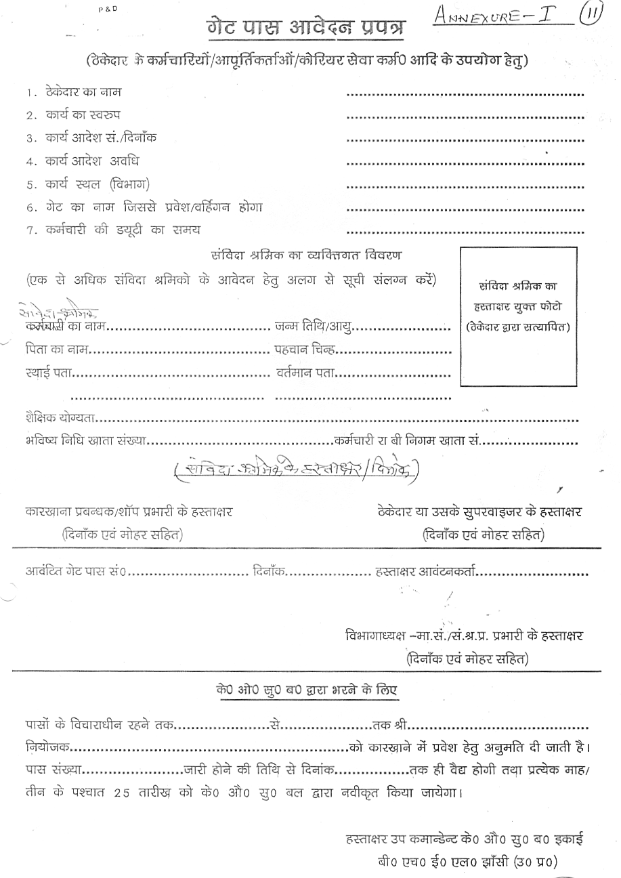
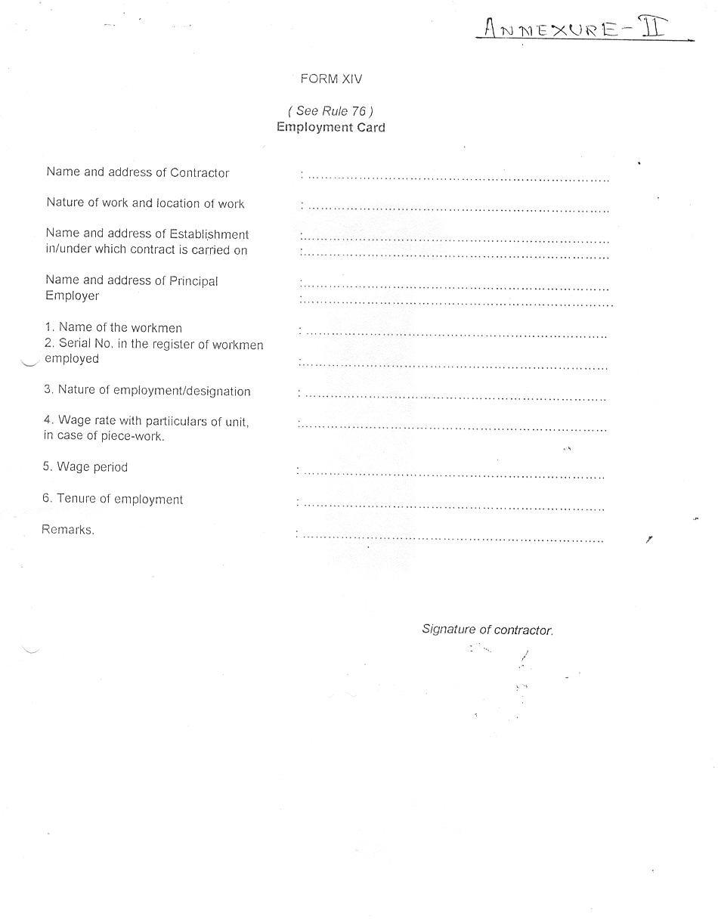

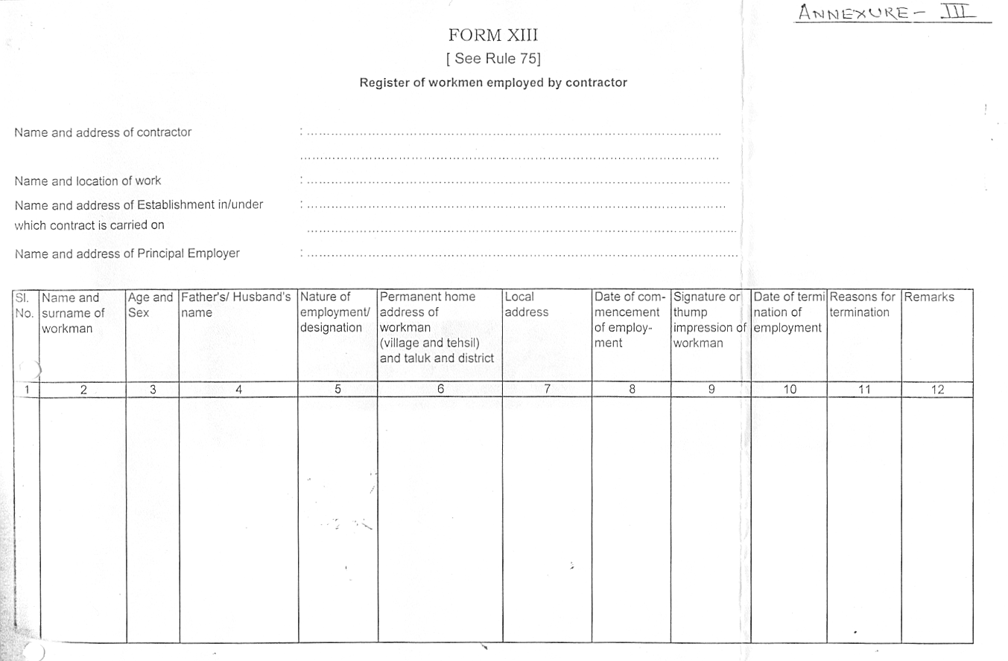

ANNEXURE-IV

STATEMENT OF THE CONTRACTOR FOR THE MONTH OF ____________20____
WORK ORDER NO-------------------------------
CONTRACTING DEPARTMENT----------------------
CONTRACTOR NAME----------------------------------

S.NO | NAME OF WORKER | CAT. | NORMAL  DAYS | OT  DAYS | GROSS  WAGES | EMPLOYEES CONTRIBUTION DEDUCTION |  | OTHER  DEDUCTION | TOTAL RECOVERY | NET PAYABLE | EMPLOYER'S CONTRIBUTION
 |  |  |  |  |  | PF 12% | ESI 1.75% | OTHER  DEDUCTION | TOTAL RECOVERY | NET PAYABLE | PF 13.61% | ESI 4.75%
 |  |  |  |  |  |  |  |  |  |  |  | \

SIGNATURE OF THE CONTRACTOR

Annexure’H’

BHEL – JHANSI

Tender Documents

MEASUREMENT OF WORK AND PAYMENTS THEREOF

      - The designated officer of the Unit will periodically inspect the Work being provided by the contractor and find out deficiencies. The contractor shall rectify the same immediately to the satisfaction of the designated officer.

2. Payment towards work satisfactorily executed will be made to the contractor on the basis of following: -
Sl.No | JOB/ACTIVITY  Inspection & Testing | UNIT OF MEASURE-MENT  (Nos./ Kgs./Mtr./ words etc.) | QUANTUM OF WORK ANNUAL
1 | Pressure Vessel SP/CA/9021/AR – 1 | No. | 01
2 | Pressure Vessel SP/CA/9021/AR – 2 | No. | 01
3 | Pressure Vessel SP/CA/9030/1/AR – 5 | No. | 01
4 | Pressure Vessel ME/1/1/2011/AR – 9 | No. | 01
5 | Pressure Vessel SP/CA/9030/AR – 16 | No. | 01
6 | Pressure Vessel SP/CA/9030/AR – 7 | No. | 01
7 | Pressure Vessel SP/CA/9030/AR – 10 | No. | 01
8 | Pressure Vessel SP/CA/9028/AR – 6 | No. | 01
9 | Pressure Vessel SP/CA/9034/AR – 19 | No. | 01
10 | Pressure Vessel ME/1/3/2240/AR – 22 | No. | 01
11 | Pressure Vessel SP/CA/9029/AR – 3 | No. | 01
12 | Pressure Vessel ME/1/3/2140/AR – 23 | No. | 01
13 | Pressure Vessel ME/1/3/2140/AR – 24 | No. | 01
14 | Pressure Vessel LE/1/8/6087/AR – 8 | No. | 01
15 | Pressure Vessel SP/CA/9030/AR – 5 | No. | 01
16 | Pressure Vessel LE/3/3/6086/AR – 12 | No. | 01
17 | Pressure Vessel LE/1/1/6090/AR–11 | No. | 01
18 | Pressure Vessel SP/CA/9033/AR – 13 | No. | 01
19 | Pressure Vessel LE/3/2/6085/AR – 14 | No. | 01
20 | Pressure Vessel LE/3/3/6085/AR - 15 | No. | 01
21 | Pressure Vessel SP/CA/9031 /AR – 17 | No. | 01
22 | Pressure Vessel SP/CA/9029/2/AR – 6 | No. | 01

        - Payments will be made to the contractor on the basis of work carried out by him on a monthly basis.

        - All payments will be subject to deduction of income tax at source as per Income Tax as per the applicable Rules.

        - Measurement Book to be maintained for the work carried out daily / weekly / monthly by the contractor & the same shall be verified by BHEL official, nominated for the same.

I/we agree with the above
Signature of contractor with Seal AGM ((WEX)

Annexure’I’

BHEL – JHANSI

Tender Documents

Ref: Your Enquiry No. WEX/TE/2/18 DATE: 22.02.2013

PROFORMA FOR SUBMITTING TECHNICAL BID FOR ------------------------------

1. Name of the firm : _________________________

      - Name of the Proprietor : _________________________

      - Address and Contact Numbers : _________________________

      - Registration Number : _________________________

Copy of the Certificate : Enclosed / Not Enclosed

      - Labour Licence Number : _________________________

Copy of the Licence : Enclosed / Not Enclosed

      - PF Code Number : _________________________

Copy of the Certificate : Enclosed / Not Enclosed

      - ESI Code Number : _________________________

Copy of the Certificate : Enclosed / Not Enclosed

      - (1) PAN/TAN Number :

(2) Income Tax return last 3 yrs. Enclosed / Not Enclosed

      - Service Tax Number(PAN Based) :________________________

      - VAT/TIN Number : Enclosed / Not Enclosed
(To be submitted only in case
where material transaction is
involved)

I/we agree with the above
Signature of contractor with Seal AGM ((WEX)

Contd…(2)
:: 2 :

      - No.of Workers including Supervisors : _____________________
on the rolls of the firm

12. Earnest Money Deposit : Rs. -----------------------------

a) D.D. Number & Date : -------------------Date-------------
b) Drawn on (Bank) : --------------------------------------

13. Any other relevant information :---------------------------------------

14. Tender Cost : Rs. --------------------
D.D.No. : -------------------------

15. Validity of offer : 90 days from the date of tender Opening.

16. Blank Price bid format : Enclosed/Not Enclosed

We will fulfill all the obligations of the contractor and abide by the Terms & Conditions mentioned in the enquiry.

Signature with Name
& Office Seal

Date:

NOTE : TECHNICAL BID AND PRICE BID SHOULD BE SUBMITTED IN SEPARATE SEALED ENVELOPS. IN CASE THE BIDS ARE FOUND IN ONE SINGAL ENVELOPE THEN THE “BIDS” ARE LIABLE TO BE REJECTED.

I/we agree with the above
Signature of contractor with Seal AGM ((WEX)

Annexure “J”

PRICE BID

TENDER NO wex/te/2/18 DATE: 22.02.2013

a. Name of the firm :
b. Name of the proprietor/partners :
c. Address and contact nos :
d. Price offer on work measurement basis :

Sl.  No | JOB/ACTIVITY  Inspection & Testing | UNIT OF MEASURE-MENT  (Nos./ Kgs./Mtr./ words etc.) | QUANTUM OF WORK ANNUAL | RATE QUOTED/UNIT | TOTAL VALUE (E=C*D)
 | A | B | C | D | E
1 | Pressure Vessel SP/CA/9021/AR – 1 | No. | 01
2 | Pressure Vessel SP/CA/9021/AR – 2 | No. | 01
3 | Pressure Vessel SP/CA/9030/1/AR – 5 | No. | 01
4 | Pressure Vessel ME/1/1/2011/AR – 9 | No. | 01
5 | Pressure Vessel SP/CA/9030/AR – 16 | No. | 01
6 | Pressure Vessel SP/CA/9030/AR – 7 | No. | 01
7 | Pressure Vessel SP/CA/9030/AR – 10 | No. | 01
8 | Pressure Vessel SP/CA/9028/AR – 6 | No. | 01
9 | Pressure Vessel SP/CA/9034/AR – 19 | No. | 01
10 | Pressure Vessel ME/1/3/2240/AR – 22 | No. | 01
11 | Pressure Vessel SP/CA/9029/AR – 3 | No. | 01
12 | Pressure Vessel ME/1/3/2140/AR – 23 | No. | 01
13 | Pressure Vessel ME/1/3/2140/AR – 24 | No. | 01
14 | Pressure Vessel LE/1/8/6087/AR – 8 | No. | 01
15 | Pressure Vessel SP/CA/9030/AR – 5 | No. | 01
16 | Pressure Vessel LE/3/3/6086/AR – 12 | No. | 01
17 | Pressure Vessel LE/1/1/6090/AR–11 | No. | 01
18 | Pressure Vessel SP/CA/9033/AR – 13 | No. | 01
19 | Pressure Vessel LE/3/2/6085/AR – 14 | No. | 01
20 | Pressure Vessel LE/3/3/6085/AR - 15 | No. | 01
21 | Pressure Vessel SP/CA/9031 /AR – 17 | No. | 01
22 | Pressure Vessel SP/CA/9029/2/AR – 6 | No. | 01
 | Sub Total
 | Service Tax @ 12.36%
 | Grand Total

NOTE / CONDITIONS FOR PRICE BID

1. TECHNICAL BID AND PRICE BID SHOULD BE SUBMITTED IN SEPARATE SEALED ENVELOPES. IN CASE THE BIDS ARE FOUND IN ONE SINGLE ENVELOPE THEN THE SAME ARE LIABLE TO BE REJECTED.

2. ALL THE BLANK SPACES IN PRICE BID FORMAT SHOULD BE FILLED BY THE CONTRACTOR.

3. IF ANY OTHER ADDITION IS MADE OR ANY CONDITION IS ADDED BY THE BIDDER IN THE PRICE BID FORMAT THEN THE OFFER SHALL BE BY-PASSED.

I/We agree with above and all other terms & conditions of the contract.

Date:-----------------

I/we agree with the above
Signature of contractor with Seal AGM ((WEX)

Annexure “K”

BLANK PRICE BID

TENDER NO wex/te/2/18 DATE: 22.02.2013
a. Name of the firm :
b. Name of the proprietor/partners :
c. Address and contact nos :
d. Price offer on work measurement basis :

Sl.  No | JOB/ACTIVITY  Inspection & Testing | UNIT OF MEASURE-MENT  (Nos./ Kgs./Mtr./ words etc.) | QUANTUM OF WORK ANNUAL | RATE QUOTED/UNIT | TOTAL VALUE (E=C*D)
 | A | B | C | D | E
1 | Pressure Vessel SP/CA/9021/AR – 1 | No. | 01
2 | Pressure Vessel SP/CA/9021/AR – 2 | No. | 01
3 | Pressure Vessel SP/CA/9030/1/AR – 5 | No. | 01
4 | Pressure Vessel ME/1/1/2011/AR – 9 | No. | 01
5 | Pressure Vessel SP/CA/9030/AR – 16 | No. | 01
6 | Pressure Vessel SP/CA/9030/AR – 7 | No. | 01
7 | Pressure Vessel SP/CA/9030/AR – 10 | No. | 01
8 | Pressure Vessel SP/CA/9028/AR – 6 | No. | 01
9 | Pressure Vessel SP/CA/9034/AR – 19 | No. | 01
10 | Pressure Vessel ME/1/3/2240/AR – 22 | No. | 01
11 | Pressure Vessel SP/CA/9029/AR – 3 | No. | 01
12 | Pressure Vessel ME/1/3/2140/AR – 23 | No. | 01
13 | Pressure Vessel ME/1/3/2140/AR – 24 | No. | 01
14 | Pressure Vessel LE/1/8/6087/AR – 8 | No. | 01
15 | Pressure Vessel SP/CA/9030/AR – 5 | No. | 01
16 | Pressure Vessel LE/3/3/6086/AR – 12 | No. | 01
17 | Pressure Vessel LE/1/1/6090/AR–11 | No. | 01
18 | Pressure Vessel SP/CA/9033/AR – 13 | No. | 01
19 | Pressure Vessel LE/3/2/6085/AR – 14 | No. | 01
20 | Pressure Vessel LE/3/3/6085/AR - 15 | No. | 01
21 | Pressure Vessel SP/CA/9031 /AR – 17 | No. | 01
22 | Pressure Vessel SP/CA/9029/2/AR – 6 | No. | 01
 | Sub Total
 | Service Tax @ 12.36%
 | Grand Total

I/we agree with the above
Signature of contractor with Seal AGM ((WEX)

