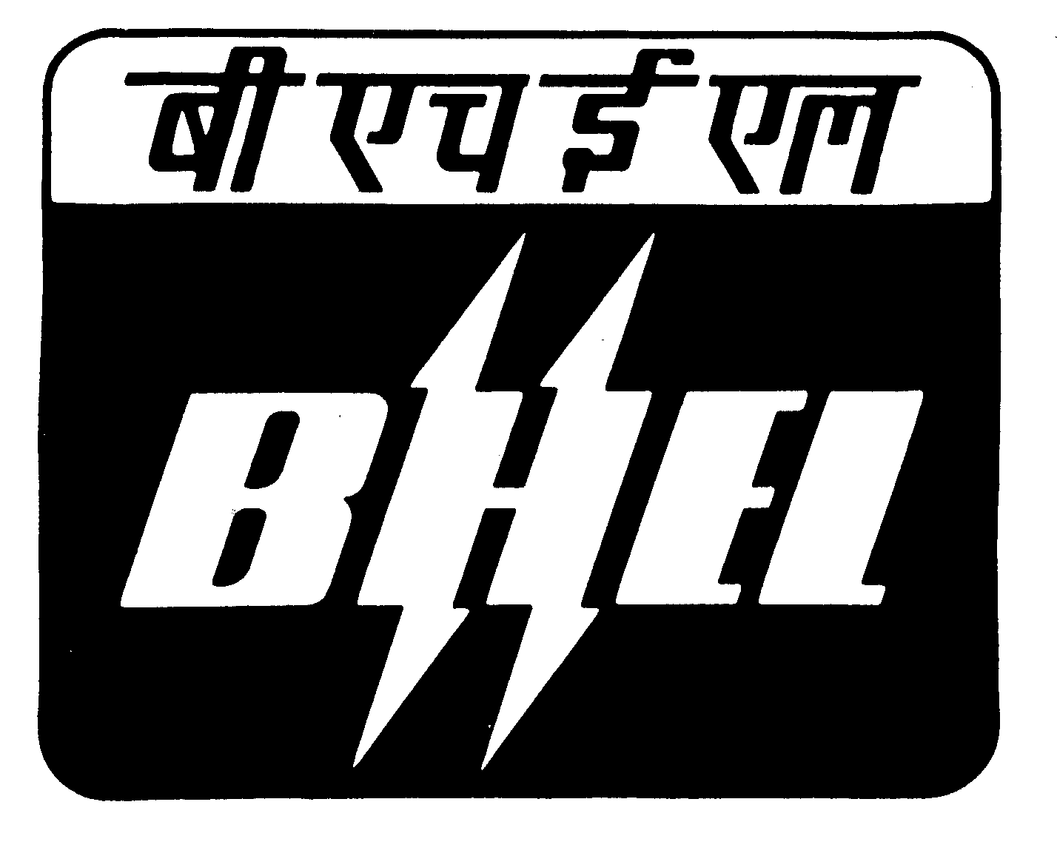BHEL, R.C.PURAM, HYDERABAD.
T & C SUB CONTRACT
TECHNO-COMMERCIAL BID FORMAT

ENQUIRY NUMBER & DATE  BHEL/HYD/OT8/ BFPDT CASING DT.28.06.11 |  |  |  |  |  | NAME OF THE VENDOR |  |  | ADDRESS:
DUE DATE FOR OPENING: 21.07.11 |  |  |  |  |  | TELEPHONE NO: |  |  | E-MAIL
TYPE OF BID: TWO PART |  |  |  |  |  |  | CONTACT PERSON |  | Your Offer no.
ITEM DETAILS : NO OF ENQUIRY ITEMS :02

S.NO | ITEM DESCRIPTION |  | DRAWING NO | QTY  (NOS) |  |  |  | SCOPE OF WORK | MACHINING REQUIREMENTS
C1 | Outer casing for 500MW BFP Drive Turbine K1401-2. | 03010100677-03-00  (3 Sheets)  03030100442-00-06  (sht 1 & 2)  23010100147-00  03010110598-02/03-02 (3 Sheets)  MATL SPEC : HY19570(GS C25)  Volumetric dimns : LxBxH : in assembled : 1965x2060x2120 mm condition :  Total weight of OC : 7686 kgs (Gross)  both UP+LP : 6990 kgs (Net) |  |  | 10 |  |  | SCOPE OF WORK CNC HORIZONTAL BORING MACHINE as per Drawings and Process  1. General Information  2. Inspection of the castings for the suitability of  machine for both upper & lower parts.  3. Marking for both upper & lower parts.  4.Rough machining of PP, resting parts face milling &  test pieces remover of LP.  5.Rough machining of PP, round bosses milling, face/  milling & test pieces removal of UP.  6. PP holes marking & tally marking for both UP & LP.  7. PP holes drilling, spot face/ back counter bore &  tapping of Upper part. PP holes drilling, spot face/  8. Back counter bore & tapping of Lower part.  9. PP holes drilling & tapping of Upper part.  10.Reference diameters machining in Lower Part.  11.PP holes mis-matching checking & Assembly of both  the parts for taper pin holes drilling.  Taper pin holes drilling & reaming.  12.Rough machining of connecting flange & rough  machining of all blade grooves & skim cut on front gland bore in combined condition in the both UP & LP.  13. Rough machining of steam entry face & A wheel  area machining in upper part only.  14. Stress relieving both Upper & Lower parts after  rough machining.  15. Parting plane finish machining of upper part.  16. Parting plane finish machining of lower part.  17. Colour matching by scraping & assembly both the  parts.  18.Taper pin holes re-reaming  19. Connecting flange machining blade grooves finish  machining without suspensions & skim cut on front  gland bore.  20. Finish m/cing of blade grooves suspensions  individually for both the parts .  21.Rough machining of front gland, BP gland, PT  flanges butting faces & finish machining of steam  entry face & A wheel area in combined condition.  NOTE:-  1) Refer the technological process sheets during m/cing  for guidence and also follow the enclosed drawings  during finish m/c'ing. 2) All standard tools and special tools which are  required for machining in vendor scope. 3) Collect the clamping fasteners i.e., parting plane  bolts, nuts, and taper pins ie.(in finished  condition ) as free issue items from BHEL-Hyd.  4) All measuring equipments and checking gauges for  threaded holes in vendor scope. 5) Upper and Lower parts Casing and castings are to  be collected from BHEL-Hyd . | Required Machinery  1.CNC/ GANTRY / Horizontal boring  WD-160 2. Vertical boring machining CNC /  Table dia 4 mts. Height :  3mts .  3.Radial Drilling VR-10  4. Portable /Universal drilling machine drilling upto dia 60 or more. 5. Heat - Treatment furnace for stress  relieving . 6. Grit blasting for surface scales  removing after stresses relieving.  Notes:  a) Machining should be done strictly  according to machining  drawings and scope of work .  b) Dimensional tolerances, geometrical  accuracies like perpendicularity,  parallality, concentricity and  cylindricity are to be maintained as mentioned in the machining drawings and  scope of work .  c) Parting Plane holes i.e. threaded holes, through holes should be perpendicular to the Parting Planes during machining as mentioned in the drgs.  d) Cap Nut / Hexagon Nut seating surfaces i.e. spot face diameters surfaces should be parallel to the parting plane during machining as  mentioned in the drawings.  e) Maintain the Parting Plane feeler gap with in 0.03mm from inside and 0.05mm from outside in free condition with out bolts tightening before taken up for finish boring in combined  condition.  f) Maintain the colour contact 80-85% area at Parting Planes before finish boring in combined condition.  g) Taper pin holes should check with taper pins after reaming for colour contact.  h) Half diameters differences should be  with in 0.05mm in both halves.  i) All the axial dimensions in specified  tolerances are to be maintained from  reference plane.  j) No flaws like blow holes, shrinkage, inclusions etc. should open up during machining. However, if any flaw opens up during machining, vendor shall immediately intimate detail and location of flaw and corrective action proposed. Further machining will be suspended till BHEL approves corrective action.  k) After finish machining, inspection report is to be submitted to BHEL for final clearance.  L) After inspection protect the machined  surfaces with rust washable preventive  paint.  m) Proper packing and clamping is to be  provided during transportation of the  Casings to BHEL-Hyd.
C2 | Outer casing for 600MW BFP Drive Turbine K1401-2. | 03010100739-S01-R00  03010100739-S02-R00  03010100739-S03-R00  03010110598-S01-R02  03010110598-S02-R02  03010110598-S03-R02  23010100147-S00-R00  23016100023-S00-R03  93030100592-S01-R00  93030100592-S02-R00  MATL SPEC : HY19570(GS C25)  Volumetric dimns : LxBxH : in assembled : 1965x2060x2120 mm condition  Total weight of OC : 7686 kgs Approx.(Gross)  both UP+LP : 6990 kgs Approx.(Net) |  |  | 30 |  |  | SCOPE OF WORK CNC HORIZONTAL BORING MACHINE as per Drawings and Process  1. General Information  2. Inspection of the castings for the suitability of  machine for both upper & lower parts.  3. Marking for both upper & lower parts.  4.Rough machining of PP, resting parts face milling &  test pieces remover of LP.  5.Rough machining of PP, round bosses milling, face/  milling & test pieces removal of UP.  6. PP holes marking & tally marking for both UP & LP.  7. PP holes drilling, spot face/ back counter bore &  tapping of Upper part. PP holes drilling, spot face/  8. Back counter bore & tapping of Lower part.  9. PP holes drilling & tapping of Upper part.  10.Reference diameters machining in Lower Part.  11.PP holes mis-matching checking & Assembly of both  the parts for taper pin holes drilling.  Taper pin holes drilling & reaming.  12.Rough machining of connecting flange & rough  machining of all blade grooves & skim cut on front gland bore in combined condition in the both UP & LP.  13. Rough machining of steam entry face & A wheel  area machining in upper part only.  14. Stress relieving both Upper & Lower parts after  rough machining.  15. Parting plane finish machining of upper part.  16. Parting plane finish machining of lower part.  17. Colour matching by scraping & assembly both the  parts.  18.Taper pin holes re-reaming  19. Connecting flange machining blade grooves finish  machining without suspensions & skim cut on front  gland bore.  20. Finish m/cing of blade grooves suspensions  individually for both the parts .  21.Rough machining of front gland, BP gland, PT  flanges butting faces & finish machining of steam  entry face & A wheel area in combined condition.  NOTE:-  1) Refer the technological process sheets during m/cing  for guidence and also follow the enclosed drawings  during finish m/c'ing. 2) All standard tools and special tools which are  required for machining in vendor scope. 3) Collect the clamping fasteners i.e., parting plane  bolts, nuts, and taper pins ie.(in finished  condition ) as free issue items from BHEL-Hyd.  4) All measuring equipments and checking gauges for  threaded holes in vendor scope. 5) Upper and Lower parts Casing and castings are to  be collected from BHEL-Hyd . | Required Machinery  1.CNC/ GANTRY / Horizontal boring  WD-160 2. Vertical boring machining CNC /  Table dia 4 mts. Height :  3mts .  3.Radial Drilling VR-10  4. Portable /Universal drilling machine drilling upto dia 60 or more. 5. Heat - Treatment furnace for stress  relieving . 6. Grit blasting for surface scales  removing after stresses relieving.  Notes:  a) Machining should be done strictly  according to machining  drawings and scope of work .  b) Dimensional tolerances, geometrical  accuracies like perpendicularity,  parallality, concentricity and  cylindricity are to be maintained as mentioned in the machining drawings and  scope of work .  c) Parting Plane holes i.e. threaded holes, through holes should be perpendicular to the Parting Planes during machining as mentioned in the drgs.  d) Cap Nut / Hexagon Nut seating surfaces i.e. spot face diameters surfaces should be parallel to the parting plane during machining as  mentioned in the drawings.  e) Maintain the Parting Plane feeler gap with in 0.03mm from inside and 0.05mm from outside in free condition with out bolts tightening before taken up for finish boring in combined  condition.  f) Maintain the colour contact 80-85% area at Parting Planes before finish boring in combined condition.  g) Taper pin holes should check with taper pins after reaming for colour contact.  h) Half diameters differences should be  with in 0.05mm in both halves.  i) All the axial dimensions in specified  tolerances are to be maintained from  reference plane.  j) No flaws like blow holes, shrinkage, inclusions etc. should open up during machining. However, if any flaw opens up during machining, vendor shall immediately intimate detail and location of flaw and corrective action proposed. Further machining will be suspended till BHEL approves corrective action.  k) After finish machining, inspection report is to be submitted to BHEL for final clearance.  L) After inspection protect the machined  surfaces with rust washable preventive  paint.  m) Proper packing and clamping is to be  provided during transportation of the  Casings to BHEL-Hyd.

- ELIGIBILITY CRITERIA - TECHNICAL REQUIREMENTS |  | VENDOR RESPONSE / COMMENTS
B1 | VENDOR SHOULD HAVE THE MACHINES as mentioned above under machining requirements.  (VENDOR SHOULD GIVE THE DETAILS OF THE MACHINE SUCH AS BRAND NAME, YEAR OF MANUFACTURE, SPECIFICATIONS, ACCURACIES & DETAILS OF MACHINE ACCESSORIES .
B2 | VENDOR SHOULD HAVE THE FOLLOWING TOOLS.  - Suspension tools and straight grooving tools
B3 | VENDOR SHOULD HAVE THE FOLLOWING MEASURING INSTRUMENTS.  - Suspension micrometers for suspension grooves checking, Outside Micrometers. Inside Micrometers.
(C) ELIGIBILITY CRITERIA - COMMERCIAL REQUIREMENTS |  | VENDOR RESPONSE / COMMENTS
C1 | VENDOR SHOULD HAVE ACHIEVED AN AVERAGE TURNOVER OF RS: 2 Crores DURING LAST 3 YEARS.
C2 | Those who are interested in doing 10 or more jobs in a year need only apply.

(D) TERMS & CONDITIONS |  |  | SUPPLIER OFFER /COMMENTS , CONFORMATIONS  FOR COMMERCIAL TERMS
D1 | Scope of work and material supply | Casing castings to be collected by vendor from BHEL.  Casing machining is to be carried out as per drawing & Technology process.  Finished casings are to be free delivery to BHEL –Hyd works.  All the Tools/ Jigs/Fixtures and Measuring Instruments are in Vendor's scope.
 |  | - VTL operation shall be carried out on a CNC VTL.
 |  | - Vendor shall submit detailed Manufacturing Process Plan (MPP) containing sequence of operations, checkpoints, facilities used, special tooling, special checking gauges and templates, etc., to BHEL for review and approval within 15 days of placement of order, before start of manufacturing.
 |  | - Vendor shall submit Vendor Quality Plan containing all the quality checkpoints, in line with MPP, to BHEL for review and approval within 15 days of placement of order, before start of manufacturing.
 |  | - Vendor shall submit detailed Dimensional Inspection Report (DIR) blank formats (in line with MPP) to BHEL for approval within 15 days of placement of order, before start of manufacturing.
 |  | - All measuring instruments, special checking gauges and templates (required for inspection) shall be in the scope of the vendor. Design and Manufacture of special checking gauges, templates, etc., shall be in the scope of the vendor. Drawings for Special Gauges (like Suspension Micrometers, etc.) shall be submitted to BHEL for approval, before start of manufacturing.
 |  | - Vendor shall submit latest calibration report for the CNC VTL (to be used for casing machining) indicating Positional Accuracies, Repeatabilities, etc., performed within last two years. Positional accuracy for Z-axis of the CNC VTL shall be better than 30 microns. (Note: Z-axis of the CNC VTL will be used for measurement of lengths on the machine.).
 |  | - Maximum spindle Runout of the CNC VTL shall be within 0.02 mm. Vendor to confirm.
 |  | - Year of Manufacture of the CNC VTL shall be 1990 or later.
 |  | 9. ISO Certification is desirable. Status of ISO certification may be indicated.
 |  | 10 After completion of all operations, Vendor shall submit detailed Dimensional Inspection Reports (DIR) in the agreed formats to the Inspection Agency for final clearance.
D2 | Distribution of quantities based on tender priorities | This tender is for machining of Outer casings  The order will be placed on technically suitable lowest vendor.(L1 vendor) for 60% of the quantity. Balance 40 % quantity will be ordered on L2 vendor, subject to acceptance of L1 rate. If the rate of L1 vendor is not accepted by the L2 vendor, other vendors will be considered in order of tender priority for ordering this 40% quantity. In case other vendors not accepting the L1 rates, total quantity may be given to L1 vendor based on BHEL requirement.
D3 | Bank guarantee towards value of BHEL material. | In the event of placement of order, vendor is required to furnish a bank guarantee amounting to Rs.5 lakhs.  The format of the bank guarantee indicating the amount, the validity period and other terms shall be sent before sending of the material. The material will be dispatched after submission of bank guarantee.
D4 | Inspection | Inspection to be done by BHEL approved inspecting agency (For indigenous vendors is by M/s. LLOYDS REGISTER OF ASIA (LRA) and for Overseas vendors by M/s.LLOYDS / BEREAU VERITAS / BNV / TUV ).  Inspection charges shall be included in the price quoted by the vendor.
D5 | Delivery Terms | The finished item should be sent to be BHEL R.C.Puram on FOR destination basis with transportation charges in vendors scope.
D6 | Offer Validity | 90 DAYS FROM THE DATE OF OPENING OF PRICE BID
D7 | Transportation | TO & FRO is in Vendor Scope
D8 | Delivery Period | Delivery should be  90 days from the date of last free issue materials by BHEL for indigenous vendors and subsequent unit at 30 days thereafter.  150 days for the date of last free issue materials by BHEL for foreign vendors and subsequent unit at 30 days thereafter.
D9 | Payment terms | 1) Dispatch of Goods on door delivery basis only. Goods dispatched with documents presented thro'Bank will not be accepted and the offer will be rejected.  2) 100% payment will be made on receipt and acceptance of materials within 90 days from the date of dispatch / Invoice.  3) Payment to SSI Units (Registered with BHEL) will be made on receipt and acceptance of materials within 45 days from the date of despatch / invoice. SSI certificate is to be enclosed along with offer.  4) Payment against proforma invoice will not be considered and the offer will be rejected.  5) In no case BHEL shall accept to pay advance / Liability towards interest.  6) Offers with deviation to the above payment terms will be LOADED at 18% .  7) For foreign vendors LC will be opened 30 days prior to despatch .
D10 | Penalty | Penalty will be applicable for delayed supplies @0.5% per week upto a maximum of 10% of total P.O. value for undelivered portion of material .  For non acceptance / deviation in acceptance of the penalty clause, the charges shall be loaded to Basic Price accordingly. ( for example, if penalty clause is not accepted, a loading of 10% will be made on the basic price. If penalty is accepted to a maximum of 5% a loading of 5% will be made on the basic price)
D11 | Defects | On receipt of Finished items at destination, if any manufacturing defects are noticed, the same shall be attended by the vendor at his own cost , without any delay.
D12 | Defects , after receipt of finished components | BHEL reserves the right to accept or reject any offer partly or fully at its discretion without assigning any reason.
D13 | Excise duty / CST/VAT | Excise Duty/CST/VAT applicable shall be cleary indicated. Further the TIN number ( in respect of VAT applicability ) also to be mentioned in your offers. BHEL will not consider any consequential taxes ( which are not mentioned) claimed by the vendors after submission of offer  Price bid shall be evaluated on total cost to BHEL basis after considering all applicable taxes and duties.

D14 | Force majure clause | Force majure clause will be applicable only in case of earthquakes, floods, riots or any act of God beyond control of the contractor. Breakdown of equipment shall not be considered as force majure
D15 | Arbitration | Arbitration : all disputes arising out of this contract shall be referred to the Executive director BHEL R.C.Puram Hyderabad 502032, or his authorized representative for arbitration and his decision shall be final and binding.
D16 | Juridiction | Jurisdiction : In case of any suit or other legal proceedings arising under or relating to the contract, the courts at Sangareddy, Medak district Andhra Pradesh only shall have the jurisdiction and this will be resorted only after exhausting the arbitration clause as above.
Note Drawings soft copies will be issued to the vendor by the Sub Contract department |  |  | Signature | Signature  Stamp  Seal

