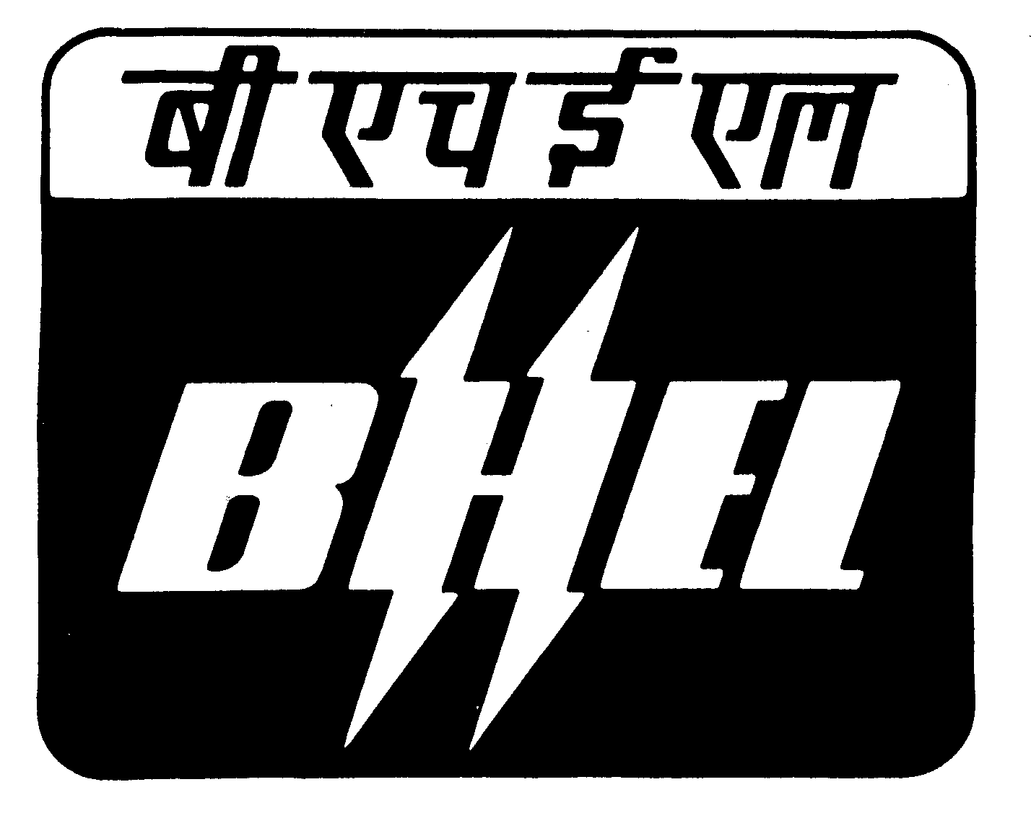BHEL, R.C.PURAM, HYDERABAD.
T & C SUB CONTRACT
TECHNO-COMMERCIAL BID FORMAT

ENQUIRY NUMBER & DATE  BHEL/HYD/OT1/MACHINING OF CASINGS DT.28.06.11 |  |  |  |  |  |  |  | NAME OF THE VENDOR |  |  |  | ADDRESS:
DUE DATE FOR OPENING: 21.07.11 |  |  |  |  |  |  |  | TELEPHONE NO: |  |  |  | E-MAIL
TYPE OF BID: TWO PART |  |  |  |  |  |  |  |  | CONTACT PERSON |  |  | Your Offer no.
ITEM DETAILS : NO OF ENQUIRY ITEMS :02

S.NO |  | ITEM DESCRIPTION |  |  |  | DRAWING NO | QTY  (NOS) |  |  |  | SCOPE OF WORK |  | MACHINING REQUIREMENTS
C1 |  | HP-IP Outer casing for 150MW Steam Turbine. |  |  |  | 01050162008 00 02  01060162955 00/01 04  330768 00031-00-00  MATL SPEC:HY19571  (GS22Mo4)  Volumetric dimns  LxBxH  in assembled Conditions 5183x4360x2970mm  Total weight of OC 47750 kgs (Gross)  both UP+LP 44750 kgs (Net) | 10 |  |  |  | SCOPE OF WORK CNC GANRTY /CNC HORIZONTAL BORING MACHINE as per Drawing and Process.  1. Parting Plane rough and finish machining, both sides  gland bore rough m/cing & chimney & gland steam  grooves rough m/cing at both sides, inner casing  paws seating pockets upper part.  2. Parting Plane holes drilling and puncturing Upper  Part.  3. Parting plane holes back counter boring Upper Part.  4. Peripheral machining i.e. pockets, flanges,  bosses, resting paws, chimney & gland  stem flanges butting pockets for the Upper Part.  5. Peripheral drilling & tapping for upper part.  6. Parting Plane rough and finish machining, both sides  gland bore rough m/cing & chimney & gland steam  grooves rough m/cing at both sides, inner casing  paws seating pockets of Lower Part.  7. Parting Plane holes drilling and threading of Lower  Part.  8. Peripheral machining i.e., Keyways, flanges, bosses,  boss for Wall Temperature Measurement Holes for  Lower Part.  9. Peripheral drilling & tapping for lower part.  10. Parting planes PP holes mismatch checking, PP gap  checking & colour matching (Scraping) &  assembly both the parts for taper pin holes drilling & reaming.  11. Assemble and clamp both the parts with alternative studs and nuts for taper pin holes drilling and reaming and also finish boring on CNC H boring machine.  12. Carry out the taper pin holes drilling and reaming.  13. Rotate the table 180 degree or re-clamp the job during finish boring of front and rear glands machining as required .  14. Front & rear gland finish m/cing, chimney & gland steam collection grooves finish m/cing & sealing fin grooves m/cing at both sides glands in combined condition.  15. Dismantling the job.  16. Clean and deburr the sharp edges for both the parts.  17. Final inspection for both the parts.  NOTE:- 1) Refer the technological process sheets during m/cing  for guidance and also follow the enclosed drawings  during finish m/c'ing. 2) All standard tools and special tools which are  required for machining in vendor scope. 3) Collect the clamping fastners i.e., parting plane bolts,  nuts and taper pins ie., (finished condition) as free  issue items from BHEL. 4) All measuring equipments and checking gauges for  threaded holes in vendor scope. 5) Casing upper and lower parts castings are to be  collected from BHEL- Hyd.  6) Hydraulic pressure test will be carried out at BHEL  works. |  | Required machinery :  1.CNC Horizontal boring WD-200 OR  CNC Gantry Drilling & Milling.  2.Radial Drilling VR-10  3. Portable /Universal drilling machine drilling upto dia 60 or more  NOTES:  a) Machining should be done strictly  according to machining drawings  and scope of work .  b) Dimensional tolerances, geometrical  accuracies like perpendicularity,  parallality, concentricity and  cylindricity and runouts are to be  maintained as mentioned in the  machining drawings and scope of  work .  c) Parting Plane holes i.e. threaded  holes, through holes should  be perpendicular to the Parting  Planes during machining as  mentioned in the drgs.  d) Cap Nut seating surfaces i.e. spot  face diameters surfaces  should be parallel to the parting  plane during machining as  mentioned in the drawings.  e) Maintain the Parting Plane feeler  gap with in 0.03mm from inside and  0.05mm from outside in free  condition with out bolts tightening  before taken up for finish boring in  combined condition.  f) Maintain the colour contact 80-85%  area at Parting Planes before  finish boring in combined  condition.  g) Taper pin holes should check with  taper pins after reaming for  colour contact.  h) Half diameters differences should be  with in 0.05mm in both halves.  i) All the axial dimensions in specified  tolerances are to be maintained  from reference plane.  j) No flaws like blow holes, shrinkage,  inclusions etc. should open  up during machining. However, if  any flaw opens up during  machining, vendor shall  immediately intimate detail and  location of flaw and corrective  action proposed. Further  machining will be suspended till  BHEL approves corrective  action.  k) After finish machining, inspection  report is to be submitted to  BHEL for final clearance.  l) Inspection of the job at supplier’s  works shall be carried out by  BHEL / agency authorized by BHEL  for which adequate prior  notice shall be given by the sub-  contractor.  m) After inspection protect the  machined surfaces with rust  washable preventive paint.  n) Free issue of raw- material of Ring  Nut S 360x9 (4 Nos ) of drg no:  33076800031-00 from BHEL .  Manufacture the Ring Nuts & suit  to Outer casing during peripheral  Machining at vendor works.  o) Proper packing and clamping is to be  provided during transportation of  casings to BHEL – Hyd.
C2 |  | Outer casing for 80 MW Steam Turbine HNK-71/2.8 - 4 |  |  |  | Machining drg nos.  03010100189-00-04  03010100188-01-02  03010100031-01-06  03010100032-00-03  03010100034-00-02  13010100004-00-03  13010100005-00-02  13010100006-00-03  13010100008-00-01  23010100023-00-02  43010100858-00-00  Casting drg nos.  03010110341-00 -04  03010110303-00-06 | 10 |  |  |  | SCOPE OF WORK CNC GANTRY /CNC HORIZONTAL BORING MACHINE as per Drawings and Process  1. Parting Plane rough and finish machining of  upper part.  2. Parting Plane holes drilling ,back counter boring  and enlarging of Upper Part.  3. Parting plane holes back counter boring Upper  Part.  4. Parting plane rough & finish m/cing and PP  racess m/cing of lower part.  5. Parting drilling & tapping of lower part.  6. Reference dimns m/cing & record for setting in  both upper & lower parts at suitable areas during  PP finish m/ing.  7. Parting planes PP holes mismatch checking, PP  gap checking & colour matching (Scraping) &  assembly both the parts for taper pin holes  drilling & reaming. |  | Required machinery :  1.CNC Horigontal boring WD-200 OR  CNC Gantry Drilling & Milling  2.Radial Drilling VR-10  3. Portable /Universal drilling machine  drilling upto dia 60 or more  NOTES:  a) Machining should be done strictly according to machining drawings and scope of work .  b) Dimensional tolerances,  geometrical accuracies like  perpendicularity, parallality,  concentricity and cylindricity and  runouts are  to be maintained as mentioned  in the machining drawings and  scope of work .  c) Parting Plane holes i.e. threaded  holes, through holes should be  perpendicular to the Parting  Planes during machining as  mentioned in the drgs.
 |  |  |  |  | MATL SPEC : HY19572  (GS17CrMo55)  Volumetric dimns  LxBxH in assembled  condition  3725x2740x2850mm  Total weight of  both UP + LP  25554 kgs (Gross)  22999 kgs (Net)  Drg NO: 33076800031 -00 -00  Matl. Spec: HY10665  Raw Matl Size: Dia 400x160 |  |  |  |  | 8. Assemble and clamp both the parts with  alternative studs and nuts for taper pin holes  drilling and reaming and also finish boring on  CNC H boring machine.  9. Carry out the taper pin holes drilling and  reaming.  10.Finish m/c the connecting flange face DRP and  through bores, counter bores both sides for to  maintain the coller widths for GBC -IV,III & II  by circular interpolation  11. Rotate the table 180 degree or re-clamp the job  i.e., front faces to the machines spindle .  12. Finish machine the front gland area.  13.Dismantle both the parts.  14. Re clamp both the parts side by side vertically  such that PP faces to be machines spindle .  15. Finish machine the BP gland, inner casing  sitting by locating / seating grooves and  GBC-I by circular interpolation.  16.Periparal m/cing i.e. seating lugs, resting paws  mainstream inlet bores, flanges faces & inner  casing area grooves of upper part.  17.Periparal drilling & tapping of upper part.  18.Periparal m/cing i.e. seating lugs, bottom  pockets, key ways, drain slots, eccentric pin holes,  resting paws ,middle guide & teirod bosses &  bottom surfaces for flanges butting faces &  main steam inlet bores m/cing of lower part  19.Periparal m/cing i.e. seating lugs, resting  paws, main steam inlet bores, flange faces &  inner casing area grooves of lower part.F9F11  20.Periparal drilling & tapping of lower part.  21. Clean and deburr the Sharper edges for both the  parts.  22.Final Inspection for both the parts. |  |  | d) Cap Nut seating surfaces i.e. spot  face diameters surfaces should  be parallel to the parting plane  during machining as mentioned  in the drawings.  e) Maintain the Parting Plane feeler  gap with in 0.03mm from inside  and 0.05mm from  outside in free condition with out  bolts tightening before  taken up for finish boring in  combined condition.  f) Maintain the colour contact 80-  85% area at  Parting Planes before finish  boring in combined condition.  g) Taper pin holes should check  with taper pins after  reaming for colour contact.  h) Half diameters differences  should be with in 0.05mm  in both halves.  i) All the axial dimensions in  specified tolerances are to be  maintained from reference plane.  j) No flaws like blow holes,  shrinkage, inclusions etc. should  open up during machining.  However, if any flaw opens up  during machining, vendor shall  immediately intimate detail and  location of flaw and corrective  action proposed. Further  machining will be suspended  till BHEL approves corrective  action.
 |  |  |  |  |  |  |  |  |  |  | NOTE:-  1) Refer the technological process sheets during  m/cing for guidance and also follow the  enclosed drawings during finish m/c'ing.  2) All standard tools and special tools which are  required for machining in vendor scope.  3) During main steam inlet bores suit the butters  threading S360x9 with matting part i.e., Ring  Nut S360x9 (Drg no: 33076800031-00) Raw  material free issue from BHEL.  4) Collect the clamping fasteners i.e., parting plane  bolts, nuts and taper pins ie.,  (in finished condition) as free issue items from  BHEL-Hyd.  5) All measuring equipments and checking gauges  for threaded holes in vendor scope.  6) Upper and lower parts of Casing & Castings are  to be collected from BHEL-Hyd. | k) After finish machining,  inspection report is to be  submitted to BHEL for final  clearance.  l) Inspection of the job at  supplier’s works shall be carried  out by BHEL / agency authorized  by BHEL for which adequate  prior notice shall be given by the  sub-contractor.  m) After inspection protect the  machined surfaces with rust  washable preventive paint.  n) Proper packing and clamping is to be  provided during transportation of the  Casings to BHEL-Hyd.
- ELIGIBILITY CRITERIA - TECHNICAL REQUIREMENTS |  |  |  |  |  |  |  |  |  |  |  | VENDOR RESPONSE / COMMENTS
B1 |  |  | VENDOR SHOULD HAVE THE MACHINES as mentioned above under machining requirements.  (VENDOR SHOULD GIVE THE DETAILS OF THE MACHINE SUCH AS BRAND NAME, YEAR OF MANUFACTURE, SPECIFICATIONS, ACCURACIES & DETAILS OF MACHINE ACCESSORIES .
B2 |  |  | VENDOR SHOULD HAVE THE FOLLOWING TOOLS.  - Suspension tools and straight grooving tools
B3 |  |  | VENDOR SHOULD HAVE THE FOLLOWING MEASURING INSTRUMENTS.  - Suspension micrometers for suspension grooves checking, Outside Micrometers.

(C) ELIGIBILITY CRITERIA - COMMERCIAL REQUIREMENTS |  |  |  | VENDOR RESPONSE / COMMENTS
C1 | VENDOR SHOULD HAVE ACHIEVED AN AVERAGE TURNOVER OF RS: 2 Crores DURING LAST 3 YEARS.
C2 | THOSE VENDORS WHO ARE INTERESTED DOING MACHINING OF 10 OR MORE CASINGS NEED APPLY.
(D) TERMS & CONDITIONS |  |  |  | SUPPLIER OFFER /COMMENTS , CONFORMATIONS  FOR COMMERCIAL TERMS
D1 |  | Scope of work and material supply | Casing castings to be collected by vendor from BHEL.  Casing machining is to be carried out as per drawing & Technology process.  All the Tools/ Jigs/Fixtures and Measuring Instruments are in Vendor's scope.
 |  |  | - Vendor shall submit detailed Manufacturing Process Plan (MPP) containing sequence of operations, checkpoints, facilities used, special tooling, special checking gauges and templates, etc., to BHEL for review and approval within 15 days of placement of order, before start of manufacturing.
 |  |  | - Vendor shall submit Vendor Quality Plan containing all the quality checkpoints, in line with MPP, to BHEL for review and approval within 15 days of placement of order, before start of manufacturing.
 |  |  | - Vendor shall submit detailed Dimensional Inspection Report (DIR) blank formats (in line with MPP) to BHEL for approval within 15 days of placement of order, before start of manufacturing.
 |  |  | 4. All measuring instruments and checking gauges shall be in the scope of the vendor
 |  |  | 5. ISO Certification is desirable. Status of ISO certification may be indicated.
 |  |  | - After completion of all operations, Vendor shall submit detailed Dimensional inspection Reports (DIR) in the agreed formats to the Inspection Agency for final clearance.
D2 |  | Distribution of quantities based on tender priorities | This tender is for machining of Outer casings  The order will be placed on technically suitable lowest vendor.(L1 vendor) for 60% of the quantity. Balance 40 % quantity will be ordered on L2 vendor, subject to acceptance of L1 rate. If the rate of L1 vendor is not accepted by the L2 vendor, other vendors will be considered in order of tender priority for ordering this 40% quantity. In case other vendors are not accepting the L1 rates, total quantity may be given to L1 vendor based on BHEL requirement.
D3 |  | Bank guarantee towards value of BHEL material. | In the event of placement of order, vendor is required to furnish a bank guarantee amounting to Rs.5 lakhs.  The format of the bank guarantee indicating the amount, the validity period and other terms shall be sent before sending of the material. The material will be dispatched after submission of bank guarantee.
D4 |  | Inspection | Inspection to be done by BHEL approved inspecting agency (For indigenous vendors is by M/s. LLOYDS and for Overseas vendors by M/s.LLOYDS / BEREAU VERITAS / BNV / TUV ).  Inspection charges shall be included in the price quoted by the vendor.
D5 |  | Delivery Terms | The finished item should be sent to be BHEL R.C.Puram on FOR destination basis with transportation charges in vendors scope.
D6 |  | Offer Validity | 90 DAYS FROM THE DATE OF OPENING OF PRICE BID . In the event of placement of Order, the order rate will be shall be valid for 12 months from the date of issue of rate contract order.
D7 |  | Transportation | TO & FRO is in Vendor Scope
D8 |  | Delivery Period | Delivery should be  90 days from the date of last free issue materials by BHEL for indigenous vendors.  150 days for the date of last free issue materials by BHEL for foreign vendors.  In the event of placement of order, if the progress of work is not satisfactory, bhel reserves the right to short close the order and with draw the material supplied as free issue. No claim towards charges for partial completion of the work will be entertained. BHEL reserves the right to go for risk purchase in such cases
D9 |  | Payment terms | 1) Dispatch of Goods on door delivery basis only. Goods dispatched with documents presented thro'Bank will not be accepted and the offer will be rejected.  2) 100% payment will be made on receipt and acceptance of materials within 90 days from the date of dispatch / Invoice.  3) Payment to SSI Units (Registered with BHEL) will be made on receipt and acceptance of materials within 45 days from the date of despatch / invoice. SSI certificate is to be enclosed along with offer.  4) Payment against proforma invoice will not be considered and the offer will be rejected.  5) In no case BHEL shall accept to pay advance / Liability towards interest.  6) Offers with deviation to the above payment terms will be LOADED at 18% .  7) For foreign vendors LC will be opened 30 days prior to despatch .
D10 |  | Penalty | Penalty will be applicable for delayed supplies @0.5% per week upto a maximum of 10% of total P.O. value for undelivered portion of material for non acceptance / deviation in acceptance of the penalty clause, the charges shall be loaded to Basic Price accordingly. ( for example, if penalty clause is not accepted, a loading of 10% will be made on the basic price. If penalty is accepted to a maximum of 5% a loading of 5% will be made on the basic price)
D11 |  | Discretion clause | BHEL reserves the right to accept or reject any offer partly or fully at its discretion without assigning any reason.
D12 |  | Defects , after receipt of finished components | On receipt of Finished items at destination, if any manufacturing defects are noticed, the same shall be attended by the vendor at his own cost , without any delay.
D13 |  | Excise duty / CST/VAT | Excise Duty/CST/VAT applicable shall be cleary indicated. Further the TIN number ( in respect of VAT applicability ) also to be mentioned in your offers. BHEL will not consider any consequential taxes ( which are not mentioned) claimed by the vendors after submission of offer  Price bid shall be evaluated on total cost to BHEL basis after considering all applicable taxes and duties.

D14 | Force majure clause | Force majure clause will be applicable only in case of earthquakes, floods, riots or any act of God beyond control of the contractor. Breakdown of equipment shall not be considered as force majure
D15 | Arbitration | Arbitration : all disputes arising out of this contract shall be referred to the Executive director BHEL R.C.Puram Hyderabad 502032, or his authorized representative for arbitration and his decision shall be final and binding.
D16 | Juridiction | Jurisdiction : In case of any suit or other legal proceedings arising under or relating to the contract, the courts at Sangareddy, Medak district Andhra Pradesh only shall have the jurisdiction and this will be resorted only after exhausting the arbitration clause as above.
Note Drawings soft copies will be issued to the vendor by the Sub Contract department |  |  | Signature | Signature  Stamp  Seal

