BHEL JHANSI

Tender Documents

inner panneling work in cabin of shunting locomotive/bcm.

BHEL JHANSI is in the process of finalizing the service Contract for inner panneling WORK IN cabin of shunting locomotive/bcm.

1. The tender document has been detailed as follows:
  - Notice Inviting Tender (Annexure A)
  - Work Specifications (Annexure B)
  - Qualifying Requirements (Annexure C)
  - Instruction to Tenderers (Annexure D)
  - Tender Evaluation Criteria (Annexure E)
  - Contractor’s obligations (Annexure F)
  - Other General Terms and Conditions for deployment of labour under Works/Job contract (Annexure G)
  - Criteria for measurement of work (Annexure H)
  - Technical Bid Application (Annexure I)
  - Price / Rate Bid (Annexure J)

- The duly filled in Technical and Price / Rate bids (Annexure) along with the instructions to the tenderers, Contractor’s Obligations, General Terms and Conditions with the signature of the tenderer affixed on all the pages and complete in all respects super scribed as “INNER PANELING WORK IN CABIN OF SHUNTING LOCOMOTIVE/BCM. ” should reach us in a sealed cover on or before 07.08.2007 through Registered / Speed post or the same may be dropped in the tender box available in the reception office (ADM Building) at the following address:

Sr. Manager (LMM)
Bharat Heavy Electricals Limited
Khailar, Jhansi-284 129

NOTE: TECHNICAL BID AND PRICE BID SHOULD BE SUBMITTED IN SEPARATE SEALED ENVELOPES. IN CASE THE BIDS ARE FOUND IN ONE SINGLE ENVELOPE THE “BIDS” ARE LIABLE TO BE REJECTED.

BHEL JHANSI Tender Documents

CONTENTS

Sl. No. | Description | ANNEXURE NO | Page No.
01. | Notice Inviting Tender | A
02. | Work Specifications | B
03. | Qualifying Requirements | C
04 | Instructions to Tenderers | D
05. | Tender Evaluation Criteria | E
06. | Contractors obligations | F
07. | Other General Terms & Conditions | G
09. | Criteria for measurement of work | H
10. | Technical Bid | I
11. | Price/Rate Bid | J

Annexure ‘A’

BHEL – JHANSI

Tender Documents

NOTICE INVITING TENDER

1. Scope of Work : INNER PANELING WORK IN CABIN
OF SHUNTING LOCOMOTIVE/BCM

2. Tender Evaluation Criteria As per Annexure –E
3. Duration of the Contract : One year from the date of the award of the contract.
4. Last date of receipt of the Tender : 1300 hours on 07.08.2007
5. Date of opening of Techno : 1400 hours on 07.08.2007
Commercial Bid
6. Address for receipt of Tender : Sr. Manager (LMM)
Bharat Heavy Electricals Limited
Khailar, Jhansi
7. Earnest Money Deposit : NIL
Payable in the form of Demand Draft /
Banker’s Cheque favoring BHEL, Jhansi
(1. in case of successful tenderer EMD shall be converted and adjusted against the security deposit
2. in case of others the EMD shall be returned within 15 days of acceptance of award of work by the successful tenderer.)
8. Cost of tender documents : Rs.200/- (Rs Two Hundred Only)

NOTE :
- TECHNO-COMMERCIAL BID AND PRICE BID SHOULD BE SUBMITTED IN SEPARATE SEALED ENVELOPES. IN CASE THE BIDS ARE FOUND IN ONE SINGLE ENVELOPE THE “BIDS” ARE LIABLE TO BE REJECTED. THESE TWO ENVELOPS SHOULD CLEARLY BE MARKED AS “ TECHNO COMMERCIAL BID” OR “ PRICE BID” ON THE TOP POSITION OF THE ENVELOPE (AS CASE MAY BE). THESE TWO ENVELOPS SHOULD BE SEALED AND BE PUT IN THE THIRD ENVELOPE WHICH SHOULD BEAR THE ENQUIRY NO. & DUE DATE ONLY.
- THE CONTRACTORS SHOULD PHYSICALLY VISIT THE WORKPLACE BEFORE QUOTING THEIR RATES.
Annexure’B’

BHEL – JHANSI Tender Documents

WORK SPECIFICATIONS

Sl.No. | Work content | AREA  (A) | Measurement criteria/units (B) | No. of units for the contract period (1 year)
1.  2.  3.  4.  5. | Prepration of proper size glass wool pads by meshing it between wire mesh.  Fixing of glass wool pads in cabins.  Fitting of inner paneling sheet with pop rivet.  Fixing of glass in fixed windows with rubber beading and its locking.  Fixing of aluminium sliding side windows. | LOCO ASSLY.  SHOP | No. of cabins | 20

Annexure’C’

BHEL – JHANSI

Tender Documents

QUALIFYING REQUIREMENTS

1. The contractor should be a specialized reputed agency for providing inner paneling work in cabin of locomotive.

- Should have at least 3 years experience in executing similar work preferably in large organizations.

- Labour contractors presently working in BHEL, Jhansi and deploying 20 or more labours should have Labour License from the licensing officer of Jhansi Region on the date of opening of techno-commercial bid.

- Should have independent ESI Code number

- Should have independent PF Code number

- Should have PAN number

- Income Tax Returns for last three years

- Should have local Sale Tax Registration No.

- Should have Service Tax number

- Solvency certificate---Should not be insolvent

Annexure’D’

BHEL – JHANSI Tender Documents

INSTRUCTIONS TO TENDERERS

1. The tender is to be processed in two parts viz. Technical bid and price/rate bid. The Technical Bid Application (Annexure - I) and its enclosures along with the Contractor’s Obligations, Other General Terms & Conditions must be submitted in one sealed envelope super scribed as “ TENDER FOR INNERPANELING WORK IN CABIN OF LOCOMOTIVE/BCM” OF BHEL JHANSI – TECHNICAL BID”. The second envelope duly sealed should contain the price bid (Annexure – J) only super scribed as “TENDER FOR INNERPANELING WORK IN CABIN OF LOCOMOTIVE/BCM” OF BHEL JHANSI – PRICE BID”. Any other enclosures, which the tenderer wishes to submit, must be enclosed with the Technical Bid only. The price bid envelope should contain the rates only. Offers not in line with the above procedure or quoted in any other format will be rejected.
- Both the technical bid and price bid sealed envelopes must be again sent in a single envelope duly sealed and super scribed “TENDER FOR INNERPANELING WORK IN CABIN OF LOCOMOTIVE/BCM” OF BHEL JHANSI”. The same should be dropped in the tender box kept in the CISF gate of Administrative Building, BHEL, Khailar, Jhansi, within the specified date and time by the representative of the tenderer. Late offers / quote through e-mail / fax / courier will not be considered. However, tenders sent by Registered / Speed post and received before the time/date of tender opening will be considered.
- All tenderers can witness the opening of the Technical Bid. After evaluation of the Technical Bid which may involve visit to the tenderer’s / clients place by authorised officials, price bids of only those tenderers who are technically/commercially found suitable will be opened on a subsequent date which will be informed to the concerned parties in advance for witnessing the Price Bid opening.
- All entries in the tender document should be in one ink. Corrections, over writing, cuttings, etc. will not be permitted. All the columns in the tender form should be filled without leaving blank in any page of the tender and all the pages must be duly signed by the tenderer.
- The price / rate should be quoted in figures as well as in words.

Annexure’E’

BHEL – JHANSI

Tender Documents

TENDER EVALUATION CRITERIA

The evaluation of the Tender will be carried out as follows:

- The tenders confirming to the Notice Inviting Tender, Qualifying requirements, Instructions to the Tenderers, Contractor’s obligations, Other General Terms and Conditions, Technical and Price bids conditions only will be evaluated.

- Such of those tenders which confirm to the technical bid (Annexure - I) only will be evaluated.

- BHEL officials may visit the tenderer’s office & their client’s place to evaluate the capability and assess the performance.

- Capability of the Contractor will be assessed on the basis of employees including supervisors on their rolls, machinery, equipments in its possession, previous track record, experience in other organizations, etc.

- Successful tenderers after the above process only will be invited for opening of the rate / price bid.

- The tenderer who quotes the lowest rate/price will be awarded the contract.

Annexure’F’

BHEL – JHANSI

Tender Documents

CONTRACTOR’S OBLIGATIONS

- CONTRACTUAL

Towards selection, control and supervision of employees

  - Contractor shall decide the number of employees to be deployed for execution of the work awarded to him and he or his authorized representative will be solely entitled to dictate such workers about the manner of carrying out the work as per the prescribed specifications and quality plan.

b) Contractor shall supervise the work allotted to him and to be carried out by his employees.

c) Contractor to ensure that the employees deployed in the premises of BHEL are physically and mentally fit and do not have any criminal record. Such employees should possess requisite skill, proficiency, qualification, experience etc.

d) Contractor to maintain appropriate records of his employees deployed to carry out the job(s).

e) Contractor should issue appropriate appointment letters to his employees.

f) Contractor will ensure that the job is executed through his employees on his rolls and under no circumstances the contractor will not deploy any casual employee to carry out the job nor shall sub-contract the job without prior written permission.

g) Contractor will keep watch on his employees and he will be liable for any pilferage / loss to BHEL due to acts of omission and commission by his employees. Similarly, liability for any compensation to outsiders on account of any act of omission and commission by the employees deployed by the contractor shall lie exclusively with him.
i) The contractor has to provide badges bearing logo of his establishment, which shall be affixed by the contract labour on the left side of his pocket.

- Contractor to ensure that all precautions are taken for safety of his employees and equipments.

- In the event of termination of contract for any reason whatsoever, the contractor shall withdraw all his employees from the establishment of BHEL. In case contractor decides to terminate services of his employees. He should settle all terminal dues.

B) Towards supply safety equipment and appliances

Contractor shall provide safety appliances and maintain the same at his own cost, which may be required under the statute or otherwise.

C) Towards statutory liability

a) As mentioned in the terms and conditions enclosed as Annexure ‘G’ of this contract.

b) Contractor shall indemnify BHEL against all claims by statutory authorities and loses under various Labour Laws, statutes or any civil or criminal law in connection with employees deployed by him.

c) In case a contractor employs women as employee he will discharge his obligation under law in respect of such women workers such prohibition of engaging them during night-hours, prohibition of employing them for more than 9 hours per day, provision of crèche facility, grant of maternity leave as per rules etc.

d) Contractor shall be responsible for making payment of wages before expiry of 10 days from the last day of wage period and to ensure disbursement of wages in the presence of the authorities representative of contract operating division who shall record under his signature at the end of entries in the Register of wages.

e) Contractor to obtain licence under CL(R&A) Act, 1970.

D) Towards Finance

Contractor to arrange his own finance for carrying out the job including payment of wages to his employees. Rates quoted shall be net and inclusive of all the capital cost, material cost, taxes and levies which might be applicable to this type of job.

Annexure’G’

BHEL – JHANSI

Tender Documents

OTHER GENERAL TERMS & CONDITIONS FOR CONTRACTORS FOR DEPLOYMENT OF LABOURS UNDER WORKS/JOB CONTRACT.
Works contracts shall only be awarded for the works on the following terms and conditions.

- LABOUR LICENCE AND OTHER REQUIREMENTS IN CASE OF CONTRACTORS WORKING IN BHEL, JHANSI:-

  - Contractor should possess valid labour licence for the maximum number of contract labours deployed on any day from the competent authority for carrying out the various activities mentioned in the contract document.

  - No. of labours in no case should exceed the quantity of labours mentioned in the work order; it should be amended and renewed immediately in case required to do so.

  - The contractor shall deploy such number labours in the premises of BHEL, Jhansi, as required for completion of the contract. The labours such deployed shall be his own labours.

  - In case the number of labour deployed by the contractor in premises of BHEL Jhansi exceeds the number of labour allowed in the license then the contractor shall immediately inform the HR and concerned department. The contractor shall also apply to the licensing officer in the region for amendment in the license within 7 days of exceeding the number of labours mentioned in the license.
  - The contractor shall also have to submit copy of PAN card and latest IT return.

  - The contract must posses Service Tax Registration No.

  - The contractor must posses Local Sales Tax Registration No.

1.A. LABOUR LICENCE AND OTHER REQUIREMENTS IN CASE OF CONTRACTORS NOT WORKING IN BHEL, JHANSI OR HAS LESS THAN 20 WORKERS ON HIS ROLLS: -

1.A.1. The contractor should have worked in large/medium-sized organization for at least three years.

1.A.2. The contractor should possess valid labour license issued by licensing authority outside jhansi region, in case he has worked outside jhansi region and has deployed 20 or more workers in any organization.

1.A.3. All conditions stipulated in para 1.5, 1.6 and 1.7 above shall be applicable.

- APPOINTMENT AND ENTRY IN FACTORY PREMISES:

  - The contractor shall deploy his own labours for carrying out the works contract awarded to him. At the time of appointment the contractor shall issue appointment letter along with terms and conditions of employment to his own labours.

  - The labours deployed in the manner as in 2.1 shall be allowed to enter the premises of the factory only if the terms and conditions of employment are acceptable to them.

  - The contractor shall submit the following to HR, contracting department and CISF
- The details of the labour proposed to be deployed in Annexure I.
- Proof of remittance of fees for character certificate at District Magistrate’s Office.
- Copy of employment card issued by contractor to his own labour.

  - After submission of documents as in para 2.3, the contractor shall issue photo identity card to the labour and submit to HR department. This identity card shall be forwarded by HR department to the CISF, which shall then authorize the labour to enter the factory premises initially for a period of one month.

  - The photo identity card shall have to be revalidated every month on 25th. In absence of such revalidation, duly forwarded by HR department, CISF shall not allow any labour to enter the premises of BHEL Jhansi.

  - The contractor, besides the photo identity card shall also issue employment card to his own labours, at his own cost within a period of three days from beginning of employment in the format prescribed under Rule 76 of UP Contract Labour Rules. A copy of this format is annexed as Annexure II, to these terms and conditions. A copy of this format shall have to be submitted by the contractor to the contracting department, HR department and CISF, as mentioned in para 2.3.

  - The contractor shall maintain a register of persons employed by him in the format prescribed under Rule 75 of UP Contract Labour Rules, 1975. A copy of this format is annexed as Annexure III.

- BILLS PAYMENT, ATTENDANCE AND PAYMENT OF WAGES

  - The contractor shall compile attendance everyday in respect of the labours deployed by him under the works / job contract.

  - The contractor shall maintain an attendance card in respect of every labour deployed by him.

  - The contractor shall generate a daily statement in the prescribed format, as in Annexure IV, annexed to these terms and conditions of deployment. This statement shall be prepared by the contractor in three copies. One copy shall be forwarded to the department and another copy shall be forwarded to HR department. The third copy shall be retained by the contractor.

  - The contractor shall submit bills to the contracting department on 2nd of each month.

  - The contractors bills should be accompanied with
  - Statement of wages of labours deployed him under the works contract, PF/ESI no., statutory deductions etc., in the format as in Annexure V annexed to these terms and conditions.
  - PF and ESI challans for previous month - separate for concerned works contract
  - Wage payment sheet for the previous month
  - Copy of Form-5 and Form-10 (PF monthly returns) submitted by contractor to RPFC for billing month.
  - Copy of Form 12A-regarding PF remittance
  - List of CL covered under accident insurance policy
  - Statement of material supplied by the contractor
  - Copy of Labour License
  - Challan of service tax payment (separate in respect of each works contract).

  - The executing department shall pass the bills of the contractor, on 3rd of each month, after checking the documents as in Para 3.5, above and forward them to HR department along with its statement as in Annexure VI, annexed to these terms and conditions. In case any discrepancy/non-compliance is detected then the contractor has to clarify the query within two days of intimation such discrepancy. In such cases bills shall be passed by the contracting department, within two days of receiving such clarification.

  - HR department shall check the labour laws compliances with respect to the entire works contract running in the factory and forward the bills, alongwith requisite documents, to Finance department. In case any discrepancy/non-compliance is detected then the contractor/department shall clarify the query within two days of intimation such discrepancy. In such cases bills shall be forwarded to Finance department within two days of receiving such clarification.

  - Finance department shall, on satisfactory compliances, and after deductions on account of stamp duty charges and security amount, shall make payment on 8th of each month in the following manner
- 1st cheque Favoring SBI, BHEL, jhansi-RPFC a/c of contractor
- 2nd cheque Favoring SBI, Jhansi-ESIC a/c of contractor (a&b shall be prepared on the basis of Annexure V and VI prepared by the contractor and contracting department respectively)
- 3rd cheque Favoring the contractor

  - The contractor shall issue pay slips to his labours, deployed for undertaking activities under the works contract, on 7th/8th of each month.

  - The contractor shall make payment to his own labours/contract workers on 10th of each month. The payment of wages to the labours shall not be subject to payment against the bills.

  - The contractor shall remit the cheques favoring RPFC and ESI Kanpur with the appropriate banks with such period as stipulated under relevant provisions. Last date for remittance of PF is 15th and that in case of ESI is 21st of each month.

  - BHEL shall pay/reimburse the damages/penalty, if any, in case the PF and ESI cheques are released after due dates prescribed under the provisions of the relevant scheme. However, the delay should not have been a result of lack of satisfactory clarification/ incomplete information or any other reason assignable to the contractor.

  - The contractor shall make payment of wages to his labours on due date in presence of an authorized representative of contracting department. The authorized representative shall retain a copy of wage payment sheet with him.

  - In cases where the payment to the contractor is due only after completion of work and the payment is not made monthly then the contractor shall have to produce documents as enumerated in para 3.5 above, in respect of all labours deployed by him against the contract, for each month, separately, along with final bill(s). Para 3.8 shall not be applicable in such cases. The contractor shall be paid through cheque in his/firm’s favour.

- Provident Fund

  - The Contractor should allot PF account number and get the nomination form, duly filled in, from each labour deployed by him at the time of joining.

  - In case the labour already has PF/pension account number, allotted to him, previously, then the contractor shall get the transfer form filled up at the time of joining and send to the office of concerned Regional Provident Fund Commissioner.

  - After termination of contract the contractor shall provide due assistance to the labour for withdrawal of PF/pension amount, when due.

  - The Contractor shall liaison with the PF officials to get the annual PF slips and distribute amongst his own labours.

  - PF CONTRIBUTION:
Employee’s Contribution Employer’s Contribution
12% of Normal waged paid PF Contribution 3.67%

Insp./Admn charges 1.10%

Pension Fund 8.33%
Admn/InspCharges 0.01%
EDLI charges 0.5%

  - The Contractor shall submit annual returns in Form-6A and Form 3A, prescribed under statutory EPF scheme, 1952, in respect of each labour deployed by him with a copy to HR and finance department.

5.0 Employees State Insurance

  - The Contractor should allot ESI account number and get the nomination form, duly filled in, from each labour deployed by him at the time of joining.

  - At the time of joining the contractor shall get the self/family registration form filled by the labour and submit to the local ESI office.

  - The contractor shall collect the identity card issued after submission of registration form, from ESI office and handover the card to the concerned labour.

  - ESI CONTRIBUTION :-
Employee’s Contribution Employer Contribution
1.75% of gross wages 4.75% of gross wages

5.5 The Contractor shall submit annual returns in Form-6 prescribed under ESI Act, deployed by him with a copy to HR and finance department

- Bonus

The contractor shall be liable to pay statutory bonus under Payment of Bonus Act, 1965.

- Discipline

  - The Contractor shall be responsible for the discipline of his own labours deployed under the works contract. In case of any loss to the BHEL Jhansi on account of indiscipline of contract labour then such loss shall be assessed and
recovered from the running bills of the contractor or from the security deposit.

  - The contractor shall not employ any person who has not completed his 18 years of age.

  - The contractor shall not employ any person who has attained 55 years of age.

  - The contractor, on advise of authorized BHEL official, shall immediately remove any person employed by him, who may in the opinion of such authorized BHEL official is involved in misconduct. Such person shall not be employed by the contractor without prior permission.

8.0 LEAVE WITH WAGES TO CONTRACT LABOUR: -

Guidelines as per UP factories Rules 1950 should be strictly observed with regard to crediting / availment of leave. Register as prescribed under the said rules should be maintained by the contractor.

- INDEMINITY BOND/COMPLIANCE OF LEGAL PROVISION

  - The contractor shall at all times indemnify the company/corporation against all claims, damages or compensation under the provision of Factories Act, 1948. Contract Labour (R&A) Act-1970, payment of wages Act-1936 Minimum Wages Act- 1948, Payment of Bonus Act-1965, Employees Provident Fund and Misc, Act-1952, Employees State Insurance Act-1948, Employer’s Liability Act-1938, Workman’s Compensation Act-1923, Industrial Dispute Act – 1947, Maternity Benefit Act- 1961, Inter State Migrant Workmen Act-1979, Payment of Gratuity Act-1992 or any modification thereof or any other law relating thereto and rules made there under from time to time or as consequence of any accident of injury to any workman or other persons in or about the work whether in the employment of contract or not save the except whether such accident or injury has resulted from any Act of the Company/ Corporation, its agents, or servants, and also against all costs/ charges and expenses of any suit, action or proceeding paid to compromise or settle any such claims.

- GENERAL TERMS AND CONDITIONS: -

  - In case of non-satisfactory performance of the contract, BHEL shall have a right of forfeiting the security deposit. In case of any dispute, decision of concerned Head of the Department will be final.

  - The work shall be supervised by the contractor or through the authorized representatives on day-to-day basis.

  - The Contractor shall compensate BHEL for any loss or damage to the plant/property, material of BHEL due to his workmen/representatives’ negligence or otherwise during execution of work.

  - In the event of contractor abandoning the work or BHEL revoking the contract BHEL shall have a right to get incomplete work completed at contractor’s risk and cost. BHEL shall have a right to terminate the contract at any time without assigning any reason thereof.

  - The Contractor shall get the character antecedent of his own labour verified from District Magistrate’s office and intimate the same to the management.

  - The contractor shall deposit security deposit, in the manner as prescribed under Clause 8.2 of Works Policy of BHEL (Annexure-VII). This security deposit shall be liable to be returned to contractor after termination of contract and fulfillment of contract and statutory obligations.

  - Security deposit will be released on submission of following certificates from departments mentioned as under: -

a. Completion of work and certification of payment of minimum wages to contractors labours from contracting department.

b. Certificate of compliance of labour laws from HR department.

d. No-dues certificate regarding service tax payment, TDS or any other dues liable to be remitted by contractor under financial laws, by Finance department

10.8 The contractor shall provide required safety equipments to the labours engaged by him.

  - Notwithstanding anything contained in this Agreement, the contract may be terminated by BHEL without assigning any reason thereof by giving a notice of 15 days to the contractor.

  - Stamp duty as per Indian Stamp Act, 1899, list 1.b Para 40 and 40.b shall be deducted from the running bills of the contractor.

10.11 All disputes arising in connection with the contract shall be settled by mutual consultation. If no agreement is reached the dispute shall be settled in accordance with the provisions of the Arbitration and Conciliation Act, 1996 and the rules made there under. The dispute shall be referred for arbitration to any arbitrator to be appointed by Head of the Unit. The award of the arbitrator shall be final and binding on both the Parties. The venue of the Arbitration shall be Jhansi. The Award to be given by the Arbitration shall be a speaking award. All questions, disputes, differences arising under, out of or in connection with this contract shall be to the exclusive jurisdiction of Jhansi Courts.

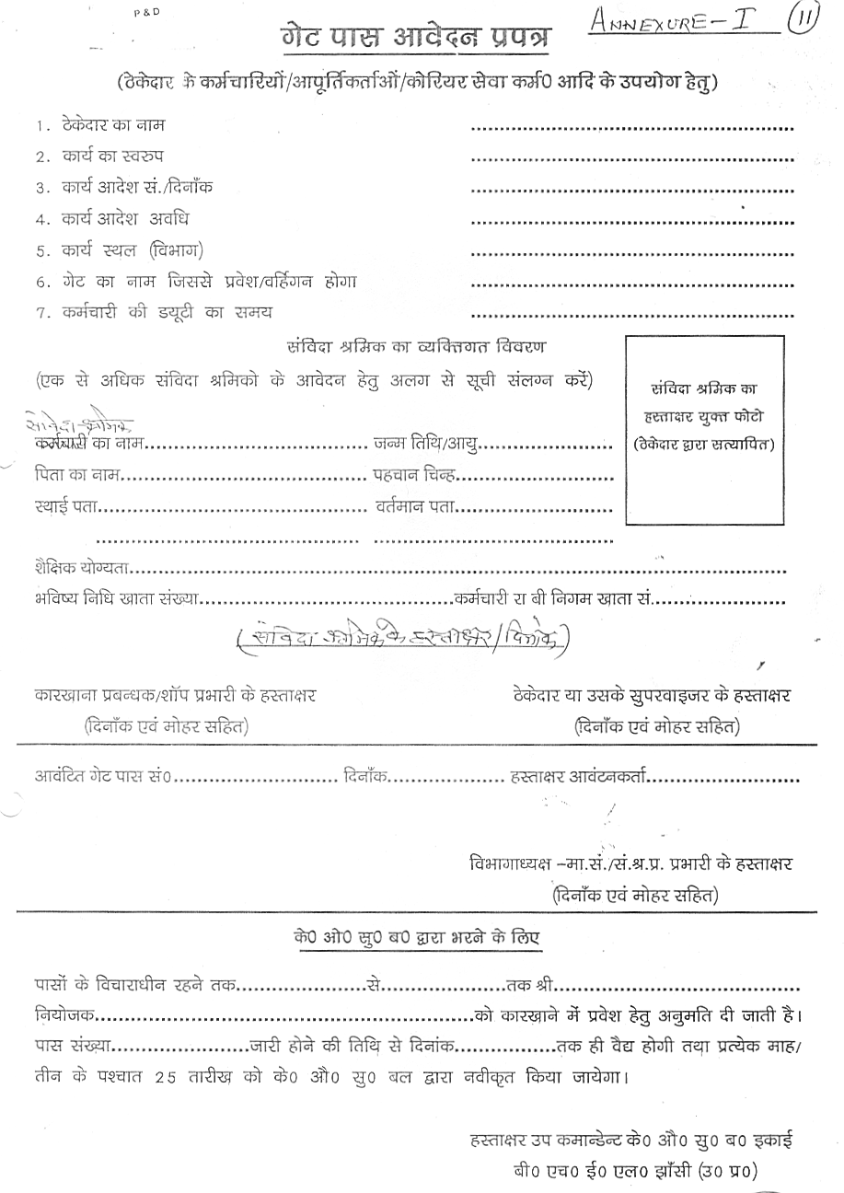

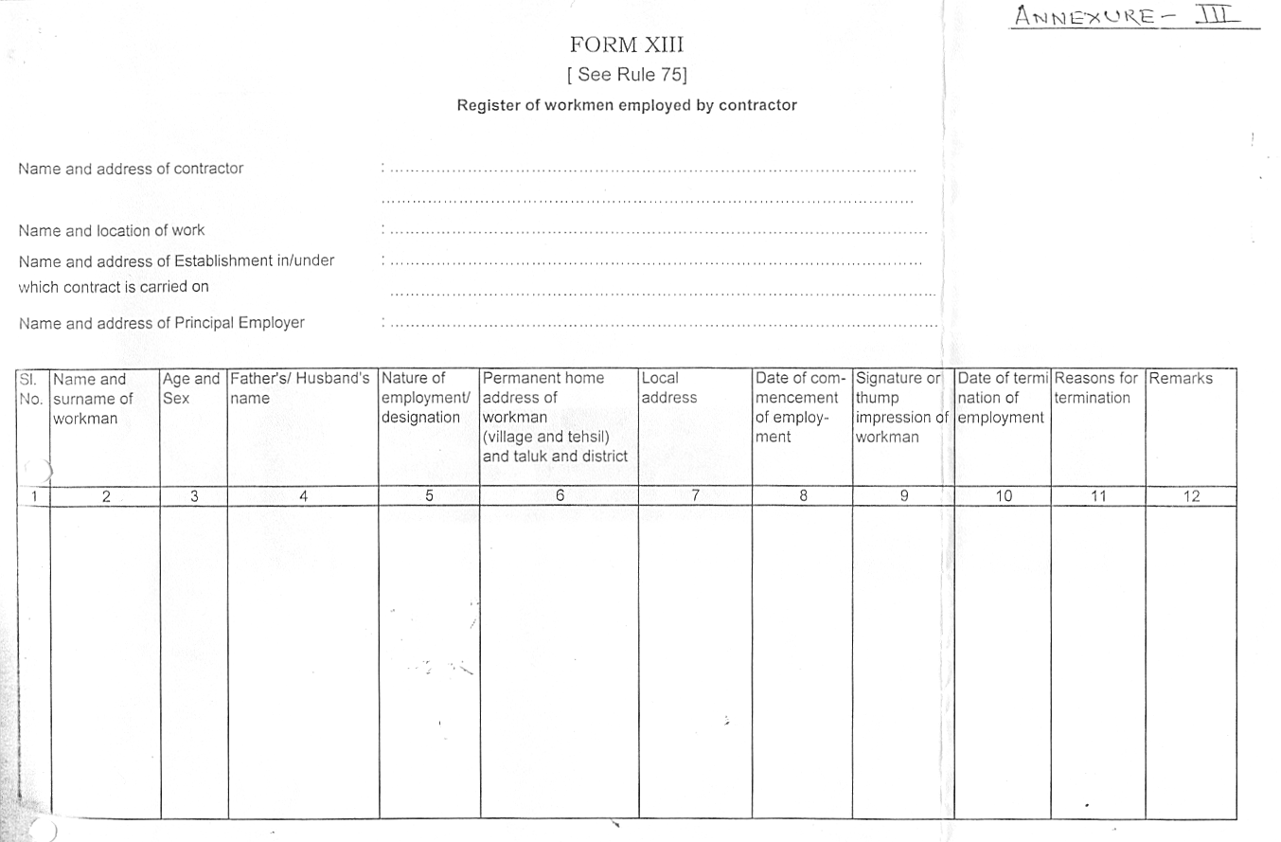

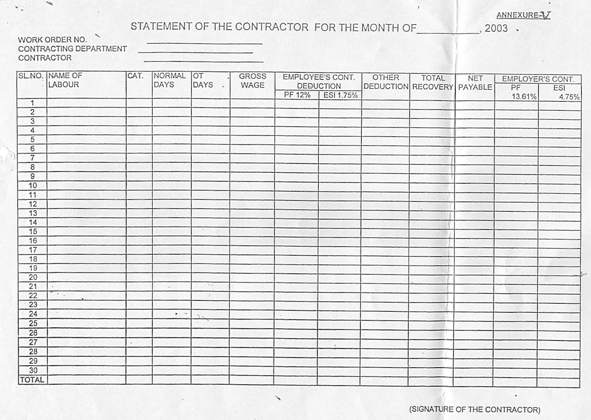
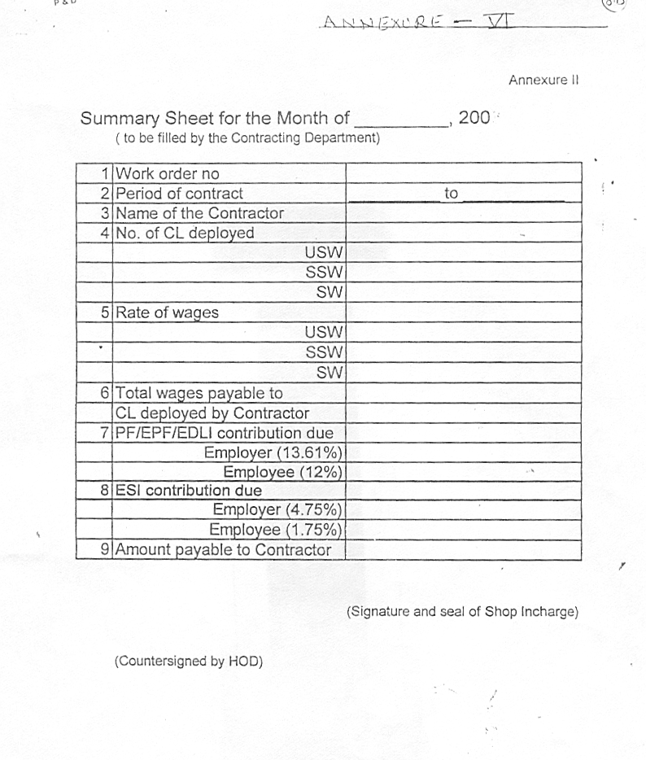
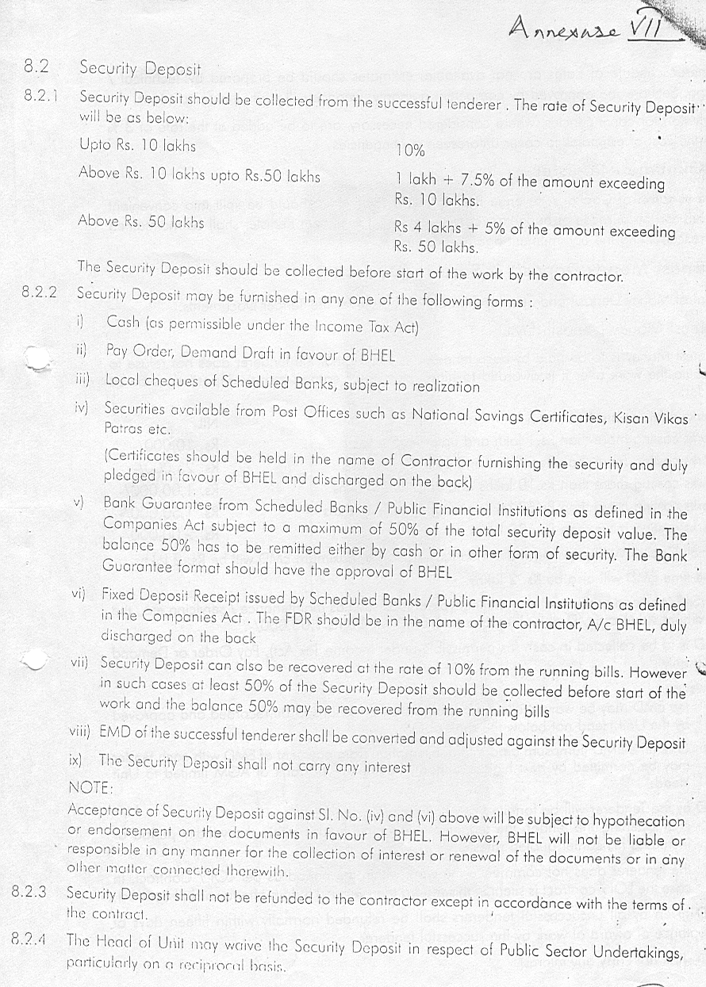

Annexure ’H’

BHEL – JHANSI Tender Documents

MEASUREMENT OF WORK AND PAYMENTS THEREOF.

1. The quality control department will periodically inspect the services being provided by the contractor and find out deficiencies. The contractor shall rectify the same immediately to the satisfaction of the Quality control dept.

2. Payment towards work satisfactorily executed will be made to the contractor on the basis of following: -

Sl.No. | Work content | AREA  (A) | Measurement criteria/units (B) | No. of units for the contract period (1 year)
1.  2.  3.  4.  5. | Preparation of proper size glass wool pads by meshing it between wire mesh.  Fixing of glass wool pads in cabins.  Fitting of inner paneling sheet with pop rivet.  Fixing of glass in fixed windows with rubber beading and its locking.  Fixing of aluminium sliding side windows. | LOCO ASSLY.  SHOP | No. of cabins | 20

3. Payments will be made to the contractor on the basis of work carried out by him on a monthly basis.

4. All payments will be subject to deduction of income tax at source as per Income Tax and Service Tax as per the applicable Rules.

5. Logbook to be maintained for the work carried out daily / weekly / monthly to be certified by the contractor’s representative and BHEL official, nominated for the same.

Annexure’I’
Technical Bid Format

BHEL – JHANSI Tender Documents

Ref: Your Enquiry No. ___________________dated____________

innerpaneling WORK IN cabin of locomotive/BCM.

1. Name of the firm :

2. Name of the Proprietor :

3. Address and Contact Numbers :

4. Registration Number :

5. Copy of the Certificate : Enclosed / Not Enclosed

6. Labour Licence Number :

7. Concerned Office from which :
Licence Issued

8. No. of labours for which licence :
issued

9. Copy of the Licence : Enclosed / Not Enclosed

10. PF Code Number :

11. Copy of the Certificate : Enclosed / Not Enclosed

12. ESI Code Number :

13. Copy of the Certificate : Enclosed / Not Enclosed

  - PAN Number :

  - Income Tax Returns for last 3 years : Enclosed / Not Enclosed

  - Service Tax Registration Number : Enclosed / Not Enclosed

  - Sales Tax Registration Number : Enclosed / Not Enclosed

18. Solvency certificate : Enclosed/ Not enclosed

19. List of Clients : Certificates Enclosed / Not Enclosed

- No. of Workers including
Supervisors on the rolls of the firm :

21. Earnest Money Deposit : Rs. 10,000/-(Rs. Ten Thousand only)

a) Demand Draft Number & Date :

b) Drawn on :

22. Any other relevant information :

23. If there is any change in minimum wages, statutory contribution / taxes / duties ( i.e PF / EPF/ DLI, ESI, Service Tax), the payment will be made to the contractor considering revised rate in the price bid. However contractor commission & other incidentals as per Sl. No. 10 of price bid ( absolute value in rupees ) will remain unchanged. Further payment will not be changed on any other account even if there is change during the contract validity period e.g changes in TDS, Stamp duty.

24. The quantum of work & no. of contract labours to be deployed indicated in the price bid is only for tendering purpose and to decide the contract in favour of the lowest bidder. The bidder who quotes the minimum percentage at Sl. No. 8 of the price bid format shall become the lowest (L-1). These quantities can very marginally both on higher & lower side based on BHEL need of production & Services. Payment to the contractor will be done considering the actual labour deployed and quantam of work done during the wage period.

We will fulfill all the obligations of the contractor and abide by the Terms & Conditions mentioned in the enquiry.

Signature with Name
& Office Seal

Date:

NOTE: TECHNICAL BID AND PRICE BID SHOULD BE SUBMITTED IN SEPARATE SEALED ENVELOPES. IN CASE THE BIDS ARE FOUND IN ONE SINGLE ENVELOPE THE “BIDS” ARE LIABLE TO BE REJECTED.

Annexure’J’
Price Bid Format

BHEL – JHANSI Tender Documents
Your Enquiry No.------------------- dated ----------------
inner paneling work in cabin of shunting locomotive/bcm.

1: Price Offer On Work Measurement Basis
S.N | Description of work | Quantum of work during the contract period of one year | Quoted Rate per Cabin | Total Cost (Rs.)
 | (A) | (B) | (C) | (D)=(B)X(C)
1.  2.  3.  4.  5. | Preparation of proper size glass wool pads by meshing it between wire mesh.  Fixing of glass wool pads in cabins.  Fitting of inner paneling sheet with pop rivet.  Fixing of glass in fixed windows with rubber beading and its locking.  Fixing of aluminum sliding side windows. | 20 | Rs. ............ | Rs. ............
 | total |  |  | Rs........
BASIS OF OFFER
2. Applicable Service Tax on the amount at Sl. No. 10 will be paid extra by BHEL at actuals.
3. Minimum wages per day per Skilled labour =Rs.140.00
4. PF/EDLI/Pension Contribution by contractor(13.61%) =Rs.19.054
5. ESI contribution by the contractor (4.75%) =Rs.6.650
6. Total amount payable to each manday =Rs.165.704
7. No. days expected for fulfillment of contract =170
8. No. of labour expected to be deployed =2
9. Total expenditure on account of labour deployment =Rs165.70X170X2
=Rs.56339/-
- Contractors Commission and any other incidental to
meet any liability arising out of tender terms &
conditions including supervision, financing cost, =_______%of sl. no.9
stamp duty deduction, TDS, Safety equipment to
labours, wages for the leave period as per UP
Factories Rules etc.
11. Value payable to the contractor = ( 100+ .....% at Sl. No. 10 )
( Service tax will be paid extra ) Rs.............................
Remarks
i) Payment of statutory bonus @8.33% (Max. Rs. 2500/- per labour per year ) + Service tax @ 12.36% will be reimbursed by BHEL as per clause no. 6.0 of General Terms & Condition at Annex.-'G'.
ii) The bidders have to fill in the rate / value only at Sl. No. 1, 10 & 11 in Blank spaces. All other entries in the price bid format are fixed and can not be changed for quoting purposes. If any fixed figure / rate is changed, the offer shall be summarily bypassed.
iii) Total value at Sl. No. 1 should exactly match with value at Sl. No. 11, if these two value are different, the offer shall be bypassed.
iv) Blank price bid after erasing filled-in entries must be submitted in the techno-commercial bid (Part I of tender).
- If any other any addition is made or any condition is added by the bidder in the price bid format , the offer shall be bypassed.
vi) Service tax shall be payable extra over and above the value of the offer price quoted above at sl. no. 9 at the rate applicable (presently 12.36%)

I/We agree with above and all other terms & conditions of this work contract tender.

Signature :
Place : Name of Firm :
Date: Seal :

Signature of BHEL tender issuing officer :

