Tender Document- 4
Page 1 of 15
GENERAL TERMS & CONDITIONS FOR CONTRACTORS FOR DEPLOYMENT OF CONTRACT LABOURS UNDER SERVICE CONTRACT.

Service contracts shall only be awarded for the works on the following terms and conditions.

- LABOUR LICENCE AND OTHER REQUIREMENTS IN CASE OF CONTRACTOR WORKING IN BHEL JHANSI AND DEPLOYING 20 OR MORE LABOURS:-

  - Contractor should possess valid labour licence for the maximum number of contract labours deployed on any day from the competent authority for carrying out the various activities mentioned in the contract document.

  - No. of labours in no case should exceed the quantity of labours mentioned in the work order, it should be amended and renewed immediately in case required to do so.

  - The contractor shall deploy such number labours in the premises of BHEL, Jhansi, as required for completion of the contract. The labours such deployed shall be his own labours.

  - In case the number of labour deployed by the contractor in premises of BHEL Jhansi exceeds the number of labour allowed in the licence then the contractor shall immediately inform the HR and concerned department. The contractor shall also apply to the licencing officer in the region for amendment in the licence within 7 days of exceeding the number of labours mentioned in the licence.

  - The contractor shall also have to submit copy of PAN card and latest IT return

  - The contractor must possesss service tax registration no under relevant code head.

  - The contractor should possess Sales Tax Registration Number.

  - Labour licence and other requirement in case of contractors NOT working in BHEL Jhansi or has less than 20 workers on his rolls.

- The contractor should have worked in large/medium sized organization for at least three years.

Page 2 of 15

- The contractor should possess valid labour licence issued by licensing authourity out side Jhansi region, in case he has worked out side Jhansi region and has deployed 20 or more workers in any organization.
- All the conditions stipulated in para 1.5,1.6 and 1.7 above shall be applicable.

- APPOINTMENT AND ENTRY IN FACTORY PREMISES :

  - The contractor shall deploy his own labours for carrying out the service contract awarded to him. At the time of appointment the contractor shall issue appointment letter alongwith terms and conditions of employment to his own labours.
  - The labours deployed in the manner as in 2.1 shall be allowed to enter the premises of the factory only if the terms and conditions of employment is acceptable to them.

  - The contractor shall submit the following to HR, contracting department and CISF
- The details of the labour proposed to be deployed in annexure I.
- Proof of remittance of fees for character certificate at District Magistrate’s Office.
- Copy of employment card issued by contractor to his own labour.

  - After submission of documents as in para 2.3, the contractor shall issue photo identity card to the labour and submit to HR department. This identity card shall be forwarded by HR department to CISF, which shall then authorize the labour to enter the factory premises initially for a period of one month.

  - The photo identity card shall have to be revalidated every month on 25th . In absence of such revalidation, duly forwarded by HR department, CISF shall not allow any labour to enter the premises of BHEL Jhansi.

  - The contractor, besides the photo identity card shall also issue employment card to his own labours, at his own cost within a period of three days from beginning of employment in the format prescribed under Rule 76 of UP Contract Labour Rules. A copy of this format is annexed as annexure II, to these terms and conditions. A copy of this format shall have to be submitted by the contractor to the contracting department, HR department and CISF, as mentioned in para 2.3.

  - The contractor shall maintain a register of persons employed by him in the format prescribed under Rule 75 of UP Contract Labour Rules, 1975. A copy of this format is annexed as annexure III.

- BILLS PAYMENT , ATTENDANCE AND PAYMENT OF WAGES

Page 3 of 15

  - The contractor shall compile attendance everyday in respect of the labours deployed by him under the works/job contract.

  - The contractor shall maintain an attendance card in respect of every labour deployed by him.

  - The contractor shall generate a daily statement in the prescribed format, as in annexure IV, annexed to these terms and conditions of deployment. This statement shall be Page 3 of 14 prepared by the contractor in three copies. One copy shall be forwarded to the department and another copy shall be forwarded to HR department. The third copy shall be retained by the contractor.

  - The contractor shall submit bills to the contracting department on 2nd of each month.

  - The contractors bills should be accompanied with
  - Copy of Measurement Book entries/Statement of work done by the Contractor
  - Statement of wages of labours deployed him under the service contract, PF/ESI no., statutory deductions etc., in the format as in Annexure V annexed to these terms and conditions.
c) PF and ESI challans for previous month- separate for concerned service contract
d) Wage payment sheet for the previous month
e) Copy of Form-5 and Form-10 (PF monthly returns) submitted by contractor to RPFC for billing month.
f) Copy of Form 12A-regarding PF remittance
g) List of CL covered under accident insurance policy
h) Statement of material supplied by the contractor
i) Copy of Labour Licence
j) Challan of service tax payment (separate in respect of each service contract contract).

  - The executing department shall pass the bills of the contractor, on 3rd of each month, after checking the documents as in para 3.5, above and forward them to HR department alongwith its statement as in Annexure VI, annexed to these terms and conditions. In case any discrepancy/non-compliance is detected then the contractor has to clarify the query within two days of intimation such discrepancy. In such cases bills shall be passed by the contracting department, within two days of receiving such clarification.

  - HR department shall check the labour laws compliances with respect to all the service contract running in the factory and forward the bills, alongwith requisite documents, to Finance department. In case any discrepancy/non-compliance is detected then the contractor/department shall clarify the query within two days of intimation such discrepancy. In such cases bills shall be forwarded to Finance department within two days of receiving such clarification.

Page 4 of 15

  - Finance department shall, on satisfactory compliances, and after deductions on account of stamp duty charges and security amount, shall make payment on 8th of each month in the following manner

- 1st cheque Favoring SBI, BHEL, jhansi-RPFC a/c of contractor

b.2nd cheque Favoring SBI, Jhansi-ESIC a/c of contractor
(a&b shall be prepared on the basis of Annexure V and VI prepared by the contractor and contracting department respectively)

c.3rd cheque Favoring the contractor

  - The contractor shall issue pay slips to his labours, deployed for undertaking activities under the works contract, on 7th/8th of each month.

  - The contractor shall make payment to the his own labours/contract workers on 10th of each month. The payment of wages to the labours shall not be subject to payment against the bills.

  - The contractor shall remit the cheques favouring RPFC and ESI Kanpur with the appropriate banks with such period as stipulated under relevant provisions. Last date for remittance of PF is 15th and that in case of ESI is 21st of each month.

  - BHEL shall pay/reimburse the damages/penalty, if any, in case the PF and ESI cheques are released after due dates prescribed under the provisions of the relevant scheme. however, the delay should not have been a result of lack of satisfactory clarification/ incomplete information or any other reason assignable to the contractor.

  - The contractor shall make payment of wages to his labours on due date in presence of an authorized representative of contracting department. The authorized representative shall retain a copy of wage payment sheet with him.

  - In cases where the payment to the contractor is due only after completion of work and the payment is not made monthly then the contractor shall have to produce documents as enumerated in para 3.5 above, in respect of all labours deployed by him against the contract, for each month, separately, alongwith final bill(s). Para 3.8 shall not be applicable in such cases. The contractor shall be paid through cheque in his/firm’s favour.

- Provident Fund

  - The Contractor should allot PF account number and get the nomination form, duly filled in, from each labour deployed by him at the time of joining.

Page 5 of 15

  - In case the labour already has PF/pension account number, allotted to him, previously, then the contractor shall get the transfer form filled up at the time of joining and send to the office of concerned Regional Provident Fund Commissioner.

  - After termination of contract the contractor shall provide due assistance to the labour for withdrawal of PF/pension amount, when due.

  - The Contractor shall liaison with the PF officials to get the annual PF slips and distribute amongst his own labours.

  - PF CONTRIBUTION :
Employee’s Contribution Employer’s Contribution
12% of Normal waged paid PF Contribution 3.67%

Insp./Admn charges 1.10%

Admn/Insp charges 0.01%
Pension Fund 8.33%
EDLI charges 0.5%

  - The Contractor shall submit annual returns in Form-6A and Form 3A, prescribed under statutory EPF scheme, 1952, in respect of each labour deployed by him with a copy to HR and finance department.

5.0 Employees State Insurance

  - The Contractor should allot ESI account number and get the nomination form, duly filled in, from each labour deployed by him at the time of joining.

  - At the time of joining the contractor shall get the self/family registration form filled by the labour and submit to the local ESI office.

  - The contractor shall collect the identity card issued after submission of registration form, from ESI office and handover the card to the concerned labour.

  - ESI CONTRIBUTION :-

Employee’s Contribution Employer Contribution
1.75% of gross wages 4.75% of gross wages

  - The Contractor shall submit annual returns in Form-6 prescribed under ESI Act, deployed by him with a copy to HR and finance department

Page 6 of 15
- Bonus

The contractor shall be liable to pay statutory bonus under Payment of Bonus Act, 1965. However, BHEL shall be liable to pay to the contractor only an amount equivalent to the minimum statutory rate existing for the period under consideration. This reimbursement shall be made by BHEL only after production of sufficient/satisfactory proof of payment of bonus.

- Discipline

  - The Contractor shall be responsible for the discipline of his own labours deployed under the service contract contract. In case of any loss to the BHEL Jhansi on account of indiscipline of contract labour then such loss shall be assessed and
recovered from the running bills of the contractor or from the security deposit.

  - The contractor shall not employ any person who has not completed his 18 years of age.

7.3 The contractor shall not employ any any person
who has attained 55 years of age.

  - The contractor, on advise of authorized BHEL official, shall immediately remove any person employed by him, who may in the opinion of such authorized BHEL official is involved in misconduct. Such person shall not be employed by the contractor without prior permission.

8.0 LEAVE WITH WAGES TO CONTRACT LABOUR :-

Guidelines as per UP factories Rules 1950 should be strictly observed with regard to crediting/availment of leave. Register as prescribed under the said rules should be maintained by the contractor.

- INDEMINITY BOND/COMPLIANCE OF LEGAL PROVISION

  - The contractor shall at all times indemnify the company/corporation against all claims, damages or compensation under the provision of Factories Act, 1948. Contract Labour (R&A) Act-1970, payment of wages Act-1936 Minimum Wages Act- 1948, Payment of Bonus Act-1965, Employees Provident Fund and Misc, Act-1952, Employees State Insurance Act-1948, Employer’s Liability Act-1938, Workman’s Compensation Act-1923, Industrial Dispute Act – 1947, Maternity Benefit Act- 1961, Inter State Migrant Workmen Act-1979, Payment of Gratuity Act-1992 or any modification therof or any other law relating thereto and rules made thereunder from time to time or as consequence of any accident of injury to any workman or other persons in or about the work whether in the employment of contract or not save the except whether such accident or injury has resulted from any Act of the Company/ Corporation, its agents, or servants, and also against all costs/ charges and expenses of any suit, action or proceeding paid to compromise or settle any such claims.

Page 7 of 15

- GENERAL TERMS AND CONDITIONS :-

  - In case of non satisfactory performance of the contract, BHEL shall have a right of forfeiting the security deposit. In case of any dispute, decision of concerned Head of the Department will be final.

  - The work shall be supervised by the contractor or through the authorized representatives on day to day basis.

  - The Contractor shall compensate BHEL for any loss
or damage to the plant/property, material of BHEL due to his workmen/representatives’ negligence or otherwise during execution of work.

  - In the event of contractor abandoning the work or BHEL revoking the contract BHEL shall have a right to get incomplete work completed at contractor’s risk and cost. BHEL shall have a right to terminate the contract at any time without assigning any reason thereof.

  - The Contractor shall get the character antecedent
of his own labour verified from District Magistrate’s office and intimate the same to the management.

10.6 The contractor shall deposit an amount of security deposit in the manner as prescribed under Clause 8.2 of Works Policy of BHEL. This security deposit shall be liable to be returned to contractor after termination of contract and fulfillment of contract and statutory obligations.

  - Security deposit will be released on submission of following certificates from departments mentioned as under:-

a. Completion of work and certification of payment of minimum wages to contractors labours from contracting department.

- Certificate of compliance of labour laws from HR department.

- No-dues certificate regarding service tax
payment, TDS or any other dues liable to be remitted by contractor under financial laws, by Finance department

  - The contractor shall provide required safety equipments to the labours engaged by him. The contractor shall also provide for uniform to his own labour. The colour of such uniform should be separate from the colour of uniform of regular employee of BHEL Jhansi. Page 8 of 15

  - Notwithstanding anything contained in this Agreement, the contract may be terminated by BHEL without assigning any reason thereof by giving a notice of 15 days to the contractor.

10.10 The contract will commence on ____________ date
and will remain valid for a period of ___ year(s) till __________ date. The parties reserve the right to extend the contract on mutually agreed terms and conditions.

  - Any matter of dispute arising out of or in connection with this contract shall be under jurisdiction of Jhansi Court only.

- Stamp duty on security deposit shall be payable 50% in cash and balance according to stamp duty act 1899 list 1 b para 40 (a) & 40 (b) as per following;

  - In case stamp duty is deposited in cash Rs 125 per thousand of security deposit amount shall be payable as per para 40 (a).
  - In case stamp duty is deposited in form of fixed deposit receipt,NSC,Kishan Vikas Patra etc Rs 70 per thousand of security deposit amount shall be payable as per para 40 (b).
  - In case stamp duty is deposited in form of third party affidavit cash Rs 100 per thousand of security deposit amount shall be payable as per para 57.
  - In case stamp duty is deposited in form of bank garentee cash Rs 5 per thousand of security deposit amount maximum upto 10000, shall be payable as per list12 (a).

Security Deposit

12.1 security deposit shall be payable by successful tenderer as per following:

Upto Rs.10 lakhs 10%

Above Rs.10 lakhs upto Rs 50 lakhs 1lakh + 7.5% of the amount
exceeding Rs.10 lakhs.

Above Rs.50 lakhs Rs. 4 lakhs + 5% of the amount
Exceeding Rs.50 lakhs

The security deposit will be collected before start of the work by the contractor.

  - Security Deposit may be furnished in any one of the following forms
    - Cash (as permissible under the Income Tax Act)
    - Pay Order, Demand Draft in favour of BHEL,Jhansi.
    - Local Cheques of scheduled banks, subject to realization.

Page 9 of 15
    - Securities available from Post Offices such as National Saving Certificates, Kisan Vikas Patras etc. (Certificates should
Page 9 of 14
be held in the name of contractor furnishing the security and duly pledged in favour of BHEL, Jhansi and discharged on the back).
    - Bank Guarantee from Scheduled Banks/Public Financial Institutions as defined in the Companies Act subject to maximum of 50% of the total security deposit value. The balance 50% has to be remitted either by cash or in the other form of security. The Bank Guarantee format should have the approval of BHEL, Jhansi.
    - Fixed Deposit Receipt issued by Scheduled Banks/ Public Financial Institutions as defined in the Companies Act. The FDR should be in the name of the contractor, A/C BHEL Jhansi, duly discharged on the back.
    - Security deposit can also be recovered at the rate of 10% from the running bills. However in such cases at least 50% of the Security Deposit will be collected before start of work and the balance 50% may be recovered from the running bills.
    - EMD of the successful tender can be converted and adjusted against the security deposit.
    - The Security Deposit shall not carry any interest.
Note: Acceptance of the Security Deposit against Sl No (iv) and (vi) above will be subject to hypothecation or endorsement on the documents in favour of BHEL, Jhansi. However BHEL, Jhansi will not be liable or responsible in any manner for the collection or interest or renewal of the documents or in any other matter connected therewith.

I/we agree with the above
Signature of contractor with Seal AGM (TRM & TRP

Page 10 of 15

xsV ikl vkosnu izi=k¼Bsdsnkj ds deZpkfj;ksa@vkiwfrZdrkZvksa@ vkfn ds mi;ksx gsrq½

- Bsdsnkj dk uke -----------------------------------------------------------------------------------------------------------
- dk;Z dk Lo#i -----------------------------------------------------------------------------------------------------------
- dk;Z vkns'k la-@fnukWad ---------------------------------------------------------------------------------------------------------
- dk;Z vkns'k vof/k -----------------------------------------------------------------------------------------------------------
- dk;Z LFky ¼foHkkx½ -----------------------------------------------------------------------------------------------------------
- xsV dk uke ftlls izos'k@ofgZxu gksxk -----------------------------------------------------------------------------------------------------------
7- deZpkjh dk M;wVh dk le; -------------------------------------------------------------------------------------------------------

lafonk Jfed dk gLrk{kj ;qDr QksVks
¼Bsdsnkj }kjk lR;kfir ½

lafonk Jfed dk O;fDrxr fooj.k
¼ ,d ls vf/kd lafonk Jfedksa ds vkosnu gasrq vyx ls lwph layXu djsa ½

deZpkjh dk uke ------------------------------------------------ tUefrfFk@vk;q %-¼izek.ki=k izfr lfgr½-----------------------------------------------------------
firk dk uke ----------------------------------------------- ------------------igpku fpUg ----------------------------------------------------------------------------------
LFkkbZ irk ----------------------------------------------------------------- --- orZeku irk ----------------------------------------------------------------------------------
----------------------------------------------------------------------- ---------------------------------------------------------------------------------
'kSf{kd ;ksX;rk ¼izek.ki=k izfr lfgr½ ---------------------------------------------------------------------------------------------------------------------------------------------
Hkfo"; fuf/k [kkrk la[;k -------------------------------------------------------------- deZpkjh jk-ch-fuxe [kkrk la- ------------------------------------------------

lafonk Jfed ds gLrk{kj
Bsdsnkj ;k mlds lqijokbtj ds gLrk{kj
¼fnukWad ,oa eksgj lfgr½

vkoafVr xsV ikl la0 --------------------------------------- fnukWad ----------------------------------------- gLrk{kj vkoaVudrkZ ---------------------------------------

dkj[kkuk izcU/kd@'kkWi izHkkjh ds gLrk{kj foHkkxk/;{k & ek-la-@la-J-iz-izHkkjh ds gLrk{kj
¼fnukWad ,oa eksgj lfgr½ ¼fnukWad ,oa eksgj lfgr½
----------------------------------------------------------------------------------------------------------------------------------------------------------------------------------------------------------------------
ds0vkS0lq0cy }kjk Hkjus ds fy,
iklksa ds fopkjk/khu jgus rd ----------------------------------------- ls ---------------------------------------------- rd Jh ---------------------------------------------------] fu;kstd ---------------------------------------------------- dks dkj[kkus esa izos'k gsrq vuqefr nh tkrh gS A ikl l[;k---------------tkjh gksus dh frfFk ls fnukWad ----------------------- rd gh oS/k gksxh rFkk izR;sd ekg @ rhu ekg ds i'pkr 25 rkjh[k dks ds0vkS0lq0cy }kjk uohd`r fd;k tk;sxk A

gLrk{kj mi dekUMsUV ds0vkS0lq0cy] >kWalh bdkbZ

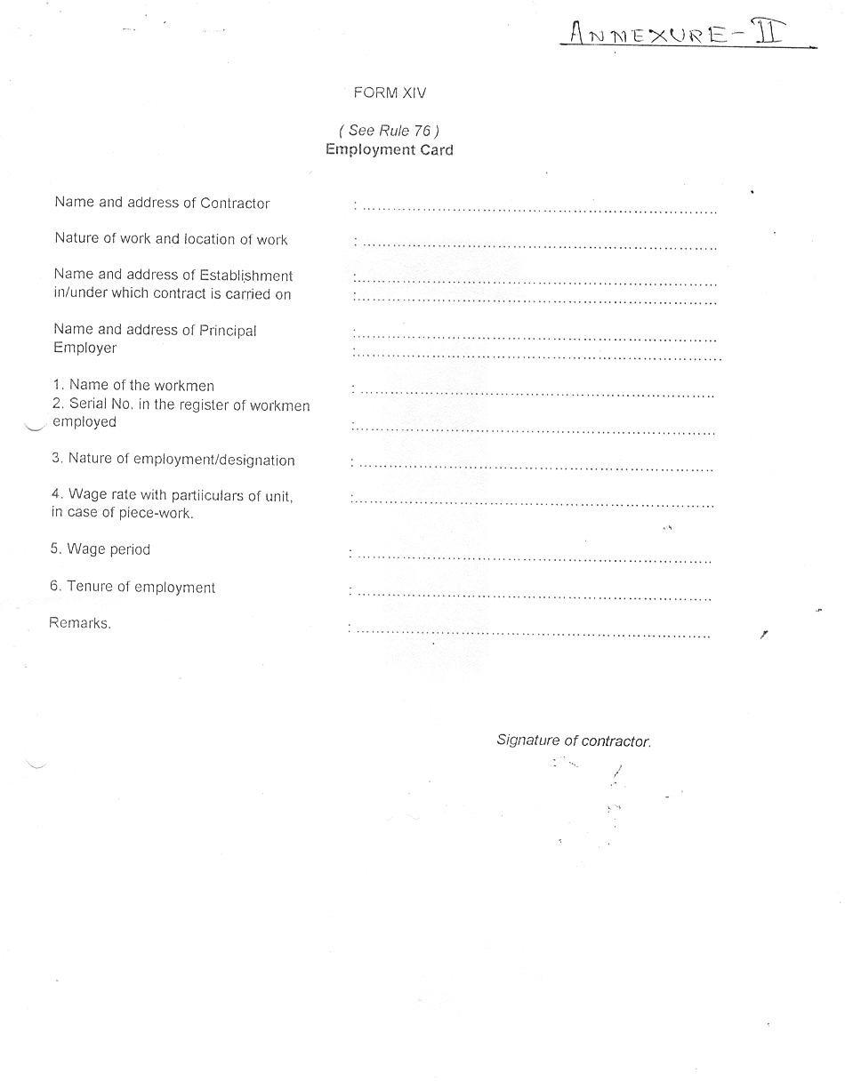

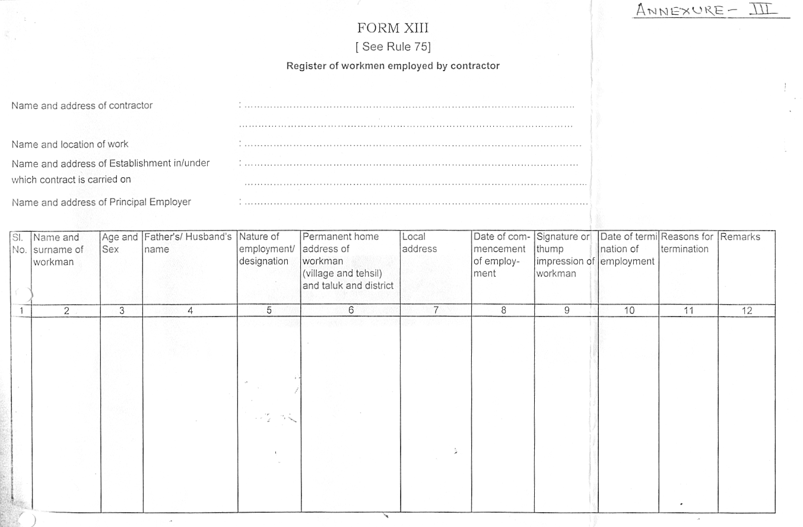

Page 13 of 15

Annexure IV

Certificate of deployment

This is to certify that on this ____day of________,200 , I have deployed the ____unskilled, _________semi-skilled and ______skilled labours in your department for works undertaken against contract no._____________________awarded to M/s____________________.

Contractor
Original to
Concerned HOD

CC
HR department
CISF


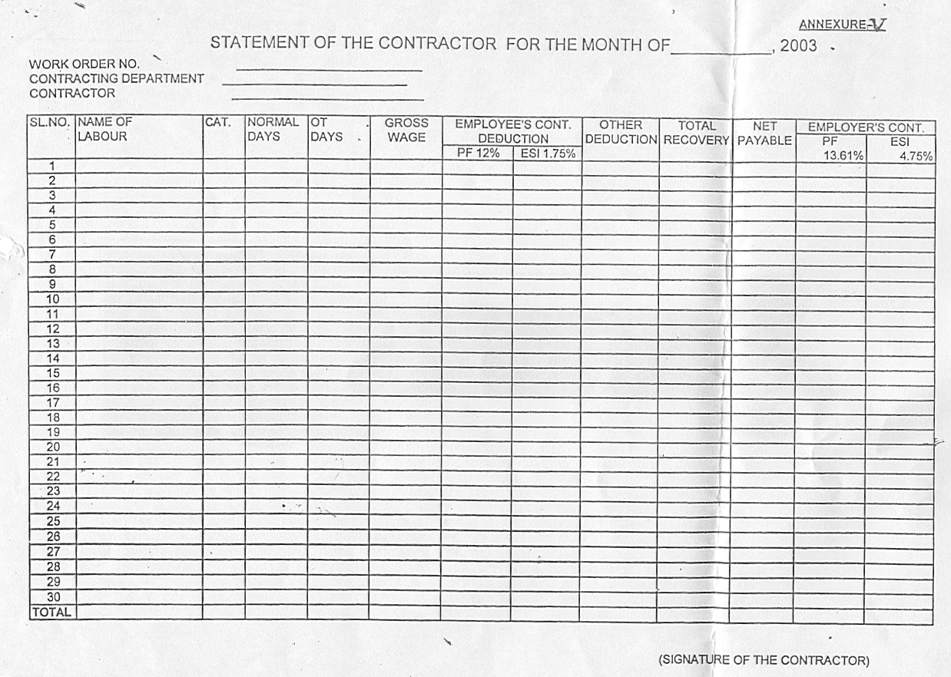

Annexure VI
Page 15 of 15
Summary Sheet for the Month of ……………….200 .
(to be tilled by the Contracting Department)

1 | Work Order no.
2 | Period of contract | From | To
3 | Name of the Contractor
4 | No. Of CL deployed during the month | Category | Number
 |  | USW
 |  | SSW
 |  | SW
5 | Total Payment to | Category | Number
 |  | USW
 |  | SSW
 |  | SW
 | Total wages payable to
6 | PF/EPF/EDLI contribution due
 | (a) Employer (13.61%)
 | (b) Employee (12%)
7 | ESI contribution due
 | (a) Employer (4.75%)
 | (b) Employee (1.75%)
8 | Amount payable to Contractor  (5+6a+7a)

(Signature and Seal of Shop Incharge)
(Countersigned by HOD)

