BHARAT HEAVY ELECTRICALS LIMITED

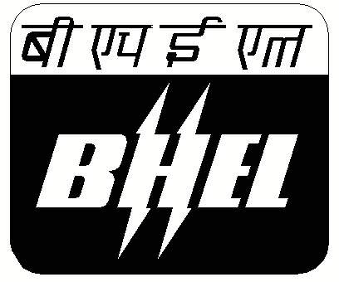
INSLUATOR PLANT , JAGADISHPUR

NOTICE INVITING TENDER

Fax No : 05361-270140,270110

TENDER ENQUIRY NO BHEL/IP/MM/PACKING/01-2007-08

Sealed tenders are invited, in two bid system , from the experienced parties for the supply of packing wood The interested parties can obtain tender document from the office of the DGM/ MM , BHEL Jagadishpur on all working days . The cost of tender document is Rs 1000 . The tender document can be obtained by submitting Demand Draft in favour of BHEL , Jagadishpur for an amount Rs 1000 payable ,at Jagadishpur. BHEL reserves the right to reject or accept any offer.

The last date for issuing of tender document : 16.05.2007
The last date & time for submission of tender 2;30 PM on 17.05.2007
The technical bid opening of the tender 3 PM on 17.05.2007

Dy General Manager / MM
Tele & Fax : 05361-270140,270110
Email : babulal@bhelepd.com

