ISO 9001:2000  &14001:2004  NAVARATNA  COMPANY | ºÉÉàÉOÉÉÒ |É¤ÉxvÉxÉ (µÉEªÉ ÉÊ´É£ÉÉMÉ)  MATERIAL MANAGEMENT(PURCHASE)  ºÉäx]ÅãÉ {ÉEÉ>óxbÅÉÒ {ÉEÉäVÉÇÂ {ãÉÉx], £ÉÉ®iÉ cè´ÉÉÒ <ãÉèÉÎBÉD]ÅBÉEãºÉ ÉÊãÉÉÊàÉ]äb  CENTRAL FOUNDRY FORGE PLANT,BHEL  ®ÉxÉÉÒ{ÉÖ®, cÉÊ®uÉ® (£ÉÉ®iÉ)  RANIPUR, HARIDWAR (INDIA) – 249403  Phone No.+91-1334-285326, FAX No. 225892  e-mail : subendu@bhelhwr.co.in

M/S
------------------------------------------------------
------------------------------------------------------
------------------------------------------------------
------------------------------------------------------
------------------------------------------------------

Sub: Tender Enquiry No: FF/PPX/1501/P/351/6/1102C/2 DT. 27/03/2007 Due on 24th April’2007.

Dear Sir,

We are pleased to invite offer as per enclosed specifications, terms and conditions and instruction to bidders, in sealed covers for the under mentioned equipment/systems.

Sl.  No. | Tender No. | Description of material | Quantity  MT | Date of  Opening
01 | FF/PPX/1501/611022  Dt. 27/03/2007 | FF5365790014  Burnt Lime as per specification no.FF05030  Rev.00  Lump size 50-80mm | 2000 | 24th April’2007

KINDLY READ INSTRUCTIONS TO BIDDERS. OFFER NOT IN ACCORDANCE WITH THE INSTRUCTIONS IS LIABLE TO BE DISQUALIFIED AND IGNORED.

PLESAE VISIT www.bhel.com or www.bhelhwr.co.in for more details and tender documents.

Thanking You,
Yours Faithfully,
For & ON BEHALF OF CFFP, BHEL, HARIDWAR

SUBHENDU KUMAR DAS
ENGINEER (PURCHASE)
CFFP, BHEL, HARIDWAR

LIST OF DOCUMENTS:

- Instruction to bidders.
- Technical specification.
- Acceptance of commercial terms by vendor: Annexure-I.
- List of consortium banks: Annexure-II.
- Proforma for bank guarantee (security deposit): Annexure-III.

INSTRUCTION TO BIDDERS

Tender No: FF/PPX/1501/611022 Dt. 27/03/2007 for Burnt Lime Lumps.
Tender opening date & time: 24/04/2007 at 2.00 P.M
Quantity: 2000 MT to be supplied in small lots as per requirement on intimation basis..
Period of contract shall be approximately one year or till completion of contract whichever is later.
-----------------------------------------------------------------------------------------------------------------------------------------------------
1.TENDER addressed to The Material Manager, CENTRAL FOUNDRY FORGE PLANT, BHEL, HARDWAR must be posted with due allowance for postal delay or deposited in the Tender Box, placed in the office of Purchase Department, Administrative Building Ground Floor, CFFP. Tender must reach this Office or deposited in the Tender Box before 2.00 PM on or before the tender opening date. TENDERS RECEIVED AFTER OPENNING TIME & DATE ARE LIABLE TO REJECTION.
2. Vendors may visit site i.e. CFFP, BHEL, HARIDWAR before submitting offer for any clarification.
3. Submit the tender in two parts i.e. Part-I Technical / Commercial Bid Part-II Price Bid
Technical / Commercial {part one} & Price Bid {part two} should be put in separate sealed envelopes. Both envelopes should be super scribed with Tender Number, Date of Opening & Technical / Commercial Bid and Price Bid respectively along with name of firm. Both the envelopes i.e. containing Technical / Commercial Bid and Price Bid should again be kept in one envelope super scribed again with Tender No. and Date of Opening and the name of firm submitting the tender.
Part-I
A} Envelopes super scribed with Technical / Commercial Bid must contain all information especially:-
(a) Specification of the material being offered as compared with the specifications mentioned in tender documents. Deviations if any should be clearly mentioned.
(b) All commercial terms i.e. packing, forwarding, ST/STT/VAT/CST, Excise duty, Bank Charges, payment terms & Insurance etc. Mention present rate of applicable taxes & duties even if inclusive in rates.
(c) Delivery terms & period required for supply from order.
(d) Confirm to submit all required commercial documents (tax invoice, cenvatable duplicate copy of invoice, packing list, transit sale agreement etc.)& technical documents (TC/GC/QP/drawings etc.)
(e) Registration Numbers of SSI, Central Excise, Sales tax, Income tax, DGS&D, ECC etc. (If SSI submit copy of certificate).
(f) Acceptance sheet Annexure 1
(g) Un priced copy of Price Bid.
Part-II Envelopes super scribed with Price Bid should contain priced copy of Price Bid. The price should be mentioned both in figures and words.
4. CFFP, BHEL, HARIDWAR reserves the right to opt for e-auction/reverse auction for obtaining best prices. It is advised that all vendors must make themselves conversant with the process and obtain requisite hardware / facilities for the same.
5. Authorized Signatory should authenticate tender documents.
6. Techno-commercial bid ( Part-I ) will be opened on the due date at 2.00 PM. in the presence of participating vendors or authorized representatives, who may wish to be present. Representative deputed to witness tender opening must produce an authority letter from the signatory of offer. After evaluation of technical bids & finalization of technical, commercial terms & condition, price bid of only successful vendors will be opened. Priced bid opening date will be intimated separately. Acceptance of offer is subject to successful vendor evaluation.
7. The goods offered must conform to the required BIS/BHEL specification of the latest revision. Manufacture’s name, trade name etc. must be mentioned. Enclose complete illustrative Technical literature/catalogue drawing etc.. Original manufacturer or processor’s details must be mentioned in the offer for assessment of suitability.
8. Validity of offers for acceptance in part or in full should be for 3 month from the date of tender opening. Price should remain fixed till the supplies are completed until unless specified otherwise.
9. Guarantee the goods offered against all defects. The supplier shall replace non conforming supply due to any defect, free of cost and at their risk.
10. Terms of payment
Payment within 30 days of receipt of material after acceptance.
No other payment terms will be acceptable.
11. Inspection shall be carried out after receipt of material in CFFP. The results obtained at CFFP shall be final and binding. BHEL may carry out inspection at vendors works too or may opt for third party pre dispatch inspection.
12. Original Test Certificate from the Manufacturers or Government or Recognized Test House shall have to be produced wherever applicable without any extra cost. This may please be clearly confirmed in the quotation without which the offer will not be considered.

13. Please quote minimum prices. Prices shall be compared on the basis of total cost to CFFP /BHEL, Hardwar. Charges, if any, such as packing, forwarding, taxes, transportation up to CFFP Stores, as applicable in addition to ex works prices should be clearly mentioned.
14. Quantities given in enquiry may not be ordered. Suppliers should be prepared, to accept order for reduced quantity without any extra charges. CFFP BHEL reserves right to procure partial / full/more quantity from any one or more than one vendor. Preference shall be given to lowest priced offer and those meeting technical and delivery requirements. Mention quantities that can be supplied on daily/weekly basis.
15. Delivery in small lots on the basis of requirement. To be supplied within 24 hours of intimation. The promised period is the essence of contract. The supply must be made with in the delivery period mentioned as per requirement. Alternative delivery period may be offered if supply during the required delivery period cannot be arranged.
Vendors will be obliged to maintain close liaison with shop planning to ensure supply and maintain minimum inventory at CFFP.
Please note that
(a) If the delivery is not completed with in the prescribed period specified in the order, supplier shall be liable to pay an unconditional penalty of 5% of the price of goods in arrears per day or part there off subject to a maximum of 10%.of total order value (Reference Acceptance sheet Annexure1)
(b) For material not supplied in time and/or not conforming to specification, the purchaser shall have the discretion to resort purchase from else where on the risk and cost of the supplier without any notice.
16 Orders placed against this enquiry will be subjected to normal clauses for imposing penalty, liquidated damages, risk purchase, cancellation and arbitration etc. as per terms of purchase order in case of delay in effecting supply or any other defaults.
17. Bharat Heavy Electricals Ltd. Ranipur (Hardwar) reserves the right to accept or reject any or all tenders without assigning any reason there of.
18. Specific confirmation to the acceptance to the above terms and condition should be given in the quotation by the tenderer.
19. Tenders not submitted in the prescribed manner are likely to be ignored/ rejected.
20. CFFP, BHEL, HARIDWAR reserves the right to amend technical or commercial terms and conditions of enquiry.
21. TENDERER MUST ENSURE THAT ALL STATUTORY & ISO REQUIREMENTS ARE COMPILED WITH.

Subhendu Kumar Das)
Engineer (Purchase)

TECHNICAL SPECIFICATION

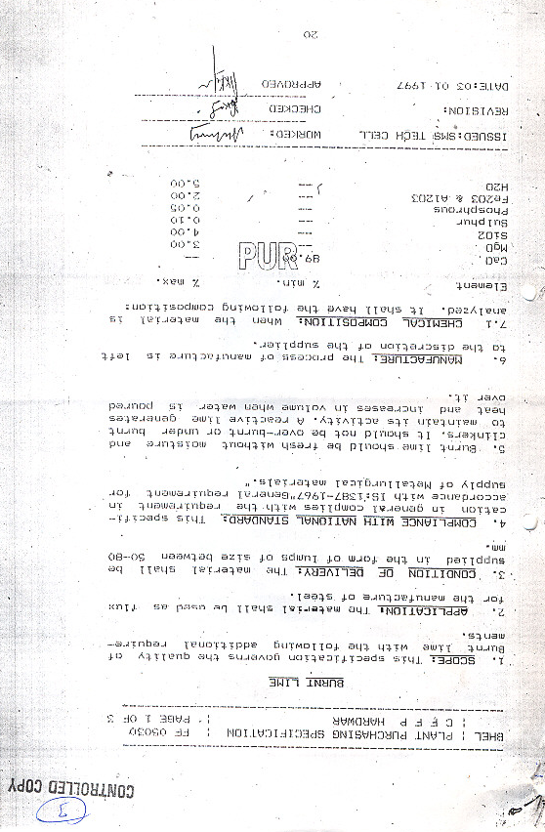

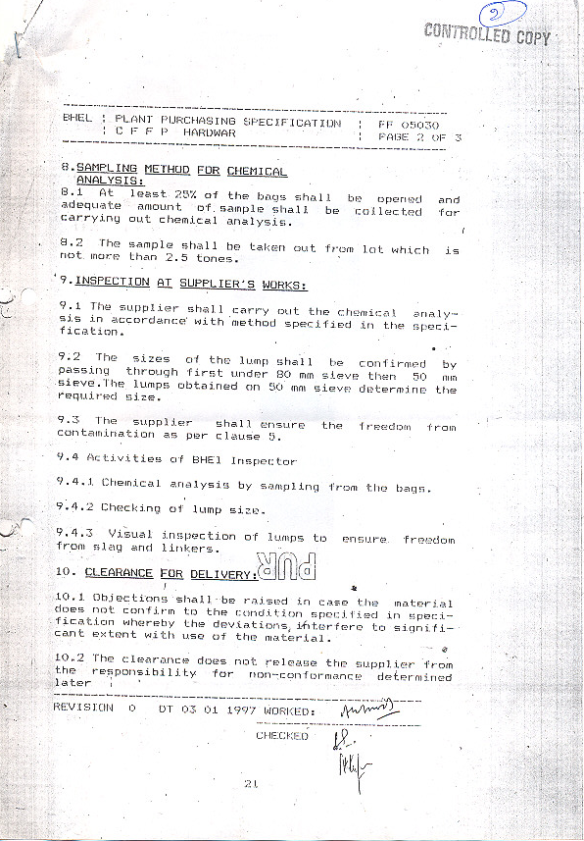

ANNEXURE I
ACCEPTANCE OF COMMERCIAL TERMS BY BIDDERS:

TENDER NO: FF/PPX/1501/611022 DT. 27/03/2007 FOR BURNT LIME LUMPS

DESCRIPITION | VENDOR’S CONFIRMATION
1) Confirm to accept payment within 30 days of receipt & after acceptance of material at CFFP/BHEL.
2) Confirm to submit security deposit equal to 5% of the total order value within one month of receipt of order in the form of Bank Guarantee in BHEL format valid till for completion of contract. 1st payment to be released after receipt of bank guarantee, alternatively BHEL will retain 5% of contract value till completion of supply.
3) Confirm to submit Cenvatable duplicate copy of excise invoice.
Mention rate of a) Excise duty.
b) CESS
c) CST/VAT
d) Any other taxes or levies.
e) Freight
f) Service tax on freight
g) Total cost considering Rs. 1000/- PMT as basic cost of
Lime (Including packing, forwarding etc.)
h) Less cenvatable amount
i) Less VAT refund (65% of VAT paid)
j) Total cost to CFFP
(This is to illustrate the calculation of total landed cost to CFFP)
MATERIAL IS TO BE SUPPLIED ON FOR DESTINATION BASIS FREIGHT PRE PAID.
4) Delivery as per requirement of Steel Melting Shop, approximately 6-7 MT per day, however this changes as per production schedule. Burnt Lime has to be supplied to maintain minimum inventory in the Shop and avoid deterioration in storage. Conform to supply as per requirement either on the same day or next day.
5) Penalty shall be applicable for delayed delivery @5% per day for required quantity subject to a maximum of 10% for total P.O. value. Repeated failure to supply in time may lead to risk purchase or cancellation of order.
6) BHEL is authorized to pre inspect the material at works. In case CFFP, BHEL wants to pre inspect the material, then it will be dispatched only after getting clearance from of CFFP. Representative of CFFP will be given free access for witnessing the manufacturing & testing process.
7) Details of Contact person
Name
Complete postal, E-mail address
Fax no, phone, Mobile no.
8) Validity of the offer should be 3 months from the date of tender opening.
9) Mention details of Bank account for e-payment.
All Bank Charges to be borne by vendor.
10) Confirm to submit Vendor Registration Form. Form can be obtained from undersigned on any working day or can be down loaded from website www.bhelhwr.co.in.

Note:
Attach separate sheet for additional information if necessary.The above terms & condition supersedes the terms & conditions found contract.

ANNEXURE II

LIST OF CONSORTIUM BANKS:

State Bank of India 10. HDFC Bank Ltd
CAG Branch, 5th Floor, HT House,
10-th Floor, Vijaya Building, K G Marg,
Barakhamba Road, New-Delhi-110001
New-Delhi-110001

- Canara Bank 11. CITI Bank N A
74, Janpath, Jeevan Vihar Building,
New-Delhi-110001 Sansad Marg,
New-Delhi-110001

3. Punjab National Bank 12. Standard Chartered Bank
74, Janpath, H2 Block, Connaught place,
New-Delhi-110001 New-Delhi-110001

4. Bank of Baroda 13. ICIC Bank Ltd.
Corporate Banking Branch, ICIC Tower,
11th Floor, BOB Building, Bisham Pitamah Marg,
Sansad Marg, Pragati Vihar,
New-Delhi-110001 New Delhi 110003

5. Deutsche Bank 14. IDBI Bank Ltd.
Tolstoy Marg, 19, K G Marg,
New-Delhi-110001 Surya Kiran Building,
New-Delhi-110001

6. State Bank of Hydrabad 15. HSBC Ltd.
Surya Kiran Building, ECE House,
K. G. Marg, 28 KG Marg,
New-Delhi-110001 New-Delhi-110001

7. State Bank of Mysore
Antriksh Bhawan,
K. G. Marg,
New-Delhi-110001

- State Bank of Mysore
Industrial Finance Branch,
Ramanashree Arcade,
MG Road,
Bangalore-560001

- State Bank of Travancore
Travancore House,
IF Branch, K G Marg,
New-Delhi-110001
ANNEXURE III

PROFORMA FOR SECURITY DEPOSIT
(TO BE STAMPED IN ACCORDANCE WITH STAMP ACT)

This deed of guarantee made this ……………………...day of ………………………...Two Thousand………………………..by (bank) hereinafter called ‘the Guarantor’) which expression shall unless repugnant to the context or meaning thereof be deemed to include its successors and assigns)IN FAVOUR OF M/s Bharat Heavy Electricals Limited (A Government of India Undertaking ) a Company incorporated under the Companies Act, 1956 having its registered office at “BHEL House” Siri Fort, New Delhi 110 049 , through its Unit/Division at Hardwar (Central Foundry Forge Plant) hereinafter called “ the Company” (which expression shall unless repugnant to the context of meaning thereof be deemed to include its successors and assigns).

WHEREAS M/s…………………………………………………….. (hereinafter referred to as the vendor) have entered into a contract bearing no……………………..……………Dated………………………………….(Hereinafter referred to as “the Contract”) for the supply of …………………………………………………With the Company.

AND WHEREAS the Contract interalia provides that the vendor shall furnish Security Money to the Company in the form a Bank Guarantee for a sum of Rs…………………….(Rs…………..only) as Security for due and faithful execution of deliveries within specified period in the contract.

AND WHEREAS THE VENDOR has approached the Guarantor and in consideration of the arrangement arrived at between the Vendor and Guarantor; the Guarantor has agreed to give the guarantee as hereinafter mentioned in favour of the Company.

NOW THIS DEED WITHNESS AS FOLLOWS:-

- The Guarantor do hereby guarantee to the Company the due and faithful performance, observance or discharge of the Contract by the Vendor and further unconditionally and irrevocable undertake to pay the Company without demur and merely on demand to the extent of ………………. Any claim made by the Company on them for any loss, damage, costs charges and expenses caused to or suffered by the company by reason of the vendor making any default in the performance, observance or discharge of the terms , conditions stipulations or undertakings or any one of them gas contained in the Contract.

- The decision of the Company whether any default has occurred or has been committed by the Vendor in the execution of the supplies, observance or discharge of any of the terms, conditions stipulations or undertakings or any one of them as contained in the Contract and or as to the extent of loss, damage, costs ,charges and expenses caused to or suffered by the Company by reason of the vendor making any default in the performance, observance or discharge of any of the terms, conditions, stipulations or undertakings or any one of them shall be conclusive and binding on the Guarantor irrespective of the fact whether the vendor admits or denies the default or questions the correctness of any demand made by the company in any Court, Tribunal or Arbitration Proceedings or before any other authority.

- The Company shall have fullest liberty without affecting in any way the liability of the Guarantor under this guarantee, from time to time to enforce or forbear from enforcing any of the terms and conditions governing the contract or securities available to the Company and the Guarantor shall not be released from its liability under these presents by any exercise by the Company of the liberty with reference to the matters aforesaid or by reason of time being given to the vendor or any other forbearance, act or commission of the part of the company or any indulgence by the company to the vendor or of any other matter or thing whatsoever which under the law relating to sureties, would but for this provision have the effect of so releasing the Guarantor from its liability under this Guarantee.

- The Guarantor further agree that the Guarantee herein contained shall remain in full force and effect during the period that would be taken to the performance of the Contract and that it shall continue to be enforceable till all the dues of the Company under or by virtue of the said Contract have been fully paid and its claims satisfied or discharged and till the Company certifies that the terms and conditions of the Contract have been fully and properly carried out by the Vendor and accordingly discharges this Guarantee, subject, however, that this Guarantee is only valid for written demands by the Company on or before…………..(specify date).

The Guarantor undertake not to revoke this Guarantee during the period it is in force except wit the previous consent of the Company in writing and agree that any liquidation or winding up or insolvency or dissolution or any change in the constitution of the Vendor or the Guarantor shall not discharge the Guarantor’s liability hereunder:

It shall not be necessary for the Company to proceed against the Vendor before proceeding against he Guarantor and the Guarantee herein contained shall be enforceable against them notwithstanding any security which the Company may have obtained or obtain from the Vendor shall at the time where proceedings are taken against he Guarantor hereunder by outstanding or unrealized.

The Guarantor hereby declares that it has power to execute this guarantee under it is Memorandum and Articles of association and the executants has full powers to do so on its behalf under the Power of Attorney dated………….granted to him by the proper authorities of the Guarantor..

IN WITNESS whereof the ………………………. (Bank) have caused this deed to be signed hereunder or their behalf on the date first above mentioned.

Signed for and on behalf of the (Bank)

Name:
Designation:
Address:

Fax No. (With country code):
E-mail address:

NOTE: IN CAE A BANK IN INDIA IS GIVING THIS BANK GUARANTEE; IT WILL BE EXECUTED ON A STAMP PAPER OF RS. 62.50 BUT IF IT WILL BE FROM AN OVERSEAS BANK, IT WILL HAVE TO BE EXECUTED AS PER LAWS OF THAT COUNTRY.

