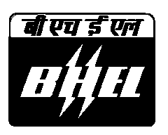  ISO 9001-2000,ISO 14001 and OHSAS 18001 certified company  SubContract and Purchase Deptt. | Bharat Heavy Electricals Limited  (A Govt. Of India Undertaking)  Power Sector – Northren Region,  Plot No. 25 , Sector - 16A , Noida  Distt.Ghaziabad, NOIDA – 201301.INDIA  Phone: 0091-0120-2515476 / 2515464 / 2515479  Fax 091-0120-2515464 / 2515476 Email: sku@bhelpsnr.co.in / msd@bhelpsnr.co.in

CORRIGENDUM-I

Tender No. BHEL:PSNR(SCT):KOSTI:CIVIL(3):375

Following amendments are hereby incorporated in specifications for the above mentioned tender:

1.0
LAST DATE OF SALE : 30.01.2007
DUE DATE : 30.01.2007
DATE OF OPENING : 30.01.2007

2.0 All other terms and conditions shall remain unchanged

This corrigendum shall form a part of the tender and is to be submitted, duly signed and stamped, along with the Technical bid (Part-I).

