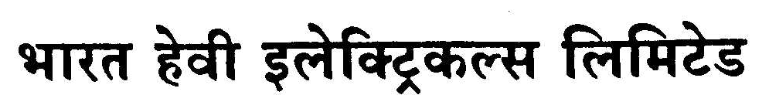SWITCHGEAR OPERATIONS

TENDER NOTIFICATION

NO.HY/SG/OPRNS/MSNP/JWC/01/2006

Date: 07-June-06

Name of the Department : SWITCHGEAR PRODN-MACHINE SHOP & NP

Sealed tenders in two sealed covers 1) Documentary evidence for technical scrutiny and 2) Commercial Bid, superscribing the tender notice number and name(s) of the work, will be received by Dy.Gen.Manager, Prodn, M & S of Switchgear Block, BHEL, R.C.PURAM, HYD-32 from the contractors satisfying the pre-qualification requirements indicated below and will be opened by the undersigned or his nominee in his office, in the presence of tenderers or their authorised agents.

1. Name of the work : Part A- Deburring, Band saw operation & Hand works
Part B- Material Handling & Cleaning

2. Nature of the work : Part A- Semi-skilled

Part B- Un-skilled

3. Issue of tender documents : Available to be downloaded from web site
‘http://bhel.com’
4. Cost of tender document : nil

5. EMD value : Rs.10,000/-

5. Last date and time of receipt of tender : 14-06-06 ------ 10-00 hrs.

6. Date and time of tender opening : 15-06-05 ------ 14-00 hrs.

8. Period of completion of contract : by 31-03-2007

Pre-qualification requirements:

- The Contractor should be a BHEL registered contractor. The details of reference number, date of registration at BHEL, class of contractor and turnover of work executed in the last 2 years should be furnished.

- Tender shall furnish the Provident Fund Code number and also enclose the copies of the letter/certificate issued by provident fund authorities. (Form 6A)

- Tender shall furnish the ESI Code number and Income Tax clearance certificate.

- Tender shall furnish clearance certificate issued by IR section of BHEL, R.C.Puram

- Tender shall furnish proof of valid labour licence.

- Tenders without EMD shall be disqualified for commercial bidding.

- Proof of IT returns and PAN No.

- BHEL reserves the right to reject any or all tenders in part or in full without assigning any reasons

For and on behalf of

Bharat Heavy Electricals Ltd., R.C.Puram, Hyderabad-32

