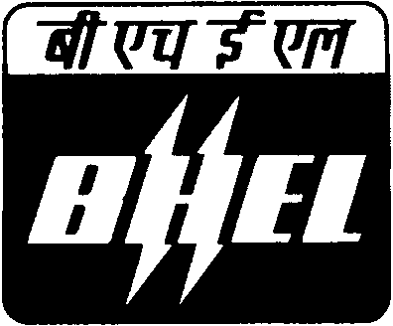 |  | BHARAT HEAVY ELECTRICALS LIMITED  INDUSTRIAL VALVES PLANT  433, INDUSTRIAL COMPLEX  GOINDWAL SAHIB  DISTT. TARN TARAN- PUNJAB |  |  |  |  | No. BHE:IVP:VR:  2011-12/I
NOTICE INVITING EXPRESSION OF INTEREST FOR WALL BLOWER SUB-ASSEMBLIES
BHARAT HEAVY ELECTRICALS LIMITED [BHEL] is manufacturing Industrial Valves and other Boiler accessories at its Industrial Valves Plant, Goindwal Sahib unit. The plant is heading towards increasing its volume as well as range of items. From current turnover of Rs. 200 Cr. we are aiming to grow exponentially by 30%-40% each year.

BHEL at its above unit has planned to add wall blower in its existing product range of industrial cast valves. Wall blower is used to clean the soot/deposit in boilers in power plants. It consists of seven sub-assemblies each assembled from various mechanical components/parts. BHEL is looking for reputed and experienced parties who are engaged in assembling similar nature of products, to undertake assembly work with parts manufactured themselves/supplied by BHEL.

Our immediate requirement of 3000 nos. of wall blower within next six months period is slated to increase substantially thereafter.

A brief description about these sub-assemblies is given below. The drawings of sub-assemblies are uploaded separately at the respective NIT No. :

S.No. | Sub-Assembly Name |  | NIT No. for drawings | Description/Introduction
1 | SBV HEAD ASSEMBLY |  | 10164 | This is a mechanical assembly and is made of approx ten components. Small mechanical parts are to be fitted/assembled in machined Carbon steel casting. Welding in also involved. For details refer material description and drawing.
2 | RACK GEAR HOUSING ASSY |  | 10164 | This is also a mechanical assembly and consists of approx thirty components. Small mechanical parts are to be fitted/assembled in machined Carbon steel casting .For details refer material description and drawing.
3 | GEAR BOX ASSY |  | 10165 | This is also a mechanical assembly and consists of approx thirty major components. Small mechanical parts are to be fitted/assembled in machined Aluminium casting using hardware. For details refer material description and drawing.
4 | SWITCH BOX ASSY |  | 10165 | This is an electrical assembly and parts are to be connected using cables & limit switches in machined Aluminium casting. For details refer material description and drawing.
5 | SWIVEL TUBE ASSY (WELDMENT) |  | 10167 | This is a mechanical assembly of shaft welded at one end of a tube. For details refer material description and drawing.
6 | CLEVIS BRACKET ASSY |  | 10167 | This is a mechanical assembly of levers fitted into a small casting. For details refer material description and drawing.
7 | CAM ASSY |  | 10167 | This is a mechanical assembly of cam made of non-ferrous [Al. bronze] material. For details refer material description and drawing.
Interested parties can visit our plant to understand the assembly procedure. Any technical support for assembling shall be extended by BHEL. For any clarification vendors may visit to our plant on any working day from Monday to Saturday between 0930 Hrs to 1630 Hrs/ contact undersigned regarding:
Items details and requirement |  |  |  |  |  | Vendor registration form/procedure
Gurbax Singh Sokhal  Manager(MM, P&D) |  |  |  |  | Manmeet Kumar  ET(MM,P&D) | Vishal Devgon  Manager(IT, SD & HSE)
Phone: 01859-224615 |  |  |  |  | 01859-224616 | 01859-224623
Mobile: 088729 77877 |  |  |  |  | 09592177349 | 092163 49001
E-mail: gss@ivp.bhel.in |  |  |  |  | manmeet@ivp.bhel.in | vishal@ivp.bhel.in
Fax: 01859-222061
BHARAT HEAVY ELECTRICALS LIMITED
INDUSTRIAL VALVES PLANT
433, INDUSTRIAL COMPLEX
GOINDWAL SAHIB, DISTT. TARN TARAN

