BHARAT HEAVY ELECTRICALS LIMITED
(A Government of India Undertaking)
P.O. BHEL Jhansi -284129

FACTORY MAIN STORE

TENDER DOCUMENT
For

HIRING OF 1 NO OPEN BODY TRUCK CAPACITY UP TO 15 MT HAVING LOADING PLATFORM LENGTH OF 22 FEET OR MORE
ALONG WITH DRIVER
(DURATION OF CONTRACT – 3 MONTH’S)

Tender Enquiry No.
CRX/TE/2/05

DETAIL OF TENDER DOCUMENT

NATURE OF WORK: Hiring of 1 no open body truck capacity upto 15 MT having loading platform length of 22 feet or more, along with driver.
- BHEL JHANSI is in the process of finalizing the Contract for:
‘ Hiring of 1 no open body truck capacity upto 15 MT having loading platform length of 25 feet or more , along with driver’
The tender document has been detailed as follows:

  - Notice Inviting Tender (Annexure A)
  - Work Specifications (Annexure B)
  - Qualifying Requirements (Annexure C)
  - Instruction to Bidders (Annexure D)
  - Tender Evaluation Criteria (Annexure E)
  - General Terms and Conditions (Annexure F)
  - Technical Bid Application (Annexure I)
  - Price Bid ( Annexure J)

- The duly filled in Technical and Price /Rate bids (Annexure I and J, separately) along with the instructions to the bidders, Contractor’s obligations, General Terms and Conditions with the signature of the bidder on all the pages and complete in all respects super scribed as “Quotation for Tender No.CRX/TE/2/05” and the should reach us in a sealed cover on or before 29.01.2013 (1315 hrs) through Registered / Speed Post or in the tender box available at following address :-

CISF Control Room/Office
Administrative Building
BHEL
Jhansi-284129

NOTE : TECHNICAL BID AND PRICE BID SHOULD BE SUBMITTED IN SEPARATE SEALED ENVELOPES, IN CASE THE BIDS FOUNDS IN ONE SINGLE ENVELOPE THEN THE “BIDS” ARE LIABLE TO BE REJECTED.

CONTENTS

SL.NO. | Description | ANNEXURE NO | Page No.
01 | Notice inviting Tender | A | 4-5
02 | Work Specifications | B | 6
03 | Qualifying Requirements | C | 7
04 | Instructions to Tenderers | D | 8
05 | Tender Evaluation Criteria | E | 9
06 | General Terms & Condition with Annexures | F | 10-12
09 | Technical Bid | I | 13
10 | Blank Price Bid Format | J | 14

NOTICE FOR INVITING TENDER
Annexure-A

1. SCOPE OF WORK: : Hiring of 1 no open body truck capacity upto 15 MT having loading platform length of 22 feet or more, along with driver

2. Tender Evaluation Criteria : As Per Annexure –E

3. Duration of the Contract : For three months from the date of the award of the contract
4. Other specific requirements : Labor law and Govt. Rules to be followed.

5 Last date of receipt of the Tender : 29/01/2013 on 13.15 hours or before

6. Date of opening of Techno : 29/01/2013 on 14.00 hours
Commercial Bid
7. Address for issue of tender : Sr. Dy. General Manager (FMS)
Documents Factory Min Store, BHEL Jhansi

8. EARNEST MOMENT DEPOSIT (EMD) : Rs 20,000/- (Twenty Thousand Only)
Payable in the form of Demand Draft/Banker’s Cheque in favour of BHEL, Jhansi and copy of receipt may be enclosed alongwith tender
OR
One time EMD of Rs.2 Lacs can also be deposited in above form and copy of receipt may be enclosed alongwith tender form.

In case of successful bidder, EMD will be converted and adjusted against the security deposit.
In case of others, the EMD shall be returned within 15 days of acceptance of award of work by the successful bidder.

9. COST OF TENDER DOCUMENT : Rs 200/- + VAT@14%= Rs 228/-
(Payable through a Separate Demand Draft in favour of “BHEL, Jhansi” along with technical bid, in case the documents downloaded from website)

10. SECURITY DEPOSIT

  - Depending on value of contract awarded the amount of Performance Security Deposit shall be as following:
Upto Rs 10 Lakhs | 10%
Above Rs 10 Lakhs & upto Rs 50 Lakhs | Rs.1.0 Lakh + 7.5% of the amount exceeding Rs 10 Lakhs
Above 50 Lakhs | Rs. 4.0 Lakhs + 5% of the amount exceeding Rs. 50 Lakhs.
  - The bidder shall submit the ‘Performance Security Deposit’ within 30 days of awarding of contract/ issue of Letter of Intent as following:-
  - Pay Order, Demand Draft drawn in favor of M/s “Bharat Heavy Electricals Limited, JHANSI” valid for the period as aforesaid.
  - Local Cheque of scheduled banks, subject to realization.
  - Securities available from Post Offices such as NSC, Kisan Vikas Patras etc. (Certificates to be held in the name of bidder furnishing the security and duly pledged in favor of BHEL and discharged on the back)
  - Bank Guarantee from scheduled Banks/Public Financial Institutions as defined in Companies Act. The Bank Guarantee format should have the approval of BHEL.
  - Fixed Deposit Receipt (FDR) issued by Scheduled Banks/Public Financial Institutions as defined in Company’s Act. The FDR should be in the name of bidder; A/C BHEL JHANSI duly discharged on the back.
  - The PSD can also be recovered at the rate of 10% from running bills. However in such cases at least 50% of the PSD should be deposited through DD, before the start of work and balance 50% may be recovered from running bills.
  - All deposits in the form of bank instruments shall be caused to be submitted preferably through the issuing bank only and deposited with the Finance Deptt. of BHEL under receipt in duplicate with copy of receipt submitted to CDC.
  - The Performance Security Deposit shall not carry any interest.

NOTE :
1. The Contractors May Physically Visit The Work Place Before Quoting Their Rates.

2. FOR RELEVANT DETAILS PLEASE VISIT OUR WEBSITE “www.bhel.com” & “www.bheljhs.co.in”

I/ we agree with the above
Signature of Contractor with Seal Executive In charge

Annexure-B
WORK SPECIFICATIONS

Hiring of 1 no open body truck capacity upto 15 MT having loading platform length of 22 feet or more, along with driver.
A truck not older than 2009 is required for material handling (Loading / Unloading, Relocating of material, equipment etc) inside the factory area.
Specification of 15 MT with driver required is as follows-
Max Capacity of touras - 15 MT having loading platform length of 22 feet or more.

Shift duration - 10 Hrs (8 AM to 8 PM including 1 hr lunch break)
The payment for extra time / Sundays / holidays shall be paid on pro-rata basis.
Diesel shall be provided by BHEL free of cost
The touras shall remain in the BHEL premises for the contract period. It may be allowed to go outside for major maintenance work which cannot be done inside.
Maintenance of the touras shall be in the scope of the contractor.
Deduction on pro-rata basis will be done if the touras is out of service because of breakdown or driver’s absence.
Log book to record daily work, to be maintained by the contractor. With counter signature by store’s representative.
Scope of Work :
- Shifting of power transformer tanks, each of approximately 15 to 16 MT , from various locations inside the plant to assembly shops.
- Shifting of freight loco transformer from Bay-6 to locomotive assembly shops (old loco and new loco shops.)
- Shifting of ESP transformers from Bay-10 to ESP transformer testing area of Bay -8 and back.
- Shifting of steel plates from steel yard to fabrication shop.
- Shifting of loco shells from plant area to fabrication shop.
- Other work allotted time to time during contract period.

I/we agree with the above Executive In-charge
Signature of contractor with seal

ANNEXURE ‘C’
QUALIFYING REQUIREMENTS

- Should have PAN/TAN Number
- Should have Service Tax Number (PAN Based)
- Self Certificate that he is not Blacklisted/Banned/Delisted on the date of Tender.
- Declaration that he is not Blacklisted/under hold from BHEL Jhansi OR banned by any unit/region/office of BHEL.
- Declaration that he is not guilty by a Court of Law in India for any offence involving fraud, dishonesty and moral turpitude.
- Documentary proof in support of above eligibility criteria along with EMD shall be submitted along with Techno-commercial bid at Annexure-I
- Touras should be registered in tenderer’s name or on lease agreement. Documentary proof to be enclosed.
- The touras should not be older then year 2009 make (photo copy). Registration copy to be enclosed.
- Copy of Comprehensive Insurance & valid pollution certificate to be enclosed.
- Touras driver should have valid driving license.
- Contractor should have ESI registered (photo copy to be enclosed)
- Contractor has to confirm /certify that the state government rules/central government rule/PF act/Labour law shall be followed strictly during the contract period.

I/We agree with above
Signature Of contractor with seal Executive In-charge

Annexure ‘D’
INSTRUCTION TO TENDERERS
1. Above tender is two bid System (Technical /Commercial Bid & Price / Rate bid)
The tender is to be processed in two parts viz. 1) Technical and Commercial bid 2) and price/rate bid. The technical bid Application (Annexure – I) and its enclosures (along with General Terms & Conditions and copies of qualifying requirements ) must be submitted in one sealed envelope super scribed as “Tender for Hiring of 1 no open body truck capacity upto 15 MT having loading platform length of 22 feet or more, along with driver.
“TECHNO-COMMERCIAL BID”. EMD/ Cost of tender documents or Documents required as per qualifying requirements must be enclosed.
The second envelope duly sealed should contain the price bid (Annexure-J) only super scribed as “Hiring of 1 no open body truck capacity upto 15 MT having platform length of 22 feet or more, along with driver “. Any other enclosures, which the bidder wishes to submit, must be enclosed with the Technical bid only. The price bid envelope should contain the rates only. Offer not in line with the above procedure or quoted in any other format is liable to be rejected /by passed.
- Both the technical bid and price bid sealed envelope must be again sent in a single envelope duly sealed and super scribed as “Hiring of 1 no open body truck capacity upto 15 MT having platform length of 22 feet or more, along with driver”. Tender no. CRX/T/2/05 due date of opening 29/01/2013. The same should be dropped in the tender box kept in the CISF gate of Administrative Building, BHEL, Khailar, Jhansi, within the specified date and time by the representative of bidder.
- All bidders can witness the opening of the Technical Bid. After evaluation of the Technical Bid which may involve visit to the bidder‘s / clients place by authorized officials ,price bids of only those bidders who are technically found suitable will be opened on a subsequent date which will be informed to the concerned whose technical bid has been accepted , in advance for witnessing the Price Bid opening.
- All entries in the tender documents should be in one ink, corrections, over writing, cuttings etc. will not be permitted. All the columns in the tender form should be filled without leaving blank in any page of the tender and all the pages must be duly signed & stamped by the bidder before submission.
- The price / rate should be quoted on ‘per day basis’ (excluding service tax). Service tax will be payable by BHEL as per existing rates. Price should be valid for a period of three months from the date of opening of Techno Commercial Bid.
- The contact shall commence on the date as applicable against the contract and shall be valid as for three months from date of award. The contract can be extended on mutually agreed terms & conditions.

I/We agree with above
Signature Of contractor with seal Executive In-charge

Annexure ‘E’

TENDER EVALUATION CRITERIA

The Evaluation of the tender will be carried out as follows:

- The bidders meeting qualifying requirements as given in Annexure ‘C’ shall be evaluated.

- Successful technically qualified bidders after the process only will be invited for opening of the rate/price bid.

- The contractor shall furnish the Rate of Service Tax applicable & percentage of abetment available in the price bid.

- The contractor shall be awarded the work on over all L-1 (ie Lowest cost to BHEL)

I/We agree with the above
Signature of Contractor with Seal Executive In-charge

Annexure’F’
GENERAL TERMS AND CONDITIONS :-

a) Contractor to ensure that the driver deployed in the premises of BHEL is physically and mentally fit and does not have any criminal record. Driver should possess requisite skill, experience, valid truck license etc. (Labor Laws)
b) Contractor will be liable for any pilferage / loss to BHEL due to acts of omission and commission by his employee. Similarly, liability for any compensation to outsiders on account of any act of omission and commission by the employee deployed by the contractor shall lie exclusively with him.
c) Contractor to ensure that all precautions are taken for safety of his employee and equipments. Contractor to obtain insurance cover for his employees and equipment / tools / tackles etc. Contractor should also take third party risk insurance coverage at his own cost. BHEL will not be responsible for any loss, damage, pilferage of his property and / or his employees.
d) Contractor shall indemnify BHEL against all claims by statutory authorities and losses under various Labour Laws, statutes or any civil or criminal law in connection with employee deployed by him.
e) Contractor should provide cell phone to the driver to facilitate communication at the time of emergencies/breakdowns/accidents and any other important message to be passed to the contractor.
f) Contractor is solely responsible for payment of minimum wages/salaries and allowances to his personnel. BHEL will have no liability whatsoever in this regard.
g) The contractor shall arrange alternate driver in case the original driver falls ill, on leave or absent from duty, immediately.
h) Billing period shall be 1st day to last day of every month. The contractor shall submit bills to the contracting department on 8th of each month. Finance department shall, on satisfactory compliance, and after deduction on account of Security deposit amount and TDS will make payment to the contractor within 10 days of submission of clean bill by the contractor

OTHER TERMS AND CONDITIONS

- The Contractor shall compensate BHEL for any loss or damage to the plant/property, material of BHEL due to his workmen/representatives’ negligence or otherwise during execution of work.
- In the event of contractor abandoning the work or BHEL revoking the contract BHEL shall have a right to get incomplete work completed at contractor’s risk and cost. BHEL shall have a right to terminate the contract at any time without assigning any reason thereof.
- In case of non satisfactory performance of the contract, BHEL shall have a right of forfeiting the security deposit. In case of any dispute decision of concerned Head of the Department will be final

- SETTLEMENT OF DISPUTE/JURISDICTION/ARBITRATION ETC. :-

BHEL Reserve the following rights:-
To evaluate the bid as per BHEL policy and Govt. guidelines including CVC / Vigilance guidelines by the tender committee duly constituted by BHEL Management. The decision of BHEL, Jhansi Management or Tender committee duly approved by competent authority shall be final and binding to bidder.
Accept / Reject any or all tender fully or partly without valid reasons.

- CONFIDENTIALITY

The parties agree & acknowledge that in the course of their discussions and interaction, BHEL may disclose information of confidential proprietary nature relating to its business, products, know-how, technology, customers, employees and financial to the contractor. Such information shall be considered as confidential. The contract agrees to keep it confidential & secret at all times and not directly or indirectly disclose to any party other than its employees and authorised personnel’s strictly on a need know basis, without the prior written permission of BHEL.

- SUSPENSION

BHEL reserves the right to suspend performance of any or all of its obligations under the contract. Such notice shall specify the obligation of which performance is to be suspended, the effective date of the suspension and the reasons therefore. The Contractor shall thereupon suspend performance of such obligations until ordered in writing to resume such performance by the same authority that ordered for suspension.

- JURISDICTION

Any matter of dispute arising out of or in connection with this contract shall be under jurisdiction of Jhansi Court only.

- ARBITRATION:-

All disputes arising in connection with the contract shall be settled by mutual consultation. If no agreement is reached the dispute shall be settled in accordance with Arbitration and conciliation Act, 1996 and the rules made there under. The dispute shall be referred for arbitration to any arbitrator to be appointed by the Head of the unit.

The award of the arbitrator shall be final and binding on both the parties. The venue of the Arbitration shall be at Jhansi in India. The Award to be given by the Arbitration shall be a speaking award. All questions, disputes, differences arising under, out of or in connection with this contract shall be to the exclusive jurisdiction of Jhansi court.

I/We agree with the above
Signature of Contractor with Seal Executive In-charge

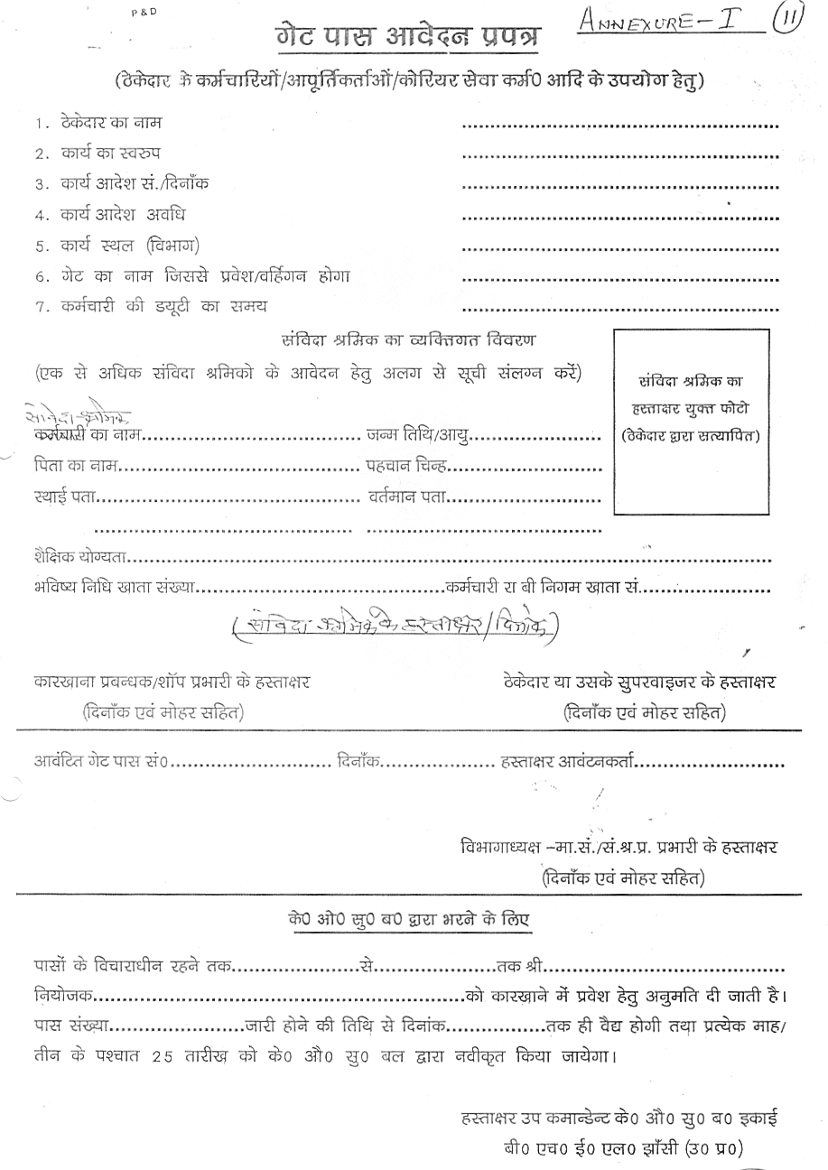
Annexure’I’

PERFORMA FOR SUBMITTING TECHNICAL BID FOR Hiring of 1 no open body truck capacity upto 15 MT having loading platform length of 22 feet or more, along with driver.
1. Name of the firm : _________________________

      - Name of the Proprietor : _________________________

      - Address and Contact Numbers : _________________________

      - Registration Number of Truck : _________________________

Copy of the Registration : Enclosed / Not Enclosed

      - Copy of the Insurance of Truck : Enclosed / Not Enclosed

      - Service Tax Number (PAN Based) :________________________
      - Category of Service in which the bidder :________________________
is registered with Service Tax deptt.
and % of abetment available.

      - Earnest Money Deposit : Rs. -----------------------------

a) D.D. Number & Date : -------------------Date-------------
b) Drawn on (Bank) : -------------------------------------

      - Tender Cost : Rs. --------------------
D.D.No. : -------------------------

9. Validity of offer : 90 days from the date of tender Opening.

10. Blank Price bid format : Enclosed/Not Enclosed

We will fulfill all the obligations of the contractor and abide by the Terms & Conditions mentioned in the enquiry.

Date Signature with
& Office Seal

NOTE: Technical bid and Price bid should be submitted in separate sealed envelops. In case the bids are found in one single envelope then the “bids” are liable to be rejected

I/We agree with the above
Signature of Contractor with Seal Executive In-charge

Annexure’J’
PRICE BID FORMAT
(To be submitted along with Techno- Commercial)

Detail of work: Hiring of 1no open body truck capacity upto 15 MT having loading platform length of 22 feet or more along with driver.

1 Name of the firms :
2 Name of the proprietor/ partners :
3 Address & contact nos. :

SL NO. | DESCRIPTION OF WORK | Rate offered by contractor, Rs.
1 | Hiring charges (per day) of 1 no truck along with driver (excluding Service Tax)
2 | Other Taxes & Duties applicable (excluding Service Tax), if any
TOTAL (1+2)
Rate offered by contractor, Rs (in words)………………………………………………………………
(Excluding Service Tax)

Applicable Rate of Service Tax ……………
% of Abetment available……………..

Payment for extra time / Sundays / holidays shall be paid on pro-rata basis.
Diesel shall be provided by BHEL free of cost

Signature of Contractor

