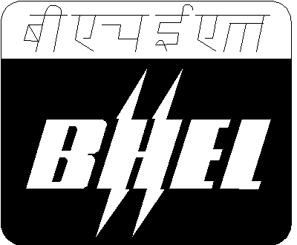
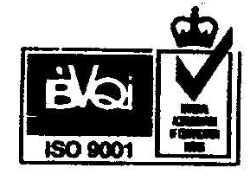

BHARAT HEAVY ELECTRICALS LIMITED
(A Government of India undertaking)
Heavy Power Equipment Plant,
Ramachandrapuram, Hyderabad – 502032 INDIA

Factory Civil Department

Phones: Off: 23182272, 23020154, Mobile: 9490165902
23182201, 23184377 (Admn. Bldg.)
Fax No.: 040 - 23020154

E-mail: aumrao@bhelhyd.co.in

Ref.: HY/FCD/ENQ/SANMAT/2010-11 Date: 23/11/2010

To:
--------------------------
--------------------------
--------------------------
--------------------------
Dear Sir(s),

Sub: - Supply of Sanitary materials for Factory Civil dept., BHEL, R.C.Puram

** ** **
We request you to kindly quote your competitive rates for “Supply of Sanitary materials for Factory Civil dept.”, BHEL, R.C. Puram.
Please submit your lowest quotation in sealed cover super scribed with enquiry No. & due date subject to our terms and conditions attached, for the materials mentioned in enclosed schedule. Your offer has to reach us on or before 03/12/2010 by 2.00 PM and the tenders will be opened at 3.00 PM. If our Enquiry No. & tender due date are not super scribed on the tender cover, your offer shall be summarily rejected. Also quote our Enquiry No. date and Enquiry Sl. No. of item in all correspondence, for prompt action.
Thanking You,
Yours truly,
For and on behalf of BHEL

A. Umamaheswara Rao
Manager/Fy-Civil

Encl.: i) Schedule
ii) General Terms & Conditions

