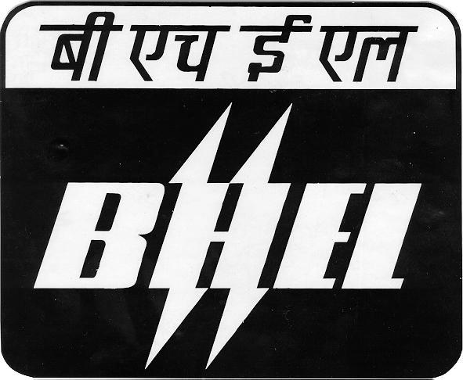
Bharat Heavy Electricals Limited
(A Govt. of India Undertaking)
R.C. PURAM, HYDERABAD-502

Doc Ref: R5/09/GT-N&B Date : 25th Nov 2009

Notice inviting expression of interest for supply of investment castings for Gas Turbine Buckets and Nozzles

- Introduction :

BHEL Hyderabad manufactures Heavy Duty Gas Turbines under a license arrangement with General Electric Company of USA. These GT models have power ratings in the range of 25 MW to 256 MW.

BHEL is presently seeking expression of interest from reputed super alloy investment casting suppliers for manufacture and supply of turbine bucket and nozzle castings for various models of Gas Turbines. The expression of interest is sought for the supply of buckets and nozzles for following specific rows and turbine models

- Frame-5PA ( MS 5001PA) Buckets and Nozzles Castings
- Frame-6B ( MS 6001B) Buckets and Nozzles Castings
- Frame-9E ( MS9001E) Nozzles Castings

BHEL upon receipt of expression of interest from probable suppliers will securitize the information, and if found acceptable, will register them as suppliers for Gas Turbine buckets and nozzle investment castings. Such suppliers will then be considered for formal enquiries against BHEL regular commercial orders as per company’s procurement and tendering procedures.

Only those suppliers need to apply against this notice who have full fledged investment castings facilities including inspection and test facilities. Such suppliers must be regular suppliers to General Electric Company or any of its licensees of heavy duty gas turbine models. In order to get qualified for supply of buckets, they should be supplying, to GE or any of its licensees, at least one stage of buckets of the same GT model for which interest is expressed. Similarly to get qualified for supply of nozzles, they should be supplying, to GE or any of its licensees, at least one stage of nozzles of the same GT model for which interest is expressed. The company should be technically and financially sound with experience of producing such super alloy investment castings on regular basis.

The Companies which are already registered with BHEL Hyderabad for supply of above mentioned investment castings need not apply. However, they need to apply for such components for which they are not registered already.

This document provides general information about the scope of supply, qualification requirements and process of submission of EOI.

- Scope of Supply

The suppliers will have to supply the following castings conforming to GE / BHEL’s technical specifications.

- Castings for Stage#1 and Stage #2 of nozzles of Frame-5PA Gas Turbines including EDM drilled cooling holes wherever applicable.
- Castings for Stgae#1 and 2of buckets of Frame-5PA Gas Turbines
- Castings for Stage#1,Stage #2 and Stage#3 of nozzles of Frame-6B Gas Turbines including EDM drilled cooling holes wherever applicable.
- Castings for Stage#1,Stage #2 and Stage#3 of buckets of Frame-6B Gas Turbines including EDM drilled cooling holes wherever applicable
- Castings for Stgae#1,Stage#2 and Stage#3 of nozzles of Fr-9E Gas Turbines including EDM drilled cooling holes wherever applicable.

BHEL typically requires about 5 sets each of the above castings annually. This requirement is expected to be met through sourcing from registered vendors as per procurement practices of BHEL.

- Test Piece Qualification Requirements

The registered vendors if found suitable for ordering will have to undergo first piece qualification as per BHEL’s qualification requirements.

No drawings or specifications will be provided to the vendors at this stage. Technical specifications and related details for each item will be provided to the qualified vendor at the time of sending formal enquiries/ RFQs.

- How to Apply
The interested parties are requested to furnish the following information and data;

- Company profile
- Company’s product profile
- Reference list of customers
- Details of manufacturing and inspection facilities
- Details of Manpower resources
- Evidence of any tie-up with other principal companies (if any)
- ISO-9000 or any such certification
- Evidence of being a regular supplier to GE or other licensees of GE
- Filled-up Supplier Registration Forms (blank forms attached)

The above information duly signed and endorsed by company representative may be sent along with a covering letter to the following address:

Sr DGM/Supplier Development Cell
BHEL, Ramachandrapuram,
Hyderabad 502032, A.P
INDIA

A copy of the same shall be sent to DGM/Purchase-GT, BHEL , Ramachandrapuram,
Hyderabad 502032, INDIA

The last date of receipt of above information at the above address is 24th Dec 2009. BHEL reserves the right to select or reject an application at its discretion.

