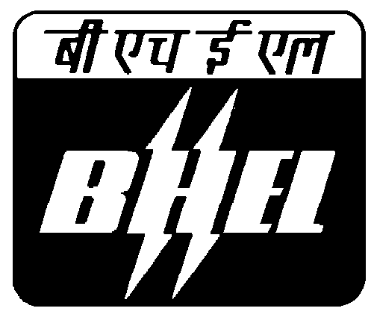 BHARAT HEAVY ELECTRICALS LTD.
TRANSMISSION BUSINESS GROUP - MATERIALS MANAGEMENT
3rd Floor, Industry Sector, Integrated Office Complex, Lodhi Road, New Delhi-110003

Sub: Regarding due date extension
Project: Ballia-Bhiwadi
Item: Silicon Rich Iron Electrode
NIT No.9069

Dear Sir,
With reference to above please note that the due date of opening of the
above item has been extended up to 08.12.2010 . Please expedite your
offer at the earliest. Please note that the bids shall be opened on the same
date at 14:00 Hrs. Please depute your representative to attend the same.

Regards,

Shashi Kapoor Rai
Engineer / TBMM,
TBG, BHEL, Industry Sector,
New Delhi - 110003.
PH: 011-41793169

