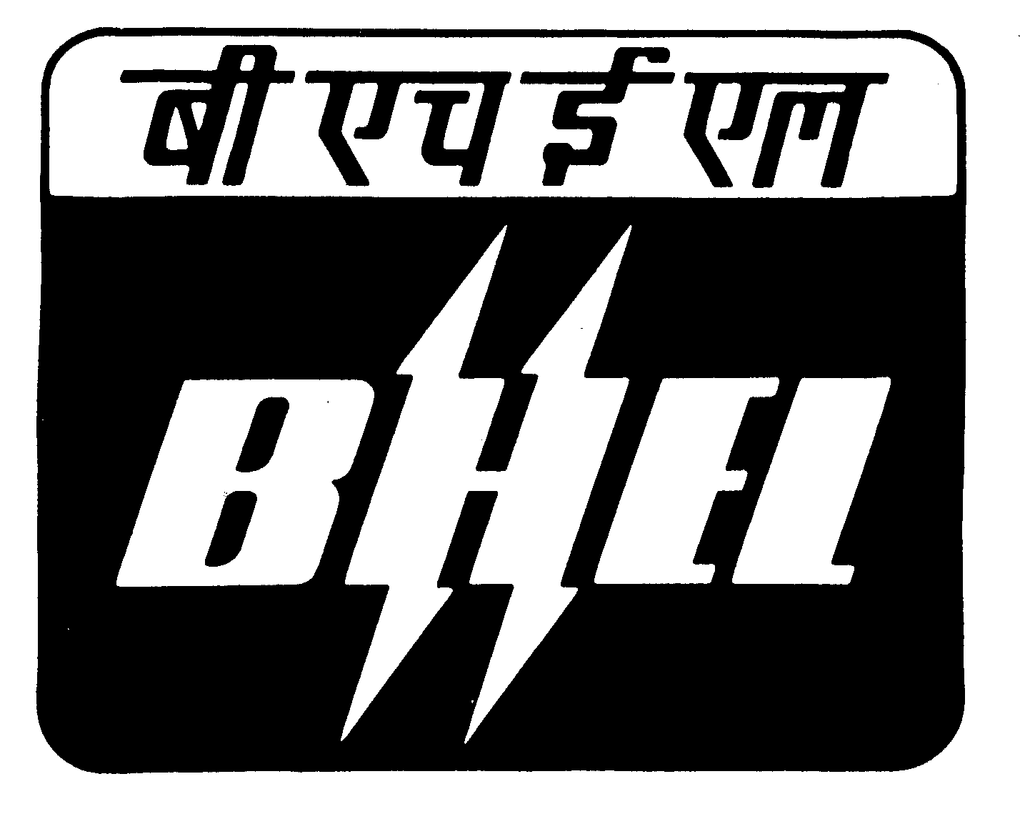
BHARAT HEAVY ELECTRICALS LIMITED

HEAVY POWER EQUIPMENT PLANT
RAMACHANDRAPURAM, HYDERABAD – 502 032.
FAX NOS: 0091 (0) 40 -23186013, PHONE NO. : 0091 (0) 40 - 23183276,
PURCHASE DEPARTMENT

EXTENSION OF TENDER DUE DATE
REF: M2/11/1200010114/PGK DATE:28.11.2011
Sub: Corrigendum & Extension of tender due date – intimation – Reg.
Ref: Our Enq. No. M2/11/1200010114/PGK, DT: 08.10.2011

***************
With reference to our tender enquiry cited, it is to inform you that RRL synthetic hose length is 22.5 metres and dia 63 mm. we request you to submit your offer with above referred hose size. The due date for submission of your quotation is hereby extended from 26.11.2011 to 27.12.2011
You are requested to submit your revised quotation to reach the undersigned on or before 27.12.2011 by 11.00 A.M. without fail.
Thanking you,

Note:
- If you have already submitted your offer with above referred RRL synthetic hose size, you need not submit the offer once again else submit your offer with above referred Hose size within the Due date.
- You have to submit “Regret Letter”, if you are not participating in this tender. Otherwise you will be evaluated your performance and you will not be considered for future enquiries.

Yours faithfully,
For BHARAT HEAVY ELECTRICALS LIMITED.
PURCHASE EXECUTIVE.

