TECHNICAL SPECIFICATION OF HEAT SHRINKABLE MEDIUM VOLTAGE TERMINATION KITS FOR INDOOR & OUTDOOR APPLICATION FOR POLYMERIC CABLES UPTO 11KV

1.0 PURPOSE : For termination of various types of Medium HT voltage grade polymeric cables. This cables will be connected to Indoor Vacuum Circuit breakers, Indoor Transformer, Outdoor Transformer, Off Load Isolator, Soft Starter, Induction Motor terminals etc.

2.0 BRIEF TECHNICAL DETAILS :
2.1 Joints shall have mechanical connectors and triple extruded tubing combining the following
- Heat shrinkable outer conductive layer
- Heat shrinkable insulation layer
- Elastomeric Insulation layer

2.2 Terminations should have anti tracking outer tubing integrated with ceramic based stress control and sealant layer throughout its length.
2.3 For 3-core cables, the kit should include a conductive breakout & tubing for custom core length.

3.0 BASIC FEATURES : Heat shrinkable termination kit should have the following basic features.
- High performance termination material – for outstanding UV properties, Exceptional track & erosion resistance, highly hydrophobic and excellent high voltage insulation material
- ZnO Stress control system – for high impulse withstand performance
- Integrated Stress control over entire termination length – for ensuring stress control system correctly positioned
- Separate mastic tapes for moisture sealing – for excellent resistance to moisture ingress
- Shelf life – Unlimited shelf life
- Compact design – for space saving and universal application
- Range taking kit – fewer range kit for wide range of cables
- Easy application – for simple to install & high reliability.

4.0 TERMINATION KIT MATERIALS :
4.1 Insulation Material
- Insulation material should be proven polymer compounds exhibiting excellent stability and long time performance under severe environmental condition.
- It should be outstanding tracking and erosion resistance, mechanical strength, weatherability & high dielectric properties.

4.2 Stress Control Material
- ZnO stress control system integrating in heat shrinkable insulating tubing.

5.0.0 Typical sketch for Heat shrinkable termination kit for HT polymeric cables
is shown in page -3. Heat shrinkable termination kit should be as per the
sketch.

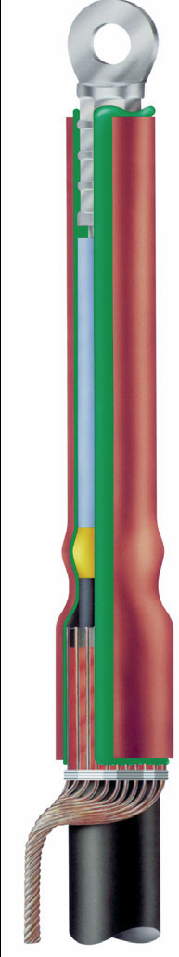
Insulating tubing
Stress control and sealant layer
Stress controlling void filler
Sealant tape

