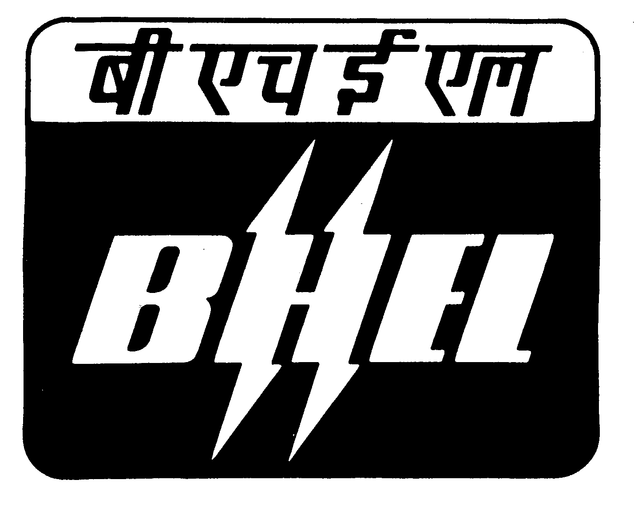

BHARAT HEAVY ELECTRICALS LIMITED
Heavy Power Equipment Plant, Ramachandrapuram, Hyderabad - 502 032
Phones : 040 - 23183411 , FAX No : 040- 23020102
Email: barad@bhelhyd.co.in

CENTRAL DESPATCH CELL

CORRIGENDUM

Tender Notice No.: CDC/Shipping/HT/2009-’10 dated 22-06-2009

With reference to NIT No. 6705 dated 25-06-2009 i.e “ TRANSPORTATION OF EQUIPMENT BY HYDRAULIC TRAILERS ”
Clause No. 4 of Section-I of Annexure-A to be read as “ Transporters
Name should figure on Gazette published by “ The Ministry of Shipping,
Road Transport & Highways(Department of Road Transport & Highways).

Sd/-
Sr.Dy.General Manager / CDC

