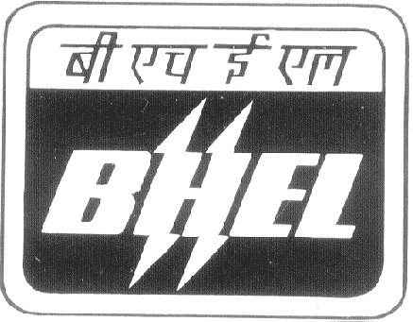 | BHARAT HEAVY ELECTRICALS LIMITED  RAMACHANDRAPURAM, HYDERABAD-502 032 (A.P)  Phone: 040-23021869/23184349/23184089 E-mail: dbr@bhelhyd.co.in  Fax: 040-23020102 Internal Phones: 4349 / 4089

(Stores Department-CMM)
Ref.No.: SM(S)/SUB-CONT/002/2008-09 Date : 05.04.2008

CORRIGENDUM

Sub:- Tender No.SM(S)/SUB-CONT/002/2008-09, Dt.07.02.08
Ref:- [01] Web Site : bhel.com
[02] Web Site Ref. No. : NIT_4166
****

The Tender No.SM(S)/SUB-CONT/002/2008-09, Dt.07.02.08 for Sub-Contract Material Movement through lorries/trailors and van has been extended upto 19.04.2008 at 14.00 Hrs. The tender will be opened at 14.30 Hrs. Please see our Web Site www.bhel.com (NIT No.: NIT-4166) for further details of the tender.

SR.MANAGER/STORES (CMM)

