|  |
| --- |
| **Bharat Heavy Electricals Limited**  [A Government of India Undertaking]  *AN ISO 9001*  *COMPANY*  **Materials Management/Manufacturing**  Tiruchirappalli - 620 014, INDIA  🕿: 0431 – 2578243  E mail : a.anil@bhel.in |

**CORRIGENDUM-1 DT: 03.02.25**

Bid No: [**GEM/2025/B/5861758**](https://bidplus.gem.gov.in/showbidDocument/7423256) **Dt: 03.02.25**

**Website References:** [**https://gem.gov.in/**](https://gem.gov.in/)

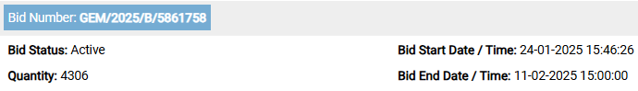

Corrigendum Details

1. Bid extended to **2025-02-11 15:00:00**

**2. Technical specification against Group-2 revised, details as mentioned in GeM Bid Corrigendum (ATC terms)**

**All other terms and conditions as published in the tender remain unaltered**

**This is for your information.**