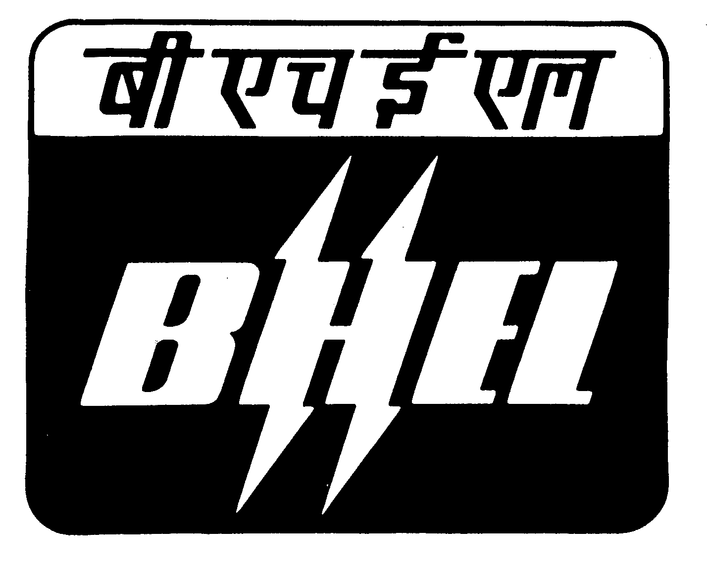
BHARAT HEAVY ELECTRICALS LIMITED

(A Government of India Undertaking)
Ramachandrapuram, Hyderabad – 502 032. INDIA
PURCHASE DEPARTMENT (CG).
Ph.Nos: 0091-040-23182250

Fax.Nos.0091-40-23020173

Capital Purchase Corrigendum No : 1/09

With reference to Tender No : M208CG8A0086/BRK published on 07/08/2008 in The Hindu, The Times of India, Amar Ujhala (Hindi) and also Published in Indian Trade Journal 20/08/2008 issue, for procurement of Strip Cladding Machine for BHEL-Hyderabad, there is a change in specifications, which are given below. For complete details please visit our website: www.bhel.com. Interested parties may submit their offers in two part bid, if they have not participated already, on or before 16/06/2009 before 11.00 AM.

Tender No: M208CG8A0086/BRK STRIP CLADDING WELDING MACHINE

Sl No | Clause no: | NIT requirement | Amendment
1 | 4.2 | AC motor with VFD for horizontal and vertical travel | AC motor with VFD or DC motor with DC drive - for horizontal and vertical travel
2 | 5.6 | Strip feed motor : AC motor with VFD | Strip feed motor : AC motor with VFD or DC motor and DC drive.

Sr. Manager/ Pur-CG

