|  |  |  |
| --- | --- | --- |
| **BUYER SPECIFIC - ADDITIONAL TERMS & CONDITIONS (ATC)** | | |
| **NOTE: Bidder to confirm in affirmative by typing "YES" or "Applicable Data" in the response column** | | |
| Sl.no | Detailed Terms & Conditions | Bidder Response |
| **1**. | **GENERAL INSTRUCTIONS:** |  |
| A | The quotation should be neatly typed and free from over writing/ erasures. Any correction or addition must be authenticated. The offer including annexures and brochures should be submitted in English. All Pages of Techno Commercial Bids (Main Pages), ATC should be signed and Stamped. Prices shall be quoted both in figures and words. In case of any discrepancy in value, the prices quoted in words shall be considered for evaluation and establishing L1 Status. |  |
| B | Bidders to please note that the Terms & conditions contained in this document and ATC are to be read fully before submission of quotations. |  |
| C | Bidders are advised to comply with ATC &SCC, should there be any deviations (where deviations are permitted), it shall be entered in the deviation column.  BHEL reserves the right to reject such offers. |  |
| **2.** | **Documentation for Payment** |  |
| **A** | **Indigenous Purchase**  Following documents shall be submitted immediately on dispatch of material to BHEL HPEP Site   1. Original Tax Invoice (Refer ITB clause no 11 for Tax Compliance) 2. Packing List - clearly showing number of packages, gross weight and net weight. 3. Test/Warranty/Guarantee certificates, O&M Manual (If specified in ANNEXURE) 4. Insurance intimation/declaration certificate 5. Pre-dispatch Inspection report /Third Party Inspection Certificates. 6. Consignee copy of LR signed & stamped by Customer/Site representative for DD Items 7. e-waybill. 8. Inspection Release Note (IRN) – In case of Joint Inspection cases 9. MOM & Job Completion Certificate for Service/Commissioning Requirements |  |
| **3.** | **Payment Terms: Following shall be the terms of Payment.**  **Indigenous:**   1. Micro & Small Enterprises (MSEs) - 100% Direct EFT payment within 45 days 2. Medium Enterprises - 100% Direct EFT payment within 60 days 3. Non MSME Bidders - 100% direct EFT Payment within 90 Days Note 4. Above due date is reckoned from the date of Receipt of material or 15 days from the date of submission of complete set of documents as per PO whichever is later. Payment will be made on acceptance of Material. 5. MSEs (covered under MSME Act) need to register and renew periodically and update the same with BHEL 6. The taxes that are reimbursed are limited to applicable taxes as on the Purchase Order delivery date or the amount actually paid whichever is less. 7. Adherence to the above time schedule of payment is contingent upon Bidder complying with GST provisions and availment of Input Tax Credit by BHEL before the date of payment. E. In case of packaged items, 10% of supply value will be retained till completion of total supplies. |  |
| **4.** | **Excess materials** supplied beyond tolerance limit as specified in PO will not be paid and bidder may raise credit note for the excess/unaccepted material as per GST law. |  |
| **5.** | **Rejected materials**, if any, shall be collected by the bidder within 90 days of such communication to the bidder. Beyond this period the bidder forfeits their right to the materials. |  |
| **6.** | **PERFORMANCE BANK GUARANTEE (PBG) (Applicable in case mentioned in Annexure G)**    In case enquiry specifically spells out PBG requirement, PBG is to be submitted by Bidder in requisite format as per Annexure VII.  Further detailing on PBG as specified in Annexure G.  The PBG shall be for the performance of the goods and shall remain binding not withstanding such variations, alterations or extensions of item as may be made, give, conceded or agreed to between the Bidder and BHEL under these Terms and conditions or otherwise. |  |
| **7.** | Procurement directly from the manufacturers/ suppliers shall be preferred. However, no agent shall be allowed to represent more than one manufacturer/ supplier in the same tender. Moreover, either the agent could bid on behalf of the manufacturer/ supplier or the manufacturer / supplier could bid directly but not both. In case bids are received from both from the manufacturer/ supplier and the agent, bid received from the agent shall be ignored. | |
| **8.** | **RIGHT OF REJECTION /NON- PLACEMENT OF PO:** BHEL reserves the right to accept or reject any or all bid/s in full or part without assigning any reason whatsoever. | |
| **9.** | **INTEGRITY PACT**  Bidders shall have to enter into Integrity Pact with BHEL as per Annexure VI - for Tender value of rupees two crores and above and shall be signed by the authorized signatory along with the offer, failing which Bidder’s offer will be rejected. | |
| **10.** | BHEL HPEP is registered with RXIL (TReDS) platform. MSME bidders are requested to get registered with RXIL (TReDS) platform to avail the facility as per the GOI guidelines. | |
| **11.** | Inspection Measuring and Test Equipment (IMTE) used by the Bidder/ Contractor or sub-contractor shall be calibrated, maintained and controlled. Calibration shall be valid and IMTE maintained in sound condition during usage. | |
| **12.** | ISO-9001, ISO14001 and OHSAS 18001 shall be complied | |
| **13.** | **Risk Purchase clause:**    In case bidder fails/delays to supply whole or part of the ordered items or supplies defective items or fails to fulfil any other terms and conditions given in Purchase Order/Contract, BHEL has the right to terminate the order/contract or withdraw balance scope of work/supply and make the purchase of such material / services from elsewhere at the risk and cost of the defaulted bidder. The bidder is liable for the additional expenditure / difference in Cost, if any, including consequential losses which BHEL may sustain by reason of risk purchase in addition to the applicable LD as per the order/contract.  Non-performance of contract attracts penal provisions in line with BHEL guidelines for Suspension of Business Dealings (SBD). | |
| **14.** | Any other terms and conditions of the bidder attached / referred against the tender enquiry will not be considered. | |
| **15.** | All drawings, patterns and tools supplied by BHEL or made at BHEL's expense are BHEL's property. These cannot be used or referred to any other party and must be used only in the execution of BHEL's orders. | |
| **16.** | Any amount payable by the bidder under any of the conditions of this contract shall be liable to be adjusted against any amount payable to the bidder under any other work / contract awarded by BHEL HPEP or any other BHEL Units. This is without prejudice to any other action as may be deemed fit by BHEL. | |
| **17.** | The bids of the bidders who are on the banned list and also the bids of the bidders, who engage the services of the banned firms, will be rejected. The list of firms banned by BHEL is available on BHEL web site: [www.bhel.com](http://www.bhel.com) | |
| **18.** | **Execution**  The whole contract is to be executed in the most workman like manner, substantial and approved as per the contracted terms. | |
| **19.** | **Progress Report**  The bidder shall render such report as to the progress of work and in such form as may be called for by the Buyer from time to time. The submission and acceptance of such reports shall not prejudice the rights of the buyer in any manner. Bidder shall communicate to BHEL immediately, the change of address, ownership, contact person(s), the mobile numbers and e-mail of the dealing person concerned.    Milestones shall be periodically updated by bidder through PRADAN Portal **(https://web.bhelhyd.co.in/mm/ ).** Non updation will adversely affect service rating of bidder performance. | |
| **20.** | **Non-disclosure Obligations**  Drawings, technical documents or other technical information received by one party shall not without the consent of the other party, be used for any other purpose than that for which they were provided. They may not, without the consent of the submitting party, otherwise be used or copied, reproduced, transmitted or communicated to third parties. All information and data contained in general product documentation, whether in electronic or any other form, are confidential and binding only to the extent that they are by reference expressly included in the contract.    The bidder shall, as per agreed date/s but not later than the date of delivery, provide free of charge any information and/or drawings which are necessary to permit the Buyer to erect, commission, operate and maintain the product. Such information and drawings shall be supplied as specified in technical specification.    All intellectual properties, including designs, drawings and product information etc. exchanged during the formation and execution of the contract shall continue to be the property of the submitting party.    The bidder shall provide Buyer with all information pertaining to the delivery in so far as it could be of importance to Buyer. The bidder shall not reveal confidential information to its own employees not involved with the tender/contract and its execution and delivery or to third parties, unless Buyer has agreed to this in writing beforehand. The bidder shall not be entitled to use the Buyer’s name in advertisements and other commercial publications including website without prior written permission from Buyer. In the event of violation of the confidentiality as agreed, BHEL will take legal action as deemed fit. Non-disclosure agreement to be entered as per **Annexure- II** wherever applicable. | |
| **21.** | **Inspection and Testing**  The goods and stores shall be manufactured by approved quality system and each part/component may be inspected and tested by the Buyer prior to shipment and shall comply with relevant requirements. Buyer has the right to inspect at any stage during manufacture/ delivery. | |
|  | Buyer or his authorized representative shall be entitled at all reasonable times during execution to inspect, examine and test at the bidder’s premises the material and workmanship of all stores to be supplied under the contract, and if the part of the stores are being manufactured at other premises, the bidder shall obtain for buyer or his authorized representative permission to inspect, examine and test as if the said stores are being manufactured at the bidder’s premises. Such inspection, examination and testing, if made shall not release the bidder from any obligation under the contract.  For indigenous bidders all costs related to first inspection request shall be borne by the buyer and the cost of subsequent inspections due to non-readiness of material/rework/ rejections shall be borne by the bidder. In case of imports all inspection charges including third party inspections if any shall be borne by the bidder. The cost of inspection staff/third party specified by the Buyer shall be borne by bidder unless otherwise specifically agreed. If the contract provides for tests on the premises of the bidder or any of his sub-contractor/s, bidder shall be responsible to provide such assistance, labor, materials, electricity, fuels, stores, apparatus, instruments as may be required and as may be reasonably demanded to carry out such tests efficiently. Cost of any type test or such other special tests shall be borne by the bidder unless otherwise specifically agreed in the contract. The Bidder shall give the authorized representative of the buyer reasonable notice in writing of the date on and the place at which any stores will be ready for inspection/ testing as provided in the Contract. Annexure – I, may strictly be complied with for the time lines. Any delay in submission of the documents by the bidder will not alter the delivery date. | |
| **22.** | **Quality and Condition of the Deliverables**  The bidder shall be responsible for compliance with applicable technical, safety, quality, environmental requirements and other regulations in relation to products, packaging and raw and ancillary materials. | |
| **23.** | **Packaging and Dispatch**  The bidder shall package the deliverables safely and carefully and pack them suitably in all respects considering the peculiarity of the material for normal safe transport by sea/air/rail/road to its destination suitably protected against loss, damage, corrosion in transit and the effect or tropical salt laden atmosphere. The packages shall be provided with fixtures/hooks and sling marks as may be required for easy and safe handling by mechanical means. Special packaging conditions/ environmental conditions as defined in the NIT shall be fully complied.  Each package must be marked with consignee name, address, P.O. number, Package Number, gross weight & net weight, dimensions (Lx B x H) and bidder’s name. The packing shall allow for easy removal and checking of goods on receipt and comply with carrier’s conditions of packing or established trade practices. Packing list for goods inside each package with P.O. item No. & quantity must also be fixed securely outside the box to indicate the contents. If any consignment needs special handling instruction, the same shall be clearly marked with standard symbols/instructions. Hazardous material should be notified as such and their packing, transportation and other protection must conform to relevant regulations. | |
| **24.** | **Rejected/Short shipments/ warranty/guarantee replacements**  In case of any short shipment during initial supply which is subsequently dispatched by the bidder or any guarantee / warranty replacements shall be dispatched on “DDP-Delivered duty paid BHEL stores” basis for imported items and “FOR-BHEL Stores/designated destination” basis for indigenous items. | |
| **25.** | **Non-waiver of Defaults**  If any individual provision of the contract is invalid, the other provisions shall not be affected. | |
| **26.** | **Settlement of Disputes**  Except as otherwise specifically provided in the contract, all disputes concerning questions of the facts arising under the contract, shall be decided by the Buyer, subject to written appeal by the bidder to the buyer, whose decision shall be final.  Any disputes of differences shall to the extent possible be settled amicably between the parties thereto, failing which the disputed issues shall be settled through arbitration.  The bidder shall continue to perform the contract, pending settlement of disputes(s). | |
| **27.** | **Conciliation clause**  CONCILIATION CLAUSE FOR CONDUCTING CONCILIATION PROCEEDINGS UNDER THE BHEL CONCILIATION SCHEME,  2018: The Parties agree that if at any time (whether before, during or after the arbitral or judicial proceedings), any Disputes (which term shall mean and include any dispute, difference, question or disagreement arising in connection with construction, meaning, operation, effect, interpretation or breach of the agreement, contract or the Memorandum of Understanding, penalty deduction, time extension), which the Parties are unable to settle mutually, arise inter-se the Parties, the same may, be referred by either party to Conciliation to be conducted through Independent Experts Committee to be appointed by competent authority of BHEL from the BHEL Panel of Conciliators.  The proceedings of Conciliation shall broadly be governed by Part-III of the Arbitration and Conciliation Act 1996 or any statutory modification thereof and as provided in Procedure in http://www.bhel.com/index.php/story_details?story=2454 . The Procedure together with its Formats will be treated as if the same is part and parcel hereof and shall be as effectual as if set out herein in this ITB | |
| **28.** | **ARBITRATION (WITH SOLE ARBITRATOR)**  **ARBITRATION FOR CONTRACT WITH PUBLIC SECTOR ENTERPRISE (PSE) OR A GOVERNMENT DEPARTMENT**  ln the event of any dispute or difference relating to the interpretation and application of the provisions of commercial contract(s)  between Central Public Sector Enterprises (CPSEs/ Port Trusts inter se and also between CPSEs and Government Departments/Organizations (excluding disputes concerning Railways, Income Tax, Customs & Excise Departments), such dispute or difference shall be taken up by either party for resolution through AMRCD as mentioned in DPE 0M No 4(1)/2013DPE(GM/FTS 1835 dated 22-05-2018. | |
| **29.** | **Applicable Laws and jurisdiction of Courts**  This agreement shall be construed and interpreted in accordance with the laws of India and shall have exclusive jurisdiction of Sangareddy/Hyderabad courts, Telangana, India. | |
| **30.** | **BHEL-Fraud prevention policy shall be adhered to.**  The Bidder along with its associate/ Collaborators/ Sub-contractors/ sub-bidders/ consultants/ service providers shall strictly adhere to BHEL Fraud Prevention policy displayed on BHEL Website http://www.bhel.com and shall immediately bring to the notice of BHEL management about any fraud or suspected fraud as soon as it comes to their notice.  List of nodal officers is hosted on BHEL Hyderabad website <https://hpep.bhel.com/>. | |
| **31.** | **Suspected Cartel Formation**  The Bidder declares that they will not enter into any illegal or undisclosed agreement or understanding, whether formal or informal with other Bidder(s). This applies in particular to prices, specifications, certifications, subsidiary contracts, submission or non-submission of bids or any other actions to restrict competitiveness or to introduce cartelization in the bidding process. In case  , the Bidder is found having indulged in above activities, suitable action shall be taken by BHEL as per extant policies / guidelines  Except as provided elsewhere in this Contract, in case amicable settlement is not reached between the Parties, in respect of any dispute or difference; arising out of the formation, breach, termination, penalty deduction, validity or execution of the Contract; time extension, or, the respective rights and liabilities of the Parties; or, in relation to interpretation of any provision of the Contract; or, in any manner touching upon the Contract, then, either Party may, by a notice in writing to the other Party refer such dispute or difference to the sole arbitration . Sole arbitrator to be appointed by Head of the Unit - BHEL , HPEP .  The Arbitrator shall pass a reasoned award and the award of the Arbitrator shall be final and binding upon the Parties.  Subject as aforesaid, the provisions of Arbitration and Conciliation Act 1996 (India) or statutory modifications or re-enactments thereof and the rules made thereunder and for the time being in force shall apply to the arbitration proceedings under this clause. The seat of arbitration shall be Sangareddy / Hyderabad, Telangana. The language of arbitration shall be English and the documents shall be submitted in English.  The cost of arbitration shall initially be borne equally by the Parties subject to the final apportionment of the cost of the arbitration in the award of the Arbitrator.  Subject to the arbitration in terms of clause 45, the courts at Sangareddy, Telangana State shall have exclusive jurisdiction over any matter arising out of or in connection with this contract.  Notwithstanding the existence or any dispute or differences and/or reference for the arbitration, the Contractor shall proceed with and continue without hindrance the performance of its obligations under this Contract with due diligence and expedition in a professional manner except where the Contract has been terminated by either Party in terms of this Contract. | |

Note: Purchase officer has to fill Annexure-I while sending enquiry.

Vendors Sign & Stamp

|  |  |  |  |  |  |
| --- | --- | --- | --- | --- | --- |
| **SPECIAL CONTRACT CONDITIONS** | | | | | |
| Sl.no | Clause | Vendor Response | Comments |
| Yes/No |
| **1** | **Penalty Clause:** As per GeM General Terms & Conditions.  **For Material:** However, C Note (In case of destination of goods is BHEL, Hyderabad) and MRC date (In case the destination of goods is Direct Dis patch to Site) shall be considered as a delivery date for Penalty Calculation.  Note: Absence of enclosed Annexure 1 (Duly signed and stamped) will entail non processing of delivery extension cases in case of delay in supplies of goods owing to reason attributable to BHEL. **For Services:** Vendor has to specify the period of days prior intimation is required for mobilizing Field Service Engineer to Site. (If vendor fails to depute their service engineer with-in specified period , LD Clause will be applicable as mentioned in GeM T&C for Services) |  | **Non Deviatable Clause** |
| **2** | **Guarantee / Warranty Period : (Deviation to this clause is not acceptable.)** Wherever required, and so provided in the specifications/Purchase Order, the seller shall guarantee that the goods supplied shall comply with the specifications laid down, for materials, workmanship and performance. If within the guarantee period, the delivery is found to be non-complaint, the seller shall on his own account, replace repair, or re-execute the delivery at Purchaser's discretion on the purchaser's first request or within the mutually agreed period, without prejudice to Purchaser’s other legal rights. If the seller continues to default on their obligations, purchaser has the right to proceed to replace, repair or re- execute the order at the seller’s expense, with or without help from third parties. Purchaser shall notify the seller of the exercise of this right in advance where ever possible. Unless otherwise specified, **guarantee period shall be 12 months from the date of commissioning or 18 months from the date of supply/replacement whichever is earlier.** For bought out packages which are intended to be incorporated in installations or systems the guarantee period shall not start until the time the installations or systems are commissioned, provided always that the period ends not later than 30 months after the date of supply of the goods. The guarantee period shall be extended by the period during which the goods are not in compliance. A guarantee period as described above shall apply afresh to replaced, repaired or re-executed parts of a delivery. |  | **Non Deviatable Clause** |
| 3 | **Detailed Billing Break up:**  Vendor has to provide detailed Price Breakup for the BHEL Material Codes after Price Bid Opening/Reverse Auction. |  | **Non Deviatable Clause** |
| 4 | **Delivery** Please quote the best possible delivery Schedule.  However, it may be noted that the delivery mentioned in the RFQ shall be meet by vendors. In case, the delivery mentioned in the tender is not met, BHEL reserves right to reject such offers.  Annexure 1 has to be duly filled and Signed Vendor to note that dispatch of goods shall be done only after obtaining Dispatch Clearance from BHEL, Hyderabad. |  |  |
| 5 | Following Duly Signed & Stamped Documents has to submitted along with your Technical Offer 1. Annexure 1 – Delivery Mile Stones agreement  2. Annexure 3 – Local Content  3. Annexure 4 – Restriction of procurement from Countries sharing land with India |  | **Non Deviatable Clause** |
| 6 | **Bill of Material:**  BOM is enclosed for your reference. Supplier has to quote for the complete Qty of BOM Table. Supplier has to quote FOR Destination inclusive of all taxes, entire BOM as Single Package.  Evaluation of offer will be done on **Overall L1 Package** of this RFQ. |  |  |
| 7 | **Others:**  Following points shall be noted   * **Customer Approval of Vendor is Applicable** * **Drawing Approval is Applicable** * **QAP Approval is applicable** |  | **Non Deviatable Clause** |
| 8 | **Consignee Address for this RFQ is as follows:** **Please refer to the Dispatching Scope document for Consignee details for the items of this RFQ.**  Supplier shall quote prices accordingly for FOR Destination Basis. | | | |
| 9 | For any Further details/queries regarding this Tender, you can contact the following Officers: S RADHIKA, Sr.Manager/Pur/TC – radhika@bhel.in Ch. Bharat Kumar, Purchase Officer/TC – chakkabharat@bhel.in You can call us on 040-23184765 | | | |
| 10 | All the offers received through GeM portal will be evaluated subject to End Customer Approval. Vendors quoting for this Enquiry shall be approved vendor of BHEL and Project details are mentioned in BOM list. | | | |
| 11 | Please note that vendors offer is liable for rejection, in case any deviation to **Non Deviatable Clause.**  Any other terms mentioned anywhere in your offer will not be considered. Terms agreed in the Buyer ATC and Special Contract Conditions are final. | | | |
| 12 | **Inspection (For Indigenous vendors):**  **Deviation to the sampling plan will lead to rejection of your bid.**  BHEL appointed TPI for all BHEL Orders.  Wherever applicable, End Customer Appointed TPI/End Customer will also participate in Joint Inspection.  Indian Offers will be loaded by 0.198% towards TPI charges to arrive the total destination cost to BHEL wherever TPI is applicable. | | | |

|  |  |  |  |  |
| --- | --- | --- | --- | --- |
|  |  | Annexure-I | | |
|  |  | Major Activity timelines shall be considered for indigenous purchases | | |
| S No | Activity | Agency | Timeline | Acceptance / Remarks |
| 1 | PO acknowledgement | Vendor | 04 days from the date of receipt of PO |  |
| 2 | First submission of Drawings,  Data sheets and QP Rev-00 | Vendor | 15 days from receipt of PO |  |
| 3 | commented / approved drawings  / data sheets and QP to vendor | BHEL/Customer | 07 days from the receipt of Rev-00 submission. |  |
| 4 | Subsequent submission of revised drawings / data sheets and QP | Vendor | 07 days from the receipt of commented drawings / data sheets and QP |  |
| 5 | Subsequent Approved  /commented Drawings and QP to vendor | BHEL/Customer | 07 days from the date of receipt of revised drawings / data sheets and QAP. |  |
| 6 | Raising of Inspection Call | Vendor | 07 days before the proposing inspection date. (BHEL will provide approved QP before  raising inspection call) |  |
| 7 | Inspection completion | BHEL Third party inspection agency / Customer | 07 days from inspection call date. |  |
| 8 | Despatch Instructions | BHEL | 07 days from the date of receipt of final approved inspection report to BHEL. |  |
| 9 | Receipt of Material at BHEL stores/ site | Vendor | 15 days from Despatch instructions |  |

Absence of this annexure in NIT will entail non processing of delivery extension cases in case of delay in supplies of goods owing to reason attributable to BHEL.

**Vendor’s Signature**

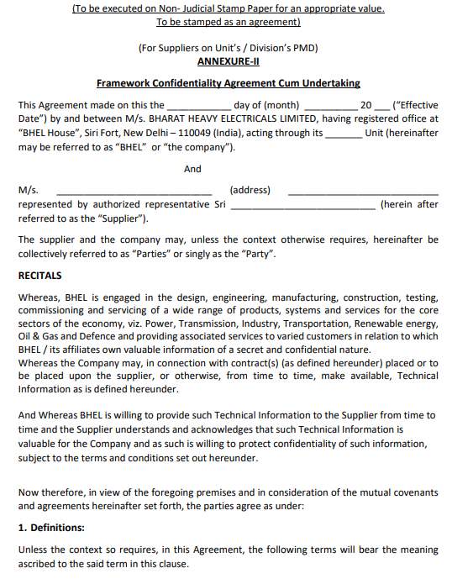

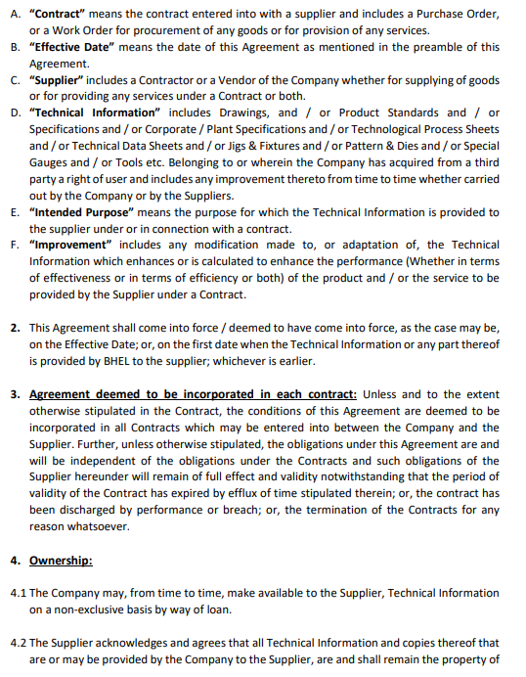

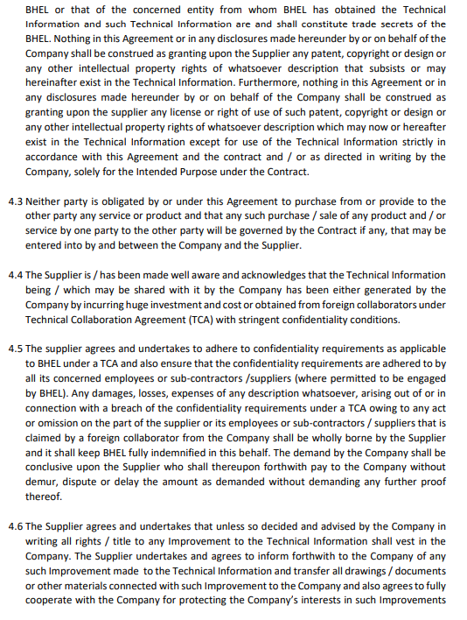

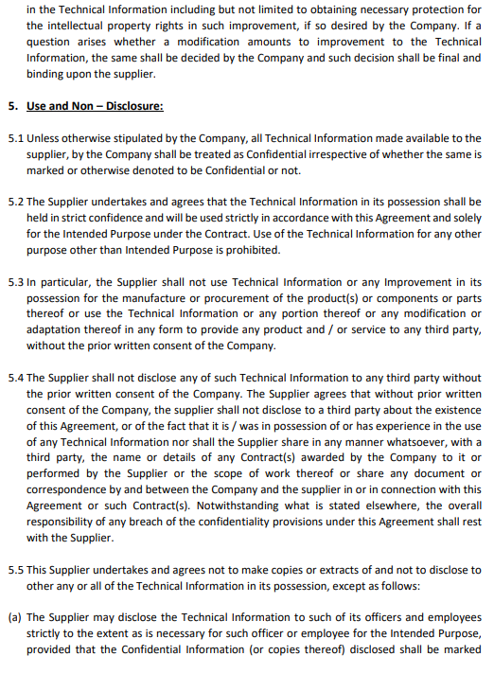

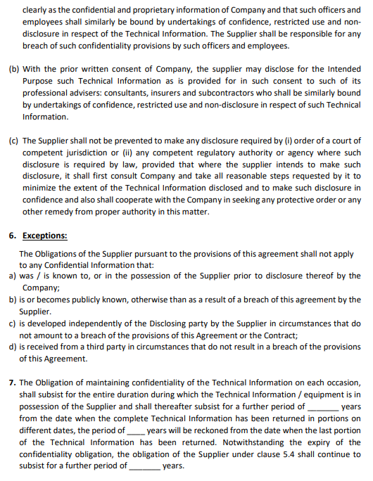

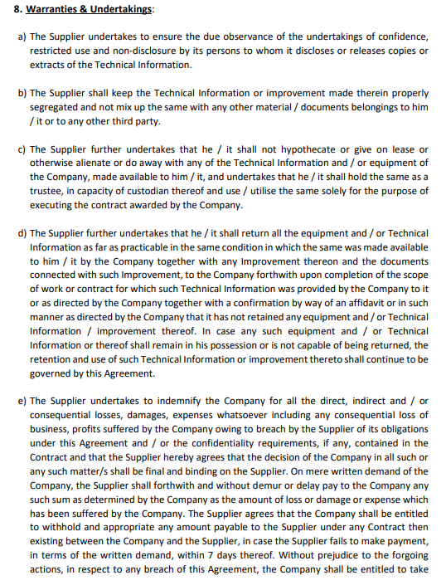

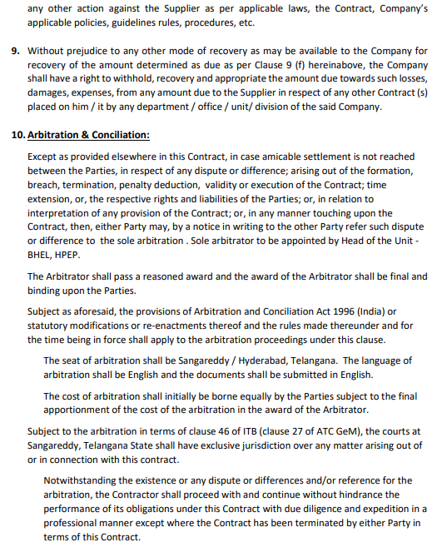

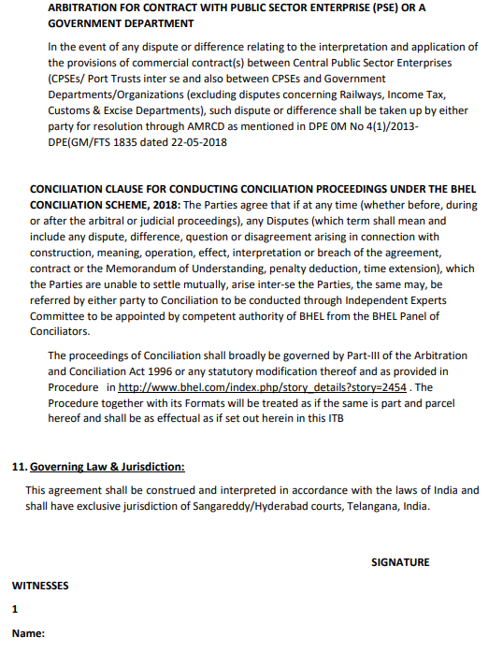

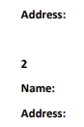



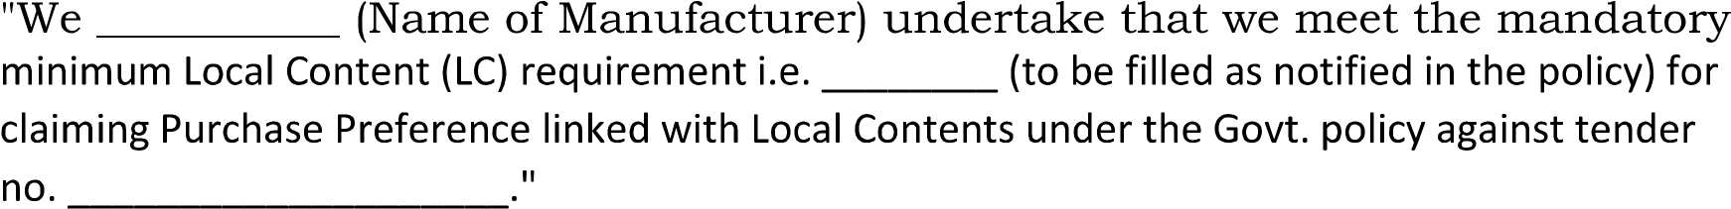

Note: As per GOI circular, the bidders offering Imported items falls under the category Non-Local Supplier. They can’t claim as Class I Local Supplier/Class II Local Suppliers by claiming the services as transportation, Insurance, Installation, Commissioning & training and after sales service support like AMC/CMC etc as local value addition





Note: As per GOI circular, the bidders offering Imported items falls under the category Non-Local Supplier. They can’t claim as Class I Local Supplier/Class II Local Suppliers by claiming the services as transportation, Insurance, Installation, Commissioning & training and after sales service support like AMC/CMC etc as local value addition

**ANNEXURE IV**

**Proforma for self-certification by Supplier for Compliance to below Clause**

**Clause:** Any Bidder from a country which shares a land border with India will be eligible to bid in this tender only if the bidder is registered with competent authority. https://www.mea.gov.in/ to be referred for latest details of competent authority and exemptions.

I have read the clause regarding restrictions on procurement from a bidder of a country which shares a land border with India and I certify that M/s_____________**(Name of firm)**

(Tick the Appropriate)

**Is not from such a country**

**Is from such a country** **and has been duly registered with the Competent authority.** (If, Yes Please enclose the Approval obtained from Competent Authority)

I hereby certify M/s ____________________________ **(Name of firm)** fulfills all requirements in this regard and is eligible to be considered (where applicable, valid registration by the competent authority shall be attached)

Sd/-

Authorized Signatory with Stamp

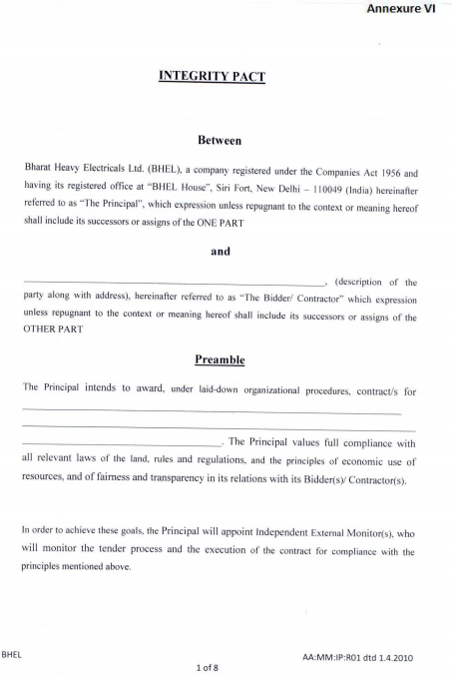

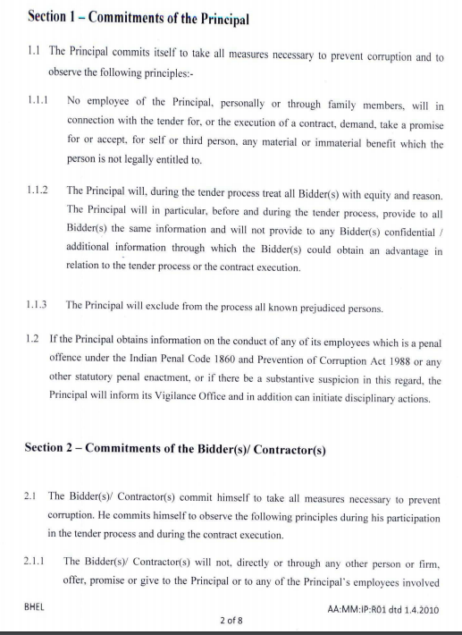

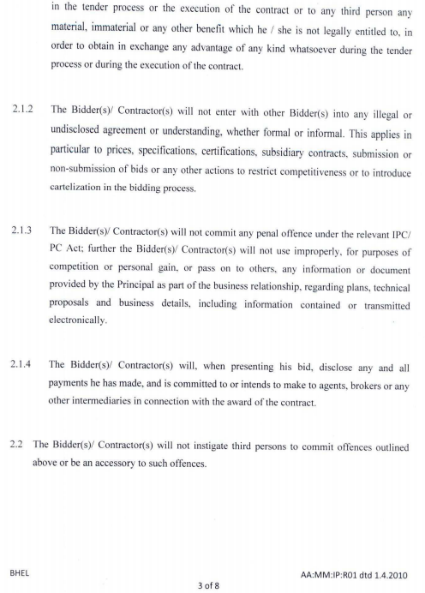

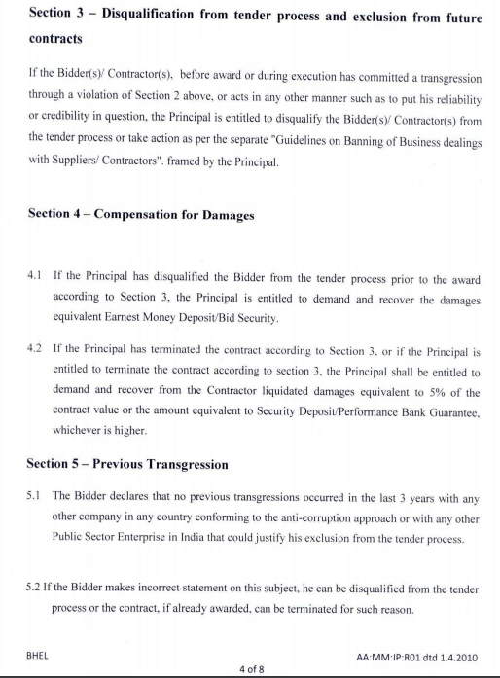

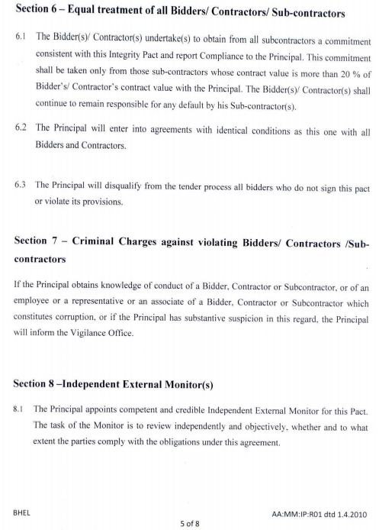

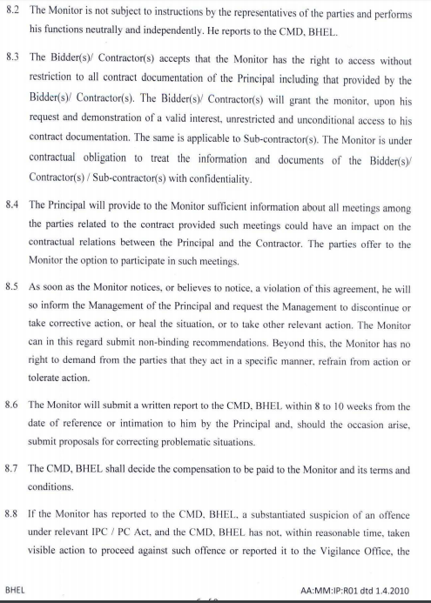

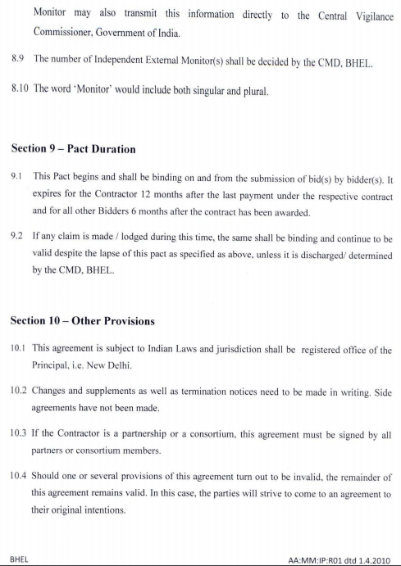

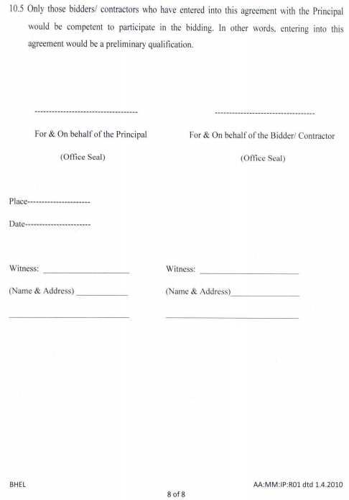

**BILL OF MATERIAL AND DISPATCHING SCOPE OF ITEMS FOR THIS RFQ/ENQUIRY ARE AS FOLLOWS:**

1. **BOM FOR CABLES FOR GAIL USAR MCA1075 project CONSISTS OF FOLLOWING ITEMS**

|  |  |  |  |  |  |
| --- | --- | --- | --- | --- | --- |
| **PR Ref** | **Matl Code** | **Material Description** | **Qty** | **MU** | **Dispatch Location** |
| 1900148609 | TC9765353219 | IS SIG CAB 1PX1.5SQMM,XLPE,FIRE RESIS | 100 | M | GAIL (India) Limited/  Post: Malyan, Dist: Raigad/  Usar- 402203 |
| 1900148685 | TC9765353219 | IS SIG CAB 1PX1.5SQMM,XLPE,FIRE RESIS | 700 | M |
| 1900148686 | TC9765353227 | IS SIG CAB 1PX2.5SQMM,XLPE,FIRE RESIS | 50 | M |
| 1900148687 | TC9765353340 | 8TX1SQMM, LOW CAP, IS,XLPE, FRLS&FR | 10,600.00 | M |
| 1900148701 | TC9765353227 | IS SIG CAB 1PX2.5SQMM,XLPE,FIRE RESIS | 10 | M |
| 1900148702 | TC9765353340 | 8TX1SQMM, LOW CAP, IS,XLPE, FRLS&FR | 1,000.00 | M |
| 8000113073 | TC9765353219 | IS SIG CAB 1PX1.5SQMM,XLPE,FIRE RESIS | 150 | M | 01 STORES,  BHEL, RC Puram  Hyderabad- 502032 |

b) **BOM FOR CABLES FOR GAIL USAR MCA1076 project CONSISTS OF FOLLOWING ITEMS**

|  |  |  |  |  |  |
| --- | --- | --- | --- | --- | --- |
| **PR Ref** | **Matl Code** | **Material Description** | **Qty** | **MU** | **Dispatch Location** |
| 1900148698 | TC9765353219 | IS SIG CAB 1PX1.5SQMM,XLPE,FIRE RESIS | 850 | M | GAIL (India) Limited/  Post: Malyan, Dist: Raigad/  Usar- 402203 |
| 1900148699 | TC9765353227 | IS SIG CAB 1PX2.5SQMM,XLPE,FIRE RESIS | 100 | M |
| 1900148710 | TC9765353340 | 8TX1SQMM, LOW CAP, IS,XLPE, FRLS&FR | 10,500.00 | M |
| 1900148722 | TC9765353219 | IS SIG CAB 1PX1.5SQMM,XLPE,FIRE RESIS | 100 | M |
| 1900148730 | TC9765353227 | IS SIG CAB 1PX2.5SQMM,XLPE,FIRE RESIS | 10 | M |
| 1900148731 | TC9765353340 | 8TX1SQMM, LOW CAP, IS,XLPE, FRLS&FR | 1,000.00 | M |
| 8000113103 | TC9765353219 | IS SIG CAB 1PX1.5SQMM,XLPE,FIRE RESIS | 200 | M | 01 STORES,  BHEL, RC Puram  Hyderabad- 502032 |

c) **BOM FOR CABLES FOR GAIL USAR MCA1077 project CONSISTS OF FOLLOWING ITEMS**

|  |  |  |  |  |  |
| --- | --- | --- | --- | --- | --- |
| **PR Ref** | **Matl Code** | **Material Description** | **Qty** | **MU** | **Dispatch Location** |
| 1900148754 | TC9765353219 | IS SIG CAB 1PX1.5SQMM,XLPE,FIRE RESIS | 1,900.00 | M | GAIL (India) Limited/  Post: Malyan, Dist: Raigad/  Usar- 402203 |
| 1900148755 | TC9765353227 | IS SIG CAB 1PX2.5SQMM,XLPE,FIRE RESIS | 150 | M |
| 1900148756 | TC9765353340 | 8TX1SQMM, LOW CAP, IS,XLPE, FRLS&FR | 8,500.00 | M |
| 1900148767 | TC9765353219 | IS SIG CAB 1PX1.5SQMM,XLPE,FIRE RESIS | 10 | M |
| 1900148775 | TC9765353227 | IS SIG CAB 1PX2.5SQMM,XLPE,FIRE RESIS | 15 | M |
| 1900148776 | TC9765353340 | 8TX1SQMM, LOW CAP, IS,XLPE, FRLS&FR | 850 | M |
| 8000113046 | TC9765353219 | IS SIG CAB 1PX1.5SQMM,XLPE,FIRE RESIS | 300 | M | 01 STORES,  BHEL, RC Puram  Hyderabad- 502032 |

**Evaluation Scope for above items listed is on Overall L1 Evaluation. Part Submission is not Acceptable.**