13-10-2020

14. Not able to download PDF, Form submit have validation error in phone no., Again and again pop up open or not openOrnate Done (Error show in email id but form submit) 22-10-2020 **Re-Open**

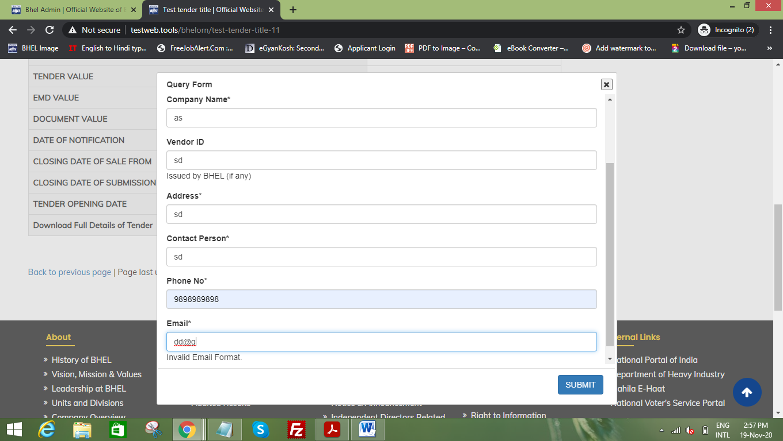

27-10-2020

1. Tender upload by previous date by keyboard 53361 Not Done **Re-Open**

5. Corrigendum view not see in corrigendum section 53359 (old website NIT No. 54551) New image missing **Re-Open**

30-10-2020

1. Concall form –Download Excel, Active and de-active and user side **Re-Open**

13-Nov-2020 **New Point**

1. After login show user id name on top
2. In sub admin Tender search by NIT No 5015 so display extra tender in below
3. Tender section word file upload successfully but not show in tender –Ornate-done
4. Corrigendum view not show correct corrigendum description
5. Add corrigendum NIT No.53362 so closing sale form, submission form and opening date show today date

Tender slider not edit.

