BHEL JHANSI

Tender Documents
TENDER NO. PUR/WC/T/123
31.10.08

ASSISTANCE IN ELECTRIC loco AND DESL / BCM ASSEMBLY.

BHEL JHANSI is in the process of finalizing the service Contract for ASSISTANCE IN ASSEMBLY OF ELECTRIC LOCO AND Diesel ElectrIC SHUNTING LOCO (DESL) / (BALLAST CLEANING MACHINE (BCM).

1. The tender document has been detailed as follows:
  - Notice Inviting Tender (Annexure A)
  - Work Specifications (Annexure B)
  - Qualifying Requirements (Annexure C)
  - Instruction to Tenderers (Annexure D)
  - Tender Evaluation Criteria (Annexure E)
  - Contractor’s obligations (Annexure F)
  - Other General Terms and Conditions for deployment of labour under Works/Job contract (Annexure G)
  - Criteria for measurement of work (Annexure H)
  - Technical Bid Application (Annexure I)
  - Price / Rate Bid (Annexure J)

- The duly filled in Technical and Price / Rate bids (Annexure I & J seprately) along with the instructions to the tenderers, Contractor’s Obligations, General Terms and Conditions with the signature of the tenderer affixed on all the pages and complete in all respects super scribed as quotation for " ASSISTANCE IN ELECTRIC LOCO ASSLY. AND DESL / BCM ASSEMBLY " should reach us in a sealed cover on or before 25.11.08 at 13.15 Hrs through Registered / Speed post or the same may be dropped in the tender box available at the following address :

CISF Control Room / Office
Administrative Building
Bharat Heavy Electricals Limited
Khailar, Jhansi-284 129

BHEL JHANSI Tender Documents
TENDER NO. PUR/WC/T/123
31.10.08

NOTE: TECHNICAL BID AND PRICE BID SHOULD BE SUBMITTED IN SEPARATE SEALED ENVELOPES. IN CASE THE BIDS ARE FOUND IN ONE SINGLE ENVELOPE THE “BIDS” ARE LIABLE TO BE REJECTED.

CONTENTS

Sl. No. | Description | ANNEXURE NO | Page No.
01. | Notice Inviting Tender | A | 3
02. | Work Specifications | B | 5
03. | Qualifying Requirements | C | 6
04 | Instructions to Tenderers | D | 7
05. | Tender Evaluation Criteria | E | 8
06. | Contractors obligations | F | 9-10
07. | Other General Terms & Conditions | G | 11 TO 27
09. | Criteria for measurement of work | H | 28
10. | Technical Bid | I | 29-30
11. | Price/Rate Bid | J | 31 TO 33

Annexure ‘A’

BHEL – JHANSI
TENDER NO. PUR/WC/T/123
31.10.08

Tender Documents

NOTICE INVITING TENDER

1. Scope of Work : ASSISTANCE IN ELECTRIC LOCO AND DESL / BCM ASSEMBLY.

2. Tender Evaluation Criteria As per Annexure –E
3. Duration of the Contract : One year from the date of the award of the contract.
4. Last date of receipt of the Tender : 25.11.08 at 13.15 Hours
5. Date of opening of Techno : 25.11.08 at 14.00 Hours
Commercial Bid
6. Address for receipt of Tender : Sr. Dy.General Manager (MM)
Bharat Heavy Electricals Limited
Khailar, Jhansi
7. Earnest Money Deposit : Rs. ONE LAC FIFTY THOUSAND only.
Payable in the form of Demand Draft /
Banker’s Cheque favoring BHEL, Jhansi
alongwith technical bid.
(1. in case of successful tenderer EMD shall be converted and adjusted against the security deposit
2. in case of others the EMD shall be returned within 15 days of acceptance of award of work by the successful tenderer.)
OR
You may deposit one time EMD Rs. 2,00,000=00 at BHEL Jhansi cash office and photo copy of receipt may be enclosed.

8. Cost of tender documents : Rs.1000/- (Rs One Thousans Only)
Payable through a separate Demand
Draft in favour BHEL, Jhansi along with
technical bid.

NOTE :
- TECHNICAL BID AND PRICE BID SHOULD BE SUBMITTED IN SEPARATE SEALED ENVELOPES marking tender no /descriptionand due date. IN CASE THE BIDS ARE FOUND IN ONE SINGLE ENVELOPE THEN THE “BIDS” ARE LIABLE TO BE REJECTED.
- THE CONTRACTORS SHOULD PHYSICALLY VISIT THE WORKPLACE BEFORE QUOTING THEIR RATES.
- FOR RELIEVENT DETAILS PLEASE contact on ph 05102412564,051-2412576 OR VISIT OUR WEBSITE " www.bhel.com"

I/We agree with the above

signature of contractor with seal Executive Incharge
Annexure’B’

BHEL – JHANSI Tender Documents
TENDER NO. PUR/WC/T/123
31.10.08

WORK SPECIFICATIONS

S.N. | WORK DESCRIPTION | Rate | QUANTAM OF WORK (NOS.) | ESTIMATED RATE/LOCO | TOTAL VALUE
1. | Assistance in Electric loco Assy. :  Assistance in mechanical /Pneumatic/ electrical work  a) Equipment mtg.  b) Door & Chequred Plate Fitting in Cabin.  c) Handling of Pipes.  d) Pneumatic pipe fitting.  e) Leakage arresting of Pne./ vacuum system.  f) Cable Cutting.  g) Cable laying.  h) Cable termination |  | 14 | Rs. | Rs.

S.N. | WORK DESCRIPTION | Rate | QUANTAM OF WORK (NOS.) | ESTIMATED RATE/LOCO | TOTAL VALUE
1. | Assistance in DESL/BCM :  Assistance in mechanical /Pneumatic/ electrical work  a) Equipment mtg.  b) Finishing work in cabin.  c) Handling of Pipes.  d) Pneumatic pipe fitting.  e) Leakage arresting of Pne./ vacuum system.  f) Cable Cutting.  g) Cable laying.  h) Cable termination |  | 17 | Rs. | Rs.

I/We agree with the above

signature of contractor with seal Executive Incharge

Annexure’C’

BHEL – JHANSI
TENDER NO. PUR/WC/T/123
31.10.08

Tender Documents

QUALIFYING REQUIREMENTS

1 Should have at least 3 years experience in executing similar type of work.

- Labour contractors presently working in BHEL, Jhansi and deploying 20 or more labours should have Labour License from the licensing officer of Jhansi Region . For other reference clause 1.A.3 page-11.

- Should have independent ESI Code number

- Should have independent PF Code number

- Should have PAN / TAN number

- Income Tax Returns for last three years

- Should have Service Tax Registration No.

- Solvency certificate from Tehsildar or Chartered Accountants .

- Self certificate that he is not blacklisted by any of the BHEL unit and other organization where he worked.

- Declaration that he is not guilty by a court of Law in India for any offence involving fraud, dishonesty and moral turpitude.

I/We agree with the above

signature of contractor with seal Executive Incharge

Annexure’D’

BHEL – JHANSI
TENDER NO. PUR/WC/T/123
31.10.08

Tender Documents

INSTRUCTIONS TO TENDERERS

1. The tender is to be processed in two parts viz. Technical bid and price/rate bid. The Technical Bid Application (Annexure - I) and its enclosures along with the Contractor’s Obligations, Other General Terms & Conditions must be submitted in one sealed envelope super scribed as “ TENDER FOR ASSISTANCE IN ELECTRIC LOCO AND DESL / BCM ASSEMBLY.” OF BHEL JHANSI – TECHNICAL BID”. The second envelope duly sealed should contain the price bid (Annexure – J) only super scribed as "TENDER FOR ASSISTANCE IN ELECTRIC LOCO AND DESL / BCM ASSEMBLY.” OF BHEL JHANSI –PRICE BID”. Any other enclosures, which the tenderer wishes to submit, must be enclosed with the Technical Bid only. The price bid envelope should contain the rates only. Offers not in line with the above procedure or quoted in any other format will be rejected / bypass.
- Both the technical bid and price bid sealed envelopes must be again sent in a single envelope duly sealed and super scribed “TENDER FOR ASSISTANCE IN ELECTRIC LOCO AND DESL / BCM ASSEMBLY." OF BHEL JHANSI ”. The same should be dropped in the tender box kept in the CISF gate of Administrative Building, BHEL, Khailar, Jhansi, within the specified date and time by the representative of the tenderer.
- All tenderers can witness the opening of the Technical Bid. After evaluation of the Technical Bid which may involve visit to the tenderer’s / clients place by authorised officials, price bids of only those tenderers who are technically found suitable will be opened on a subsequent date which will be informed to the concerned whose technical bid has been accepted in advance for witnessing the price bid opening
- All entries in the tender document should be in one ink. Corrections, over writing, cuttings, etc. will not be permitted. All the columns in the tender form should be filled without leaving blank in any page of the tender and all the pages must be duly signed & stamped by the tenderer before the submission.
- The price / rate should be quoted in figures as well as in words.

I/We agree with the above

signature of contractor with seal Executive Incharge

Annexure’E’

BHEL – JHANSI
TENDER NO. PUR/WC/T/123
31.10.08

Tender Documents

TENDER EVALUATION CRITERIA

The evaluation of the Tender will be carried out as follows:

- The bidders meeting qualifying requirements as given as annexure-"C" shall be evaluated for technical suitability.

- BHEL officials may visit the tenderer’s office & their client’s place to evaluate the capability and assess the performance.

- Successful technically qualified tendrers after tha above process only will be invited for opening of the rate / price bid.

- The contractor shall be awarded the work on overall L-1 basis (i.e. On L-1 of Grand total price (1i+2i) in price bid.).

I/We agree with the above

signature of contractor with seal Executive Incharge

Annexure’F’
BHEL – JHANSI
TENDER NO. PUR/WC/T/123
31.10.08

Tender Documents
CONTRACTOR’S OBLIGATIONS
- CONTRACTUAL

Towards selection, control and supervision of employees

  - Contractor shall decide the number of employees to be deployed for execution of the work awarded to him and he or his authorized representative will be solely entitled to dictate such workers about the manner of carrying out the work as per the prescribed specifications and quality plan.

b) Contractor shall supervise the work allotted to him and to be carried out by his employees.

c) Contractor to ensure that the employees deployed in the premises of BHEL are physically and mentally fit and do not have any criminal record. Such employees should possess requisite skill, proficiency, qualification, experience etc.

d) Contractor to maintain appropriate records of his employees deployed to carry out the job(s).

e) Contractor should issue appropriate appointment letters to his employees.

f) Contractor will ensure that the job is executed through his employees on his rolls and under no circumstances the contractor will not deploy any casual employee to carry out the job nor shall sub-contract the job without prior written permission.

g) Contractor will keep watch on his employees and he will be liable for any pilferage / loss to BHEL due to acts of omission and commission by his employees. Similarly, liability for any compensation to outsiders on account of any act of omission and commission by the employees deployed by the contractor shall lie exclusively with him.

h) The contractor has to provide badges bearing logo of his establishment, which shall be affixed by the contract labour on the left side of his pocket.

- Contractor to ensure that all precautions are taken for safety of his employees and equipments.

j) In the event of termination of contract for any reason whatsoever, the contractor shall withdraw all his employees from the establishment of BHEL. In case contractor decides to terminate services of his employees. He should settle all terminal dues.

B) Towards supply safety equipment and appliances

a) Contractor shall provide safety appliances and maintain the same at his own cost, which may be required under the statute or otherwise.

b) BHEL shall provide all tools, tackles , equipments & materials to the contractor free of cost.

C) Towards statutory liability

a) As mentioned in the terms and conditions enclosed as Annexure ‘G’ of this contract.

b) Contractor shall indemnify BHEL against all claims by statutory authorities and loses under various Labour Laws, statutes or any civil or criminal law in connection with employees deployed by him.

c) In case a contractor employs women as employee he will discharge his obligation under law in respect of such women workers such prohibition of engaging them during night-hours, prohibition of employing them for more than 9 hours per day, provision of crèche facility, grant of maternity leave as per rules etc.

d) Contractor shall be responsible for making payment of wages before expiry of 10 days from the last day of wage period and to ensure disbursement of wages in the presence of the authorities representative of contract operating division who shall record under his signature at the end of entries in the Register of wages.

e) Contractor to obtain licence under CL(R&A) Act, 1970.

D) Towards Finance

Contractor to arrange his own finance for carrying out the job including payment of wages to his employees . Rates quoted shall be net and inclusive of all the capital cost, material cost, taxes and levies which might be applicable to this type of job.
I/We agree with the above

signature of contractor with seal Executive Incharge

Annexure’G’

BHEL – JHANSI
TENDER NO. PUR/WC/T/123
31.10.08

Tender Documents

OTHER GENERAL TERMS & CONDITIONS FOR CONTRACTORS FOR DEPLOYMENT OF LABOURS UNDER WORKS/JOB CONTRACT.
Service contracts shall only be awarded for the works on the following terms and conditions.

- LABOUR LICENCE AND OTHER REQUIREMENTS :- LABOUR LICENCE AND OTHER REQUIREMENTS IN CASE OF CONTRACTORS WORKING IN BHEL, JHANSI AND DEPLOYING 20 OR MORE LABOURS.

  - Contractor should possess valid labour licence for the maximum number of contract labours deployed on any day from the competent authority for carrying out the various activities mentioned in the contract document.

  - No. of labours mentioned in estimate / price bid should ordinarily not exceed. However, in view exigencies / increased activities, the nos. to be deployed can very but in no case estimated value will be changed. If enhancement of value is also required then prior approval Unit Head must be obtained by giving reason for the same.

  - The contractor shall deploy such number labours in the premises of BHEL, Jhansi, as required for completion of the contract. The labours such deployed shall be his own labours.

  - In case the number of labour deployed by the contractor in premises of BHEL Jhansi exceeds the number of labour allowed in the license then the contractor shall immediately inform the HR and concerned department. The contractor shall also apply to the licensing officer in the region for amendment in the license within 7 days of exceeding the number of labours mentioned in the license.

1.A. LABOUR LICENCE AND OTHER REQUIREMENTS IN CASE OF CONTRACTORS NOT WORKING IN BHEL, JHANSI OR HAS LESS THAN 20 WORKERS ON HIS ROLLS: -

1.A.1. The contractor should have worked in large/medium-sized organization for at least three years.

1.A.2. The contractor should possess valid labour license issued by licensing authority outside jhansi region, in case he has worked outside jhansi region and has deployed 20 or more workers in any organization.

1.A.3. After being eligible to apply as per para 1.A.2 if the contractor is awarded the contract then he should apply for form -V for the BHEL to obtain labour licence from Dy. Labour Commissioner, Jhansi and submit the same within one month from tha award of contract. Till then award will be treated as PROVISIONAL

1.A.4 The contractor shall also have to submit copy of PAN card and latest IT return.

1.A.5 The contractor must possess service tax registration number under relevant code head.

1.A.6 The contractor should possess VAT/TIN number if material is supplied/consumed. The contractor should not be disqualified from bidding in case the contractor does not have TIN number. However he shall have to produce TIN NO. before opening of price bid.

1.A.7 Stamp Duty : Contractor should deposit stam duty on security deposit as per stamp duty act.

1.A.8 Should have local Sale Tax Registration No. (TIN NO. ). This is required only is case where material transaction is involved.

- APPOINTMENT AND ENTRY IN FACTORY PREMISES:

  - The contractor shall deploy his own labours for carrying out the works contract awarded to him. At the time of appointment the contractor shall issue appointment letter along with terms and conditions of employment to his own labours.

  - The labours deployed in the manner as in 2.1 shall be allowed to enter the premises of the factory only if the terms and conditions of employment are acceptable to them.

  - The contractor shall submit the following to HR, contracting department and CISF
- The details of the labour proposed to be deployed in Annexure I.
- Character certificate issued by District Magistrate’s Office. or Proof of remittance of fees for character certificate at District Magistrate's office.
- Copy of employment card issued by contractor to his own labour.

  - After submission of documents as in para 2.3, the contractor shall issue photo identity card to the labour and submit to HR department. This identity card shall be forwarded by HR department. This identity card shall be forwarded by HR department to the CISF, which shall then authorize the labour to enter the factory premises initially for a period of one month.

  - The photo identity card shall have to be revalidated every month on 25th or any other date fixed to do so. In absence of such revalidation, duly forwarded by HR department, CISF shall not allow any labour to enter the premises of BHEL Jhansi.

  - The contractor, besides the photo identity card shall also issue employment card to his own labours, at his own cost within a period of three days from beginning of employment in the format prescribed under Rule 76 of UP Contract Labour Rules. A copy of this format is annexed as Annexure II, to these terms and conditions. A copy of this format shall have to be submitted by the contractor to the contracting department, HR department and CISF, as mentioned in para 2.3.

  - The contractor shall maintain a register of persons employed by him in the format prescribed under Rule 75 of UP Contract Labour Rules, 1975. A copy of this format is annexed as Annexure III.

- BILLS PAYMENT, ATTENDANCE AND PAYMENT OF WAGES

  - The contractor shall compile attendance everyday in respect of the labours deployed by him under the service / job contract.

  - The contractor shall maintain an attendance card in respect of every labour deployed by him.

  - The contractor shall generate a daily statement in the prescribed format, as in Annexure IV, annexed to these terms and conditions of deployment. This statement shall be prepared by the contractor in three copies. One copy shall be forwarded to the department and another copy shall be forwarded to HR department. The third copy shall be retained by the contractor.

  - The contractor shall submit bills to the contracting department on 2nd of each month.

  - The contractors bills should be accompanied with
  - Copy of measurement book entries/Statement of work done by the contractor.
  - Statement of wages of labours deployed him under the service contract, PF/ESI no., statutory deductions etc., in the format as in Annexure V annexed to these terms and conditions.
  - PF and ESI challans for previous month - separate for concerned works contract
  - Wage payment sheet for the previous month
  - Copy of Form-5 and Form-10 (PF monthly returns) submitted by contractor to RPFC for billing month.
  - Copy of Form 12A-regarding PF remittance
  - List of CL covered under accident insurance policy
  - Statement of material supplied by the contractor
  - Copy of Labour License
  - Challan of service tax payment (separate in respect of each works contract).

  - The executing department shall pass the bills of the contractor, on 3rd of each month, after checking the documents as in Para 3.5, above and forward them to HR department along with its statement as in Annexure VI, annexed to these terms and conditions. In case any discrepancy/non-compliance is detected then the contractor has to clarify the query within two days of intimation such discrepancy. In such cases bills shall be passed by the contracting department, within two days of receiving such clarification.

  - After checking labour laws compliences with respect to the concern service contract HR department after retaining copies of PF and ESI challans and wage payment sheet pertaining to previous monthAnnexure-V etc. willl forward the bill alongwith requisite documents ( the bill in original and service tax challan ) to finanace department. Finance department shall, on satisfactory compliences, on account of stam duty charges and security deposit amount, make payment as per contract.

  - Finance department shall, on satisfactory compliances, and after deductions on account of security deposit amount and TDS shall make consolidated payment on 10th of each.

  - The contractor shall issue pay slips to his labours, deployed for undertaking activities under the service contract, on 7th/8th of each month.

  - The contractor shall make payment to his own labours/contract workers on 10th of each month. The payment of wages to the labours shall not be subject to payment against the bills.

  - The contractor shall remit the cheques favoring RPFC and ESI Kanpur with the appropriate banks with such period as stipulated under relevant provisions. Last date for remittance of PF is 15th and that in case of ESI is 21st of each month.

  - The contractor shall make payment of wages to his labours on due date in presence of an authorized representative of contracting department. The authorized representative shall retain a copy of wage payment sheet with him.

  - In cases where the payment to the contractor is due only after completion of work and the payment is not made monthly then the contractor shall have to produce documents as enumerated in para 3.5 above, in respect of all labours deployed by him against the contract, for each month, separately, along with final bill(s). Para 3.8 shall not be applicable in such cases. The contractor shall be paid through cheque in his/firm’s favour.

- Provident Fund :

  - The Contractor should allot PF account number and get the nomination form, duly filled in, from each labour deployed by him at the time of joining.

  - In case the labour already has PF/pension account number, allotted to him, previously, then the contractor shall get the transfer form filled up at the time of joining and send to the office of concerned Regional Provident Fund Commissioner.

  - After termination of contract the contractor shall provide due assistance to the labour for withdrawal of PF/pension amount, when due.

  - The Contractor shall liaison with the PF officials to get the annual PF slips and distribute amongst his own labours.

  - PF CONTRIBUTION:
Employee’s Contribution Employer’s Contribution
12% of Normal waged paid PF Contribution 3.67%

Insp./Admn charges 1.10%

Pension Fund 8.33%
Admn/InspCharges 0.01%
EDLI charges 0.5%

  - The Contractor shall submit annual returns in Form-6A and Form 3A, prescribed under statutory EPF scheme, 1952, in respect of each labour deployed by him with a copy to HR and finance department.

5.0 Employees State Insurance :

  - The Contractor should allot ESI account number and get the nomination form, duly filled in, from each labour deployed by him at the time of joining.

  - At the time of joining the contractor shall get the self/family registration form filled by the labour and submit to the local ESI office.

  - The contractor shall collect the identity card issued after submission of registration form, from ESI office and handover the card to the concerned labour.

  - ESI CONTRIBUTION :-
Employee’s Contribution Employer Contribution
1.75% of gross wages 4.75% of gross wages

  - The Contractor shall submit annual returns in Form-6 prescribed under ESI Act, deployed by him with a copy to HR and finance department.

Bonus:

The contractor shall be liable to pay statutory bonus under Payment of Bonus Act, 1965. However, BHEL shall be liable to pay to the contractor only an amount equivalent to the minimum statutory rate existing for the period under consideration. This reimbursement shall be made by BHEL Extra only after production of sufficient/satisfactory proof of payment of bonus.

- Discipline :

  - The Contractor shall be responsible for the discipline of his own labours deployed under the Service contract. In case of any loss to the BHEL Jhansi on account of indiscipline of contract labour then such loss shall be assessed and recovered from the running bills of the contractor or from the security deposit.

  - The contractor shall not employ any person who has not completed his 18 years of age.

  - The contractor shall not employ any person who has attained 55 years of age.

  - The contractor, on advise of authorized BHEL official, shall immediately remove any person employed by him, who may in the opinion of such authorized BHEL official is involved in misconduct. Such person shall not be employed by the contractor without prior permission.

8.0 LEAVE WITH WAGES TO CONTRACT LABOUR: -

Guidelines as per UP factories Rules 1950 should be strictly observed with regard to crediting / availment of leave. Register as prescribed under the said rules should be maintained by the contractor.

- INDEMINITY BOND/COMPLIANCE OF LEGAL PROVISION

  - The contractor shall at all times indemnify the company/corporation against all claims, damages or compensation under the provision of Factories Act, 1948. Contract Labour (R&A) Act-1970, payment of wages Act-1936 Minimum Wages Act- 1948, Payment of Bonus Act-1965, Employees Provident Fund and Misc, Act-1952, Employees State Insurance Act-1948, Employer’s Liability Act-1938, Workman’s Compensation Act-1923, Industrial Dispute Act – 1947, Maternity Benefit Act- 1961, Inter State Migrant Workmen Act-1979, Payment of Gratuity Act-1992 or any modification thereof or any other law relating thereto and rules made there under from time to time or as consequence of any accident of injury to any workman or other persons in or about the work whether in the employment of contract or not save the except whether such accident or injury has resulted from any Act of the Company/ Corporation, its agents, or servants, and also against all costs/ charges and expenses of any suit, action or proceeding paid to compromise or settle any such claims.

- GENERAL TERMS AND CONDITIONS: -

  - In case of non-satisfactory performance of the contract, BHEL shall have a right of forfeiting the security deposit. In case of any dispute, decision of concerned Head of the Department will be final.

  - The work shall be supervised by the contractor or through the authorized representatives on day-to-day basis.

  - The Contractor shall compensate BHEL for any loss or damage to the plant/property, material of BHEL due to his workmen/representatives’ negligence or otherwise during execution of work.

  - In the event of contractor abandoning the work or BHEL revoking the contract BHEL shall have a right to get incomplete work completed at contractor’s risk and cost. BHEL shall have a right to terminate the contract at any time without assigning any reason thereof.

  - The Contractor shall get the character antecedent of his own labour verified from District Magistrate’s office and intimate the same to the management.

  - The contractor shall deposit an amount Rs. .... as security deposit, in the manner as prescribed under Clause 8.2 of Works Policy of BHEL . This security deposit shall be liable to be returned to contractor after termination of contract and fulfillment of contract and statutory obligations.

  - Security deposit will be released on submission of following certificates from departments mentioned as under: -

a. Completion of work and certification of payment of minimum wages to contractors labours from contracting department.

b. Certificate of compliance of labour laws from HR department.

- Compliance of Bonus duly certified by HR.

- No-dues certificate regarding service tax payment, TDS or any other dues liable to be remitted by contractor under financial laws, to Finance department

  - The contractor shall provide required safety equipments to the labours engaged by him.

  - .Notwithstanding anything contained in this Agreement, the contract may be terminated by BHEL without assigning any reason thereof by giving a notice of 15 days to the contractor.

  - The contract commence.. on a date after awarding the contract ( date) and will remain valid for period of .one year(s) .The parties reserve the right to extend the contract on mutually agreed terms conditions.

11. CONTRACTOR'S COMMISSION:-
If there is any change in minimum Wages, Statutory contribution/Taxes/Duties ( i.e. PF/EDLI, ESI, etc.) the same will be borne by the contractor and there will not be any change in the %age of contractor's commission quoted.

12. SETTLEMENT OF DISPUTE/JURISDICTION/ARBITRATION ETC :-

12.1 BHEL RESERVE THE FOLLOWING RIGHTS :-
To evaluate the bid as per BHEL policy and Govt. guidelines including CVC/Vigilances guidelines by the tender committee duly constituted by BHEL management. The decision BHEL, Jhansi management or tender committee duly approved by competent authority shall be final and binding to bidder.

Accept/Reject any or all tender fully or partly without assigning any reason thereof.

Contractor should not have been blacklisted and / or suspended from business by any BHEL Unit/reason continuously for one year or more. the contractor whose suspension from business or delisting from contractor's list has been removed/withdrawn by the concerned BHEL unit on or earlier to tender due date, shall become eligible to qualify for this tender. Blacklisted contractor may become eligible only after expiry of blacklisting period on tender due date if blacklisting is not permanent. Tenderer has to give self declaration or certificate from BHEL sister unit in this regard. Any declaration/certificate found/detected to be false at a later date shall lead to cancellation of the contract forthwith apart from other penal action that BHEL may impose.

The tender should not have been held guilty by Court of law in India for any offence involving fraud, dishonesty and moral turpitude. Declaration to that effect must be submitted along with the offer.

12.2 CONFEDENTIALITY :-

The parties agree & acknowledge that in the course of their discussions and interaction, BHEL may disclose information of confidential proprietary nature relating to its business, products, know-how, technology, customers, employees and financial to the contractor. Such information shall be considered as confidential. The contract agrees to keep it confidential & secret at all times and not directly or indirectly disclose to any party other than its employees and authorised personnel's strictly on a need know basis, without the prior written permission of BHEL.

  - SUSPENSION :-

BHEL reserve the right to suspend performance of any or all of its obligations under the contract. Such notice shall specify the obligation of which performance is to be suspended, the effective date of the suspension and the reason therefore. The Contractor shall thereupon suspend performance of such obligations until ordered in writing to resume such performance by the same authority that ordered for suspension.

  - TERMINATION OF CONTRACT :-

BHEL reserve the right to terminate the contract at any time during the validity period on account of non fulfillment of contract condition, adverse feedback regarding quality of services rendered, indulgence in unethical practices or questionable integrity.

  - JURISDICTION :-

Any other of dispute arising out of or in connection with this contract shall be under jurisdiction of Jhansi Court only.

  - ARBITRATION :-

Any dispute(s) or difference(s) arising out of or in connection with the contract shall, to the extent possible in the first instance be resolved amicably between the contractor and BHEL.

In case a dispite is not resolved, the same shall be referred for conciliation by an officer of BHEL. In case, it still remains unresolved, the dispute will be referred for arbitration by an officer of BHEL. (In case arbitration by an officer of BHEL's is not acceptable, the same could be entrusted to any mutually agreeable common functionary or an independent person). The arbitrator will give his award within a shortest period. The award of the arbitrator shall be final, conclusive and binding on both parties.

The arbitration proceeds shall be conducted in accodance with "Indian Arbitration and Conciliation Act 1996 or any statutory modification there of language of the arbitration proceedings shall be in English. The venue of Arbitration shall be Jhansi, India.

The court of Jhansi shall have exclusive jurisdiction.

I/We agree with the above

signature of contractor with seal Executive Incharge
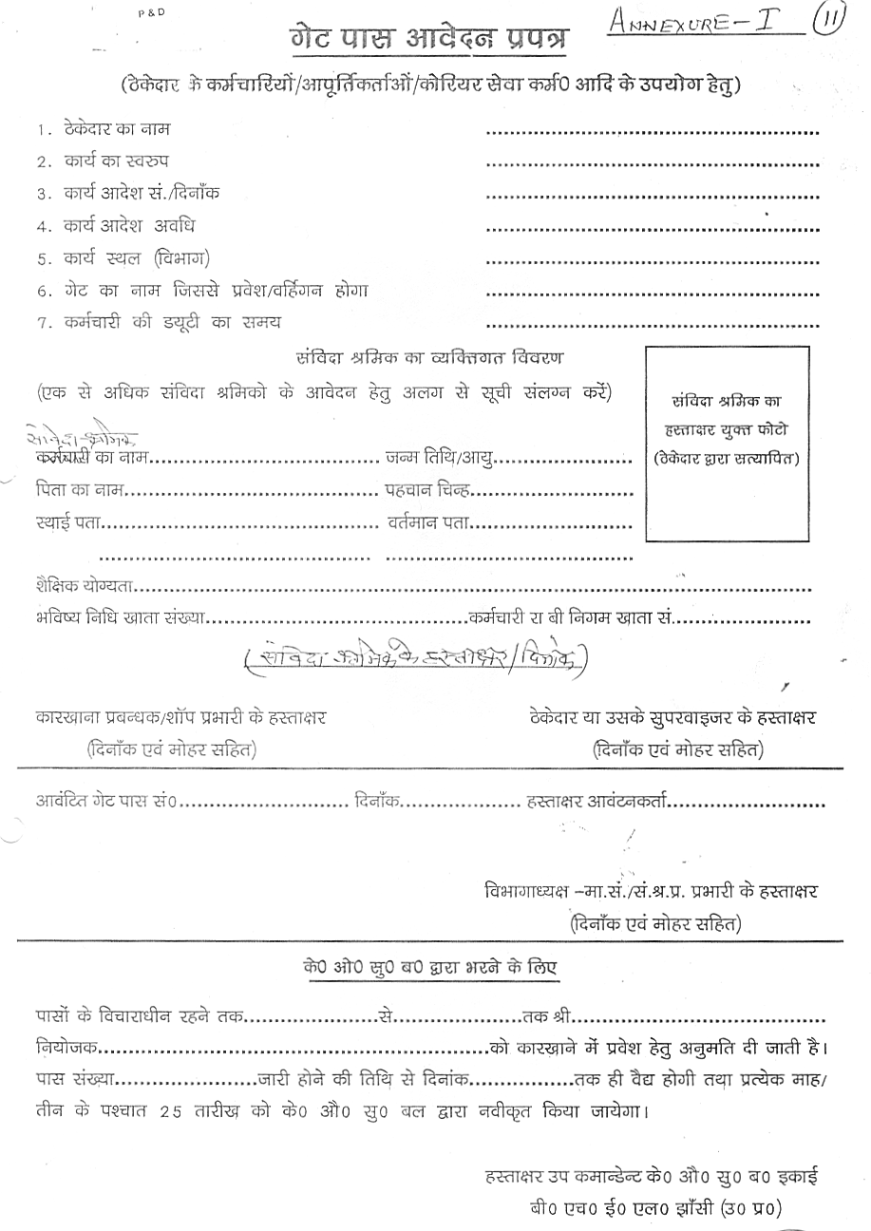

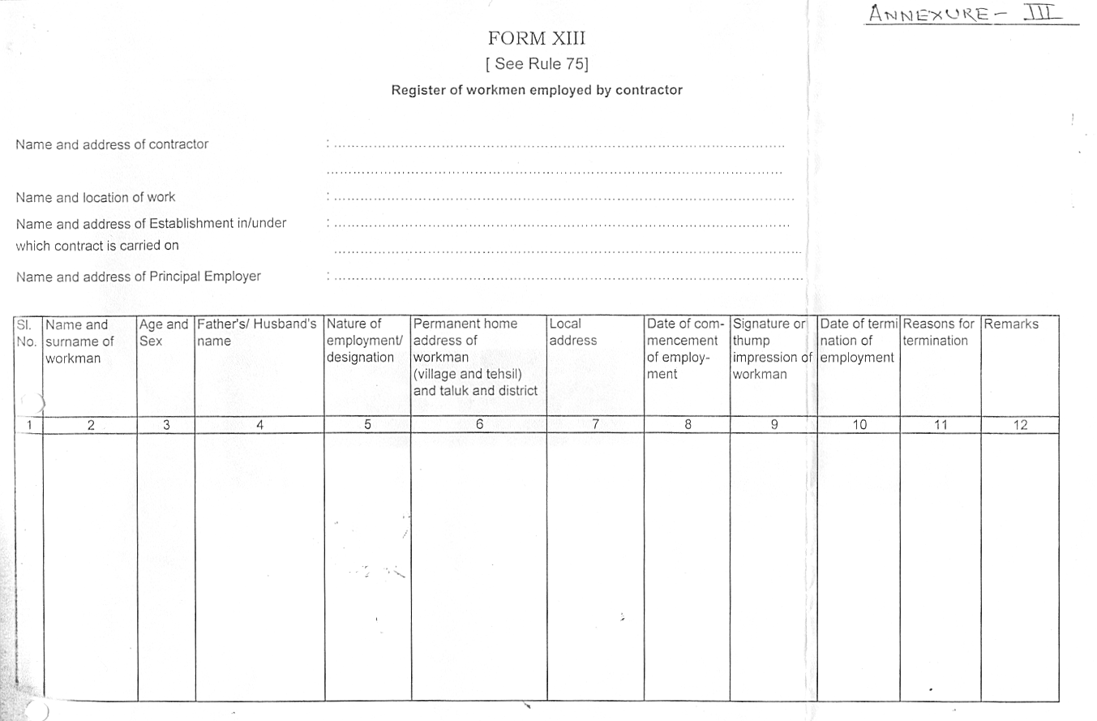

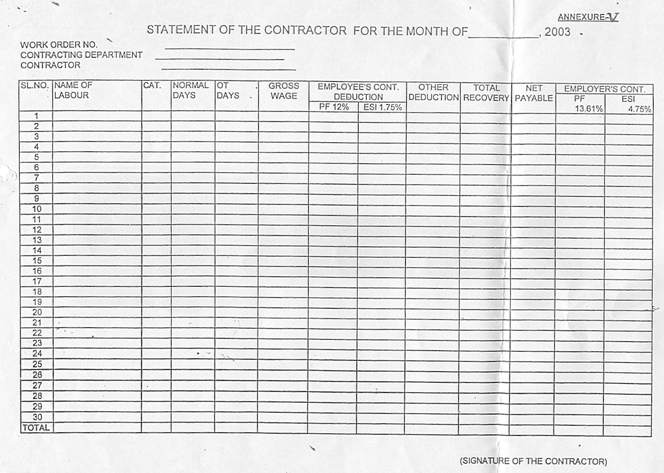

Annexure-VI
SUMMARY SHEET FOR THE MONTH OF , 200.... ( TO BE FILLED BY THE CONTRACTING DEPARTMENT)

01 SERVICE CONTRACT NO. DATE :

02 PERIOD OF CONTRACT : FROM TO

03 NAME OF THE CONTRACTOR : M/s.

04 NO. OF CONTRACT LABOUR DEPLOYED CATEGORY NUMBER
DURING THE MONTH
USW

SSW

SW

05 TOTAL PAYMENT AGAINST WAGES CATEGORY AMOUNT (RS) PAYABLE TO GROSS NET
USW

SSW

SW

TOTAL (RS)

06. PF/EPF/EDLI CONTRIBUTION DUE a. EMPLOYER @ 13.61% =

b. EMPLOYEE @ 12.00% =

c. TOTAL (a+b) (Rs.) =

07 ESI CONTRIBUTION DUE a. EMPLOYER @ 4.75% =

b. EMPLOYEE @ 1.75% =

c. TOTAL (a+b) (Rs.) =

08 AMOUNT PAYABLE TO CONTRACTOR Rs.=
(5+6(a)+7(a))

( COUNTERSIGNED BY HOD ) ( SIG. & SEAL OF SHOP INCHARGE )

I/We agree with the above

signature of contractor with seal Executive Incharge

Annexure ’H’

BHEL – JHANSI Tender Documents

MEASUREMENT OF WORK AND PAYMENTS THEREOF.

1. The quality control department will periodically inspect the services being provided by the contractor and find out deficiencies. The contractor shall rectify the same immediately to the satisfaction of the Quality control dept.

2. Payment towards work satisfactorily executed will be made to the contractor on the basis of following: -
S.N. | WORK DESCRIPTION | Rate | QUANTAM OF WORK (NOS.) | ESTIMATED RATE/LOCO | TOTAL VALUE
1. | Assistance in Electric loco Assy. :  Assistance in mechanical /Pneumatic/ electrical work  a) Equipment mtg.  b) Door & Chequred Plate Fitting in Cabin.  c) Handling of Pipes.  d) Pneumatic pipe fitting.  e) Leakage arresting of Pne./ vacuum system.  f) Cable Cutting.  g) Cable laying.  h) Cable termination |  | 14 | Rs. | Rs.

S.N. | WORK DESCRIPTION | Rate | QUANTAM OF WORK (NOS.) | ESTIMATED RATE/LOCO | TOTAL VALUE
1. | Assistance in DESL/BCM :  Assistance in mechanical /Pneumatic/ electrical work  a) Equipment mtg.  b) Finishing work in cabin.  c) Handling of Pipes.  d) Pneumatic pipe fitting.  e) Leakage arresting of Pne./ vacuum system.  f) Cable Cutting.  g) Cable laying.  h) Cable termination |  | 17 | Rs. | Rs.

3. Payments will be made to the contractor on the basis of work carried out by him on a monthly basis.

4. All payments will be subject to deduction of income tax at source as per Income Tax Rules.

5. Logbook to be maintained for the work carried out daily / weekly / monthly to be certified by the contractor’s representative and BHEL official, nominated for the same.
I/We agree with the above

signature of contractor with seal Executive Incharge

Annexure’I’
Technical Bid Format

BHEL – JHANSI
TENDER NO. PUR/WC/T/123
31.10.08

Tender Documents

Ref: Your Enquiry No. ___________________dated____________

ASSISTANCE IN ELECTRIC LOCO AND DESL / BCM ASSEMBLY.

1. Name of the firm :

2. Name of the Proprietor :

3. Address and Contact Numbers :

4. Registration Number :

Copy of the Certificate : Enclosed / Not Enclosed

5. Labour Licence Number :

Copy of the licence : Enclosed / Not Enclosed

6. PF Code Number :

Copy of the Certificate : Enclosed / Not Enclosed

7. ESI Code Number :

Copy of the Certificate : Enclosed / Not Enclosed

8. PAN/TAN Number :

9. Income Tax Returns for last 3 years : Enclosed / Not enclosed

10. Service Tax Number :

11. VAT/TIN Number :
(To be submitted only in case
where material transaction is involved)

12. Solvency certificate : Enclosed/ Not enclosed

13. No. of Workers including
Supervisors on the rolls of the firm :

14. Blank Price bid format : Enclosed/ Not enclosed

14. Earnest Money Deposit : Rs. One Lac fifty thousand only.

a) Demand Draft Number & Date :
b) Drawn on (Bank ) :

15. Any other relevant information :

16. Tender Cost : Rs. ............................................
D.D.No. : ..................................................

We will fulfill all the obligations of the contractor and abide by the Terms & Conditions mentioned in the enquiry.

Signature with Name
& Office Seal

Date:

- NOTE: TECHNICAL BID AND PRICE BID SHOULD BE SUBMITTED IN SEPARATE SEALED ENVELOPES. MENTIONED ENQUIRY NO., PRICEBID/TECHNICAL BID AND DUE DATE, IN CASE THE BIDS ARE FOUND IN ONE SINGLE ENVELOPE THEN THE “BIDS” ARE LIABLE TO BE REJECTED.

I/We agree with the above

signature of contractor with seal Executive Incharge

Annexure’J’
TENDER NO. PUR/WC/T/123
31.10.08

BHARAT HEAVY ELECTRICALS LIMITED : JHANSI

Your Enquiry No.---------------------------------- dated -----------------------

PRICE BID

a. Name of the firm :
b. Name of the proprietor/partners :
c. Address and contact nos. :
d. Price offer on work measurement basis :
S.N. | JOB/ACTIVITY | QUANTITY | UNIT OF MEASUREMENT | EXPECTED NO. OF UNITS FOR ENTIRE CONTRACT PERIOD | RATE QUOTED PER UNIT | TOTAL VALUE (G=E X F )
(A) | (B) | (C) | (D) | (E) | (F) | (G)
1. | Assistance in Electric loco Assy. :
a. | Equipment mtg. | 14 | Per Loco | 14
b. | Door & Chequred Plate Fitting in Cabin. | 14 | Per Loco | 14
c. | Handling of Pipes. | 14 | Per Loco | 14
d. | Pneumatic pipe fitting. | 14 | Per Loco | 14
e. | Leakage arresting of Pne./ vacuum system. | 14 | Per Loco | 14
f. | Cable Cutting. | 14 | Per Loco | 14
g. | Cable laying. | 14 | Per Loco | 14
h. | Cable termination | 14 | Per Loco | 14
i. | TOTAL
2. | Assistance in DESL/BCM Assy. :
a. | Equipment mtg. | 17 | Per Loco | 17
b. | Finishing work in cabin. | 17 | Per Loco | 17
c. | Handling of Pipes. | 17 | Per Loco | 17
d. | Pneumatic pipe fitting. | 17 | Per Loco | 17
e. | Leakage arresting of Pne./ vacuum system. | 17 | Per Loco | 17
f. | Cable Cutting. | 17 | Per Loco | 17
g. | Cable laying. | 17 | Per Loco | 17
h. | Cable termination | 17 | Per Loco | 17
i. | TOTAL
j. | GRAND TOTAL (1i +2i)

TENDER NO. PUR/WC/T/123
31.10.08
BASIS OF OFFER
UNIT USW

1. Category wise No. of contract Labours NO. 103 ( 83 for electric loco and 20 for DESL,BCM )
2. Category wise Min. wages per day/Labour ( Rs.) 148/-

3. Category wise No. of days expected for ( Days) 300
fulfillment of contract

4. Category wise total of normal wage ( Rs.) 45,73,200/-
(Sl. No. 1 X 2 X 3 )
---------------------------------------------------------------------------------------------------------------------------------
5. Total Minimum Wages (RS.) 45,73,200/-

6. O.T. @ 15% of Minimum Wages (RS.) 6,85,980/-

7. Contingency @ 6% of Sl. No. 5 due to (RS.) 2,74,392/-
revision of DA Rates and increase in
minimum wages accordingly.

8. Contingency @ 6% of Sl. No. 6 due to (RS.) 41,159/-
revision of DA Rates and increase in
minimum wages accordingly.

9. Total contingency ( sl.no. 7+8) (RS.) 3,15,551/--

10. PF/EDLI/Pension (RS.) 6,59,757/-
Employer's contribution @ 13.61%
(Calculated on Amt. of sl.no. 5&7 i.e.
Rs.48,47,592/- )

11. ESI Employer's Contribution @ 4.75% (RS.) 2,64,800/-
( Calculated on Amt. of sl. no. 5,6&9 i.e
Rs. 55,74,731/- )

12. Grand Total ( Sl.no. 5+6+9+10+11) Total (Rs.) 64,99,288/-

13. Contractor's Commission for fulfillment of work
described above and to meet incidental charges
including supervision, financing cost, stamp duty
charges, safety equipment for labours, wages for
leave period as per UP Factories Rules, etc. = -- % of total of sl. no. 12

= Rs. ---------------------------

14. Total value of the Contract payable to the = amount at sl. no. 12+sl.no.13
bidder/price offer (excluding Service Tax = Rs. ---------------------------------
and Statutory bonus amount)

REMARKS :
- Service tax shall be payable extra over and above the value of the offer price quoted above at sl. no. 14 at the rates applicable (presently 12.36%)
- Payment of statutory bonus @8.33% (At present Max. Rs. 3500/- per labour per year) will be reimbursed by BHEL as per clause no. 6.0 of General Terms & Conditions at Annexure 'G'.
Signature of the Contractor

NOTE/CONDITIONS FOR PRICE BID

1. TECHNICAL BID AND PRICE BID SHOULD BE SUBMITTED IN SEPRATE SEALED ENVELOPS. IN CASE THE BIDS ARE FOUND IN ONE SINGLE ENVELOPE THEN THE SAME ARE LIABLE TO BE REJECTED.

2. ALL THE BLANK SPACES IN PRICE BID (REFER ANNEXURE- J) AT SL. NO.
2.J :GRAND TOTAL (1i +2i) & SL. NO. 14 OF BASIS OF OFFER FORMAT
SHOULD BE FILLED BY THE CONTRACTOR. IF ANY FIXED FIGURE IN THE
PRICE BID FORMAT IS CHANGED THEN THE BID SHALL BE
SUMMARRIRILY BY-PASSED.

3. THE FIGURE AT SL.NO. 2.j : GRAND TOTAL (1i +2i) (OF PRICE BID FORMAT)
SHOULD MATCH/TALLY WITH FIGURE AT SL.NO. 14. (OF BASIS OF
OFFER) IF THESE TWO VALUES ARE DIFFERENT THEN THE OFFER SHALL BE BY-PASSED.

4. TOTAL CONTINGENCY OF 6% INDICATED AT SL.NO. 9 ABOVE IS NOTIONAL. WAGES DECLARED BY THE GOVT. OF U.P. FROM TIME TO TIME.

5. IF ANY OTHER ADDITION IS MADE OR ANY CONDITION IS ADDED BY THE BIDDER IN THE PRICE BID FORMAT THEN THE OFFER SHALL BE BY- PASSED.

6. CONTRACTOR HAS TO COMPLY WITH PAYMENT OF MINIMUM WAGES AND OTHER STATUTORY LEVIES AS PER PROVISION OF THE RESPECTIVE ACTS.

I/We agree with above and all other terms & conditions of the contract.

Date : Name & signature with office seal

I/We agree with the above

signature of contractor with seal Executive Incharge

