Project | 5X800 MW YADADRI TPS
Package | Cable Trays & Acc.
Subject | BUYER ADDED BID SPECIFIC ATC CLAUSES
GeM Bid No. | GEM/2023/B/3496368 dated 26.05.23  FINANCIAL PQR is enclosed at Pg. No. 23 of 23

Sl. No. | TERMS & CONDITIONS
1. | Terms of Payment: | Supply  100 % Payments shall be made to the Seller as per above schedule of issue of consignee receipt-cum-acceptance certificate (CRAC) and on-line submission of bills (This is in supersession of 10 days’ time as provided in clause 12 of GeM GTC).  Supplier has to provide Original Tax Invoice , Packing List, LR/RR or AWB, CRAC, Insurance intimation, Guarantee Certificate, E-way bill (as applicable), PVC calculation sheet and indices for payment.  Provision of offline payment in GeM shall be utilized.
  Type of Seller | Payment Terms (Number of days)
  Micro & Small Enterprises (MSEs) | 45 days
  Medium Enterprises | 60 days
  Non MSME | 90 days
2. | Terms of Delivery | Terms of delivery shall be F.O.R. dispatch station. All dispatches shall be through Road Carriers on Freight Pre-Paid basis. Road Permit/E-way Bill if required will be arranged by Supplier. Transit insurance shall be in the scope of supplier as per GeM. However, unloading of items at delivery point shall be in the scope of BHEL. Bidder to quote prices accordingly.  W.r.t. Transit Insurance supplier has to inform the details of dispatches (such as Policy No., Consignee Name, Consignment Packing details, Project Name, Purchase Order No., LR No. & date, Invoice No. & date, Dispatch Origin & destination details etc.) to policy underwriter with a copy to BHEL.
3. | Delivery Schedule | Delivery period for sake of GeM bid shall be chosen as 730 days from PO date. This is Indicative only. However, this period shall not be considered for Delivery and Delay analysis purpose.  For Delivery and delay analysis purpose, delivery schedule mentioned below shall be considered:  Main Supply: Within Six (06) months from date of CAT-1 approval of Primary drawing/documents or manufacturing clearance whichever is later, subjected to drawing/document submission/re-submission schedule as stipulated, in case of any delay in submission/re-submission of Primary drawing/documents, then same shall be reduced from the given delivery period.  Engineering Drgs. /docs. applicable are as below:  Additional Qty. (if provided separately under Qty. var. clause of contract): Supply within four (4) months from the date of Quantity clearance by BHEL.  Notes:  1. Vendor to start manufacturing activities only after obtaining specific manufacturing clearance from BHEL Purchase group.  2. In case BHEL manufacturing clearance date is later than the date of Cat-1 approval of Primary drawing/documents, then the contractual delivery period will be calculated by setting off the time gap between Cat-1 approval date of Primary drawing/documents and the manufacturing clearance date, from any delay by vendor in submission/re-submission of Primary drawing/documents  3. The end period specified is for completion of the deliveries. Deliveries to start progressively so as to meet the completion schedule.  4. The delivery conditions specified are for contractual LD purposes, however BHEL may ask for early deliveries without any compensation thereof.  5. Wherever schedule of drawings/documents submission / re-submission is stipulated in the Technical Specifications, same shall be superseded by delivery specified in NIT.  6. In case clearances are not accorded by BHEL within 730 days from date of PO than contractual delivery extension shall be with mutual consent of buyer & seller.
  Drg. No. | Drg. Title | Primary/Secondary | Schedule
  PE-V0-XXX-507-E902 | QUALITY PLAN FOR CABLE TRAYS & ACCESSORIES | Primary | R-0 within 14 days from PO & subsequent revisions within 10 days of comments received from BHEL.
  PE-V0-XXX-507-E011 | TECHNICAL DATA SHEET FOR CABLE TRAYS & ACCESSORIES | Primary
  PE-V0-XXX-507-E012 | GA DRG. OF CABLE TRAYS & ACCESSORIES | Primary
  PE-V0-XXX-507-E013 | BOQ OF COUPLER PLATE, NUT BOLT AND WASHER, TRAY COVER ACCESSORIES (FLATS, PIPES, etc.) | Secondary
4 | Liquidated Damage | For Main Supply: Purchaser reserves the right to recover from the Seller/ Contractor, as agreed liquidated damages and not by way of penalty, a sum equivalent to half (½) percent and applicable GST thereon, of the total contract price excluding GST per week or part thereof, subject to a maximum of ten (10) percent of the total contract price excluding GST, if the Seller/ Contractor fails to deliver any part of the ordered goods/stores within the period stipulated in the Order/ Contract. Additional Qty. (if provided separately under Qty. var. clause of contract) then same shall be considered as separate Main Supply lot for LD purpose.  NOTE:  i. LR/RR date for indigenous supplies (Bill of Lading/AWB for Foreign supplies) shall be treated as the date of dispatch for levying LD.  ii. In case of any amendment/ revision, LD shall be linked to the amended/ revised contract value and delivery date(s).  iii. If Order/ Contract involves two or more Units/ Sets/ Lots/ Stages, then Liquidated Damages shall be levied on order/ contract value excluding GST of the delayed Unit/ Set/ Lot/ Stage, provided delivery stipulated in the Order/ Contract is Unit/ Set/ Lot/Stage wise, however total LD amount shall be limited to 10% of total order/ amended order value excluding GST of delayed Unit/ Set/ Lot/Stage. Any subsequent lot released (not envisaged in original contract) due to increase in quantity within permissible quantity variation shall be treated as separate lot for the purpose of LD.  iv. The sum specified above is not a penalty but a genuine pre-estimate of the loss/ damage which will be suffered by purchaser on account of delay on the part of the Contractor/Seller and the said amount will be deductible without proof of actual loss or damage caused by such delay.  Above LD clause shall prevail over the LD clause of GeM GTC.
5 | Guarantee Terms | As per Cl. No. 10 of GTC on GeM for the bid. However, time period shall be as under:  Guarantee & Warrantee time period shall be 18 months from the date of last supply in the Main Supply scope. Additional Qty. (if provided separately under Qty. var. clause of contract) than same shall be considered as separate Main Supply scope lot.
6 | Quantity Variation | Upto +25%, as per GEM logics.
7 | CIF | CIF is not available for this Package.
8 | Bank Guarantee | As per bid terms & cl. No. 7 of GeM GTC with initial validity of 28 Months. Further, extension if any shall be as per GeM Terms. However, proportionate value of BG can be reduced on elapse of 2 months from expiry of Guarantee & Warrantee period of Respective main supply lot (as applicable due to quantity var).  Bank Guarantees shall be from Consortium Bank as per list and directives on www. pem.bhel.com.  In case of private sector banks, a clause to be incorporated in the text of bank guarantee that it can be enforced by being presented at any branch of the bank located in the NCR.
9 | This is a conditional tender enquiry. Financial bid opening (Part-II) of a bidder shall be subjected to the following:  i) Techno-Commercial evaluation by BHEL.  ii) Qualification of Technical PQR & Financial PQR  iii) Offered item should mandatorily conform to PP-MII order provisions.  iv) Approval of vendor by end customer (TSGENCO). (i.e. Those bidder(s) who are approved by BHEL's customer shall be considered for evaluation. Bidders who are not approved with BHEL's customer can also quote in the tender. However, their credentials will be assessed for consideration in the tender before price bid opening)
10 | PVC | PVC shall be applicable for the subject package. All bidders to quote as per the Price Variation Formulae enclosed with Technical Specification.  PVC ceiling limit shall be positive (+ve) 20% and negative (-ve) unlimited  PVC shall be payable within contractual delivery period (including any extension thereto)
11 | This item/package /system falls under the list of items defined in para 3 of ministry of finance guideline dtd. 20.09.16 (Procurement of items related to Public safety, Health, Critical Security operations & Equipment's etc.) & hence criteria of prior experience/Turnover shall be same for all the bidders including start-up/MSME
12 | MII Provision | Bidders have to note, “For this procurement, the local content to categorize a supplier as a Class I Local Supplier / Class II Local Supplier / Non Local supplier and Purchase preference to Class I local supplier, is as defined in Public Procurement (Preference to Make in India), (PPP-MII) Order 2017 dt. 16/09/2020 issued by DPIIT & Ministry of Power notification no. A-1/2021-FSC-Part(5) dtd. 16.11.21 issued by DPIIT. In case of subsequent orders issued by the nodal ministry, changing the definition of local content for the items of the NIT, the same shall be applicable even if issued after issue of this NIT, but before opening of Part-II bids against this NIT.”  Following point to be noted regarding verification of local content: -  The local supplier at the time of tender, bidding or solicitation shall be required to provide a certificate w.r.t. minimum local content, in accordance with para 9 of PP-MII order revision dated 16.09.2020 & Ministry of Power notification no. A-1/2021-FSC-Part(5) dtd. 16.11.21 issued by DPIIT.  Following may also pls. be noted by the bidders:  a. Eligibility of Suppliers : Class I Local Supplier & Class II Local Supplier (as per para no. 3(b) of Public Procurement (Preference to Make in India), (PPP-MII) Order 2017 dt. 16/09/2020 & Ministry of Power notification no. A-1/2021-FSC-Part(5) dtd. 16.11.21 issued by DPIIT).  b. Minimum Local Content required for qualifying a bidder as "Class I Local Supplier"/"Class II Local Supplier": As per para no. 5 of Public Procurement (Preference to Make in India), (PPP-MII) Order 2017 dt. 16/09/2020 & Ministry of Power notification no. A-1/2021-FSC-Part(5) dtd. 16.11.21 issued by DPIIT.  c. Margin of purchase preference: As per para no. 6 of Public Procurement (Preference to Make in India), (PPP-MII) Order 2017 dt. 16/09/2020  d. Nature of Package: Divisible  e. MII Purchase Preference: As per para 3B of Public Procurement (Preference to Make in India), (PPP-MII) Order 2017 dt. 16/09/2020  Note: Subsequent orders/circulars shall be applicable, if any.
13 | Bidders to ensure that Third party / customer issued certificates being submitted as proof of PQR qualification should have verifiable details of document / certificate issuing authority such as name & designation of Issuing Authority and its organisation contact number and e‐mail Id etc. In case the same found not available, Purchaser has right to reject such document from evaluation.
14 | Bidders to,  - ensure compliance to Ministry of Power (MoP) Order No. 25‐11/6/2018‐PG dt. 02/07/2020 & Order No. 11/05/2018‐Coord. dt. 23/07/2020, if applicable.  - ensure compliance to Order (Public Procurement No.4) dated 23.02.2023 released by Ministry of Finance Government of India (No.F.7/10/2021-PPD (1)) dated 23.02.2023.  - ensure compliance of Ministry of Finance (MoF) Order (Public Procurement No. 1 & 2) F. No. 6/18/2019/PPD dt. 23/07/2020.  - to submit “Model Certificate for Tenders” as per Annexure-III of Ministry of Finance (MoF) Order (Public Procurement No. 1 & 2) F. No. 6/18/2019/PPD dt. 23/07/2020.  Note: Subsequent orders/circulars to be checked and to be complied
15 | Purchase preference to Micro and Small Enterprises (MSEs) | Purchase preference to Micro and Small Enterprises (MSEs): Purchase preference to Micro and Small Enterprises (MSEs): Purchase preference will be given to MSEs as defined in Public Procurement Policy for Micro and Small Enterprises (MSEs) Order, 2012 dated 23.03.2012 issued by Ministry of Micro, Small and Medium Enterprises and its subsequent Orders/Notifications issued by concerned Ministry. If the bidder wants to avail the Purchase preference, the bidder must be the manufacturer of the offered product in case of bid for supply of goods. Traders are excluded from the purview of Public Procurement Policy for Micro and Small Enterprises. In respect of bid for Services, the bidder must be the Service provider of the offered Service. Relevant documentary evidence in this regard shall be uploaded along with the bid in respect of the offered product or service.  If L-1 is not an MSE and MSE Seller (s) has/have quoted price within L 1 + 15% of margin of purchase preference /price band defined in relevant policy, such Seller(s) shall be given opportunity to match L-1 price and contract will be awarded for 30 % (#) percentage of total quantity.  - If L1 bidder is MSE bidder, MSE preference shall not be exercised and splitting criteria as mentioned at sl. no. 16 shall be exercised (post implementation of below note, as applicable).  - In case of more than one such MSE (when MSE preference is exercised), within the price band of L1 +15%, the quantity shall be shared proportionately, provided the available quantum can be split.  Note: For concurrent application of Public Procurement Policy for Micro and Small Enterprise Order, 2012 and Public Procurement (Preference to Make in India) Order, 2017, office memorandum No. F.1/4.2021-PPD dated 18.05.2023 shall be applicable.
16 | Split Criteria | Bidders to note that contract of subject tender is proposed to be done with Two (02) vendors in the ratio of 70:30 value-wise at L1 price.  L1 price (Ex-works+Freight+GST) shall be counter offered to all those techno-commercially bidders who were eligible for participation in RA process as per GEM logic, for 30% of order value. In case acceptance of counter offer is received from more than one vendor, then acceptance of counter offer for ordering shall be as per GEM CST (comparative statement) ranking post RA. If none of the bidder accepts counter-offered L1 rates, then contract shall be awarded to L1 vendor for 100% value.  However, owing to practical constraints of maintaining standard length of tray etc. minor quantity adjustments may be done to meet the 70:30 split ratio upto maximum extent.  Note: Above splitting criteria shall be applicable only if splitting of tendered quantities is not achieved through MSE/ MII preference.
17 | The Bidder declares that they will not enter into any illegal or undisclosed agreement or understanding, whether formal or informal with other Bidder(s). This applies in particular to prices, specifications, certifications, subsidiary contracts, submission or non-submission of bids or any other actions to restrict competitiveness or to introduce cartelization in the bidding process. In case, the bidder is found having indulged in above activities, suitable action shall be taken by BHEL as per extant policies/guideline.
18 | Due to COVID-19 pandemic condition prevailing in the country, BHEL/PEM may go for Remote Inspection of Offered items, if required. Vendors are requested to be equipped with the facilities/gadgets as indicated in the guidelines attached to take up the inspection REMOTELY as indicated in the guidelines available at :  https://pem.bhel.com/Documents/VendorSection/Vendor/Guidelines.pdf  Inspection call to be raised by bidder on BHEL CQIR portal (details shall be shared at the of execution of order) and Inspection agency shall attend at the inspection within seven (07) days of the date on which the material is notified as being ready. In case of delay in witnessing of inspection beyond stipulated time (i.e. 7 days from the date on which the material is notified as being ready), by BHEL arising due to reasons not attributable to vendor, BHEL will extend the delivery period for such delay in carrying out inspection. If BHEL is not able to witness inspection up to 15 days then in addition to delay beyond stipulated period, extension in delivery time of 07 days for arranging fresh inspection will be given.  When the tests have been satisfactorily completed at Seller/ Contractor's works, the Inspection Agency shall issue an inspection report that effect within seven (07) days after completion of the tests, but if the tests were not witnessed by the Inspection Agency or his representative, the material acceptance report would be issued within seven (07) days after receipt of the test certificates by the Purchaser.  Purchaser will issue MDCC to the Seller/ Contractor within 7 days based on inspection report/ test certificates/Certificate of Conformance as applicable. In case of delay in issuance of MDCC beyond 7 days stipulated time (i.e. from the date of successful inspection report), by BHEL arising due to reasons not attributable to vendor, BHEL will extend the delivery period for such delay in issuing MDCC. If BHEL is not able to issue MDCC up to 15 days then in addition to delay beyond stipulated period, 7 days’ additional time shall be given to vendor to facilitate the vendor for arranging logistics arrangements
19 | Bidders to mention freight/GST percentage for all the items as part of un-priced bid to be submitted along with their Techno-Commercial offer. However, negotiation/RA shall be on Total Evaluation (FOR as per GeM) price only as per GeM logics. 'Detailed Price Break up (as per Annexure - B)' of 'Total Ordering Price on GeM Portal' to be submitted by bidder prior to Order Placement. Further, bidder has to note that notes mentioned in Annexure - B shall be applicable.
20 | Technical PQR & Financial PQR | Bidder has to provide the details as per TECHNICAL & FINANCIAL PQR (part of Technical Specification) in its offer and has to note that bids of only those bidders shall be evaluated who meet the Technical Pre-Qualifying requirements & Financial Pre -Qualifying Requirements. Above terms for PQR shall prevail in conflict (if any).
21 | Risk Purchase | Bidders to note that Risk Purchase clause shall be as per Annexure A, in case of default by GeM bidder.
22 | Integrity pact | Integrity pact is applicable for subject package. IP is a tool to ensure that activities and transactions between the Company and its Bidders/ Contractors are handled in a fair, transparent and corruption free manner. Following Independent External Monitors (IEMs) on the present panel have been appointed by BHEL with the approval of CVC to oversee implementation of IP in BHEL.  The IP as enclosed with the tender is to be submitted (duly signed by authorized signatory) along with techno-commercial bid (Part-I, in case of two/ three part bid). Only those bidders who have entered into such an IP with BHEL would be competent to participate in the bidding. In other words, entering into this Pact would be a preliminary qualification.  Please refer Section-8 of IP for Role and Responsibilities of IEMs. In case of any complaint arising out of the tendering process, the matter may be referred to any of the above IEM(s). All correspondence with the IEMs shall be done through email only.  Note:No routine correspondence shall be addressed to the IEM (phone/ post/ email) regarding the clarifications, time extensions or any other administrative queries, etc. on the tender issued. All such clarification/ issues shall be addressed directly to the tender issuing (procurement) department's officials whose contact details are provided below:  Details of contact person(s):
  SI | IEM | Email
  1 | Shri Otem Dai, IAS (Retd.) | iem1@bhel.in
  2 | Shri Bishwamitra Pandey, IRAS (Retd.) | iem2@bhel.in
  3 | Shri Mukesh Mittal, IRS (Retd.) | iem3@bhel.in
  Mr. Amit Kumar Gupta , MANAGER /PG I  M/s Bharat Heavy Electricals Ltd.,  Project Engineering Management,  PPEI Building, HRD & ESI Complex,  Plot No 25, Sector-16 A, Noida-201301  E-MAIL: amitkg@bhel.in  Ph. No. 0120-4368873 | Ms. Naina Singh, Sr. MANAGER /PG I  M/s Bharat Heavy Electricals Ltd.,  Project Engineering Management,  PPEI Building, HRD & ESI Complex,  Plot No 25, Sector-16 A, Noida-201301  E-MAIL: nainasingh@bhel.in  Ph. No. +91-120-4368762
23 | - Bidder's offer is liable to be rejected if they don't upload any of the certificates / documents sought in the Bid document, ATC and Corrigendum if any.  - Data Sheet of the product(s) offered in the bid, are to be uploaded along with the bid documents. Buyers can match and verify the Data Sheet with the product specifications offered. In case of any unexplained mismatch of technical parameters, the bid is liable for rejection.  - The bidder is required to upload, along with the bid, all relevant certificates such as BIS license, type test certificate, approval certificates and other certificates as prescribed in the Product Specification given in the bid document.  - While generating invoice in GeM portal, the seller must upload scanned copy of GST invoice and the screenshot of GST portal confirming payment of GST.  - Material shall be dispatched by vendor after issuance of MDCC by BHEL only.  - Advance intimation of dispatch by bidder shall be given, to PEM and Insurance agency/Site  - Bidders to submit applicable Freight % & GST % included in their prices during tender clarification stage.
24 | Evaluation shall be on the basis of total all inclusive, landed price at consignee destination (Refer cl. No. 6 of GTC on GEM). However, unloading of items (at delivery point) shall be in the scope of buyer. Bidder to quote prices accordingly.
25 | For bidders (who are not registered with BHEL-PEM) - Online registration portal is operational, Non-registered Vendors who wish to apply for registration in BHEL-PEM can apply through Online Registration Portal available at www.pem.bhel.com - vendor section - Online Supplier Registration. All credentials and/or documents duly signed and stamped related to registration can be uploaded on the website and submit the application for registration. However, registration of suppliers is not mandatory in case of open tender.
26 | All other terms & conditions shall be as per Buyer added bid specific ATC, selected Additional Terms & Conditions for subject bid and GTC version available on GeM Portal on enquiry date. All the Buyer Added Bid Specific Additional Terms and Conditions shall supersede relevant terms & conditions of GeM GTC and shall prevail in case of conflict (if any).
27 | A bidder shall not have conflict of interest with other bidders. Such conflict of interest can lead to anti-competitive practices to the detriment of Procuring Entity’s interests. The bidder found to have a conflict of interest shall be disqualified. A bidder may be considered to have a conflict of interest with one or more parties in this bidding process, if:  - They have controlling partner (s) in common; or  - They receive or have received any direct or indirect subsidy/financial stake from any of them; or  - They have the same legal representative/agent for purposes of this bid; or  - They have relationship with each other, directly or through common third parties, that puts them in a position to have access to information about or influence on the bid of another Bidder; or  - Bidder participates in more than one bid in this bidding process. Participation by a bidder in more than one bid will result in the disqualification of all bids in which the parties are involved. However, this does not limit the inclusion of the components/sub-assembly/sub-assemblies from one bidding manufacturer in more than one bid; or  - In cases of agents quoting in offshore procurements, on behalf of their principal manufacturers, one agent cannot represent two manufacturers or quote on their behalf in a particular tender enquiry. One manufacturer can also authorise only one agent /dealer. There can be only one bid from the following:  - The principal manufacturer directly or through one Indian agent on his behalf; and  - Indian /foreign agent on behalf of only one principal;  Or  - A Bidder or any of its affiliates participated as a consultant in the preparation of the design or technical specifications of the contract that is the subject of the Bid; or  - In case of a holding company having more than one independently manufacturing units , or more than one unit having common business ownership/management ,only one unit should quote. Similar restrictions would apply to closely related sister companies. Bidder must proactively declare such sister/common business/management units in same/similar line of business.
28 | Consignee Details (for PRC - Provisional Receipt Certificate & CRAC - Consignee's Receipt cum Acceptance Certificate, as applicable) shall be as per Project Site official details.  CONSIGNEE ID: CON_YADADRI1  Sh. Kavila Mohan Prabhakar,  Construction Manager,  BHEL, Site Office, 5X800MW YADADRI TPS (EPC),  VEERLAPALEM, DAMARACHARLA MANDAL, NALGONDA, TELNGANA-508001
Details of Contact person for the Tender:
Mr. Amit Kumar Gupta , MANAGER /PG I  M/s Bharat Heavy Electricals Ltd.,  Project Engineering Management,  PPEI Building, HRD & ESI Complex,  Plot No 25, Sector-16 A, Noida-201301  E-MAIL: amitkg@bhel.in  Ph. No. 0120-4368873 |  |  | Ms. Naina Singh, Sr. MANAGER /PG I  M/s Bharat Heavy Electricals Ltd.,  Project Engineering Management,  PPEI Building, HRD & ESI Complex,  Plot No 25, Sector-16 A, Noida-201301  E-MAIL: nainasingh@bhel.in  Ph. No. +91-120-4368762

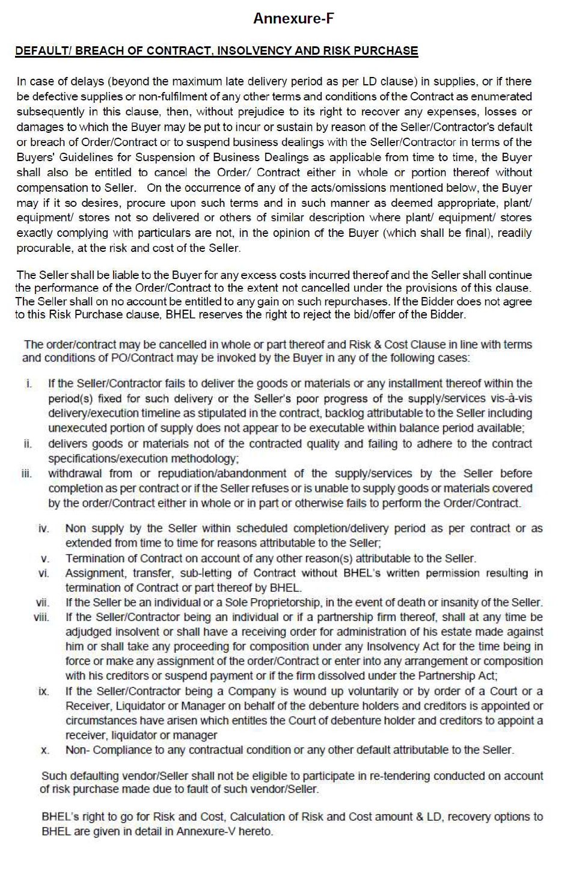
ANNEXURE A
ANNEXURE V

ANNEXURE B
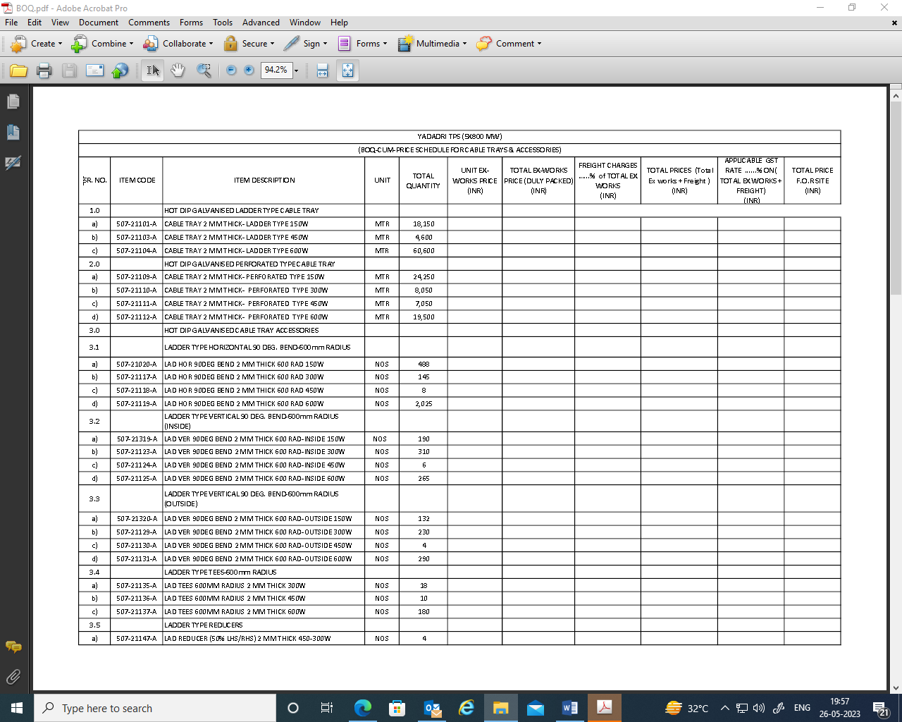
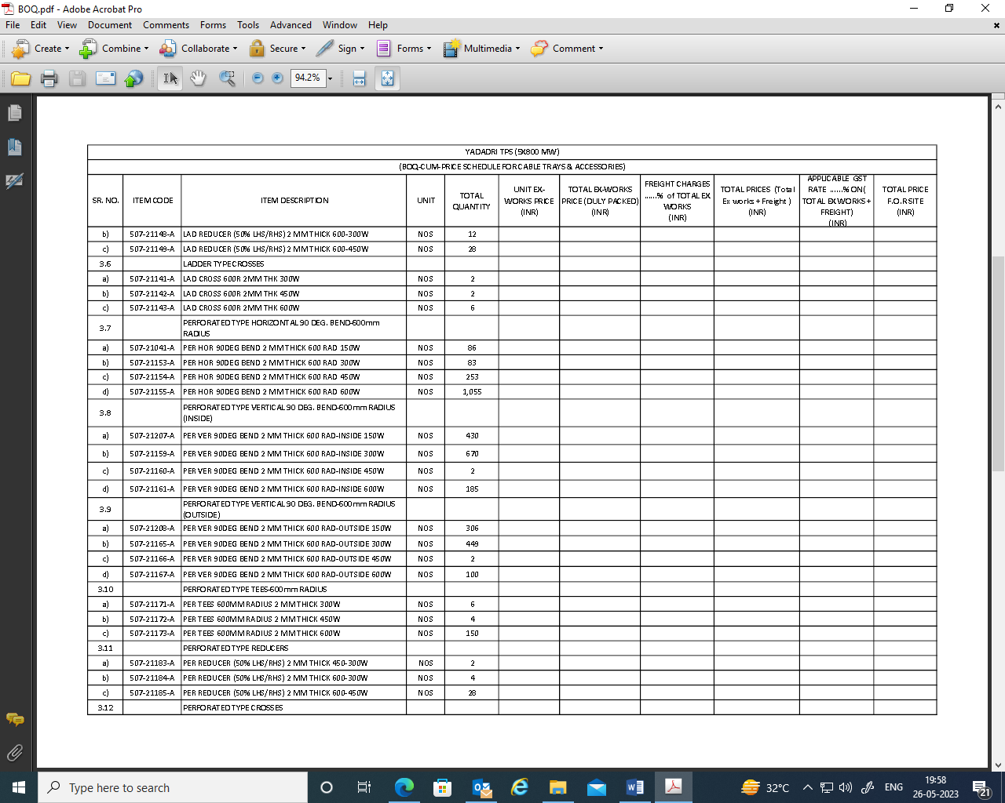

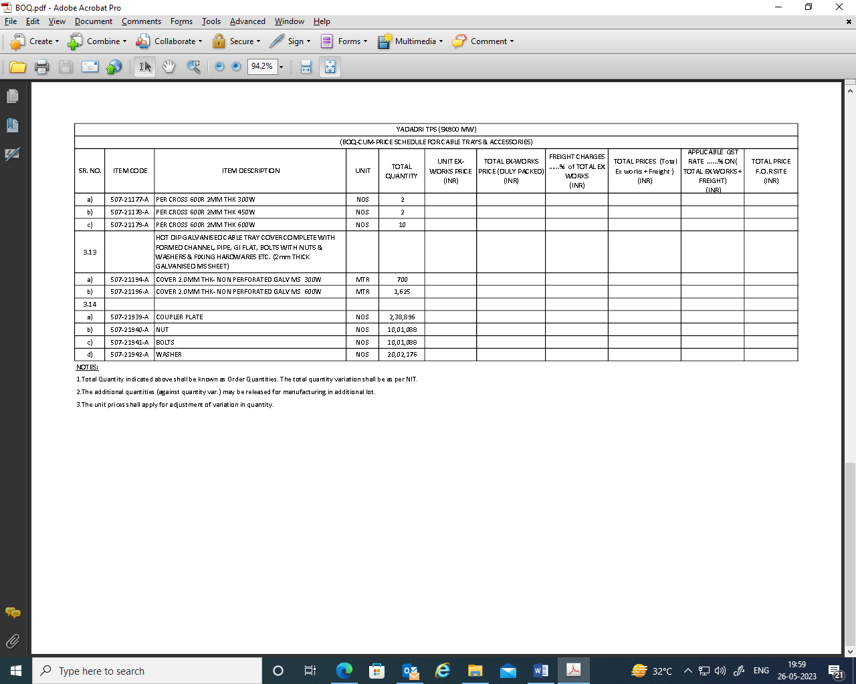

TECHNICAL PQR (Page 1 of 2)
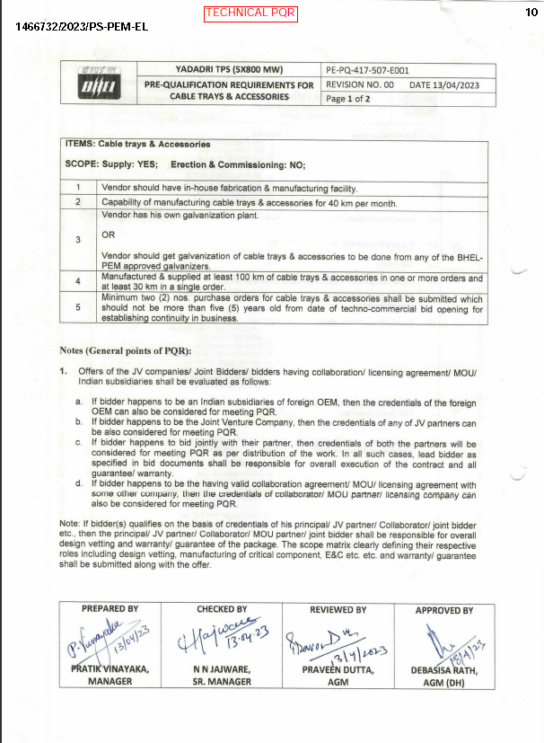

TECHNICAL PQR (Page 2 of 2)

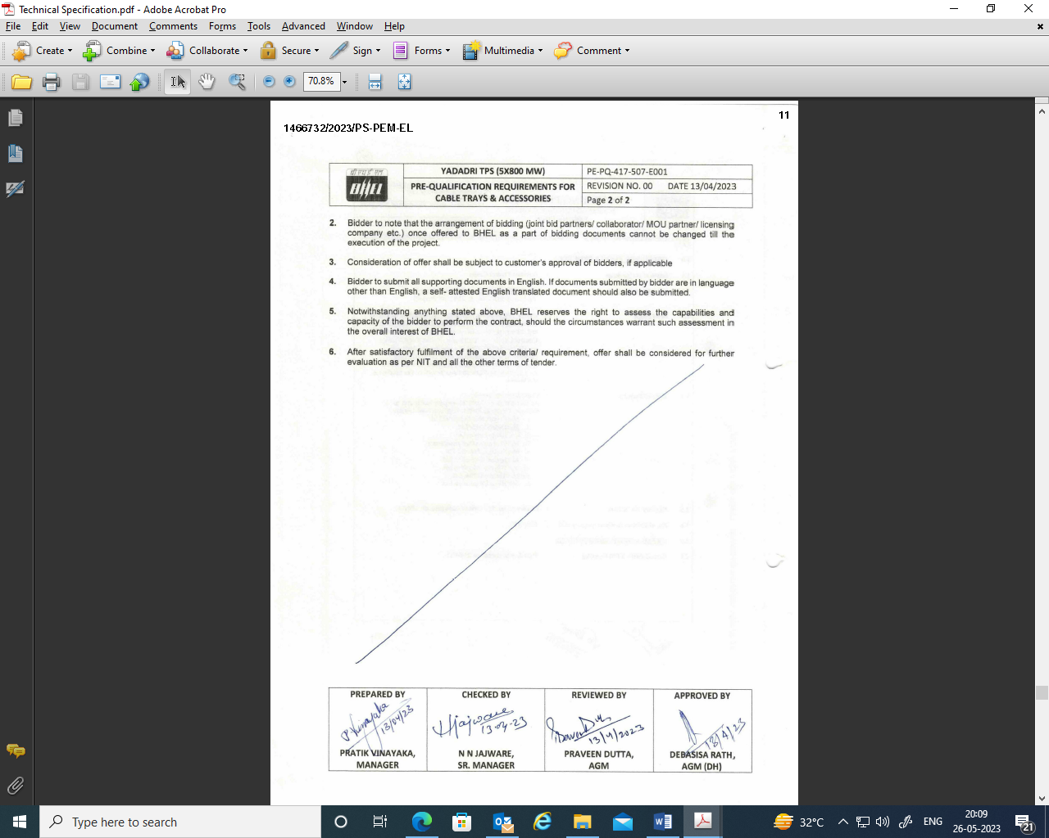

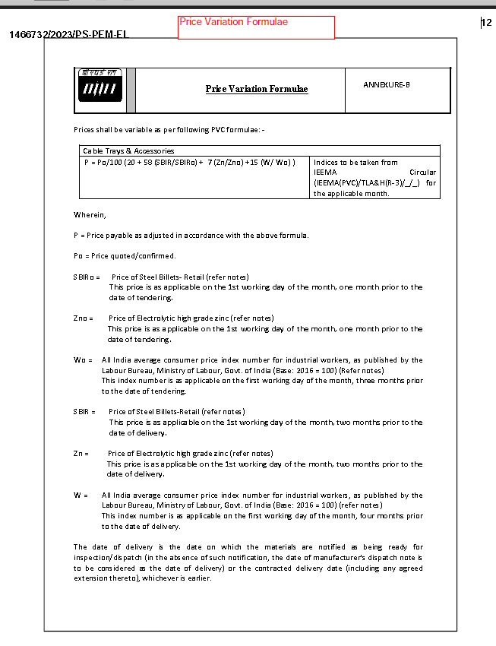

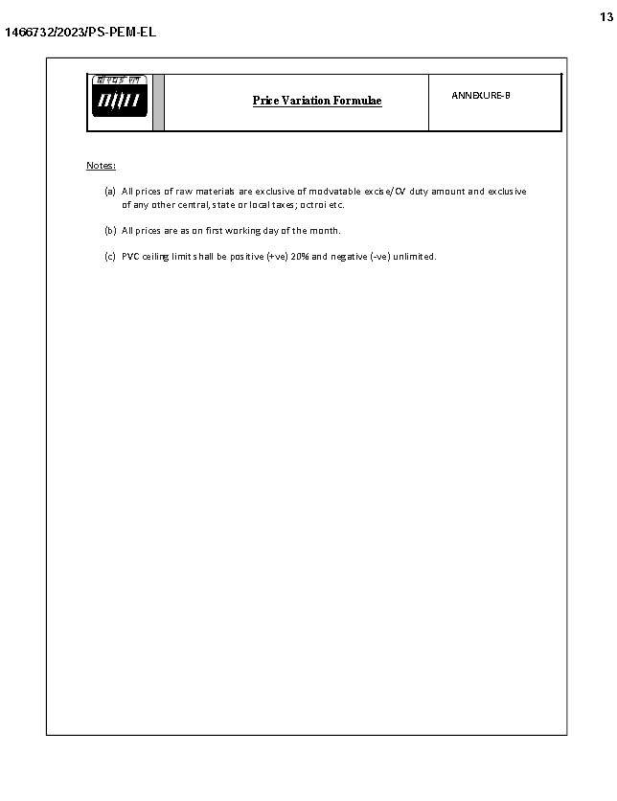

Land Border sharing Certificate

To,

M/s Bharat Heavy Electricals Ltd.,
Project Engineering Management,
Power Project Engineering Institute,
HRD & ESI Complex,
Plot No 25, Sector‐16 A, Noida‐201301

Dear Sir,

This has reference to:
1. Our offer for Cable Trays & Accessories for 5x800 MW Yadadri TPS., Tender No. GEM/2023/B/3496368 dated 26.05.23
2. Order no. F. No. 6/18/2019-PPD dt. 23.07.2020 issued by Ministry of Finance, Department of Expenditure Public Procurement Division.

I have read the clause regarding restriction on procurement from a bidder of a country which shares a land border with India; I certify that M/s (Company Name______________________________) is not from such a country,
or,
if from such a country, has been registered with the competent authority. (Strike through if not applicable)

I hereby certify that M/s (Company Name__________________________) fulfil all requirements in this regard and is eligible to be considered for procurement on GeM.

[where applicable, evidence of valid registration by the competent authority shall be attached]

Thanking You,
Yours faithfully,

Director/Proprietor/Partner
M/s _______________

LOCAL CONTENT CERTIFICATE

To,
Bharat Heavy Electricals Limited
PEM, PPEI Building, Plot No 25,
Sector 16 A, Noida (U.P)-201301

Subject: - Certification regarding local content
Reference: Tender Enquiry No.: GEM/2023/B/3496368 dated 26.05.23
Name of Package: Cable Trays & Accessories
Project Name: 5x800 MW Yadadri TPS

Dear Sir,

We hereby certify that items offered by us for above cited Tender Enquiry ref. ………….. has local content of _____%

Further, it is also certified that the local content % certified above is in line with definition of local content given in Public Procurement (Preference to Make in India), Order 2017-revision, having ref no. P45021/2017/-PP (BE-II) dtd. 04.06.20 & 16.09.20 and we qualify as Class_____ local supplier.

We further confirm that address of the location at which the local value addition is made will be as follows:
____________________________
____________________________
____________________________
____________________________
____________________________

Thanking You,
Yours faithfully,

M/s _______________

FINANCIAL PQR (Page 1 of 1)

