- Package | PRE-TREATMENT PLANT
- Project | 2X660 MW ENNORE SEZ STPP
- End Customer | TANGEDCO
- Executing Agency | BHEL-PSSR
- Nature of Package  (Divisible/Non-Divisible) | Non-Divisible
- Technical Scope | As per Technical specification No: PE-TS-412-158-A002
- Schedule of Pre-Bid Discussion | Based on Bidder’s request, Pre-Bid meeting shall be arranged.
- Prequalification Requirement | Financial PQR- YES | Technical PQR- YES
- Earnest Money Deposit | EMD is applicable. EMD amount shall be Rs. 6 Lakh.  Modes of deposit: -  The EMD may be accepted only in the following forms:  - Electronic Fund Transfer credited in BHEL account (before tender opening) and furnish the details of EFT along with the offer  BHEL-PEM account details are as follows:  Bank name, State Bank of India  Account No: 39922687394  IFSC: SBIN0017313  BRANCH-CAG II NEW DELHI​  - Banker's cheque/ Pay order/ Demand draft, in favour of BHEL-PEM, Noida (along with the offer).  - Fixed Deposit Receipt (FDR)  - Bank Guarantee from any of the Scheduled Banks.  - Insurance Surety Bonds.  The EMD shall remain valid for a period of 45 (forty-five) days beyond the final bid validity period.  Forfeiture of EMD  - A bidder's EMD will be forfeited if the bidder withdraws or amends its/his tender or impairs or derogates from the tender in any respect within the period of validity of the tender or if the successful bidder fails to furnish the required performance security within the specified period mentioned in the Tender.  - EMD by the tenderer to be withheld in case any action on the bidder is envisaged under the provisions of extant "Guidelines on Suspension of business dealings with suppliers/ contractors (abridged version of guidelines is available on www.bhel.com)" and forfeited/ released based on the action as determined under these guidelines.  - Bid securities of the unsuccessful bidders shall be returned to them after expiry of the final bid validity period and latest by the 30th day after the award of the contract. However, bid securities of unsuccessful bidders during first stage i.e. technical-commercial evaluation etc. shall be returned within 30 days of declaration of result of first stage i.e. technical-commercial evaluation.  - Bid security shall be refunded to the successful bidder on conclusion of the order/ receipt of a performance security.  - EMD shall not carry any interest
- Performance Security | - Initially 10% of the contract value (total order value excluding PVC). However, 5% of the contract value (as above) will be released after completion of Main Supply based on certification by BHEL.  OR  - 5% of the contract value (total order value excluding PVC). Additional 5% of the contract value will be retained from first bill & subsequent bill(s) of the same contract. The retention amount will be released after completion of Main Supply based on certification by BHEL.  - Initial validity of performance security shall be 26 months from LOA date (Considering delivery period of 06 months + 18 months guarantee period + 2 months claim period is already mentioned in GTC cl no. 7.ii GeM 3.0). Further, extension if any shall be as per GeM Terms.  Modes of deposit:  Performance security may be furnished in the following forms:  - Local cheques of Scheduled Banks (subject to realization)/ Pay Order/ Demand Draft/ Electronic Fund Transfer in favour of BHEL.  - Bank Guarantee from Scheduled Banks / Public Financial Institutions as defined in the Companies Act. The Bank Guarantee format should have the approval of BHEL.  - Fixed Deposit Receipt issued by Scheduled Banks / Public Financial Institutions as defined in the Companies Act (FDR should be in the name of the Contractor, a/c BHEL).  - Securities available from Indian Post offices such as National Savings Certificates, Kisan Vikas Patras etc. (held in the name of Contractor furnishing the security and duly endorsed/ hypothecated/ pledged, as applicable, in favour of BHEL).  - Insurance Surety Bond.  (Note: BHEL will not be liable or responsible in any manner for the collection of interest or renewal of the documents or in any other matter connected therewith)  Performance Security is to be furnished within 14 days from the date of PO/LOA and it should remain valid for a period of 60 (sixty) days beyond the date of completion of all contractual obligations of the supplier, including warranty obligations.  Forfeiture of Performance Security:  - The performance security will be forfeited and credited to BHEL's account in the event of a breach of contract by the supplier.  - Performance security should be refunded to the contractor without interest, after he duly performs and completes the contract in all respects but not later than 60(sixty) days of completion of all such obligations including the warranty under the contract.  The Performance Security shall not carry any interest.
- Breach of contract, Remedies and Termination | “In case of Breach of Contract, BHEL shall recover 10% of the contract value from the Vendor using following instruments:  (i) Encashment of security instruments like EMD, Performance Security with PEM against the said contract  (ii) Balance amount (if value of security instruments is less than 10% of the contract value) from other financial remedies i.e. available bills of the Vendor, retention amount etc. with BHEL.  (iii) Balance amount from security instruments like EMD, Performance Security and other financial remedies i.e. available bills of the Vendor, retention amount etc. with other units of BHEL  (iv) if recovery is not possible then legal remedies shall be pursued”  The balance scope shall be got done independently without Risk & Cost of the failed supplier/ contractor. Further, levy of liquidated damages, debarment, termination, de-scoping, short-closure, etc., shall be applied as per provisions of the contract.
- Delivery terms for Supply portion | FOR Despatch Station
- Integrity Pact Applicability - | YES
- Bidders can also download detailed tender for subject package & project uploaded at www.pem.bhel.com and www.bhel.com.
- In line with cl. No. 12 of (ITB) BOP-GCC, following Independent External Monitors (IEMs) have been appointed by BHEL.
Shri Otem Dai, IAS (Retd.) (iem1@bhel.in)
Shri Bishwamitra Pandey, IRAS (Retd.) (iem2@bhel.in)
Shri Mukesh Mittal, IRS (Retd.) (iem3@bhel.in)
- Delivery Schedule shall be as follows-

Main Supply (along with commissioning spares) – 6 months from the date of LOA.

E&C - Within 04 months from the date of front availability by site. Site front availability will be reckoned as the date when site informs vendor for mobilization of manpower & resources.

Mandatory Spares - 3 months from approval of BBU of mandatory spares by BHEL.

Note: Above delivery conditions are to be complied by bidder strictly

Delivery on GeM portal shall be selected as 999 days. Same shall be indicative to suffice the GeM portal requirement.
- Payment Terms - As per GCC BOP Rev-00. Provision of offline payment in GeM shall be utilized.
- Evaluation Criteria - Total Package Price (including freight and taxes)
Bidder has to quote the total package price of complete scope, as per technical specification, in GeM. Price break up of total package price shall be provided by bidder in price format uploaded in GeM.
In case of discrepancy between total package price and price break up, total price quoted on GeM shall prevail and break up shall be corrected accordingly.
- In the event of conflicts or discrepancies among the Contract Documents, interpretations will be based on the following order of precedence:
i. Amendments to Purchase Order/ Work Order/ Framework Agreement
ii. Purchase Order/ Work Order/ Framework Agreement
iii. Letter of intent (LOI)/ Letter of Award (LOA)
iv. Clarifications agreed between Buyer and Seller as regards to the tender or the bidding conditions
v. The final set of deviations acceptable to purchaser with loading as specified in relevant section.
vi. Corrigenda to NIT, with those of later date having precedence over those of earlier date
vii. Enquiry letter along with Buyer specific ATC and annexures except documents listed in point no (vii) to (ix) below
viii. Technical specifications
ix. Special Conditions of Contract (SCC)
x. GeM GTC latest version applicable as on enquiry date.

Bidders to note the following Additional Terms and Conditions for subject tender-

- Insurance Deductibles and Excess:

For Marine Cover: Rs 20,000/-

For Storage /Erection and Testing Cover:
a. Normal Period: 5 % of the claim amount subject to a minimum of Rs. 2.25 Lakh.
b. Testing Period: 5% of the claim amount subject to minimum of Rs. 6.0 Lakh.

Act of God Perils: - 10% of the claim amount subject to minimum of testing period excess.

Fire / Explosion Claims: 20% of the claim amount subject to minimum of testing period excess

Extended Maintenance Cover/ Defect Liability Cover: As applicable for testing period excess.

Third Party Liability: The policy excesses (normal/testing periods) shall apply for third party liability property damage claims also. For third party liability claims arising out of acts of GOD perils. The excess applicable to AOG claims shall apply.

“The above-mentioned insurance deductibles/excess are tentative in nature and may change after award of contract which will be applicable within quoted price".

- Vendors shall submit billing documents for payment directly to BHEL. Payment will be released within days as mentioned below after submission of complete documents:

- 90 days for non MSME as per MSMED Act
- 45 days for vendors qualified and registered as Micro and Small Enterprises MSEs as per MSMED Act
- 60 days for vendors qualified as Medium Enterprises as per MSMED Act.
Notes:
- Vendors are required to issue Tax Invoice inclusive of PVC value (if applicable) wherever indices are available. In case PVC indices not available, vendors to submit PVC invoices on availability of applicable indices.
- Any negative PVC, if not adjusted in earlier payments, will be adjusted at the time of remaining payments.

- Bidder to note that this is an Open Tender enquiry & PBO/RA participation shall be subject to following condition:
a. Qualifying Technical & Financial Pre-Qualification Requirement.
b. Techno-commercial acceptance of offer by BHEL-PEM.
c. Approval of bidder by End Customer: - Same shall be taken up with end customer based on the latest credentials/reference list furnished by bidder in the format. Accordingly, bidders are requested to submit credential along with their technical bid.

The bidders who are not registered with BHEL-PEM may apply for registration in BHEL-PEM through Registration Portal available at www.pem.bhel.com -->vendor section-->online supplier registration. All credentials and/or documents duly signed & stamped related to registration has to be uploaded on the website & submit the application for registration. One set of hard copy filled-up SRF downloaded from Online Registration Portal duly signed & stamped has to be submitted.
- The offers of the bidders who are under suspension as also the offers of the bidders, who engage the services of the firms debarred across BHEL, shall be rejected. The list of firms debarred across BHEL is available on BHEL web site www.bhel.com.

- Integrity commitment, performance of the contract and punitive action thereof:

  - Commitment by BHEL: BHEL commits to take all measures necessary to prevent corruption in connection with the tender process and execution of the contract. BHEL will during the tender process treat all Bidder(s) in a transparent and fair manner, and with equity.
1.2. Commitment by Bidder/ Supplier/ Contractor:

1.2.1. The bidder/ supplier/ contractor commit to take all measures to prevent corruption and will not directly or indirectly influence any decision or benefit which he is not legally entitled to nor will act or omit in any manner which tantamount to an offence punishable under any provision of the Indian Penal Code, 1860 or any other law in force in India.

1.2.2. The bidder/ supplier/ contractor will, when presenting his bid, disclose any and all payments he has made, and is committed to or intends to make to agents, brokers or any other intermediaries in connection with the award of the contract and shall adhere to relevant guidelines issued from time to time by Govt. of India/ BHEL.

1.2.3. The bidder/ supplier/ contractor will perform/ execute the contract as per the contract terms & conditions and will not default without any reasonable cause, which causes loss of business/ money/ reputation, to BHEL.

If any bidder/ supplier/ contractor during pre-tendering/ tendering/ post tendering/ award/ execution/ post-execution stage indulges in malpractices, cheating, bribery, fraud or and other misconduct or formation of cartel so as to influence the bidding process or influence the price or acts or omits in any manner which tantamount to an offence punishable under any provision of the Indian Penal Code, 1860 or any other law in force in India, then, action may be taken against such bidder/ supplier/ contractor as per extant guidelines of the company available on www. bhel.com and/or under applicable legal provisions”.
- Bidders to ensure that Third party/customer issued certificates being submitted as proof of PQR qualification should have verifiable details of document/certificate issuing authority such as name & designation of Issuing Authority and its organization contact number and e ‐ mail Id etc. In case the same found not available, Purchaser has right to reject such document from evaluation.

- Bidders to comply Govt. of India, Ministry of Power, order no-25-111612018-PG dated 02/07/2020 regarding mandatory testing of all the imported items/equipment’s/components.

- This item/Package falls under the list of items defined in Para 3 of Ministry guideline ref no.F.20/2/214-PPD(Pt.) dated.20-09-2016 (in respect of procurement of items related to public safety, health, critical security operations and equipment’s, etc) & hence no relaxation of PQR for start-up/MSME vendors is envisaged for the items/Package”

- Bidders may visit site/ work area and study the job content, facilities available, availability of materials, prevailing site conditions including law & order situation etc. before quoting for this tender. They may also consult this office before submitting their offers, for any clarifications regarding scope of work, facilities available at sites or on terms and conditions. No additional claim shall be entertained by BHEL in future, on account of non-acquaintance of above.

- The Bidder declares that they will not enter into any illegal or undisclosed agreement or understanding, whether formal or informal with other Bidder(s). This applies in particular to prices, specifications, certifications, subsidiary contracts, submission or non-submission of bids or any other actions to restrict competitiveness or to introduce cartelization in the bidding process. In case, the Bidder is found having indulged in above activities, suitable action shall be taken by BHEL as per extant policies/ guidelines

- A bidder shall not have conflict of interest with other bidders. Such conflict of interest can lead to anti-competitive practices to the detriment of Procuring Entity's interests. The bidder found to have a conflict of interest shall be disqualified. A bidder may be considered to have a conflict of interest with one or more parties in this bidding process, if:
a) they have controlling partner (s) in common;' or
b) they receive or have received any direct or indirect subsidy/ financial stake from any of them; or
c) they have the same legal representative/agent for purposes of this bid; or
d) they have relationship with each other, directly or through common third parties, that puts them in a position to have access to information about or influence on the bid of another Bidder; or
e) Bidder participates in more than one bid in this bidding process. Participation by a Bidder in more than one Bid will result in the disqualification of all bids in which the parties are involved. However, this does not limit the inclusion of the components/ sub-assembly/ Assemblies from one bidding manufacturer in more than one bid, or
f) In cases of agents quoting in offshore procurements, on behalf of their principal manufacturers, one agent cannot represent two manufacturers or quote on their behalf in a particular tender enquiry. One manufacturer can also authorize only one agent/dealer. There can be only one bid from the following:
1. The principal manufacturer directly or through one Indian agent on his behalf; and
2. Indian/foreign agent on behalf of only one principal,'
or
g) A Bidder or any of its affiliates participated as a consultant in the preparation of the design or technical specifications of the contract that is the subject of the Bid, or
h) In case of a holding company having more than one independently manufacturing units, or more than one unit having common business ownership/management, only one unit should quote. Similar restrictions would apply to closely related sister companies. Bidders must proactively declare such sister/ common business/ management units in same/ similar line of business. "

- HSE Plan Rev-02 for site operations by contractor shall be applicable.

- Bidder to quote non-zero freight %.

- "In the course of evaluation, if more than one bidder happens to occupy L-1 status, effective L-1 will be decided by soliciting discounts from the respective L-1 bidders. In case more than one bidder happens to occupy the L-1 status even after soliciting discounts, the L-1 bidder shall be decided by a toss / draw of lots, in the presence of the respective L-1 bidder(s) or their representative(s). Ranking will be done accordingly. BHEL's decision in such situations shall be final and binding."
- Self-declarations/ auditor’s/ accountant’s certificates submitted by the manufacturer/ supplier may be verified randomly by the committee constituted as per MoP Order 28-07- 2020. In case of false documents/misrepresentation of the facts requisite action against such manufacturer/ supplier will be taken based on the recommendation of the Committee.

- Bidder to agree with all the clauses except (clause no-6.0 to 9.0, 13.0, 15.0 & 25.0 of ITB of GCC-BOP, 11.0 & 27.0 of GCTC of GCC-BOP) of GCC BOP (available on www.pem.bhel.com) & SCC Rev-02 of the project.

- All other correspondence thereof shall be addressed to the undersigned by name & designation and sent at the following address:

Sanjeev Kumar/Dy. Engineer– BOP  M/s Bharat Heavy Electricals Ltd.,  Project Engineering Management,  Power Project Engineering Institute,  HRD & ESI Complex,  Plot No 25, Sector-16 A, Noida-201301  E-MAIL: sanjeev_k@bhel.in  Ph. No. 9958175655 | Sumeet Sahay/MGR-BOP  M/s Bharat Heavy Electricals Ltd.,  Project Engineering Management,  Power Project Engineering Institute,  HRD & ESI Complex,  Plot No 25, Sector-16 A, Noida-201301  E-MAIL: sumeetsahay@bhel.in  Ph. No. 09999498202

Financial PQR

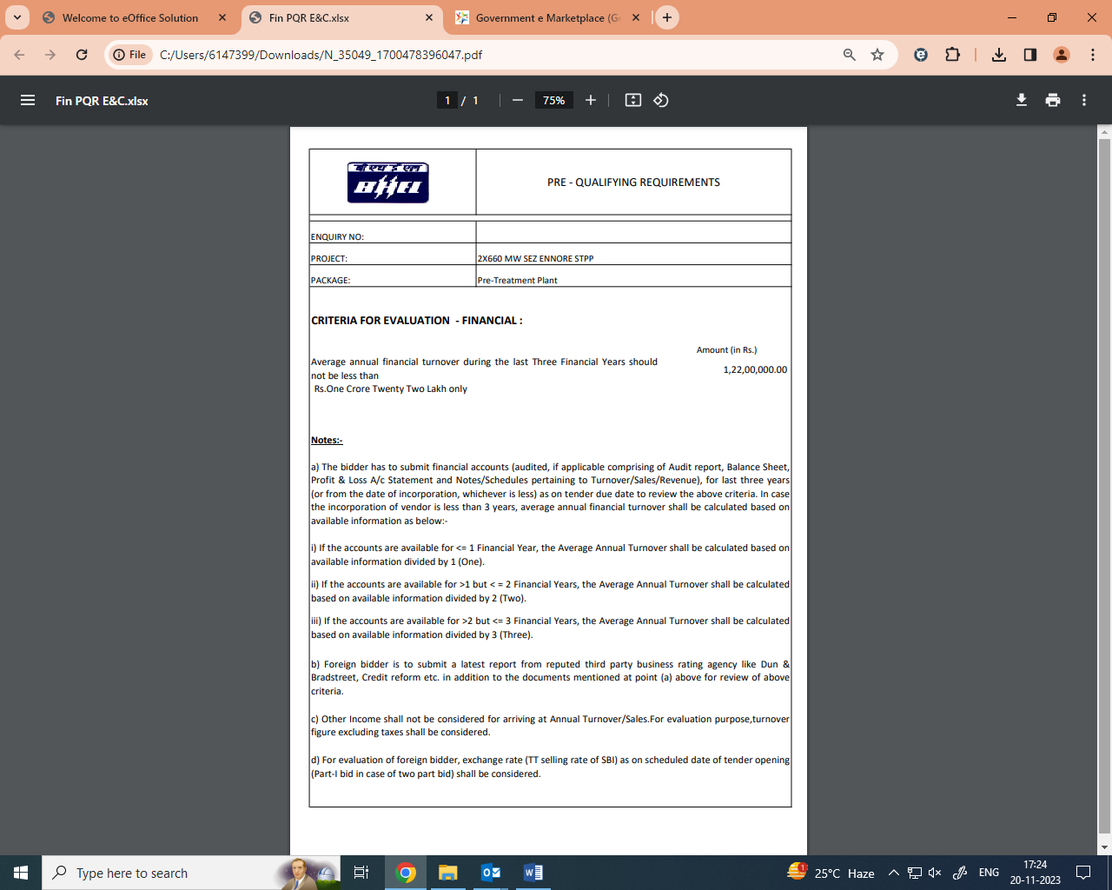

Technical PQR

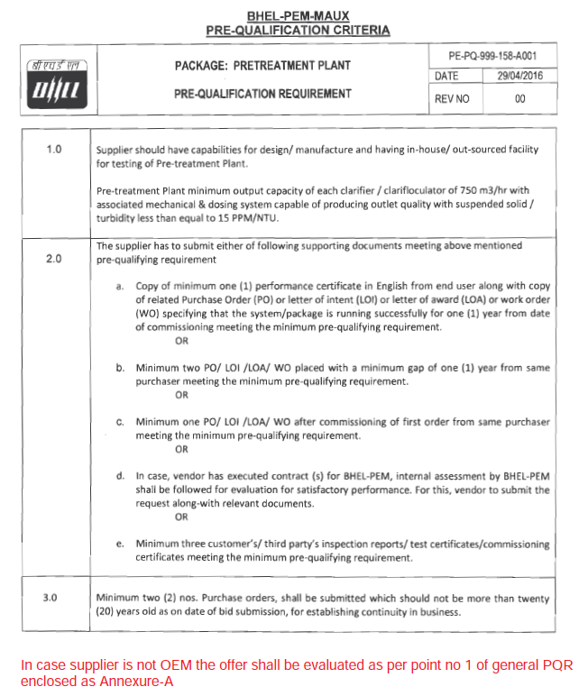
Format for Local Content Certificate

To be given on Letter head of Bidder

Ref: ……………………………………. Date: …………………….

To,
Bharat Heavy Electricals Limited
PEM, PPEI Building,
Plot No 25, Sector -16A
Noida (U.P)-201301

Reference: Tender Enquiry No‐……………………………………………………
Name of Package: ……………………………………………………………………….

Dear Sir,
We hereby certify that items of …………………………………………………………………... (Package name) for……………………………………… (Project Name) offered by M/s ……………………………………… (bidder’s name) having its works/office at …………………………………………… has local content of …………………….%.

Further, it is also certified that the local content percentage (%) certified above is in line with definition of local content given in point no 2 of Public Procurement (Preference to Make in India), Order 2017‐revision, having ref. no. P‐45021/2/2017‐PP(BE‐II) dated 04.06.2020 & 16.09.2020 an M/s……………………………....................... qualifies as Class‐I local supplier.

Details of the location(s)/Addresses at which the local value addition-

Yours very truly

…………………………. (Signing Authority Name & Sign)
…………………………… (Firm Name)

Company Stamp

Format for Local Boundary Certificate

To be given on Letter head of Bidder

Ref: ……………………………………. Date: …………………….

To,
Bharat Heavy Electricals Limited
PEM, PPEI Building,
Plot No 25, Sector -16A
Noida (U.P)-201301

Reference: Order no-F6/18/2019-PPD dated 23.07.2020 issued by Ministry of Finance.

Tender Enquiry No‐……………………………………………………

Offer No-……………………………………………….

Name of Package: ……………………………………………………………………….

Dear Sir,

I have read the clause regarding restriction on procurement from a bidder of a country which shares a land border with India. I hereby certify that Company name, is not from such a country and is eligible to be considered.

Thanking You,

Yours faithfully,

(Company director seal and signature)

