- Package | COMPRESSED AIR SYSTEM
- Project | 2 X 660 MW NTPC TALCHER TPP STAGE-III
- End Customer | NTPC
- Executing Agency | BHEL-PSWR
- Nature of Package  (Divisible/Non-Divisible) | Non-Divisible
- Technical Scope | As per Technical specification No: PE-PF-497-555-A001
- Schedule of Pre-Bid Discussion | Based on Bidder’s request, Pre-Bid meeting shall be arranged.
- Prequalification Requirement | Financial PQR- YES | Technical PQR- YES
- Delivery terms for Supply portion | FOR Despatch Station
- Integrity Pact Applicability - | YES
- Bidders to download detailed technical specification for subject package & project uploaded at www.pem.bhel.com and www.bhel.com
- In line with cl. No. 12 of (ITB) BOP-GCC, following Independent External Monitors (IEMs) have been appointed by BHEL.
Shri Otem Dai, IAS (Retd.) (iem1@bhel.in)
Shri Bishwamitra Pandey, IRAS (Retd.) (iem2@bhel.in)
Shri Mukesh Mittal, IRS (Retd.) (iem3@bhel.in)
- Delivery Schedule shall be as follows-

Design/Engg. Services- Drawing/ documents submission schedule shall be as per Annexure-III of Section-E of Technical Specification- PE-PF-497-555-A001.

Supply (along with commissioning spares) – 14 months from the date of LOA.

E&C - Within 04 months from the date of availability of front. Site front availability will be reckoned as the date when site informs vendor for mobilization of manpower & resources. **

Mandatory Spares - Mandatory Spares and Tools & tackles (if any) are to be delivered along with the last consignment of main supply within the contractual delivery period.

AMC Services- Personnel for AMC Services shall be deputed within 10 days of intimation.

** For PVC calculation purpose contractual delivery for E&C shall be considered as 18 (4 months +14 months) month from LOA.

Note: Above delivery conditions are to be complied by bidder strictly.
- Min E&C Charges: Total Erection & Commissioning Charges (excluding GST) should be minimum 10% of the total quoted price of main equipment supply (including freight & excluding GST) and erection & commissioning (excluding GST), failing which the break-up of prices shall be adjusted accordingly for ordering. However, while doing adjustments, vendor quoted prices for mandatory spares, PG test charges, O&M spares, O&M charges, etc. will not be changed.
- Payment Terms - As per GCC BOP Rev-00. Provision of offline payment in GeM shall be utilized.
- Evaluation Criteria - Total Package Price (including freight and taxes)

Bidder has to quote the total package price of complete scope, as per technical specification, in GeM. Price break up of total package price shall be provided by bidder in price format uploaded in GeM.

In case of discrepancy between total package price and price break up, total price quoted on GeM shall prevail and break up shall be corrected accordingly.

Bidders to note the following Additional Terms and Conditions for subject tender-

- The charges for Non-deployment of Safety officer and Quality Engineer is Rs. 50,000.00 per man-month for each staff. This charge amount is exclusive of GST

- Insurance Deductibles and Excess:

For Marine Cover: Rs 20,000/-

For Storage /Erection and Testing Cover:
a. Normal Period: 5 % of the claim amount subject to a minimum of Rs. 2.25 Lakh.
b. Testing Period: 5% of the claim amount subject to minimum of Rs. 6.0 Lakh.

Act of God Perils: - 10% of the claim amount subject to minimum of testing period excess.

Fire / Explosion Claims: 20% of the claim amount subject to minimum of testing period excess

Extended Maintenance Cover/ Defect Liability Cover: As applicable for testing period excess.

Third Party Liability: The policy excesses (normal/testing periods) shall apply for third party liability property damage claims also. For third party liability claims arising out of acts of GOD perils. The excess applicable to AOG claims shall apply.

“The above-mentioned insurance deductibles/excess are tentative in nature and may change after award of contract which will be applicable within quoted price".

- Vendors shall submit billing documents for payment directly to BHEL. Payment will be released within days as mentioned below after submission of complete documents:

- 90 days for non MSME as per MSMED Act
- 45 days for vendors qualified and registered as Micro and Small Enterprises MSEs as per MSMED Act
- 60 days for vendors qualified as Medium Enterprises as per MSMED Act.
Notes:
- Vendors are required to issue Tax Invoice inclusive of PVC value (if applicable) wherever indices are available. In case PVC indices not available, vendors to submit PVC invoices on availability of applicable indices.
- Any negative PVC, if not adjusted in earlier payments, will be adjusted at the time of remaining payments.

- Bidder to note that this is an Open Tender enquiry & PBO shall be subject to following condition:
a. Qualifying Technical & Financial Pre-Qualification Requirement.
b. Techno-commercial acceptance of offer by BHEL-PEM.
c. Approval of bidder by End Customer: - Same shall be taken up with end customer based on the latest credentials/reference list furnished by bidder in the format. Accordingly, bidders are requested to submit credential along with their technical bid.

The bidders who are not registered with BHEL-PEM may apply for registration in BHEL-PEM through Registration Portal available at www.pem.bhel.com -->vendor section-->online supplier registration. All credentials and/or documents duly signed & stamped related to registration has to be uploaded on the website & submit the application for registration. One set of hard copy filled-up SRF downloaded from Online Registration Portal duly signed & stamped has to be submitted.
- Bidders to ensure that Third party/customer issued certificates being submitted as proof of PQR qualification should have verifiable details of document/certificate issuing authority such as name & designation of Issuing Authority and its organization contact number and e ‐ mail Id etc. In case the same found not available, Purchaser has right to reject such document from evaluation.

- Bidders to comply Govt. of India, Ministry of Power, order no-25-111612018-PG dated 02/07/2020 regarding mandatory testing of all the imported items/equipment’s/components.

- This item/Package falls under the list of items defined in Para 3 of Ministry guideline ref no.F.20/2/214-PPD(Pt.) dated.20-09-2016 (in respect of procurement of items related to public safety, health, critical security operations and equipment’s, etc) & hence no relaxation of PQR for start-up/MSME vendors is envisaged for the items/Package”

- Bidders may visit site/ work area and study the job content, facilities available, availability of materials, prevailing site conditions including law & order situation etc. before quoting for this tender. They may also consult this office before submitting their offers, for any clarifications regarding scope of work, facilities available at sites or on terms and conditions. No additional claim shall be entertained by BHEL in future, on account of non-acquaintance of above.

- The Bidder declares that they will not enter into any illegal or undisclosed agreement or understanding, whether formal or informal with other Bidder(s). This applies in particular to prices, specifications, certifications, subsidiary contracts, submission or non-submission of bids or any other actions to restrict competitiveness or to introduce cartelization in the bidding process. In case, the Bidder is found having indulged in above activities, suitable action shall be taken by BHEL as per extant policies/ guidelines

- A bidder shall not have conflict of interest with other bidders. Such conflict of interest can lead to anti-competitive practices to the detriment of Procuring Entity's interests. The bidder found to have a conflict of interest shall be disqualified. A bidder may be considered to have a conflict of interest with one or more parties in this bidding process, if:
a) they have controlling partner (s) in common;' or
b) they receive or have received any direct or indirect subsidy/ financial stake from any of them; or
c) they have the same legal representative/agent for purposes of this bid; or
d) they have relationship with each other, directly or through common third parties, that puts them in a position to have access to information about or influence on the bid of another Bidder; or
e) Bidder participates in more than one bid in this bidding process. Participation by a Bidder in more than one Bid will result in the disqualification of all bids in which the parties are involved. However, this does not limit the inclusion of the components/ sub-assembly/ Assemblies from one bidding manufacturer in more than one bid, or
f) In cases of agents quoting in offshore procurements, on behalf of their principal manufacturers, one agent cannot represent two manufacturers or quote on their behalf in a particular tender enquiry. One manufacturer can also authorize only one agent/dealer. There can be only one bid from the following:
1. The principal manufacturer directly or through one Indian agent on his behalf; and
2. Indian/foreign agent on behalf of only one principal,'
or
g) A Bidder or any of its affiliates participated as a consultant in the preparation of the design or technical specifications of the contract that is the subject of the Bid, or
h) In case of a holding company having more than one independently manufacturing units, or more than one unit having common business ownership/management, only one unit should quote. Similar restrictions would apply to closely related sister companies. Bidders must proactively declare such sister/ common business/ management units in same/ similar line of business. "

- HSE Plan Rev-02 for site operations by contractor shall be applicable.

- Bidder to quote non-zero freight %.

- "In the course of evaluation, if more than one bidder happens to occupy L-1 status, effective L-1 will be decided by soliciting discounts from the respective L-1 bidders. In case more than one bidder happens to occupy the L-1 status even after soliciting discounts, the L-1 bidder shall be decided by a toss / draw of lots, in the presence of the respective L-1 bidder(s) or their representative(s). Ranking will be done accordingly. BHEL's decision in such situations shall be final and binding."

- “Self-declarations/ auditor’s/ accountant’s certificates submitted by the manufacturer/ supplier may be verified randomly by the committee constituted as per MoP Order 28-07- 2020. In case of false documents/misrepresentation of the facts requisite action against such manufacturer/ supplier will be taken based on the recommendation of the Committee.”

- Bidder to be in agreement with clause no. 1.6 & 22 (Instruction to bidders), clause no. 10.0, 12.0, 13.0, 14.0 to 30.0, 34.2, 36.0 to 46.0 of GCC BOP (available on www.pem.bhel.com) & SCC of the project.

- All other correspondence thereof shall be addressed to the undersigned by name & designation and sent at the following address:
Sanjeev Kumar/Dy. Engineer– BOP  M/s Bharat Heavy Electricals Ltd.,  Project Engineering Management,  Power Project Engineering Institute,  HRD & ESI Complex,  Plot No 25, Sector-16 A, Noida-201301  E-MAIL: sanjeev_k@bhel.in  Ph. No. 0120-4368590 | Sumeet Sahay/MGR-BOP  M/s Bharat Heavy Electricals Ltd.,  Project Engineering Management,  Power Project Engineering Institute,  HRD & ESI Complex,  Plot No 25, Sector-16 A, Noida-201301  E-MAIL: sumeetsahay@bhel.in  Ph. No. 09999498202

TECHNICAL PQR

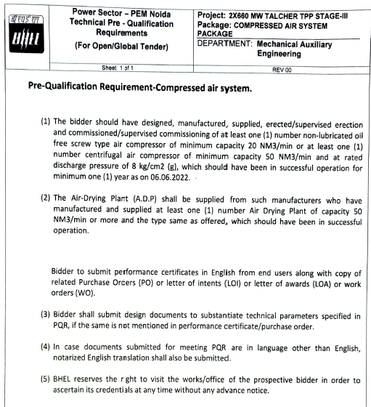

FINANCIAL PQR
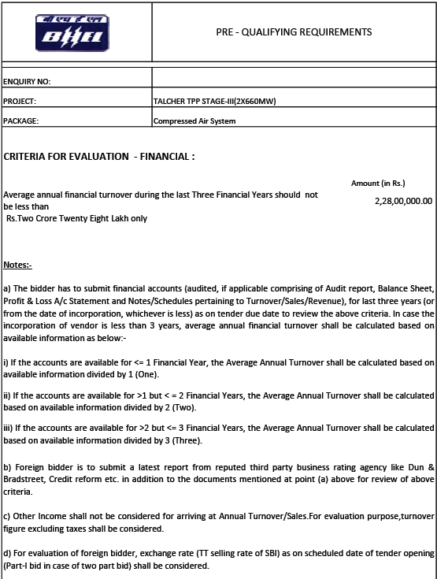
Certification regarding local content

Ref: ……………………………………. Date: …………………….

To,
Bharat Heavy Electricals Limited
PEM, PPEI Building,
Plot No 25, Sector -16A
Noida (U.P)-201301

Reference: Tender Enquiry No‐……………………………………………………
Name of Package: ……………………………………………………………………….

Dear Sir,
We hereby certify that items of …………………………………………………………………... (Package name) for……………………………………… (Project Name) offered by M/s ……………………………………… (bidder’s name) having its works/office at …………………………………………… has local content of …………………….%.

Further, it is also certified that the local content percentage (%) certified above is in line with definition of local content given in point no 2 of Public Procurement (Preference to Make in India), Order 2017‐revision, having ref. no. P‐45021/2/2017‐PP(BE‐II) dated 04.06.2020 & 16.09.2020 an M/s……………………………....................... qualifies as Class‐I/Class‐II (strike out whichever is not applicable) local supplier.

Details of the location(s)/Addresses at which the local value addition-

Yours very truly

…………………………. (Signing Authority Name & Sign)
…………………………… (Firm Name)

Company Stamp

Certification regarding land border

To be given on Letter head of Bidder

Ref: ……………………………………. Date: …………………….

To,
Bharat Heavy Electricals Limited
PEM, PPEI Building,
Plot No 25, Sector -16A
Noida (U.P)-201301

Reference:

Order no-F6/18/2019-PPD dated 23.07.2020 issued by Ministry of Finance.

Tender Enquiry No‐……………………………………………………

Offer No-………………………………………………..

Name of Package: ……………………………………………………………………….

Dear Sir,

I have read the clause regarding restriction on procurement from a bidder of a country which shares
a land border with India. I hereby certify that Company name, is not from such a country and is eligible
to be considered.

Thanking You,
Yours faithfully,
(Company director seal and signature)

SCC

VENDOR APPROVAL FORMAT

