**Corrigendum Details:**

1. Accuracy of ± 0.09 mm or better is acceptable for material codes TLMW66107784, TLMW66107792 and TLMW66107806.
2. PQR revised :

**REVISED PQR**

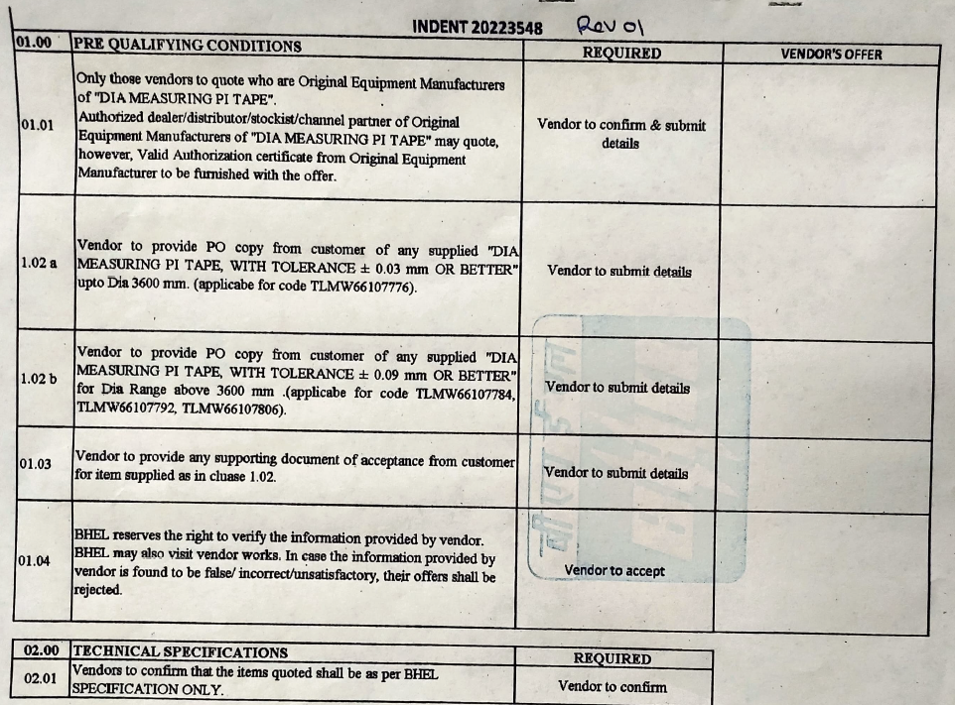

**ADDITIONAL TERMS & CONDITIONS**

**Commercial Term -**

All the commercial term shall be as per General terms and conditions on GeM 4.0 (Version 1.3).

**Special conditions of enquiry:**

1. Price bid shall be opened for only those bidders who qualifies PQR and whose techno-commercial bid is acceptable to BHEL as per technical specifications.
2. Vendor to provide point-wise reply/confirmation along with relevant supporting documents to each and every point of Pre-Qualification Requirements, Requirement of BHEL & Technical Specification (PQR, Requirement of BHEL & Technical specification) for all enquiry items. Non-compliance of these may lead to rejection of offer as these are essential condition for participating in tender enquiry.
3. Delivery is not sacrosanct. Vendor to quote best possible delivery in the offer. Early delivery is acceptable
4. MII, EMD shall not be applicable (cat B).
5. MSE splitting shall be applicable
6. VENDOR TO SUBMIT CALIBRATION CERTIFICATE ALONG WITH SUPPLY
7. Liquidated Damages (LD) for Late Deliveries shall be applicable @0.5% per week or part thereof on the respective delayed supplies subject to maximum of 10% of the lot order value. If vendor do not mention anything about LD clause in their offer, then it shall be presumed to be acceptable. No further clarification shall be asked in this regard after opening of techno-commercial bid part-1.
8. Payment terms shall be as per followings:

***“For Non MSEs bidder****:*

*100% payment along with taxes, freight & insurance will be made after receipt and acceptance of material and within 90 days from the date of invoice subject to submission of non-discrepant documents within 15 days of supply as per terms and conditions of Purchase Order.*

***For Medium Enterprises bidder****:*

*100% payment along with taxes, freight & insurance will be made after receipt and acceptance of material and within 60 days from the date of invoice subject to submission of non-discrepant documents within 15 days of supply as per terms and conditions of Purchase Order.*

***For MSEs bidder:***

*For MSEs (covered under MSME Act) which are registered and periodically renewed with BHEL, the payment will be made within 45 days or as prescribed in the relevant act.*

*Benefits of MSE (such as EMD Waiver, Tender fee exemption, Price preference, Payment preference etc.) will be given only to those MSE Vendors who are manufacturers of offered items against the NIT. No MSE benefits shall be provided to Agents / Stockists / Dealers / Traders etc. for the items offered but not manufactured by themselves.”*

1. ***Risk Purchase:***

In case of abnormal delays (beyond the maximum late delivery period as per LD clause) in supplies / defective supplies or non-fulfillment of any other terms and conditions given in Purchase Order, BHEL may cancel the Purchase Order in full or part thereof, and may also make the purchase of such material from elsewhere / alternative source at the risk and cost of the supplier. BHEL will take all reasonable steps to get the material from alternate source at optimum cost. If bidder does not agree to the above Risk Purchase Clause, BHEL reserves the right to reject the offer. In case for compelling reasons BHEL accepts the offer without acceptance of this clause by the bidder and in the eventuality of Risk Purchase, appropriate action will be taken as per BHEL extant rules. This will be without prejudice to any other right of BHEL under the contract or under General Law

1. ***Action against Bidders / vendor / supplier / contractor in case of default***:

In order to protect the commercial interests of BHEL, BHEL shall take action against supplies / contractors by way of suspension of business dealings, who either fail to perform or are in default without any reasonable cause, cause loss of business/ money/ reputation, indulge in malpractices, cheating, bribery, fraud or any other misconduct or formation of cartels so as to influence the bidding process or influence the price etc.

Suspension of Business Dealings could be in the form of “Hold” or “Banning” a supplier/ contractor or a bidder and shall be as per “Guidelines for Suspension of Business Dealings with Suppliers/ Contractors” available at BHEL’s website “<https://www.bhel.com/guidelines-suspension-business-dealings-supplierscontractors>”

1. “A bidder shall not have conflict of interest with other bidders. Such conflict of interest can lead to anti-competitive practices to the detriment of Procuring Entity's interests. The bidder found to have a conflict of interest shall be disqualified. A bidder may be considered to have a conflict of interest with one or more parties in this bidding process, if:

a) they have controlling partner (s) in common; or

b) they receive or have received any direct or indirect subsidy/ financial stake from any of them; or

c) they have the same legal representative/agent for purposes of this bid; or

d) they have relationship with each other, directly or through common third parties, that puts them in a

position to have access to information about or influence on the bid of another Bidder; or

e) Bidder participates in more than one bid in this bidding process. Participation by a Bidder in more than

one Bid will result in the disqualification of all bids in which the parties are involved. However, this does

not limit the inclusion of the components/ sub-assembly/ Assemblies from one bidding manufacturer in

more than one bid; or

f) In cases of agents quoting in offshore procurements, on behalf of their principal manufacturers, one agent

cannot represent two manufacturers or quote on their behalf in a particular tender enquiry. One

manufacturer can also authorize only one agent/dealer. There can be only one bid from the following:

1. The principal manufacturer directly or through one Indian agent on his behalf; and

2. Indian/foreign agent on behalf of only one principal;

or

g) A Bidder or any of its affiliates participated as a consultant in the preparation of the design or technical

specifications of the contract that is the subject of the Bid, or

h) In case of a holding company having more than one independently manufacturing units, or more than one

unit having common business ownership/management, only one unit should quote. Similar restrictions

would apply to closely related sister companies. Bidders must proactively declare such sister/ common

business/ management units in same/ similar line of business. "

1. RA shall be done if GeM allows RA for evaluation else RA shall not be done. The elimination criteria for RA shall be taken as “Elimination of H-1 Bidder.” *RA shall be done as per GeM guidelines as per circular AA:SSP:GeM:clar:R00 dt 01.12.22 .*

Rest terms & conditions shall be as per General terms and conditions on GeM 4.0 (Latest Version- applicable at

the time of issuance of enquiry).

**Item Details-**

|  |  |  |  |  |  |
| --- | --- | --- | --- | --- | --- |
| **Sl. No.** | **Material Code** | **Item Description** | **Qty. (NO.)** |  | **Delivery**  **Schedule** |
| 1 | TLMW66107776 | OUTER DIA MEASURING PI TAPE FOR DIA RANGE 3300-3600 MM, 6.35 MM GAGE WIDTH,12.7 MM BODY WIDTH,0.25 MM THICKNESS, ACCURACY +/- 0.03 MM,OF STAINLESS STEEL MATERIAL, CALIBRATED IN ACCORDANCE WITH ANSI/NCSL-Z540-1-1994,ISO/IEC 17025:2005 SIZE: 3300-3600 MM DIM.: DIA RANGE | 1 |  | 30.06.2023 |
| 2 | TLMW66107784 | OUTER DIA MEASURING PI TAPE FOR DIA RANGE 3600-3900 MM, 6.35 MM GAGE WIDTH, 12.7 MM BODY WIDTH,0.25 MM THICKNESS, ACCURACY +/- 0.03 MM, OF STAINLESS STEEL MATERIAL, CALIBRATED IN ACCORDANCE WITH ANSI/NCSL-Z540-1-1994,ISO/IEC 17025:2005 SIZE: 3600-3900 MM DIM.: DIA RANGE | 1 |  | 30.06.2023 |
| 3 | TLMW66107792 | OUTER DIA MEASURING PI TAPE FOR DIA RANGE 4500-4800 MM, 6.35 MM GAGE WIDTH,12.7 MM BODY WIDTH,0.25 MM THICKNESS, ACCURACY +/- 0.03 MM,OF STAINLESS STEEL MATERIAL, CALIBRATED IN ACCORDANCE WITH ANSI/NCSL-Z540-1-1994,ISO/IEC 17025:2005 SIZE: 4500-4800 MM DIM.: DIA RANGE | 1 |  | 30.06.2023 |
| 4 | TLMW66107806 | OUTER DIA MEASURING PI TAPE FOR DIA RANGE 4800-5100 MM, 6.35 MM GAGE WIDTH,12.7 MM BODY WIDTH,0.25 MM THICKNESS, ACCURACY +/- 0.03 MM,OF STAINLESS STEEL MATERIAL, CALIBRATED IN ACCORDANCE WITH ANSI/NCSL-Z540-1-1994,ISO/IEC 17025:2005 SIZE: 4800-5100 MM DIM.: DIA RANGE | 1 |  | 30.06.2023 |

All bidders to confirm below details as:

* 1. GST rate applicable (Inclusive of GST only): _.............._%
  2. Delivery period as per GeM shall be applicable.
  3. All terms and conditions as per GeM shall be applicable.

**Sign & Seal of Bidder**