Project |  |  | 5X800 MW YADADRI TPS
Package |  |  | ELECTRICAL LAB (CALIBRATION & DIAGNOSTICS)
Subject |  |  | BUYER ADDED BID SPECIFIC ATC CLAUSES
GeM Bid No. |  |  | GEM/2023/B/3984995 dated 20.09.23
Sl. No. | TERMS & CONDITIONS
1. | Terms of Payment: | a) Payment Schedule
  Type of Bidder | Payment Terms (Number of days)
  Micro & Small Enterprises (MSEs) | 45 days
  Medium Enterprises | 60 days
  Non MSME | 90 days
1. | Terms of Payment: | b) Supply:  95% Payment (for Main Equipment Supply) shall be made to the Seller as per above schedule of issue of consignee receipt-cum-acceptance certificate (CRAC) and on-line submission of bills (This is in supersession of 10 days’ time as provided in clause 12 of GeM GTC).  Supplier has to provide Tax invoice, Packing List, LR/RR, CRAC, Insurance intimation, Guarantee Certificate, E-way bill (as applicable) for payment. Provision of offline payment in GeM shall be utilized.  Balance 5% payment (for Main Equipment Supply) shall be released after successful completion of demonstration at site. In case, demonstration at site is not conducted upto 36 months from the supply completion for reason not attributable to the vendor, then last 5% payment shall be released on submission of all final documents (12 nos. of hard copies and 04 nos. of CDs of O&M Manual, final drgs. and Inspection documents) for the package duly certified by Engineering department of the purchaser. However, PBG for contract shall be released only after completion of contractual obligation.
1. | Terms of Payment: | c) Services (Demonstration & Handing over charges)  100% payment as per schedule at S. No. (a) shall be released after successful completion of the activity on pro rata basis, on site certification / certification by engineering (as applicable).
2. | Demonstration & Handing over charges | Demonstration & Handing over charges shall be as per Annexure-I to SECTION-II of Technical Specification No. PE-TS-417-556-E005B, REV. 00. These are fixed charges and will not be considered for evaluation. Separate PO's as applicable (vendor / item wise) for Demonstration & Handing over charges shall be placed outside GeM.
3. | Terms of Delivery | Terms of delivery shall be F.O.R. dispatch station. All dispatches shall be through Road Carriers on Freight Pre-Paid basis. Road Permit / E-way Bill if required will be arranged by Supplier. Transit insurance shall be in the scope of supplier as per GeM. However, unloading of items at delivery point shall be in the scope of BHEL. Bidder to quote prices accordingly.  W.r.t. Transit Insurance supplier has to inform the details of dispatches (such as Policy No., Consignee Name, Consignment Packing details, Project Name, Purchase Order No., LR No. & date, Invoice No. & date, Dispatch Origin & destination details etc.) to policy underwriter with a copy to BHEL.
4. | Delivery Schedule | a). Main Supply: Delivery completion for Main supply shall be 225 days from the PO date.  b). Services (Demonstration and Handing Over):- Vendor to depute its service engineer for respective site activity within 15 days from BHEL's intimation (for deputing service engineer) for such site activity.  Notes:  - Supplier to start manufacturing/supply only after getting the applicable engineering Drgs. /docs approved from BHEL/End Customer.  - Drawings /documents submission/re-submission schedule shall be as indicated in enclosed Annexure-1) shall be used for progress monitoring purpose and required course correction, if any.  - The delivery date specified is for completion of the deliveries. Deliveries to start progressively so as to meet the completion schedule.  - The delivery conditions specified are for contractual purposes. However, to meet project requirement, BHEL may ask for early deliveries without any compensation thereof.  *Delivery Days mentioned in GeM bid is indicative only. Delivery Days (270 days from the date of PO) mentioned in GeM bid is to be treated as currency of the contract (main supply) period only. However, delivery schedule shall be as per the points a & b above for all contractual purposes including LD.
5. | Validity of contract (PO rates, terms and conditions) | Vendor has to make supply of goods/services as per the delivery time mentioned above. However, due to unavoidable circumstances if delay happens in providing inputs/ clearances (inputs, Engineering approvals, deputing inspector for inspection, issuance of MDCC and any hold imposed owing to site issues etc.) for which delivery time extension is admissible as per point no.6, in such situation it shall be obligatory at vendor part to execute the contract at PO rates, terms and conditions where inputs/ clearances has been accorded within validity of contract. Validity period for various activities shall be as defined below or as mentioned in the NIT.  2.1. Validity of the contract for main supply  - Contract shall be valid for 270 days from the PO date. However, delay at vendor’s end (if any) shall be added to the validity period and contract validity shall get extended by the delay period at vendor’s end.  For example: Original Delivery period for main supply: “225” A (in days)  if Delay at vendor’s end: B (in days beyond “A” days)  Contract validity: C (270) + B (in days)  - Validity of the contract for Services (Demonstration and Handing Over):  Validity of contract for Services (Demonstration and Handing Over) applicable in the contract shall be one year over and above contractual validity period for main supply as specified at point no. 2.1 above.  Notes:  - B is the Vendor delay days beyond original contractual delivery period for main supply /extended delivery period owing to time taken by BHEL at point no. 2 above.  - Spares if applicable in the contract released/ cleared for manufacturing within contractual validity period, to be supplied by vendor/supplier at PO rates, terms and conditions.  - Execution of the contract quantities released beyond contract validity period shall be decided on mutual consent basis at PO rates, terms and conditions.
6. | Delivery Extension: Extension of contractual delivery time | Delivery time mentioned in the NIT includes Engineering completion time (time for drawing/document submission/resubmission by the vendor and review/approval of the same by the BHEL/End customer), manufacturing, inspection, Packing and dispatch time. Due diligence is to be observed by the vendor to ensure timely completion of engineering and supply.  During the execution of the contract, time loss occurred owing to the reason attributable to BHEL besides force majeure shall be considered for delivery time extension to the vendor as given below: -  - Any Delay in providing comments/ approval on Primary drawing/documents beyond the stipulated time as specified in NIT.  - Time Loss in approval of the drawing/document as a result of increase in the iteration not attributable to the vendor (i.e. resubmission owing to end customer comments) as certified by BHEL. Time extension equivalent to the resubmission time noted in the tech. spec and consequential increase in the approval time in lieu of increase in iteration shall be applicable. However, for incomplete re- submission time loss shall be in vendor account.  - Delay in providing engineering input/material by BHEL.  - Delay in deputing inspector for inspection and delay in release of MDCC in line with GCC/ GEM ATC terms.  - Any hold put by BHEL for whatever reasons during execution of contract (within contract validity period), time extension equivalent to hold period shall be admissible. However, in the event hold period continues for more than 30 days then, an additional fifteen days for the purposes of mobilization and demobilization of resources shall also be admissible.  Note: Extension in delivery period if any with or without imposition of LD shall be considered after detailed delay analysis based on provisions given above. However, no delay analysis will be applicable if supply is completed within delivery schedule as specified in Purchase order.
7. | Liquidated Damage | MAIN SUPPLY: - Purchaser reserves the right to recover from the Seller / Contractor, as agreed liquidated damages and not by way of penalty, a sum equivalent to half (½) percent of the total main supply contract price excluding GST per week or part thereof, subject to a maximum of ten (10) percent of the total main supply contract price excluding GST, if the Seller / Contractor fails to deliver any part of the ordered goods / stores within the period stipulated in the Order / Contract.  SERVICES: - For delay in deputing service engineer, LD on site activities portion shall be applicable @ ½% of the total site activities portion contract value (excluding element of taxes) per week or part thereof. However, total LD (supply + site activities) shall be limited to 10% of cumulative total contract value excluding taxes (supply + site activities).  NOTE:  - In case of any amendment/ revision, LD shall be linked to the amended/ revised contract value and delivery date(s).  - If Order/ Contract involves two or more Units/ Sets/ Lots/ Stages, then Liquidated Damages shall be levied on order/ contract value excluding GST of the delayed Unit/ Set/ Lot/ Stage, provided delivery stipulated in the Order/ Contract is Unit/ Set/ Lot/Stage wise, however total LD amount shall be limited to 10% of total order/ amended order value excluding GST of delayed Unit/ Set/ Lot/Stage. Any subsequent lot released (not envisaged in original contract) due to increase in quantity within permissible quantity variation shall be treated as separate lot for the purpose of LD.  - The sum specified above is not a penalty but a genuine pre-estimate of the loss/ damage which will be suffered by purchaser on account of delay on the part of the Contractor/Seller and the said amount will be deductible without proof of actual loss or damage caused by such delay.  Above LD clause shall prevail over the LD clause of GeM GTC.
8 | Guarantee Terms | As per Cl. No. 10 of GTC on GeM for the bid.  However, Guarantee & Warrantee time period shall be 18 months from the date of last supply in the contract.
9. | Quantity Variation | NIL (0%)
10. | CIF | CIF is not applicable for this Package.
11. | Bank Guarantee | As per bid terms & cl. No. 7 of GeM GTC with initial validity of 28 Months from PO date. However, BG will be released only after completion of all contractual liability or guarantee period whichever is later.  Notes: -  - PBG value given in ATC will supersede PBG value given elsewhere.  - In case any benefit with respect to BG reduction is provided by the end customer for Yadadri project, then similar benefit shall be passed on to the bidders for subject tender as well.  - Bank Guarantee submission shall be as per Cl. No.7 of GeM GTC. Further, extension if any shall be as per GeM bid Terms.  - In case of BG from private banks, a clause shall be incorporated in the text of bank guarantee that it can be enforced by being presented at any branch of the bank located in the Delhi-NCR.
12. | This is a conditional tender enquiry. Financial bid opening (Part-II) of a bidder shall be subject to the following: -  i) Techno-commercial qualification / recommendation of bidder by BHEL-PEM.  ii) Qualification of Technical PQR.  iii) Offered item should mandatorily conform to PP-MII order provisions.  iv) Approval of make by end customer i.e. M/s TSGENCO. Bidders to submit the Credentials
13 | Prices shall remain FIRM till completion of the contract.
14 | This item / package / system falls under the list of items defined in para 3 of ministry of finance guideline dtd. 20.09.16 (Procurement of items related to Public safety, Health, Critical Security operations & Equipment's etc.) & hence criteria of prior experience/Turnover shall be same for all the bidders including start-up/MSME.
15 | MII Provision | For this procurement, the local content to categorize a supplier as a Class I Local Supplier / Class II Local Supplier /Non Local supplier and Purchase preference to Class I local supplier, is as defined in Public Procurement (Preference to Make in India), (PPP-MII) Order 2017 dt. 16/09/2020 issued by DPIIT. In case of subsequent orders issued by the nodal ministry, changing the definition of local content for the items of the NIT, the same shall be applicable even if issued after issue of this NIT, but before opening of Part-II bids against this NIT.  Eligibility:  For subject tender Class I & class II local suppliers are eligible to bid (in line with clause no. 3 (b) of MII circular no P-45021/2/2017-PP (BE-II) Dtd-16-09-2020 issued by DPIIT and subsequent amendments as this package is not covered in the list of Local capacity & Local competition (LCLC) packages.  Local Content Verification  In accordance with para 9 (a) of DPIIT’s PP-MII order 2017 revision dated 04/06/2020, Class-I local suppliers” / “Class-II local suppliers” at the time of tender, bidding or solicitation shall be required to indicate percentage of local content and provide self-certification that the item offered meets the local content requirement for the Class-I local supplier” / “Class-II local supplier” as the case may be. They shall also give details of the location(s) at which the local value addition is made.  Divisibility/Non-Divisibility: Item wise BOQ is non-divisible in nature for PP-MII order provisions.  Margin of purchase preference: 20%
16. | Bidders to ensure that Third party / customer issued certificates being submitted as proof of PQR qualification should have verifiable details of document / certificate issuing authority such as name & designation of Issuing Authority and its organization contact number and e‐mail Id etc. In case the same found not available, Purchaser has right to reject such document from evaluation.
17. | Bidders to,  • ensure compliance to Ministry of Power (MoP) Order No. 25‐11/6/2018‐PG dt. 02/07/2020 & Order No. 11/05/2018‐Coord. dt. 23/07/2020, if applicable.  • ensure compliance of Ministry of Finance (MoF) Order (Public Procurement No. 1 & 2) F. No. 6/18/2019/PPD dt. 23/07/2020.  • to submit “Model Certificate for Tenders” as per Annexure-III of Ministry of Finance (MoF) Order (Public Procurement No. 1 & 2) F. No. 6/18/2019/PPD dt. 23/07/2020.  Note: Subsequent orders/circulars to be checked and to be complied.
18. | Purchase preference to Micro and Small Enterprises (MSEs) | NA
19. | The Bidder declares that they will not enter into any illegal or undisclosed agreement or understanding, whether formal or informal with other Bidder(s). This applies in particular to prices, specifications, certifications, subsidiary contracts, submission or non-submission of bids or any other actions to restrict competitiveness or to introduce cartelization in the bidding process. In case, the bidder is found having indulged in above activities, suitable action shall be taken by BHEL as per extant policies/guideline.
20. | Inspection call to be raised by bidder on BHEL CQIR portal (details shall be shared at the of execution of order) and Inspection agency shall attend at the inspection within seven (07) days of the date on which the material is notified as being ready. In case of delay in witnessing of inspection beyond stipulated time (i.e. 7 days from the date on which the material is notified as being ready), by BHEL arising due to reasons not attributable to vendor, BHEL will extend the delivery period for such delay in carrying out inspection. If BHEL is not able to witness inspection up to 15 days then in addition to delay beyond stipulated period, extension in delivery time of 07 days for arranging fresh inspection will be given.  When the tests have been satisfactorily completed at Seller/ Contractor's works, the Inspection Agency shall issue an inspection report that effect within seven (07) days after completion of the tests, but if the tests were not witnessed by the Inspection Agency or his representative, the material acceptance report would be issued within seven (07) days after receipt of the test certificates by the Purchaser.  Purchaser will issue MDCC to the Seller/ Contractor within 7 days based on inspection report/ test certificates/Certificate of Conformance as applicable. In case of delay in issuance of MDCC beyond 7 days stipulated time (i.e. from the date of successful inspection report), by BHEL arising due to reasons not attributable to vendor, BHEL will extend the delivery period for such delay in issuing MDCC. If BHEL is not able to issue MDCC up to 15 days then in addition to delay beyond stipulated period, 7 days’ additional time shall be given to vendor to facilitate the vendor for arranging logistics arrangements.
21. | Bidders to mention the included freight/GST percentage for all the quoted items as part of un-priced bid to be submitted along with their Techno-Commercial offer.
22. | Technical PQR | Bidder has to provide the details as per TECHNICAL PQR (part of Buyer added bid specific ATC/Technical Spec.) in its offer and has to note that bids of only those bidders shall be evaluated who meet the Technical Pre-Qualifying requirements Above terms for PQR shall prevail in conflict (if any)
23. | Risk Purchase | Bidders to note that Risk Purchase clause shall be as per Annexure C, in case of default by the bidder.
24. | Integrity pact | Integrity pact (enclosed Annexure-B) is applicable for subject package. IP is a tool to ensure that activities and transactions between the Company and its Bidders/ Contractors are handled in a fair, transparent and corruption free manner. Following Independent External Monitors (IEMs) on the present panel have been appointed by BHEL with the approval of CVC to oversee implementation of IP in BHEL.  The IP as enclosed with the tender is to be submitted (duly signed by authorized signatory) along with techno-commercial bid (Part-I, in case of two/ three part bid. Only those bidders who have entered into such an IP with BHEL would be competent to participate in the bidding. In other words, entering into this Pact would be a preliminary qualification.  Please refer Section-8 of IP for Role and Responsibilities of IEMs. In case of any complaint arising out of the tendering process, the matter may be referred to any of the above IEM(s). All correspondence with the IEMs shall be done through email only.  Note:  No routine correspondence shall be addressed to the IEM (phone/ post/ email) regarding the clarifications, time extensions or any other administrative queries, etc. on the tender issued. All such clarification/ issues shall be addressed directly to the tender issuing (procurement) department's officials whose contact details are provided below:  Details of contact person(s):  a. Dheeraj Singh (dheerajsingh@bhel.in; Mob. 9540939726) # BHEL-PEM, Noida, UP - 201301  b. Manju Sharma (manju_s@bhel.in; Mob. 6396458755) # BHEL-PEM, Noida, UP - 201301
  SI | IEM | Email
  1 | Shri Otem Dai, IAS (Retd.) | iem1@bhel.in
  2 | Shri Bishwamitra Pandey, IRAS (Retd.) | iem2@bhel.in
  3 | Shri Mukesh Mittal, IRS (Retd.) | iem3@bhel.in
25. | - Bidder's offer is liable to be rejected if they don't upload any of the certificates / documents sought in the Bid document, ATC and Corrigendum if any.  - Data Sheet of the product(s) offered in the bid, are to be uploaded along with the bid documents. Buyers can match and verify the Data Sheet with the product specifications offered. In case of any unexplained mismatch of technical parameters, the bid is liable for rejection.  - The bidder is required to upload, along with the bid, all relevant certificates such as BIS license, type test certificate, approval certificates and other certificates as prescribed in the Product Specification given in the bid document.  - While generating invoice in GeM portal, the seller must upload scanned copy of GST invoice and the screenshot of GST portal confirming payment of GST.  - Material shall be dispatched by vendor after issuance of MDCC by BHEL only.  - Advance intimation of dispatch by bidder shall be given, to PEM and Insurance agency.  - Bidders to submit applicable Freight % & GST % included in their prices during tender clarification stage
26. | Item-wise evaluation shall be done on the basis of total all inclusive, landed price at consignee destination (Refer cl. No. 6 of GTC on GEM). However, unloading of items (at delivery point) shall be in the scope of buyer.
27. | For bidders (who are not registered with BHEL-PEM) - Online registration portal is operational, Non-registered Vendors who wish to apply for registration in BHEL-PEM can apply through Online Registration Portal available at www.pem.bhel.com - vendor section - Online Supplier Registration. All credentials and/or documents duly signed and stamped related to registration can be uploaded on the website and submit the application for registration. However, registration of suppliers is not mandatory in case of open tender.
28. | A bidder shall not have conflict of interest with other bidders. Such conflict of interest can lead to anti-competitive practices to the detriment of Procuring Entity’s interests. The bidder found to have a conflict of interest shall be disqualified. A bidder may be considered to have a conflict of interest with one or more parties in this bidding process, if:  - They have controlling partner (s) in common; or  - They receive or have received any direct or indirect subsidy/financial stake from any of them; or  - They have the same legal representative/agent for purposes of this bid; or  - They have relationship with each other, directly or through common third parties, that puts them in a position to have access to information about or influence on the bid of another Bidder; or  - Bidder participates in more than one bid in this bidding process. Participation by a bidder in more than one bid will result in the disqualification of all bids in which the parties are involved. However, this does not limit the inclusion of the components/sub-assembly/sub-assemblies from one bidding manufacturer in more than one bid; or  - In cases of agents quoting in offshore procurements, on behalf of their principal manufacturers, one agent cannot represent two manufacturers or quote on their behalf in a particular tender enquiry. One manufacturer can also authorise only one agent /dealer. There can be only one bid from the following:  - The principal manufacturer directly or through one Indian agent on his behalf; and  - Indian /foreign agent on behalf of only one principal;  Or  - A Bidder or any of its affiliates participated as a consultant in the preparation of the design or technical specifications of the contract that is the subject of the Bid; or  - In case of a holding company having more than one independently manufacturing units, or more than one unit having common business ownership/management, only one unit should quote. Similar restrictions would apply to closely related sister companies. Bidder must proactively declare such sister/common business/management units in same/similar line of business.
29. | Consignee Details (for PRC - Provisional Receipt Certificate & CRAC - Consignee's Receipt cum Acceptance Certificate, as applicable) shall be as per Project Site official details.  CONSIGNEE ID: CON_YADADRI1  Sh. Kavila Mohan Prabhakar,  Construction Manager,  BHEL, Site Office, 5X800MW YADADRI TPS (EPC),  VEERLAPALEM, DAMARACHARLA MANDAL, NALGONDA, TELNGANA-508001
30. | All other terms & conditions shall be as per Buyer added bid specific ATC, selected Additional Terms & Conditions for subject bid and GTC version available on GeM Portal on enquiry date. All the Buyer Added Bid Specific Additional Terms and Conditions shall supersede relevant terms & conditions of GeM GTC and shall prevail in case of conflict (if any).
Details of Contact person for the Tender:
Mr. Dheeraj Singh , MANAGER /PG I  M/s Bharat Heavy Electricals Ltd.,  Project Engineering Management,  PPEI Building, HRD & ESI Complex,  Plot No 25, Sector-16 A, Noida-201301  E-MAIL: dheerajsingh@bhel.in  Mob.9540939726 |  |  |  | Ms. Manju Sharma, Dy. Engineer /PG I  M/s Bharat Heavy Electricals Ltd.,  Project Engineering Management,  PPEI Building, HRD & ESI Complex,  Plot No 25, Sector-16 A, Noida-201301  E-MAIL: Manju_s@bhel.in  Mob. 6396458755

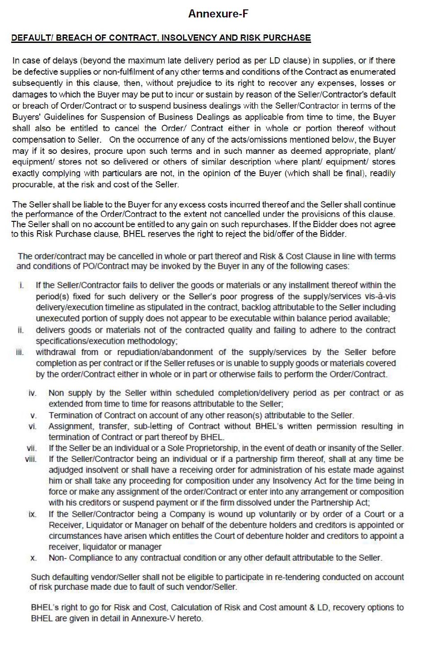
ANNEXURE C

ANNEXURE B

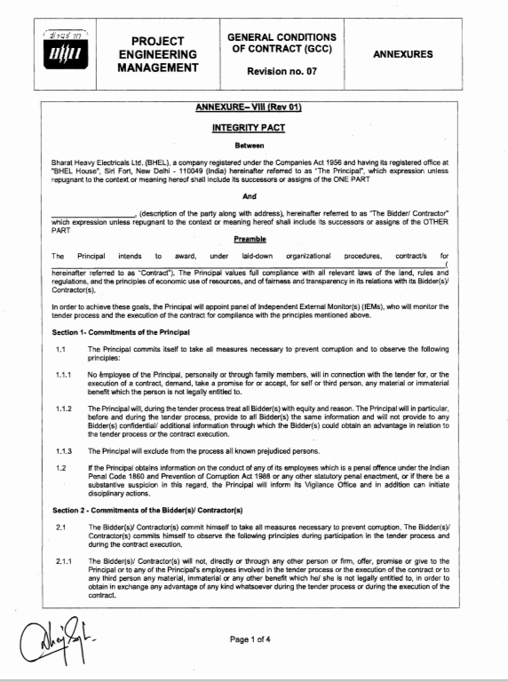

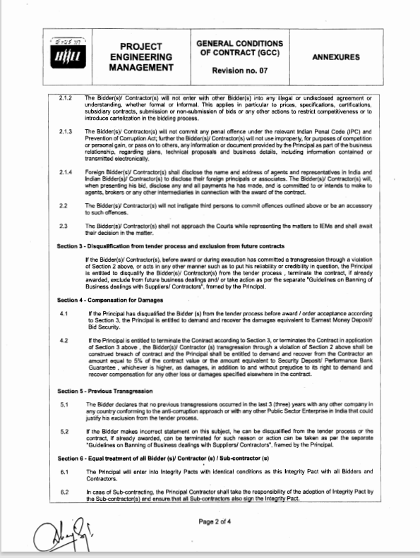

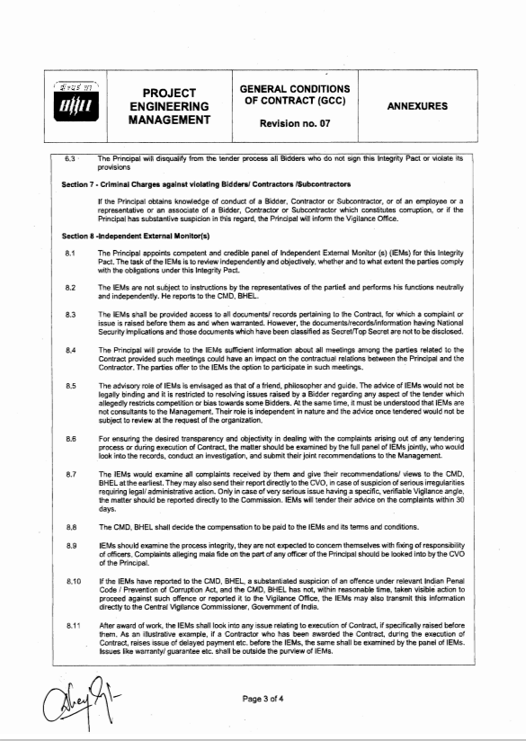
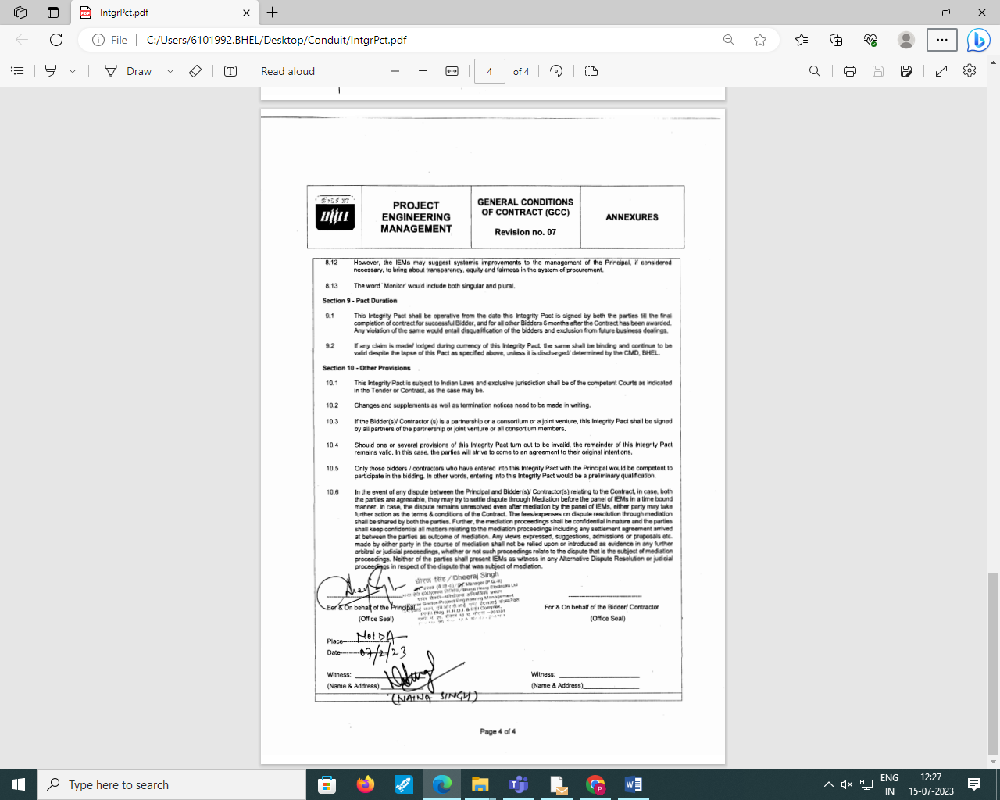

Annexure-D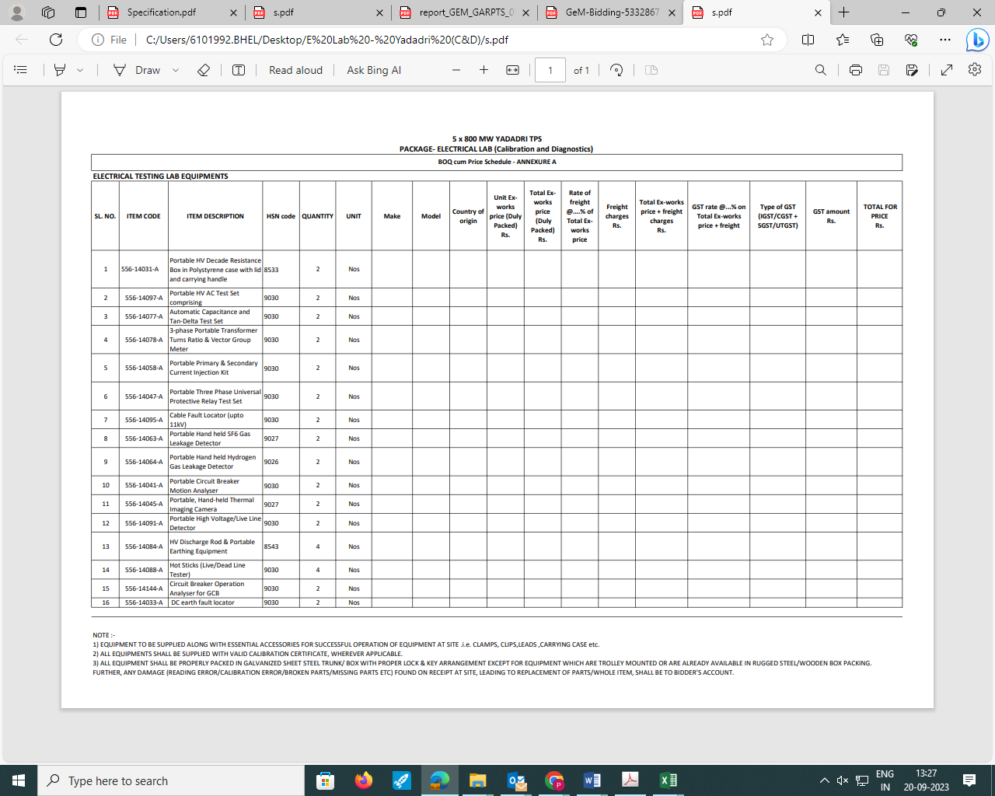

TECHNICAL PQR

Land Border sharing Certificate

To,

M/s Bharat Heavy Electricals Ltd.,
Project Engineering Management,
Power Project Engineering Institute,
HRD & ESI Complex,
Plot No 25, Sector‐16 A, Noida‐201301

Dear Sir,

This has reference to:
1. Our offer for ELECTRICAL LAB (CALIBRATION & DIAGNOSTICS) for 5x800 MW Yadadri TPS., Tender No. GEM/2023/B/3984995 dated 20.09.23
2. Order no. F. No. 6/18/2019-PPD dt. 23.07.2020 issued by Ministry of Finance, Department of Expenditure Public Procurement Division.

I have read the clause regarding restriction on procurement from a bidder of a country which shares a land border with India; I certify that M/s (Company Name______________________________) is not from such a country,

or,

if from such a country, has been registered with the competent authority. (Strike through if not applicable)

I hereby certify that M/s (Company Name__________________________) fulfil all requirements in this regard and is eligible to be considered for procurement on GeM.

[where applicable, evidence of valid registration by the competent authority shall be attached]

Thanking You,
Yours faithfully,

Director/Proprietor/Partner
M/s _______________

LOCAL CONTENT CERTIFICATE

To,
Bharat Heavy Electricals Limited
PEM, PPEI Building, Plot No 25,
Sector 16 A, Noida (U.P)-201301

Subject: - Certification regarding local content
Reference: Tender Enquiry No.: GEM/2023/B/3984995 dated 20.09.23
Name of Package: ELECTRICAL LAB (CALIBRATION & DIAGNOSTICS)
Project Name: 5x800 MW Yadadri TPS

Dear Sir,

We hereby certify that items offered by us for above cited Tender Enquiry ref. GEM/2023/B/3694972 dated 15.07.23 has local content of _____%

Further, it is also certified that the local content % certified above is in line with definition of local content given in Public Procurement (Preference to Make in India), Order 2017-revision, having ref no. P45021/2017/-PP (BE-II) dtd. 04.06.20 & 16.09.20 and we qualify as Class_____ local supplier.

We further confirm that address of the location at which the local value addition is made will be as follows:
____________________________
____________________________
____________________________
____________________________
____________________________

Thanking You,
Yours faithfully,

M/s _______________

