Sl. No. | TERMS & CONDITIONS
1 | Terms Of Payment | Payments shall be made to the Seller within 90 days (45 days for seller qualified and registered as Micro or small and 60 days for Medium enterprises as per MSMED Act.) of issue of consignee receipt-cum-acceptance certificate (CRAC) and on-line submission of bills (This is in supersession of 10 days’ time as provided in clause 12 of GeM GTC).  Supplier has to provide Original Tax Invoice + 1 copy of Tax invoice, Packing List, LR/RR or AWB, CRAC, Insurance intimation, Guarantee Certificate, E-way bill (as applicable) for payment.  Provision of offline payment in GeM shall be utilized.
  Type of bidder | Payment Terms (Number of days)
  Micro & Small Enterprises (MSEs) | 45 days
  Medium Enterprises | 60 days
  Non MSME | 90 days
2 | Terms Of Delivery | Terms of delivery shall be F.O.R. dispatch station. All dispatches shall be through Road Carriers on Freight Pre-Paid basis. Road Permit/E-way Bill if required will be arranged by Supplier. Transit insurance shall be in the scope of supplier as per GeM. However, unloading of items at delivery point shall be in the scope of BHEL. Bidder to quote prices accordingly.  W.r.t. Transit Insurance supplier has to inform the details of dispatches (such as Policy No., Consignee Name, Consignment Packing details, Project Name, Purchase Order No., LR No. & date, Invoice No. & date, Dispatch Origin & destination details etc.) to policy underwriter with a copy to BHEL.
3 | Delivery | Delivery period for sake of GeM bid is chosen as 999 days from PO date. However, this period shall not be considered for Delivery and Delay analysis purpose.  For Delivery and delay analysis (LD) purpose, delivery schedule shall be as per below:-  For Unit-2 Supply- Delivery shall be within 2 months from PO date.  For Unit-3 Supply- Delivery shall be within 10 months from PO date.  Applicable Drawing/document-  PE-QP-XXX-169-M002 : QP for CERAMIC FIBRE  Following to be noted:  - The end period specified is for completion of the deliveries. Deliveries to start progressively so as to meet the completion schedule.  - The delivery conditions specified are for contractual LD purposes, however BHEL may ask for early deliveries without any compensation thereof.
4 | Liquidated Damage | Purchaser reserves the right to recover from the Seller/ Contractor, as agreed liquidated damages and not by way of penalty, a sum equivalent to half (½) percent and applicable GST thereon, of the total main supply contract price excluding GST per week or part thereof, subject to a maximum of ten(10) percent of the total supply contract price excluding GST, if the Seller/ Contractor fails to deliver any part of the ordered goods/stores within the period stipulated in the Order/ Contract.  NOTE:  i. LR/RR date for indigenous supplies (Bill of Lading/AWB for Foreign supplies) shall be treated as the date of dispatch for levying LD. However, if receipted LR date for indigenous supply is beyond 30 days for FTL/ 45 days for PTL from the date of LR (PTL to be clearly mentioned in LR), such excess period shall be considered for LD purpose irrespective of dispatch date. Import General Manifest (IGM)/Bill of entry date (whichever is earlier), for foreign supplies, is beyond 90 days from the date of Bill of Lading/AWB, such excess period shall be considered for LD purpose irrespective of dispatch date.  ii. In case of any amendment/ revision, LD shall be linked to the amended/ revised contract value and delivery date(s).  iii. If Order/ Contract involves two or more Units/ Sets/ Lots/ Stages, then Liquidated Damages shall be levied on order/ contract value excluding GST of the delayed Unit/ Set/ Lot/ Stage, provided delivery stipulated in the Order/ Contract is Unit/ Set/ Lot/Stage wise, however total LD amount shall be limited to 10% of total order/ amended order value excluding GST of delayed Unit/ Set/ Lot/Stage. Any subsequent lot released (not envisaged in original contract) due to increase in quantity within permissible quantity variation shall be treated as separate lot for the purpose of LD.  iv. The sum specified above is not a penalty but a genuine pre-estimate of the loss/ damage which will be suffered by purchaser on account of delay on the part of the Contractor/Seller and the said amount will be deductible without proof of actual loss or damage caused by such delay.  Above LD clause shall prevail over the LD clause of GeM GTC.
5 | Guarantee Terms | As per Cl. No. 10 of GTC on GeM for the bid. However, Guarantee & Warrantee time period (Unit-wise/Lot-wise/Stage-wise/Set-wise, as applicable) shall be 18 months from the date of last supply.
6 | Quantity Variation | Qty. variation clause of + 25% of GeM ATC will be utilized for this tender i.e. the Purchaser reserves the right to increase or decrease the quantity to be ordered up to 25 percent of bid quantity at the time of placement of contract. The purchaser also reserves the right to increase the ordered quantity by up to 25% of the contracted quantity during the currency of the contract at the contracted rates. Bidders are bound to accept and execute the orders accordingly within 999 days from date of Contract/PO.
7 | Bank Guarantee | 3%.  Initial ePBG validity shall be 22 months from PO date (Considering delivery period of 2 months + 18 months guarantee period + 2 months claim period). However, BG will be released only after completion of all contractual liability or guarantee period, whichever is later.
8 | Any other special major condition | (i). Material shall be dispatched by vendor after issuance of MDCC by BHEL only.  (ii). Advance intimation of dispatch by bidder shall be given, to PEM and Insurance agency/Site.  (iii) Technical PQR to be complied by all bidders.  (iv) Please submit no deviation certificate as asked in NIT.  (v) In case of joint bidding, Bidders shall be required to furnish scope matrix which should be clearly defined between them along with the offer for the complete scope as per NIT.  (vii). All the Buyer Added Bid Specific Additional Terms and Conditions shall supersede relevant terms & conditions of GeM GTC and shall prevail in case of conflict with any other terms & conditions of tender (if any).
9 | ADDITIONAL BID TERMS & CONDITIONS
9.1 | Integrity Pact : Not Applicable
9.2 | Details of Contact person:  M/s. Bharat Heavy Electricals Ltd.,  Project Engineering Management,  PPEI Building, Plot No 25, Sector-16A, Noida-201301, U.P., INDIA
  Mr. Swetana Singh  Dy. Manager, PG-III  E-Mail: swetana@bhel.in  Ph. No. +91-120- 4368913;  Mob: 9811508427 | Mr. Manish Kumar Sinha  Sr. Manager, PG-III  E-Mail: manish.sinha@bhel.in  Ph. No. +91-120- 4368695  Mob: 9873414263
9.3 | This is a conditional Open (Indian) Tender enquiry. Hence, Reverse Auction (Part-II) shall be subject to following: -  - Techno-commercial qualification / recommendation of bidder by BHEL-PEM.  - Approval of bidder by Customer.  - Pre‐Qualifying Requirements: - Bids of only those bidders shall be evaluated who meet the Technical pre‐qualifying requirements.  - Offered item should mandatorily conform to Govt. PP-MII(Make In India) , Govt. MOP(Ministry of Power) , & Govt. MOP (Ministry of Finance) orders & provisions.
9.4 | This item/package /system falls under the list of items defined in para 3 of ministry of finance guideline dtd. 20.09.16 (Procurement of items related to Public safety, Health, Critical Security operations & Equipment etc.) & hence criteria of prior experience/Turnover shall be same for all the bidders including start-up/MSME.
9.5 | Bidders have to note, “For this procurement, the local content to categorize a supplier as a Class I Local Supplier / Class II Local Supplier / Non Local supplier and Purchase preference to Class I local supplier, is as defined in Public Procurement (Preference to Make in India), (PPP-MII) Order 2017 dt. 16/09/2020 issued by DPIIT and MOP circular No. A-1/2021-FSC-Part (5) dated 16.11.2021. In case of subsequent orders issued by the nodal ministry, changing the definition of local content for the items of the NIT, the same shall be applicable even if issued after issue of this NIT, but before opening of Part-II bids against this NIT.”  Regarding verification of local content, the local supplier at the time of tender, bidding or solicitation shall be required to provide certification as per para 9 of PP-MII order revision dated 16.09.2020 & 16.11.2021.  Both Class-I Local Supplier (LS) & Class-II Local Supplier are eligible to bid in this tender. Minimum Local Content for Class-I LS is 50% and for Class-II LS is 20% for subject Tender/NIT.  Following point to be noted regarding verification of local content: -  The local supplier at the time of tender, bidding or solicitation shall be required to provide a certificate w.r.t. minimum local content, in accordance with para 9 of PP-MII order revision dated 16.09.20 &16.11.21.  Note: Subsequent orders/circulars to be checked & applicable for this tender and same to be complied.
9.6 | Bidders to ensure that Third party / customer issued certificates being submitted as proof of PQR qualification should have verifiable details of document / certificate issuing authority such as name & designation of Issuing Authority and its organization contact number and e‐mail Id etc. In case the same found not available, Purchaser has right to reject such document from evaluation.
9.7 | Bidders to,  • ensure compliance to Ministry of Power (MoP) Order No. 25‐11/6/2018‐PG dt. 02/07/2020 & Order No. 11/05/2018‐Coord. dt. 23/07/2020, if applicable.  • ensure compliance of Ministry of Finance (MoF) Order (Public Procurement No. 1 & 2) F. No. 6/18/2019/PPD dt. 23.07.20 , 08.02.21, & 06.09.22.  • to submit “Model Certificate for Tenders” as per Annexure-III of Ministry of Finance (MoF) Order (Public Procurement No. 1 & 2) F. No. 6/18/2019/PPD dt. 23.07.20 , 08.02.21, & 06.09.22.  Note: Subsequent orders/circulars to be checked and to be complied.
9.8 | Purchase preference to Micro and Small Enterprises (MSEs): Purchase preference will be given to MSEs as defined in Public Procurement Policy for Micro and Small Enterprises (MSEs) Order, 2012 dated 23.03.2012 issued by Ministry of Micro, Small and Medium Enterprises and its subsequent Orders/Notifications issued by concerned Ministry. If the bidder wants to avail the Purchase preference, the bidder must be the manufacturer of the offered product in case of bid for supply of goods. Traders are excluded from the purview of Public Procurement Policy for Micro and Small Enterprises. In respect of bid for Services, the bidder must be the Service provider of the offered Service. Relevant documentary evidence in this regard shall be uploaded along with the bid in respect of the offered product or service. If L-1 is not an MSE and MSE Seller (s) has/have quoted price within L 1 + 15% of margin of purchase preference /price band defined in relevant policy, such Seller(s) shall be given opportunity to match L-1 price and contract will be awarded for 25% percentage of total quantity.  a) If L1 bidder is MSE bidder, entire quantity will be given to such MSE bidder only.  b) In case of more than one such MSE, within the price band of L1 +15%, the supply shall be shared proportionately, provided the available quantum can be split'.
9.9 | The Bidder declares that they will not enter into any illegal or undisclosed agreement or understanding, whether formal or informal with other Bidder(s). This applies in particular to prices, specifications, certifications, subsidiary contracts, submission or non-submission of bids or any other actions to restrict competitiveness or to introduce cartelization in the bidding process. In case, the bidder is found having indulged in above activities, suitable action shall be taken by BHEL as per extant policies/guideline.
9.10 | The Evaluation Currency for this tender shall be INR.
9.11 | Due to COVID-19 pandemic condition prevailing in the country, BHEL/PEM may go for Remote Inspection of Offered items, if required. Vendors are requested to be equipped with the facilities/gadgets as indicated in the guidelines attached to take up the inspection REMOTELY as indicated in the guidelines available at :  https://pem.bhel.com/Documents/VendorSection/Vendor/Guidelines.pdf  Inspection call to be raised by bidder on BHEL CQIR portal (details shall be shared at the of execution of order) and Inspection agency shall attend at the inspection within seven (07) days of the date on which the material is notified as being ready. In case of delay in witnessing of inspection beyond stipulated time (i.e. 7 days from the date on which the material is notified as being ready), by BHEL arising due to reasons not attributable to vendor, BHEL will extend the delivery period for such delay in carrying out inspection. If BHEL is not able to witness inspection up to 15 days then in addition to delay beyond stipulated period, extension in delivery time of 07 days for arranging fresh inspection will be given.  When the tests have been satisfactorily completed at Seller/ Contractor's works, the Inspection Agency shall issue an inspection report that effect within seven (07) days after completion of the tests, but if the tests were not witnessed by the Inspection Agency or his representative, the material acceptance report would be issued within seven (07) days after receipt of the test certificates by the Purchaser.  Purchaser will issue MDCC to the Seller/ Contractor within 7 days based on inspection report/ test certificates/Certificate of Conformance as applicable. In case of delay in issuance of MDCC beyond 7 days stipulated time (i.e. from the date of successful inspection report), by BHEL arising due to reasons not attributable to vendor, BHEL will extend the delivery period for such delay in issuing MDCC. If BHEL is not able to issue MDCC up to 15 days then in addition to delay beyond stipulated period, 7 days’ additional time shall be given to vendor to facilitate the vendor for arranging logistics arrangements.
9.12 | "Bidders to mention freight/GST percentage for all the items as part of un-priced bid to be submitted along with their Techno-Commercial offer. However, negotiation/RA shall be on Total Evaluation (FOR as per GeM) price only as per GeM logic. Detailed Price Break up to be submitted by bidder prior to Order Placement."
9.13 | Bidder has to provide the details as per TECHNICAL PQR (part of Technical Specification in its offer and has to note that bids of only those bidders shall be evaluated who meets the Pre-Qualifying requirements. Above terms for PQR shall prevail in conflict (if any).
9.14 | Evaluation shall be on the basis of total all inclusive, landed price at consignee destination (Refer cl. No. 6 of GTC on GEM). However, unloading of items (at delivery point) shall be in the scope of buyer. Bidder to quote prices accordingly.
9.15 | For bidders (who are not registered with BHEL-PEM) - Online registration portal is operational, Non-registered Vendors who wish to apply for registration in BHEL-PEM can apply through Online Registration Portal available at www.pem.bhel.com - vendor section - Online Supplier Registration. All credentials and/or documents duly signed and stamped related to registration can be uploaded on the website and submit the application for registration. However, registration of suppliers is not mandatory in case of open tender.
9.16 | Risk & Cost Purchase clause is as per Annexure-B
9.17 | PVC (Price Variation) is applicable for this tender. Please refer PVC Formula sheet enclosed with NIT documents.
9.18 | Following ATC available in GEM shall also be part of NIT: -  - Bidder's offer is liable to be rejected if they don't upload any of the certificates / documents sought in the Bid document, ATC and Corrigendum if any.  - Bidders are advised to check applicable GST on their own before quoting. Buyer will not take any responsibility in this regards. GST reimbursement will be as per actuals or as per applicable rates (whichever is lower), subject to the maximum of quoted GST %.  - Data Sheet of the product(s) offered in the bid, are to be uploaded along with the bid documents. Buyers can match and verify the Data Sheet with the product specifications offered. In case of any unexplained mismatch of technical parameters, the bid is liable for rejection.  - The bidder is required to upload, along with the bid, all relevant certificates such as type test certificate, approval certificates and other certificates as prescribed in the Product Specification given in the bid document.  - While generating invoice in GeM portal, the seller must upload scanned copy of GST invoice and the screenshot of GST portal confirming payment of GST.  - Bidders to provide detailed break-up of quoted price in Ex-works, freight & Tax components.  - All applicable Annexure & formats are attached with BOQ Specification for this Bid.  - Consignee Details (for PRC - Provisional Receipt Certificate & CRAC - Consignee's Receipt cum Acceptance Certificate, as applicable) shall be as per Project Site official details. Consignee details of project considered are mentioned in NIT document for ready reference.
9.19 | M/s Shree Ceramic Fibres is not eligible to quote for subject tender enquiry.
9.20 | All other terms & conditions shall be as per GeM bid, Additional Terms & Conditions and GTC on GeM version available on GeM Portal as on enquiry floating date.

Annexure-B (Risk Purchase clause)

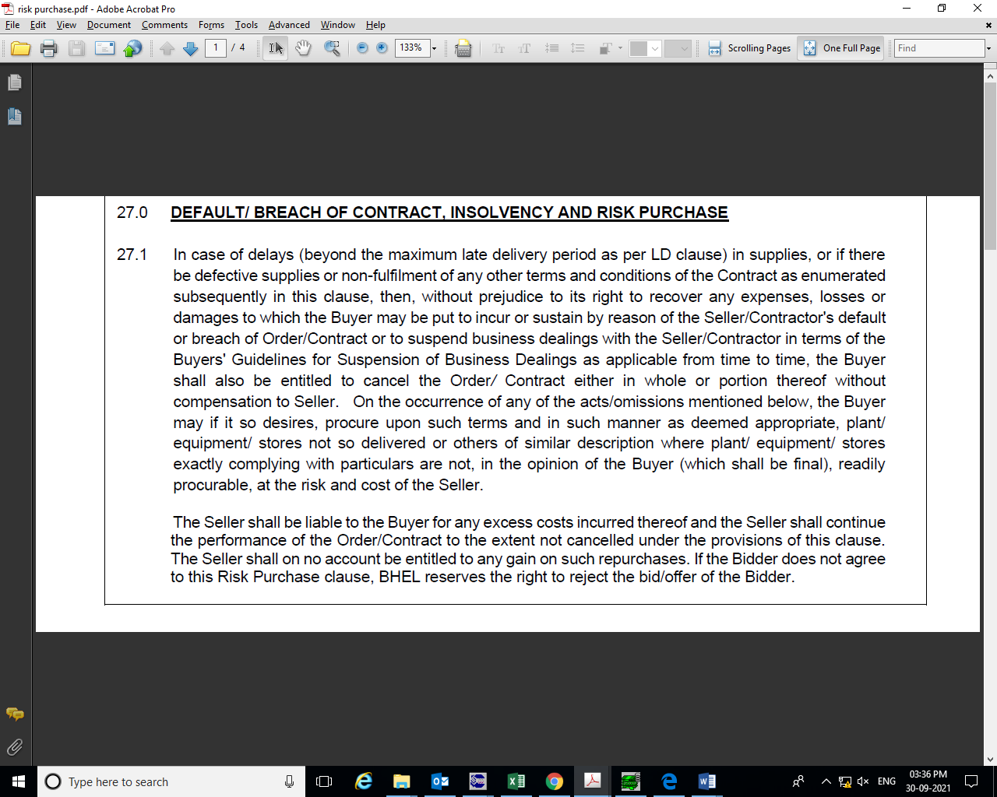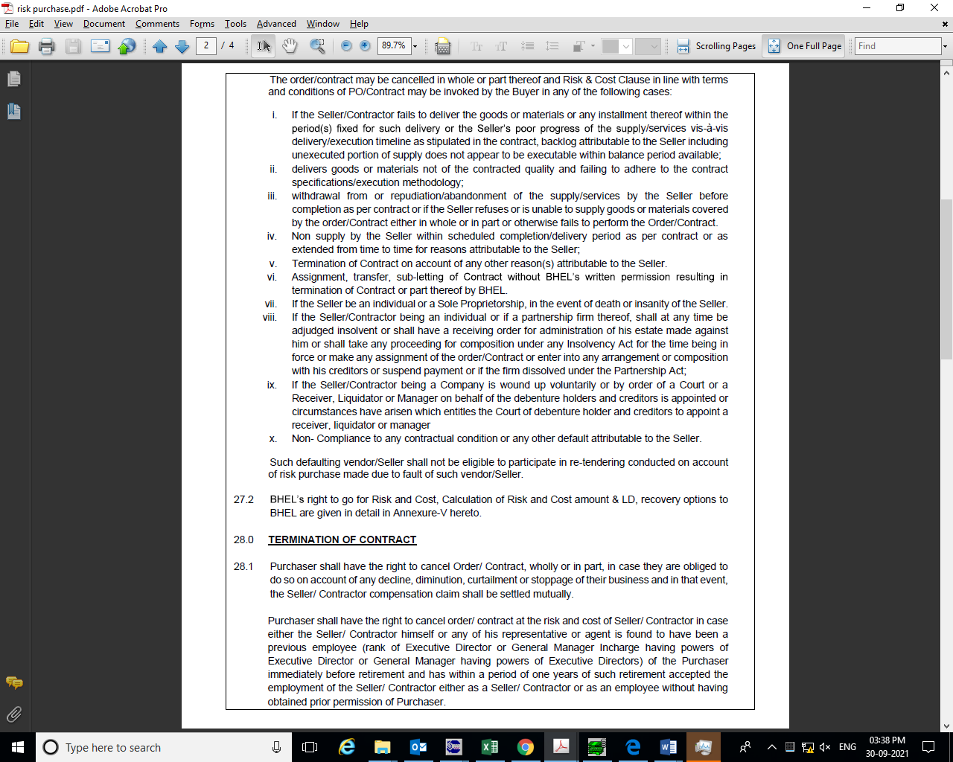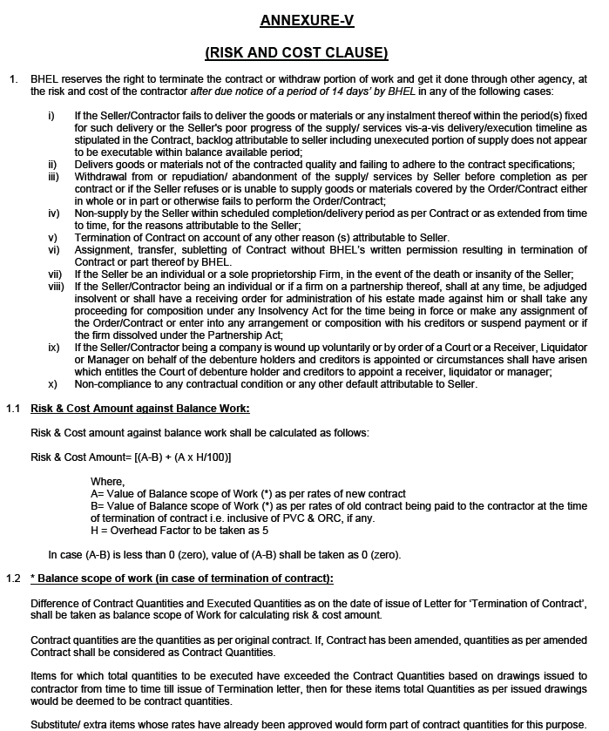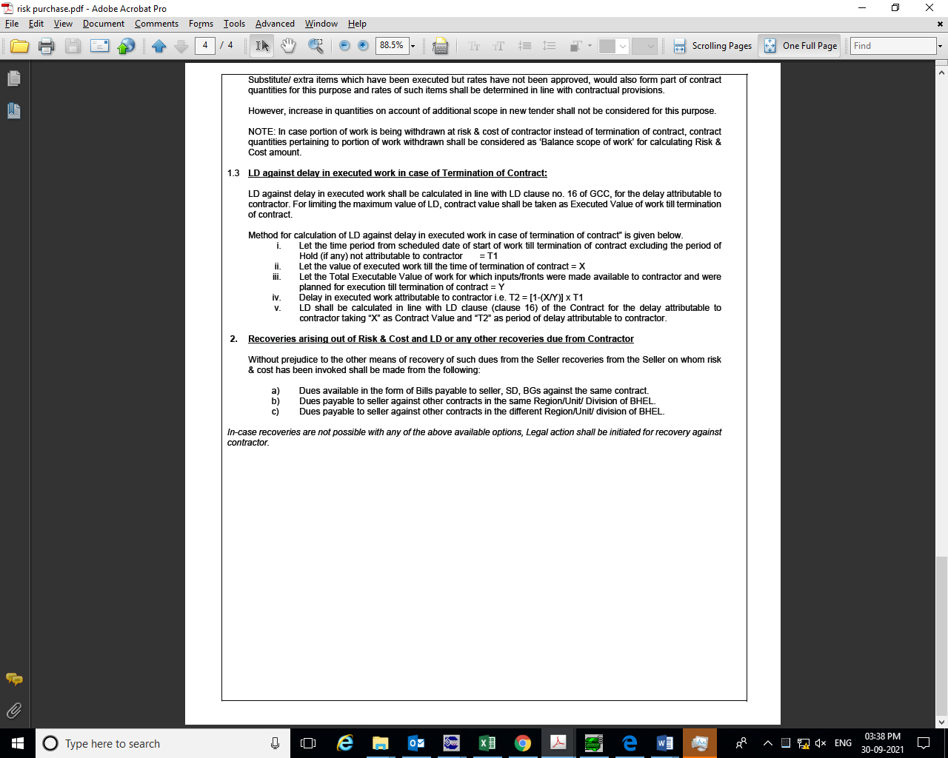

Letter head of Company (<Rs. 10 Cr value)

Ref………………………………………. Date………………………….

To,
Bharat Heavy Electricals Limited
PS-PEM, PPEI Building,
Plot No. 25, Sector ‐16A,
Noida (U.P.) ‐ 201301
Subject: ‐Certification regarding local content

Reference: Tender Enquiry No.‐
Name of Package:
PROJECT:

Dear Sir,

We hereby certify that items offered by us of __________________________________ for NORTH KARANPURA meets the requirement of minimum local content in line __________________________________ meets the requirement of minimum local content as a class – I local supplier in line with clause of NIT (GeM NIT) and the Public Procurement (Preference to Make in India), Order 2017 dated‐15.06.2017, 28.05.2018 & 29.05.2019, 04.06.20 & 16.09.20.

Local content__________ %

We further confirm that details of location at which the local value addition is made will be our registered works
at ………………………………………………………………………………………………………………………………………………………………………(address of the works)

Yours very truly

…………………………. (authorized signatory of company)

…………………………… (firm name)

authorized signatory
of company

Letter head of Company

Ref………………………………………. Date………………………….

MODEL CERTIFICATE

Reference: Tender Enquiry Ref‐ GeM Bid no. __________________
Name of Package: _________________________
PROJECT: 3X660 MW NORTH KARANPURA STPP - STG I

This is with reference to Ministry of Finance circular dated 23.07.20 reg. restriction under rule 144 (xi) of GFR.

“I have read the clause regarding restrictions on procurement from a bidder of a country which shares a land border with India. I hereby certify that M/s ……………………………………………………………….. .is not from such a country and is eligible to be considered against GeM enquiry no: ………………………………………….., Dtd. ……………………”

Sign & Signature

Date:

INSTRUCTIONS TO PACKING LIST

For faster verification of bills, successful bidder to submit detailed Bill of Material (BOM) at the time of drawings/ documents submission after placement of PO. Each item of the BOM to be uniquely identified with item code no. or item Sl. No. Supplier to ensure that all items which will find separate mention in the packing list are covered in this detailed BOM.

Supplier to also give the following undertaking in the BOM:
“The BOM provided herewith completes the scope (in content and intent) of material supply under PO No. ……. Dated …… Any additional material which may become necessary for the intended application of the supplied items/package will be supplied free of cost in most reasonable time.

Packing List must indicate:
- Packing size
- Gross weight and net weight of each package
- Contents of the package with cross reference to BOM item code no. / Sl. No.
- Quantity of each items separately.

The packing list must cover all the BOM items.
Supplier to give following undertaking in the packing list:
The Packing list provided herewith is as per BOM approved under PO No. -----

Sign & Signature

Date:

Letter head of Company

Ref………………………………………. Date………………………….

Reference: Tender Enquiry Ref‐ GeM Bid no. ___________________
Name of Package: _________________________
PROJECT: 3X660 MW NORTH KARANPURA STPP - STG I

NO COMMERCIAL DEVIATION

Yours very truly

…………………..(authorized signatory of company)
…………………..(firm name)

Company’s Seal/stamp

Letter head of Company

Ref………………………………………. Date………………………….

Reference: Tender Enquiry Ref‐ GeM Bid no. ___________________
Name of Package: _________________________
PROJECT: 3X660 MW NORTH KARANPURA STPP - STG I

NO TECHNICAL DEVIATION

Yours very truly

…………………..(authorized signatory of company)
…………………..(firm name)

Company’s Seal/stamp

