Corrigendum:

Following corrigendum Made in the enquiry GEM/2023/B/3249637 DT 10.03.2023-Procurement of Waste Ammonia and Spray Water Trip valves and its commissioning and Mandatory spares for Yadadri SCR Project

Page No 9 and 10 (out 12 pages) of Specification TSR:12 Rev 01 revised as below

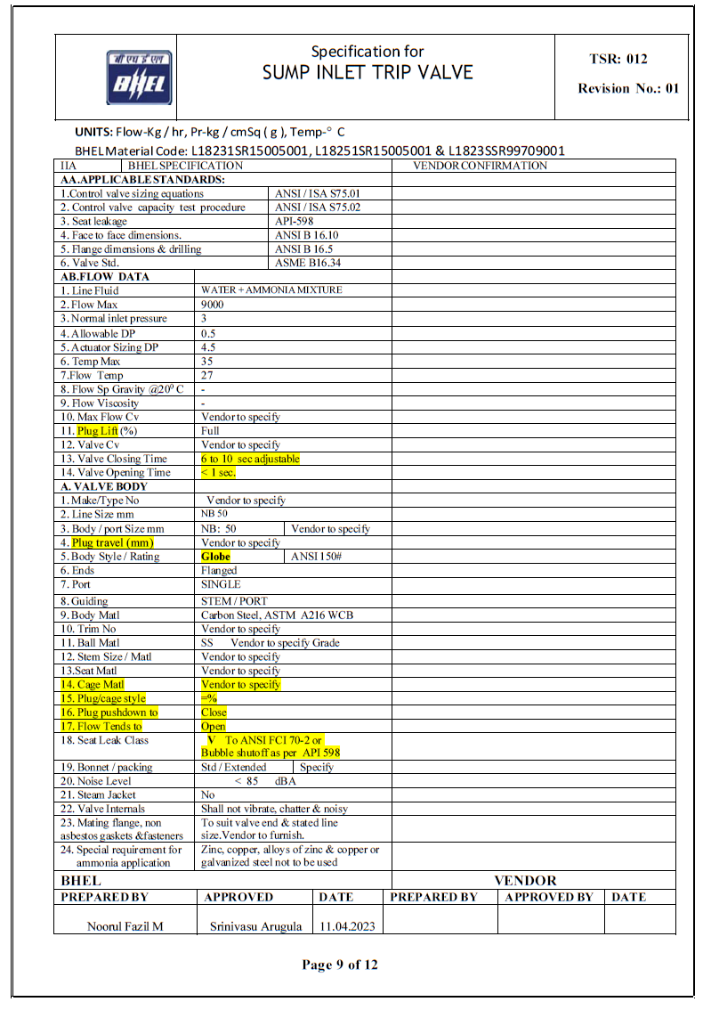
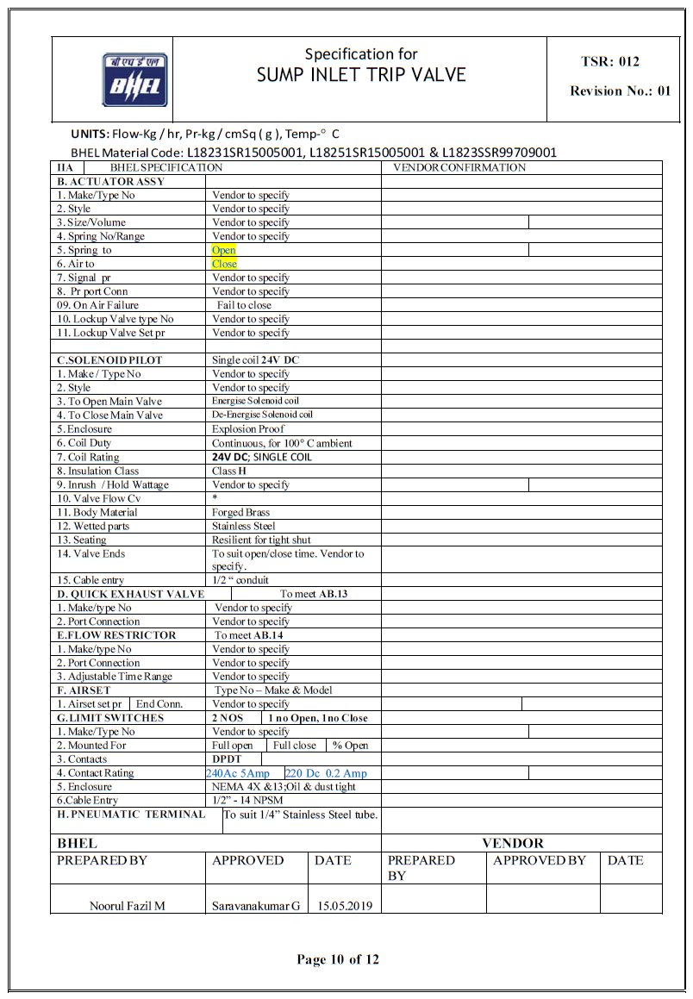

Annexure – T- Additional Terms and Conditions for GeM Enquiry
The terms and condition mentioned in this document are applicable in addition to the GeM General Terms and Conditions. Bidders shall furnish pointwise confirmation/details.

Description of the Equipment: |  | Waste Ammonia and Spray water Trip valves and its commissioning and Mandatory spares
Project covered |  | Yadadri SCR Project
To be Filled by Bidder
BHEL Tender No. & Date |  | GEM/2023/B/3249637 DT 10.03.2023

Name of the firm (Bidder)

Address

Contact details |  | Contact person 1  Name:  Designation:  Office Phone:  Mobile:  e-mail:  Contact person 2  Name:  Designation:  Office Phone:  Mobile:  e-mail:
Sl. No. | Terms and conditions |  | Vendor’s  confirmation
1 (a) | Technical: .  Bidder shall comply the specification requirements as per respective catalogues along with the offer. Any clarifications/deviations to the specification requirements are to be clearly indicated in the above format. Hidden deviations indicated elsewhere in the offer will not be evaluated.  Applicable Technical specification:  1) NB 50 TRIP VALVE (TAG NO AW30A & AW30A1) AT SUMP INLET OF WASTE AMMONIA WATER RETAINING BASIN AND ACCESSORIES - AS PER ENCLOSED TECHNICAL SPECIFICATION TSR:012/REV 01.  ENCLOSURE  TECHNICAL SPECIFICATION TSR:012/REV 01  2) SPRAY WATER TRIP VALVES FOR SCR AMMONIA TANK FARMYARD AS PER ENCLOSED TECHNICAL SPECIFICATION- TSR:014/01  REMARKS  1. O&M TO BE FURNISHED AS SPECIFIED IN TECHNICAL SPECIFICATION.  2. GUARANTEE: VENDOR SHALL GUARANTEE FOR MANUFACTURING DEFECTS FOR A PERIOD OF 12 MONTHS FROM THE DATE OF COMMISSIONING OR 18 MONTHS FROM THE DATE OF SUPPLY, WHICHEVER IS EARLIER.  3. VENDOR TO FURNISH THE WEIGHT OF THE VALVE WITH DIMENSIONS ALONG WITH OFFER ITSELF.  4. PAINTING SHALL BE DONE AS PER APPLICABLE PAINTING SCHEDULE FOR THE PROJECT.  5. WHILE CALCULATING THE QUANTITY FOR EACH ITEM OF COMMISSIONING SPARES, VENDOR SHALL ROUND THE NUMBER TO THE NEAREST HIGHER WHOLE NUMBER.  Vendor Quality Plan to be followed  Pl note that document approval (Drawings/Technical documents and QP) by BHEL is applicable.  No deviation format to be submitted along with your offer.
1 (b) | Pre-qualification requirement:  Offer shall be considered only if bidder is meeting Tender Prequalification requirement (PQR). Vendor to comply with Pre-Qualification requirement of the tender and submit along with their technical bid - the credentials and other documents as indicated in the PQR in the format prescribed. Otherwise their offer will get rejected.
1 (c) | Customer approval  Vendor offers will be considered for price bid opening subject to fulfilment of techno commercial suitability and vendor approval by end customer before price bid opening.  Vendor firms not approved by end customer shall submit supporting documents/Credentials for taking up with end customer for their approval.
1 (d) | Inspection by BHEL/ BHEL approved TPIA/Customer
2 (a) | Firm Price:  The quoted / finalised rates shall be Firm till execution of the supplies. Offer with PVC clause will not be considered.
2 (b) | Payment Term:  Payment term of 100% direct EFT payment within 90 days  from the date of issue of consignee receipt-cum-acceptance  certificate (CRAC).  For MSE suppliers, payment shall be within 45 days from the  date of CRAC.  For Medium Enterprises payment shall be within 60 days from the date of CRAC.
2(c) | TENDER FINALIZATION:  Tender will be finalized on Total Value Wise Basis through Reverse Auction in GeM
2 (d) | Liquidated Damages  If the Seller/Service Provider fails to deliver any or all of the Goods/Services within the original/re-fixed delivery period(s) specified in the contract, the Buyer will be entitled to deduct/recover the Liquidated Damages for the delay, unless covered under Force Majeure conditions aforesaid, @ 0.5% of the contract value of delayed quantity per week or part of the week of delayed period as pre-estimated damages not exceeding 10% of the contract value of delayed quantity without any controversy/dispute of any sort whatsoever.(SAP code :PU)
3 | Delivery terms:  FOR- Yadadri Project site basis (For Main valves and commissioning spares :16 Nos & 4 Sets)  FOR BHEL Trichy stores (For Mandatory spares – 5 Nos)  Qty of items as per Annexure I (Item list)  The quote shall be on respective destination basis, inclusive of Packing & forwarding and Freight charges to your account.  Transit Insurance is under BHEL scope.
4 (a) | Guarantee / Warranty Period:  ALL MATERIALS SHALL BE DEFECT FREE AND SHALL BE REPLACEABLE FREE OF COST DURING GUARANTEE PERIOD. THE ITEMS SHALL BE GUARANTEED FOR A PERIOD OF 18 MONTHS FROM THE DATE OF SUPPLY OR 12 MONTHS FROM THE DATE OF COMMISSIOING, WHICHEVER IS EARLIER.  No Deviation is permitted. If still vendor offered any deviation on the Guarantee / warranty period, it may lead to rejection of offer.
4 (b) | Performance Bank Guarantee  In case of order, BHEL require a performance Bank Guarantee to a value of 10% of supply value covering the Guarantee/Warranty period. The PBG shall be in BHEL format (Format attached) which is to be opened in any one of the banks mentioned under List of Consortium Banks attachment. All banks charges shall be to vendor account only. Any deviation on PBG leads to rejection of offer.
4 (c) | Repair & replacements: Within the guarantee period vendor has to replace / rectify the defective/ damaged items on free of cost within a reasonable time of reporting from our end.
4 (d) | Loading Criteria:  Guarantee / Warranty Period: No Deviation is permitted. If still vendor offered any deviation on the Guarantee / warranty period, it may lead to rejection of offer.
5 (a ) | Kindly Indicate the HSN Code for all items |  | HSN Code:…………
5(b) | Rate quoted in GeM portal should be on FOR destination basis inclusive of all taxes, P & F and freight etc. Transit Insurance is under BHEL scope.  Please indicate the applicable GST %, P & F and freight cost in %, which is included in your quoted rate in GeM portal |  | GST % …………….
6 (a) | Delivery Period:  Delivery shall be as follows  120 Days from Document approval (150 days in GeM Bid) -(For Main valves and Commissioning spares- 16 Nos & 4 Sets)  150 days from Document approval (180 days in GeM bid)- (For Mandatory spares – 5 Nos)  Material shall be dispatched only after obtaining dispatch clearance from BHEL.  Vendors shall strictly adhere to the following.  a. After material readiness and inspection completion (by TPI/ BHEL/ End Customer), vendor shall seek dispatch clearance from BHEL.  b. After obtaining dispatch clearance from BHEL, vendor shall proceed to generate dispatch documents. After generating dispatch documents (Invoice, LR, E-waybill etc.) vendor shall immediately share these documents to BHEL (scan copy over email) for accounting the materials and securing insurance coverage.  c. After accounting, BHEL would be issuing movement clearance to vendor immediately. Only after movement clearance is received from BHEL, actual/physical movement of goods out of vendor’s premises shall commence.  d. Non-adherence to the above may lead to GST authorities seizing the vehicle & goods and imposing penalty & interest. Any such implication would be to vendors account only.  e. Provision of GST Act highlighted below in connection to this - Pursuant to Sec 31 of CGST Act 2017, a tax invoice has to be raised by the registered person supplying taxable goods before or at the time of removal of goods for supply to the recipient, where the supply involves movement of goods. Where a taxable person supplies any goods without issue of any invoice, the tax authorities has powers to detain the consignment and impose penalties equivalent to 200% of the tax payable as per Section 129 of CGST Act 2017.”
6 (b) | Document Submission:  In case of PO placements, required documents have to be submitted for approval within 15 days from the date of PO & reply for any further clarification has to be within 7 days. Any delay beyond the above specified period will be considered during LD calculation.
7 | Invoice date/Bill of Lading date/Airway Bill date/Lorry way bill date/Railway Receipt date/E-way bill date, whichever is later will be considered for LD calculation.
8 | Documents are to be submitted along with technical bid (Part-1)  - Covering letter  - Unpriced offer.  - Filled technical specification and BHEL datasheets.  - Filled BHEL Terms and condition sheet (Annexure-T)  - Filled in PQR along with supporting documents.  - GA Drawings  - Catalogue’s  - No deviation certificate  - Self-Certification as per Make In India clause (Format attached)  - MSE/Udyam Certificates (if applicable)  Note: All the pages of documents are to be signed and sealed by authorized signatory of the company. Any query during enquiry stage shall be replied within three days failing which offer may be rejected as non-responsive.
9 | Inspection and testing requirements:  Inspection and testing requirements are to be carried out as per the specification and BHEL/Customer approved Drawing (All documents shall be submitted within 15 days from the date of PO for our approval), Technical spec & QP and all test certificates are to be submitted in complete set.  Inspection notice period: For TPI inspector visit to vendor works, a minimum of 3 working days’ notice period.
10 | O & M manuals: BHEL require 1 sets of printed O & M manuals with 3 soft copies in CD-ROM at no cost to be sent to BHEL/ Trichy.
11 | Response to Tenders for Indigenous supplier will be entertained only if the vendor has a valid GST registration Number (GSTIN) which should be clearly mentioned in the offer. If the dealer is exempted from GST registration, a declaration with due supporting documents need to be furnished for considering the offer. Dealers under composition scheme should declare that he is a composition dealer supported by the screen shot taken from GSTN portal. The dealer has to submit necessary documents if there is any change in status under GST.
12 | Supplier shall mention their GSTIN in all their invoices (incl. credit Notes, Debit Notes) and invoices shall be in the format as specified/prescribed under GST laws. Invoices shall necessarily contain Invoice number (in case of multiple numbering system is being followed for billing like SAP invoice no, commercial invoice no etc., then the Invoice No. which is linked/uploaded in GSTN network shall be clearly indicated), Billed to party (with GSTIN) & Shipped to party details, item description as per PO, Quantity, Rate, Value, applicable taxes with nomenclature (like IGST, SGST, CGST & UTGST) separately, HSN/ SAC Code, Place of Supply etc. Wherever E-Invoice is applicable, the tax invoice/ CN / DN submitted by the vendor must contain the QR code generated in E-Invoice Portal & IRN.
13 | All invoices shall bear the HSN Code for each item separately (Harmonized System of Nomenclature)/ SAC code (Services Accounting Code).
14 | Invoices will be processed only upon completion of statutory requirement and further subject to following:  - Vendor declaring such invoice in their GSTR-1 Return/ IFF  - Receipt of Goods or Services and Tax invoice by BHEL.
15 | As the continuous uploading of tax invoices in GSTN portal (in GSTR-1/ IFF) is available for all (i.e. both Small & Large) tax payers, all invoices raised on BHEL may be uploaded immediately in GST portal on dispatch of material /rendering of services. The supplier shall ensure availability of Invoice in GSTN portal before submission of invoice to BHEL. Invoices will be admitted by BHEL only if the invoices are available in GSTN portal (in BHEL’s GSTR-2A/ GSTR-2B).
16 | In case of discrepancy in the data uploaded by the supplier in the GSTN portal or in case of any shortages or rejection in the supply, then BHEL will not be able to avail the tax credit and will notify the supplier of the same. Supplier has to rectify the data discrepancy in the GSTN portal or issue credit note or debit note (details also to be uploaded in GSTN portal) for the shortages or rejections in the supplies or additional claims, within the calendar month informed by BHEL.
17 | In case GST credit is denied to BHEL due to non-receipt or delayed receipt of goods and/ or tax invoice or expiry of timeline prescribed in GST law for availing such ITC, or any other reasons not attributable to BHEL, GST amount claimed in the invoice shall be disallowed to the vendor.
18 | Where any GST liability arising on BHEL under Reverse Charge (RCM), the vendor has to submit the invoices to BHEL well within the timeline prescribed in GST Law, to enable BHEL to discharge the GST liability. If there is a delay in submission of invoice by the vendor resulting in delayed payment of GST by BHEL along with Interest, then such Interest payable or paid shall be recovered from the vendor.
19 | Under GST regime, BHEL has to discharge GST liability on LD recovered from suppliers/contracts. Hence applicable GST shall also be recoverable from suppliers/contractors on LD amount. For this Tax Invoice will be issued by BHEL indicating the respective supply invoice number.
20 | GST TDS will be deducted as per Section 51 of CGST Act 2017 and in line with Notification 50/2018 –Central Tax dated 13.09.2018. GST TDS certificate will be generated in GSTN portal subsequent to vendor accepting the TDS deduction in the GSTN portal & the vendor can directly download the Certificate from the GSTN Portal.
21 | MSE VENDOR:  Udyam Registration certificate shall be submitted by MSE eligible vendors as per GeM for availing MSE benefits.  Purchase preference to MSE vendors is as per GEM Bid document (Package Basis).
22 | Make in India:  The local supplier at the time of tender, bidding or solicitation shall be required to provide self-certification that the item offered meets the minimum local content and shall give details of the Iocation(s) at which the local value addition is made.  Purchase Preference to MII vendors is as per GEM Bid document.
23 | Fraud Prevention Policy  Bidder along with its associate /collaborators /sub-contractors /sub-vendors / consultants / service providers shall strictly adhere to BHEL Fraud Prevention Policy displayed on BHEL website http://www.bhel.com and shall immediately bring to the notice of BHEL Management about any fraud or suspected fraud as soon as it comes to their notice.
24 | Packing Requirements:  As per attached Technical specification
25 | BHEL reserve the right to inspect the item ordered at any stage at vendor's works and if found not meeting the stipulated conditions, material is liable for rejection
26 | Risk purchase clause:  a. In the event of any successful Tenderer's failure to fulfil any of the tender / Contract obligations including supply of whole or any part of the ordered items as per Contract / Agreement, BHEL has the right to terminate the contract and purchase from elsewhere, at the risk and cost of the defaulted supplier, either the whole of the goods or any part which the supplier has failed to deliver or dispatch  within the time stipulated in the contract or if the same were not available, the best and nearest available substitute thereof. The supplier shall be liable for the additional expenditure/difference in Cost, if any, including consequential losses which BHEL may sustain by reason of risk purchase in addition to the applicable LD as per the Purchase order/contract.  b) The decision of BHEL with regard to the additional expenditure / difference in cost and consequential losses incurred by BHEL shall be final and binding on the supplier.  c) The amount recoverable under risk purchase shall be recovered from the defaulted supplier in all or any of the following manners:  i. from dues available in the form of Bills payable to defaulted supplier, SD, BGs against the same contract.  ii. from the dues payable to defaulted supplier against other contracts in the same Region/Unit /any other region/unit  iii. In-case recoveries are not possible with any of the above available options, Legal action shall be initiated for recovery against defaulted supplier.  GST on amount recoverable from vendor under Risk  Purchase Clause:  In accordance with Sec. 7 of CGST Act, 2017, read with clause  5(e) of Schedule II to CGST Act, 2017, amount recovered /  recoverable by BHEL from vendor / contractor for nonperformance  of work as per contract shall be treated as  “Supply of service” by BHEL and accordingly GST shall be  applicable.  GST shall be applicable on amount being recovered /  recoverable from such vendor / contractor. In case only the  differential cost is being recovered from new vendor /  contractor, GST shall be applicable on same.  As per Sec. 13, read with Sec. 31 of CGST Act, 2017, GST shall  be applicable when such recovery against non-performance  of work has been determined and accordingly accounted for  in Books of Accounts.
27 | Deduction of tax at source (TDS) on payment of certain sum for purchase of goods u/s 194Q of the Income tax Act:  TDS on Purchase of Goods u/s 194Q of the Income Tax Act 1961 has been introduced vide Finance Act 2021. The provisions of above section are to be made applicable w.e.f. 01.07.2021. The provisions of section 194Q are reproduced below:  Section 194Q : Any person, being a buyer who is responsible for paying any sum to any resident (hereafter in this section referred to as the seller) for purchase of any goods of the value or aggregate of such value exceeding fifty lakh rupees in any previous year, shall, at the time of credit of such sum  to the account of the seller or at the time of payment thereof by any mode, whichever is earlier, deduct an amount equal to 0.1 per cent. of such sum exceeding fifty lakh rupees as income-tax. Explanation--For the purposes of  this sub-section, "buyer" means a person whose total sales, gross receipts or turnover from the business carried on by him exceed ten crore rupees during the financial year immediately preceding the financial year in which  the purchase of goods is carried out, not being a person, as the Central Government may, by notification in the Official Gazette, specify for this purpose, subject to such conditions as may be specified therein.  The key aspects of the provisions of section 194Q are as under:  a. Section 194Q requires the buyer of goods to deduct TDS @ 0.1% at the time of payment to the seller or at the time of credit to the account of seller whichever is earlier.  b. TDS is deductible where the value of goods purchased during the year exceeds Rs. 50 Lacs and is applicable on the value in excess of Rs.50 lacs.  c. Buyer for this section means a person having total sales/gross receipts/turnover exceeding Rs.10 crore during previous financial year  TCS on Sales of goods as per section 206C (1H), which is currently applicable @ 0.1%, would not be applicable wherever TDS has been deducted u/s 194Q TDS. This is in line with proviso to section 206C (1H) which states that TCS provisions will not apply if the buyer is liable to deduct  TDS on the purchase of goods under any other section of the Income Tax Act 1961 and has deducted the same.
28 | JURISDICTION: In case of any suit or other legal proceedings arising under or relating to this Contract, the courts at Trichy, Tamil Nadu only shall have the Jurisdiction and is only after exhausting the arbitration clause
29 | Banned Suppliers Rejection:  The offers of the bidders who are under suspension and also the offers of the bidders, who engage the services of the banned firms /principal/agents, shall be rejected.  The list of banned firms is available on BHEL web site www.bhel.com
30 | Clause on Integrity Pact:  - IP is a tool to ensure that activities and transactions between the Company and its Bidders/ Contractors are handled in a fair, transparent and corruption free manner. A panel of Independent External Monitors (IEMs) have been appointed to oversee implementation of IP in BHEL.  - The IP as enclosed with the tender is to be submitted (duly signed by authorized signatory who signs in the offer) along with techno-commercial bid. Only those bidders who have entered into such an IP with BHEL would be competent to participate in the bidding. In other words, entering into this Pact would be a preliminary qualification  Following IEMs on the present panel have been appointed by BHEL with the approval of CVC to oversee implementation of IP in BHEL  (c ) Please refer Section-8 of IP for Role and Responsibilities of IEMs. In case of any complaint arising out of the tendering process, the matter may be referred to the IEM mentioned in the tender.  Note: No routine correspondence should be addressed to the IEM (phone/post/email) regarding clarifications, time extensions or any administrative queries on the tender issued. All such Clarifications/issues shall be addressed directly to the tender issuing (procurement) department’s  Officials whose contact details are provided below.
  IEM | E - mail
  Shri Otem Dai, IAS (Retd.) | iem1@bhel.in
  Shri Bishwamitra Pandey, IRAS (Retd.) | iem2@bhel.in
  Shri Mukesh Mittal, IRS (Retd.) | iem3@bhel.in
  Name | B Indhumathi | Akhil K Das
  Department | Manager/MM/BOI | Dy Manager/MM/BOI
  Address | Bldg No.24, BHEL Trichy | Bldg No. 24, BHEL Trichy
  Phone | 0431-2575937 | 0431-2574553
  e-mail | indhubannari@bhel.in | akhildas@bhel.in
Note | - In the event of our customer order covering this tender being cancelled /placed on hold / otherwise modified, BHEL would be constrained to accordingly cancel / hold / modify the tender at any stage of execution.  - BHEL may negotiate the L1 rate, if not meeting our budget / estimated cost. BHEL may re-float the tender opened, if L1 price is not acceptable to BHEL.  - BHEL reserves its right to reject an offer due to unsatisfactory past performance by the respective Vendor in the execution of any contract to any BHEL project / Unit.  - Any other Techno – Commercial Terms indicated by the vendor in their offer elsewhere will be ignored. BHEL will proceed with tender evaluation as per Annexure-T and GeM general terms and conditions only.

/ On Bidder’s office letter pad /
Self-Declaration

GeM Enquiry No. | GEM/2023/B/3249637
Enquiry Date | 10.03.2023

In line with Government public procurement order Number P-45021/2/2017-B.E-II dated 15.06.2017, and further modified order dt. 28.05.2018,
I / We hereby declare that I / We are a “Local Supplier” meeting the requirement of minimum local content (…….%) defined in the above government notification for the goods against above mentioned enquiry Number.
Details of location at which local value addition will be made is as follows:
Door No.
Street / Address 1
Street / Address 2
District
State
Country
PIN Code

We also understand that the false declarations will be considered as breach of Integrity and liable for action.

For Company Name:
Seal:
Signature:
Date:
Place:
(Please fill all the yellow colour field)

429-024 | PURCHASE / MM / FB  SUB DELIVERY – ENQUIRY - DEVIATION
 | Page | OF
 | DATE
DESCRIPTION
  Supply of Waste Ammonia and Spray water Trip valves and its commissioning and Mandatory spares for Yadadri SCR Project ( GEM/2023/B/3249637)
SPECIFICATION | 1. TECHNICAL SPECIFICATION TSR:012/REV 01  2. TECHNICAL SPECIFICATION- TSR:014/01
QUALITY PLAN | Vendor Quality Plan
DOC. REFERENCE | BHEL ENQ. CALLED FOR | FIRM’S ALTERNATE OFFER
CERTIFIED THAT OTHER THAN THE ABOVE DEVIATIONS, WE ARE ACCEPTING ALL THE OTHER SPECIFICATIONS AND REQUIREMENTS IN FULL TO YOUR ENQUIRY

STATION:
DATE: SIGNATURE OF FIRMS REPRESENTETIVE FIRM SEAL

NOTE: 1. Deviations should be taken only in the extreme case.
2. If necessary, use additional sheets with page control number

