|  |  |  |
| --- | --- | --- |
|  | **ADDITIONAL TERMS & CONDITIONS: - SAME SHALL SUPERSEDE TERMS AND CONDITIONS MENTIONED ELSEWHERE IN BID** | |
| 1 | **Payment Terms** | |
| **a) Supply Portion** | Payment will be released to seller within 90 days for Non-MSME vendors, within 45 days for Micro & Small vendors and 60 days for Medium enterprises (as per MSMED Act). (This is in supersession of 10 days’ time as provided in clause 12 of GeM GTC). Supplier has to provide Tax invoice, Packing List, LR/RR, CRAC, Insurance intimation, Guarantee Certificate, E-way bill (as applicable) for payment.    Provision of offline payment in GeM shall be utilized. |
| 2 | **Insurance** | Transit Insurance shall be in bidder scope. |
| 3 | **Terms of Delivery** | F.O.R Dispatch Station Basis. However, loading & Transit insurance shall be in the scope of Seller and unloading of items at delivery point shall be in the scope of BHEL. Bidder to quote prices accordingly. |
| 4 | **Delivery** | Delivery schedule shall be as per Annexure-A. Delivery period for sake of GeM bid is chosen as 999 days (maximum allowable delivery time) from PO date. However, this period shall not be considered for  Delivery and Delay analysis purpose. For Delivery and delay analysis purpose, delivery schedule mentioned in Annexure-A shall be considered. |
| 5 | **Liquidated Damage** | **a)  Main Supply & Commissioning Spares** (if applicable) :-  Purchaser reserves the right to recover from the Seller/ Contractor, as agreed liquidated damages and not by way of penalty, a sum equivalent to half (½) percent and applicable GST thereon, of the total main supply & commissioning spares contract price excluding GST per week or part thereof, subject to a maximum of ten(10) percent of the total main supply & commissioning Spares contract price excluding GST, if the Seller/ Contractor fails to deliver any part of the ordered goods/stores within the period stipulated in the Order/ Contract.  **b)  LD on mandatory spares portion:**  - Purchaser reserves the right to recover from the Seller/ Contractor, as agreed liquidated damages and not by way of penalty, a sum equivalent to half (½) percent and applicable GST thereon, of the total Mandatory Spares contract price excluding GST per week or part thereof, subject to a maximum of ten (10) percent of the total Mandatory Spares contract price excluding GST, if the Seller/ Contractor fails to deliver any part of the ordered Mandatory Spares goods/stores within the period stipulated in the Order/ Contract.  However, total LD (main supply + mandatory spares) shall be limited to 10% of cumulative total contract value excluding taxes and freight (main supply + mandatory spares).  NOTE: i. LR/RR date for indigenous supplies (Bill of Lading/AWB for Foreign supplies) shall be treated as the date of dispatch for levying LD. However, if receipted LR date for indigenous supply is beyond 30 days for FTL/ 45 days for PTL from the date of LR (PTL to be clearly mentioned in LR), such excess period shall be considered for LD purpose irrespective of dispatch date. Import General Manifest (IGM)/Bill of entry date (whichever is earlier), for foreign supplies, is beyond 90 days from the date of Bill of Lading/AWB, such excess period shall be considered for LD purpose irrespective of dispatch date. ii. In case of any amendment/ revision, LD shall be linked to the amended/ revised contract value and delivery date(s). iii. If Order/ Contract involves two or more Units/ Sets/ Lots/ Stages, then Liquidated Damages shall be levied on order/ contract value excluding GST of the delayed Unit/ Set/ Lot/ Stage, provided delivery stipulated in the Order/ Contract is Unit/ Set/ Lot/Stage wise, however total LD amount shall be limited to 10% of total order/ amended order value excluding GST of delayed Unit/ Set/ Lot/Stage. Any subsequent lot released (not envisaged in original contract) due to increase in quantity within permissible quantity variation shall be treated as separate lot for the purpose of LD. iv. The sum specified above is not a penalty but a genuine pre-estimate of the loss/ damage which will be suffered by purchaser on account of delay on the part of the Contractor/Seller and the said amount will be deductible without proof of actual loss or damage caused by such delay. Above LD clause shall prevail over the LD clause of GeM GTC. |
| 6 | **Guarantee Terms** | As per Cl. No. 10 of GeM GTC for the bid (refer GeM GTC dtd. 13.01.23). However, time period shall be as under: Main Supply - Guarantee & Warranty time period shall be 18 months from the date of last supply in the Main Supply scope.  Mandatory Spares -Guarantee & Warranty time period shall be 18 months from the date of last supply in the Mandatory Spares Supply scope. |
| 7 | **Quantity Variation** | Quantity variation of +10% shall be applicable for this package. |
| 8 | **Any other special major condition** | 1. Material shall be dispatched only after issuance of MDCC by BHEL. 2. Advance intimation of dispatch by bidder shall be given, to PEM and Insurance agency/Site. 3. Bank Guarantee submission shall be as per cl. No. 7 of GeM GTC with initial validity of 24 Months. Further, extension if any shall be as per GeM Terms.  4. All the Buyer Added Bid Specific Additional Terms and Conditions shall supersede relevant terms & conditions of GeM GTC and shall prevail in case of conflict with any other terms & conditions of tender (if any). |
| 9 | **Site Address** | Construction Manager - BHEL site office Unit-V Sagardighi Thermal Power Project P.O. Manigram, District - Murshidabad, PIN:742237, West Bengal, India |
| 10 | This is a conditional tender enquiry.  Participation in RA of a bidder shall be subjected to the following: i) Approval of vendor/make by end customer i.e. (M/s WBPDCL)   ii) Techno-Commercial evaluation by BHEL. iii) Qualification of Technical PQR iv) Offered item should mandatorily conform to PP-MII order provisions. | |
| 11 | This item/package /system falls under the list of items defined in para 3 of ministry of finance guideline dtd. 20.09.16 (Procurement of items related to Public safety, Health, Critical Security operations & equipment etc.) & hence criteria of prior experience/Turnover shall be same for all the bidders including start-up/MSME. | |
| 12 | Provision of offline payment in GeM can be utilized. | |
| 13 | "For this procurement, the local content to categorize a supplier as a Class I local supplier / Class II local Supplier /Non Local supplier and purchase preference to Class-I local supplier, is as defined in Public Procurement (Preference to Make in India) Order 2017 dated 16.09.2020 issued by DPIIT. In case of subsequent orders issued by the nodal ministry, changing the definition of local content for the items of the NIT, the same shall be applicable even if issued after issue of this NIT, but before opening of Part-II bids against this NIT.”  Since this package  falls under clause 3 (a) of DPIIT’s PP-MII order 2017, Rev dated 17.09.2020, therefore, in line with clause no 3 (b) of DPIIT’s PP-MII order 2017, Rev dated 16.09.2020, “Class-I local suppliers” as defined in the order are eligible to bid.  In accordance with para 9 (a) of DPIIT’s PP-MII order 2017 revision dated 16.09.2020, Class-I local suppliers”  at the time of tender, bidding or solicitation shall be required to indicate percentage of local content and provide self-certification that the item offered meets the local content requirement for the “Class-I local supplier”. They shall also give details of the location(s) at which the local value addition is made.   Further, please note that as per recent GOI circulars**, bidders whose minimum local content for subject package is 60% shall be considered as Class I local supplier.** Also, please note that subject package is non-divisible in nature. | |
| 14 | Bidders to ensure that Third party / customer issued certificates being submitted as proof of PQR qualification should have verifiable details of document / certificate issuing authority such as name & designation of Issuing Authority and its organization contact number and e‐mail Id etc. In case the same found not available, Purchaser has right to reject such document from evaluation. | |
| 15 | Bidders to, • ensure compliance to Ministry of Power (MoP) Order No. 25‐11/6/2018‐PG dt. 02/07/2020 & Order No. 11/05/2018‐Coord. dt. 23/07/2020, if applicable. • ensure compliance of Ministry of Finance (MoF) Order (Public Procurement No. 1 & 2) F. No. 6/18/2019/PPD dt. 23/07/2020. • to submit “Model Certificate for Tenders” as per Annexure-III of Ministry of Finance (MoF) Order (Public Procurement No. 1 & 2) F. No. 6/18/2019/PPD dt. 23/07/2020.  Note: Subsequent orders/circulars to be checked and to be complied. | |
| 16 | Due to COVID-19/OTHER pandemic condition prevailing in the country, BHEL/PEM may go for Remote Inspection of Offered items, if required. Vendors are requested to be equipped with the facilities/gadgets as indicated in the guidelines attached to take up the inspection REMOTELY.   Inspection call to be raised by bidder on BHEL CQIR portal (details shall be shared at the of execution of order) and Inspection agency shall attend at the inspection within seven (07) days of the date on which the material is notified as being ready. In case of delay in witnessing of inspection beyond stipulated time (i.e. 7 days from the date on which the material is notified as being ready), by BHEL arising due to reasons not attributable to vendor, BHEL will extend the delivery period for such delay in carrying out inspection. If BHEL is not able to witness inspection up to 15 days then in addition to delay beyond stipulated period, extension in delivery time of 07 days for arranging fresh inspection will be given.   When the tests have been satisfactorily completed at Seller/ Contractor's works, the Inspection Agency shall issue an inspection report that effect within seven (07) days after completion of the tests, but if the tests were not witnessed by the Inspection Agency or his representative, the material acceptance report would be issued within seven (07) days after receipt of the test certificates by the Purchaser.   Purchaser will issue MDCC to the Seller/ Contractor within 7 days based on inspection report/ test certificates/Certificate of Conformance as applicable. In case of delay in issuance of MDCC beyond 7 days stipulated time (i.e. from the date of successful inspection report), by BHEL arising due to reasons not attributable to vendor, BHEL will extend the delivery period for such delay in issuing MDCC. If BHEL is not able to issue MDCC up to 15 days then in addition to delay beyond stipulated period, 7 days’ additional time shall be given to vendor to facilitate the vendor for arranging logistics arrangements. | |
| 17 | Bidders to inform freight% and GST% (percentage) for all the items as part of un-priced bid to be submitted along with their Techno-Commercial offer. However, negotiation/RA shall be on Total Evaluation (F.O.R as per GeM) price only as per GeM logics. Detailed Price Break up shall be reverse calculated based on freight/GST percentage furnished by bidder for Order Placement. | |
| 18 | Bidder has to provide the details as per TECHNICAL PQR in its offer and has to note that bids of only those bidders shall be evaluated who meet the Technical Pre-Qualifying requirements. Above terms for PQR shall prevail in conflict (if any). | |
| 19 | The Bidder declares that they will not enter into any illegal or undisclosed agreement or understanding, whether formal or informal with other Bidder(s). This applies in particular to prices, specifications, certifications, subsidiary contracts, submission or non-submission of bids or any other actions to restrict competitiveness or to introduce cartelization in the bidding process. In case, the bidder is found having indulged in above activities, suitable action shall be taken by BHEL as per extant policies/guideline. | |
| 20 | CIF is not applicable for this package. | |
| 21 | Integrity Pact is not applicable. | |
| 22 | As per SS&P Circular No. 28 of 2022-23, dtd-12.12.2022 (page no. 212-216) regarding **Conflict of interest among bidders**, please note the following:- "A bidder shall not have conflict of interest with other bidders. Such conflict of interest can lead to anti-competitive practices to the detriment of Procuring Entity's interests. The bidder found to have a conflict of interest shall be disqualified. A bidder may be considered to have a conflict of interest with one or more parties in this bidding process, if: a) they have controlling partner (s) in common;' or b) they receive or have received any direct or indirect subsidy/ financial stake from any of them; or c) they have the same legal representative/agent for purposes of this bid; or d) they have relationship with each other, directly or through common third parties, that puts them in a position to have access to information about or influence on the bid of another Bidder; or e) Bidder participates in more than one bid in this bidding process. Participation by a Bidder in more than one Bid will result in the disqualification of all bids in which the parties are involved. However, this does not limit the inclusion of the components/ sub-assembly/ Assemblies from one bidding manufacturer in more than one bid, or f) In cases of agents quoting in offshore procurements, on behalf of their principal manufacturers, one agent cannot represent two manufacturers or quote on their behalf in a particular tender enquiry. One manufacturer can also authorize only one agent/dealer. There can be only one bid from the following: 1. The principal manufacturer directly or through one Indian agent on his behalf; and 2. Indian/foreign agent on behalf of only one principal,' or g) A Bidder or any of its affiliates participated as a consultant in the preparation of the design or technical specifications of the contract that is the subject of the Bid, or h) In case of a holding company having more than one independently manufacturing units, or more than one unit having common business ownership/management, only one unit should quote. Similar restrictions would apply to closely related sister companies. Bidders must proactively declare such sister/ common business/ management units in same/ similar line of business. " | |
| 23 | For bidders (who are not registered with BHEL-PEM) - For registration in BHEL PEM- Online registration portal is operational, Non-registered Vendors who wish to apply for registration in BHEL-PEM can apply through Online Registration Portal available at www.pem.bhel.com - vendor section - Online Supplier Registration. All credentials and/or documents duly signed and stamped related to registration can be uploaded on the website and submit the application for registration. However, registration of suppliers is not mandatory in case of open tender. | |
| 24 | a) Bidders to note item description of BOQ at pg. no. **1&2 of 24** of technical specification also before quoting.  b) Bidders to note that notes mentioned at pg. no. **1&2 of 24** of technical specification document are also applicable w.r.t. BOQ of this tender. | |
| 25 | Risk Purchase clause shall be as per Annexure **D**, in case of default by GeM bidder. | |
| 26 | **Dispatch Markings:** - Each box shall be marked with Capital Letters in “Red” indicating: Main Supply OR Commissioning spare OR Mandatory Spare for 1X 660 MW SAGARDIGHI TPP EXTENSION UNIT 5, P.O. Manigram, District - Murshidabad, PIN:742237, West Bengal, India Each package/Drum delivered under the Contract shall be marked by Supplier as per details listed below and such marking must be distinct and in English Language (all previous irrelevant markings being carefully obliterated) for purposes of identification. Each and every box(package) shall be marked with following: - 1) Name and address of the consignee. 2) Project Reference. 3) Name of Supplier 4) P.O. reference no. along with package name. 5) Packing No. (1/10, 2/10, 3/10 when there are 10 packages for one consignment) 6) The Gross weight and net weight of the package. Besides above necessary, packing shall bear a special marking "TOP", "BOTTOM", "DO NOT TURN OVER", "DEEP DRY", "HANDLE WITH CARE", etc. IMPORTANT Two copies of respective standard manufacturer's erection instruction /operation manual shall be provided for immediate reference by BHEL site. The Copy of complete Packing list for the consignment must be put inside the Box/Boxes. 12 copies of supplier's Erection/ Instruction manuals to be given to the BHEL, PEM, PPEI Noida and 3 copies to BHEL, PSER, Sagardighi site within 30 days of dispatch for handing over to Customer/BHEL site. Items like pumps, Valves, Hoists, Cranes, etc. shall essentially have O&M Manuals and E&C guidelines duly enclosed in the packing box. | |
| 27 | Mandatory Spares: - Supplies of spares will be separate from main supply and separate manufacturing clearance shall be given for mandatory spares. The Mandatory spares shall be properly packed separately in separate boxes & boxes should be painted in red indicating Mandatory Spares in bold letters and each spare shall be properly tagged giving details i.e. item number of the equipment in line with the WBPDCL approved BBU for Mandatory spares & Number per item (to match the description given in the packing slip) to facilitate their proper identification by ultimate customer M/s WBPDCL. One Copy of Packing List must be put inside the BOX along with Manufacturing drawing no. reference, Catalogue reference etc. Note: - MDCC for mandatory Spares shall be issued only after receipt of detailed list of mandatory spares & photographs before final packing clearly showing mandatory spares with due tagging as per packing list (to be sent over mail/CD). Separate dispatch clearance will be issued for the mandatory spares in line with availability of customer’s stores at site. | |
| 28 | In course of evaluation, if more than one bidder happens to occupy L-1 status, effective L-1 will be decided by soliciting discounts from the respective bidders. In case more than one bidder happens to occupy L-1 status even after soliciting discounts, the L1 bidder shall be decided by a toss / draw of lots, in the presence of respective bidder(s) or their representative(s). Ranking will be done accordingly. BHEL's decision in such situation shall be final and binding. | |
| 29 | Terms and conditions mentioned at pg. no. **4 of 57** of technical specification document i.e. “Instructions to Packing List” is applicable and to be ensured for this package necessarily. | |
| 30 | Evaluation will be done on L1 (Total cost to BHEL basis, including GST). Incomplete offer or part offer of NIT BOM/BOQ shall be summarily rejected. | |
| 31 | GeM has the functionality to quote Single Unit Price (F.O.R) for each item. Bidders to furnish applicable Freight% & GST% w.r.t. Ex Works included in Single quoted (F.O.R) prices before reverse auction. | |
| 32 | For recognition of dispatch, vendor to submit following documents to BHEL by e-mail/ fax immediately on dispatch: - GST compliant invoice, LR for Indian Vendors (indicating Invoice No., no. of boxes, PTL (if applicable) etc.) / Bill of Lading or AWB for foreign vendor, Packing List (Must be indicating No. of boxes, Packing size, Gross weight and net weight of each package, Contents of the package with cross reference to BoM item code no. or item serial no. and Quantity of each item separately), Insurance Intimation to underwriter through email/fax, Dispatch Clearance. | |
| 33 | Following ATC available in GEM is also part of NIT: - i. Bidder's offer is liable to be rejected if they don't upload any of the certificates / documents sought in the Bid document, ATC and Corrigendum if any. ii. Bidders are advised to check applicable GST on their own before quoting. Buyer will not take any responsibility in this regard. GST reimbursement will be as per actuals or as per applicable rates (whichever is lower), subject to the maximum of quoted GST %. iii. Data Sheet of the product(s) offered in the bid, are to be uploaded along with the bid documents. Buyers can match and verify the Data Sheet with the product specifications offered. In case of any unexplained mismatch of technical parameters, the bid is liable for rejection. iv. The bidder is required to upload, along with the bid, all relevant certificates such as BIS license, type test certificate, approval certificates and other certificates as prescribed in the Product Specification given in the bid document. v. While generating invoice in GeM portal, the seller must upload scanned copy of GST invoice and the screenshot of GST portal confirming payment of GST. | |
| 34 | All other terms & conditions shall be as per GeM bid, selected Additional Terms & Conditions from GeM library and on GeM GTC | |

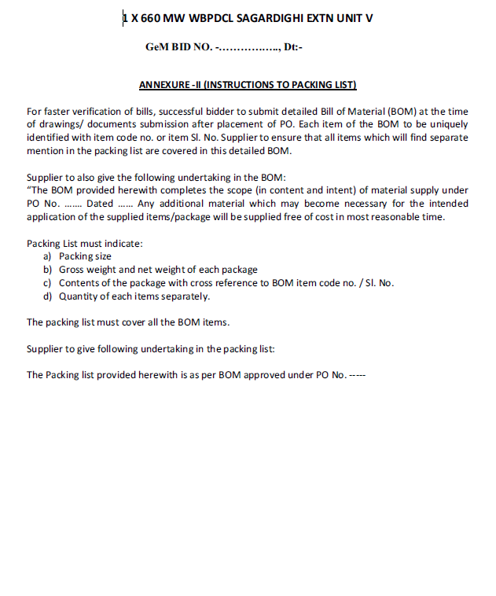

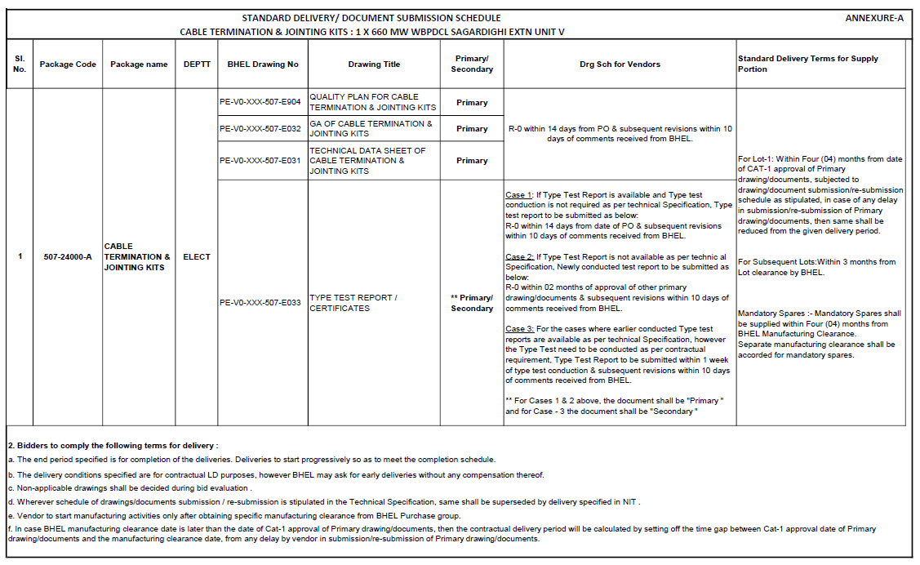

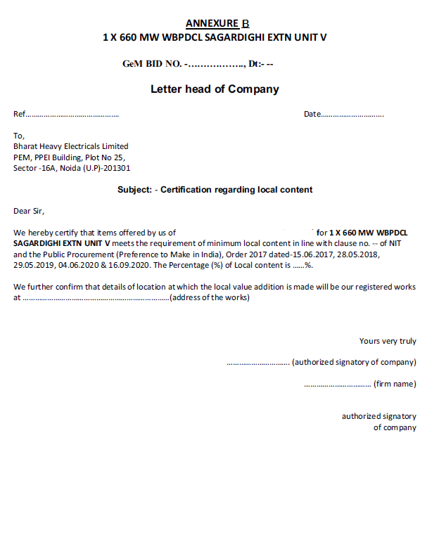

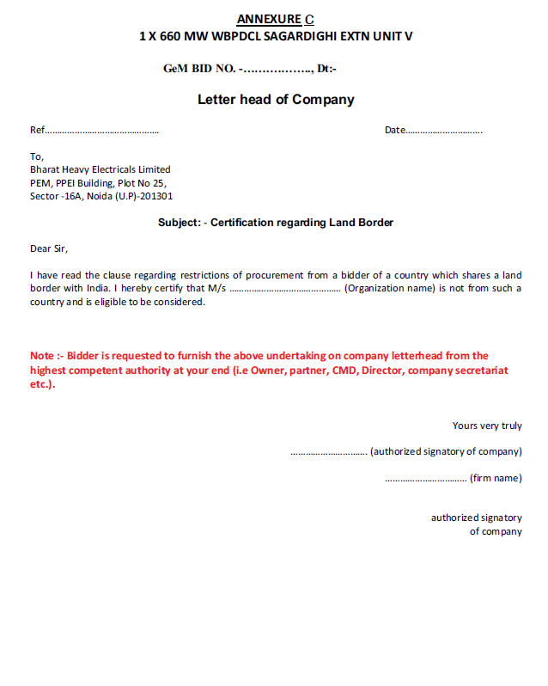

**Annexure-D (Risk Purchase clause)**

