1 | Terms of Payment
1 | a) Payment Terms: | Type of bidder | Payment Terms (Number of days)
1 | a) Payment Terms: | Micro & Small Enterprises (MSEs) | 45 days
1 | a) Payment Terms: | Medium Enterprises | 60 days
1 | a) Payment Terms: | Non MSME | 90 days
1 | a) Payment Terms: | Payment shall be made to the seller as per above schedule of issue of consignee receipt-cum-acceptance certificate (CRAC) and on-line submission of bills. Supplier has to provide Tax invoice, E-invoice, BG, Packing List, LR/RR, CRAC, Guarantee Certificate, insurance intimation, E-way bill (as applicable) for payment.  Provision of offline payment in GeM shall be utilized.
2 | Terms of Delivery | As per cl. No. 13 of GTC on GeM. However, loading shall be in the scope of Seller and unloading of items at delivery point & Transit insurance shall be in the scope of BHEL. Bidder to quote prices accordingly.  Further, w.r.t. Transit Insurance, supplier has to inform the details of dispatches (such as Policy No., Consignee Name, Consignment Packing details, Project Name, Purchase Order No., LR No. & date, Invoice No. & date, Despatch Origin & destination details etc.) to policy underwriter (whose details shall be shared post award of contract).
3 | Delivery | As per attached Annexure-A  Delivery as per the schedule (Annexure-A) shall be considered for LD calculation purposes.  Delivery days of 730 days from PO date is the contract period and delivery may be extended beyond 2 years on mutual consent within Period of contract.
4 | Liquidated Damage | Purchaser reserves the right to recover from the Seller/Contractor, as agreed liquidated damages and not by way of penalty, a sum equivalent to half (½) percent, of the total contract price per week or part thereof, subject to a maximum of ten(10) percent of the total contract price if the Seller/ Contractor fails to deliver any part of the ordered goods/stores within the period stipulated in the Order/ Contract.  NOTE:  i. Receipted LR/RR date for indigenous supplies (Bill of Lading/AWB for Foreign supplies) shall be treated as the date of dispatch for levying LD.  ii. In case of any amendment/ revision, LD shall be linked to the amended/ revised contract value and delivery date(s).  iii. If Order/ Contract involves two or more Units/ Sets/ Lots/ Stages, then Liquidated Damages shall be levied on order/ contract value excluding GST of the delayed Unit/ Set/ Lot/ Stage, provided delivery stipulated in the Order/ Contract is Unit/ Set/ Lot/Stage wise, however total LD amount shall be limited to 10% of total order/ amended order value excluding GST of delayed Unit/ Set/ Lot/Stage. Any subsequent lot released (not envisaged in original contract) due to increase in quantity within permissible quantity variation shall be treated as separate lot for the purpose of LD.  iv. The sum specified above is not a penalty but a genuine pre-estimate of the loss/ damage which will be suffered by purchaser on account of delay on the part of the Contractor/Seller and the said amount will be deductible without proof of actual loss or damage caused by such delay.  Above LD clause shall prevail over the LD clause of GeM GTC.
5 | Guarantee Terms | As per Cl. No. 10 of GTC on GeM for the bid. However, Guarantee & Warrantee time period shall be 18 months from the date of last supply in the contract.
6 | Quantity Variation | Nil
7 | Bank Guarantee | Bank Guarantee submission shall be as per cl. No. 7 of GeM GTC with initial validity of 32 Months. Further, extension if any shall be as per GeM Terms.
8 | Prices | Prices are firm till the execution of contract.
9 | Any other special major condition | 1. Material shall be dispatched only after issuance of MDCC by BHEL.  2. Advance intimation of dispatch by bidder shall be given, to PEM and  Insurance agency/Site.  3. All the Buyer Added Bid Specific Additional Terms and Conditions shall supersede relevant terms & conditions of GeM GTC and shall prevail in case of conflict with any other terms & conditions of tender (if any).
10 | ADDITIONAL BID TERMS & CONDITIONS AS PER VARIOUS CIRCULARS/ GUIDELINES/ ADVISORIES
10.1 | Integrity Pact: Integrity pact is not applicable for subject package.
10.2 | This is a conditional tender enquiry. Financial bid opening (Part-II) of a bidder shall be subjected to the following:  i) Approval of vendor by end customer i.e. (M/s TANGEDCO).  ii) Techno-Commercial evaluation by BHEL.  iii) Qualification of Technical PQR.  iv) Offered item should mandatorily conform to PP-MII order provisions.
10.3 | This item/package /system falls under the list of items defined in para 3 of ministry of finance guideline dtd. 20.09.16 (Procurement of items related to Public safety, Health, Critical Security operations & Equipments etc.) & hence criteria of prior experience/Turnover shall be same for all the bidders including start-up/MSME.
10.4 | Provision of offline payment in GeM can be utilized.
10.5 | Bidders to ensure that Third party / customer issued certificates being submitted as proof of PQR qualification should have verifiable details of document / certificate issuing authority such as name & designation of Issuing Authority and its organisation contact number and e‐mail Id etc. In case the same found not available, Purchaser has right to reject such document from evaluation.
10.6 | Bidders to,  • ensure compliance to Ministry of Power (MoP) Order No. 25‐11/6/2018‐PG dt. 02/07/2020 & Order No. 11/05/2018‐Coord. dt. 23/07/2020, if applicable.  • ensure compliance of Ministry of Finance (MoF) Order (Public Procurement No. 1 & 2) F. No. 6/18/2019/PPD dt. 23/07/2020.  • to submit “Model Certificate for Tenders” as per Annexure-III of Ministry of Finance (MoF) Order (Public Procurement No. 1 & 2) F. No. 6/18/2019/PPD dt. 23/07/2020.
10.7 | The Bidder declares that they will not enter into any illegal or undisclosed agreement or understanding, whether formal or informal with other Bidder(s). This applies in particular to prices, specifications, certifications, subsidiary contracts, submission or non-submission of bids or any other actions to restrict competitiveness or to introduce cartelization in the bidding process. In case, the bidder is found having indulged in above activities, suitable action shall be taken by BHEL as per extant policies/guidelines
10.8 | Price quoted shall be all inclusive considering point at sl. no. 2 mentioned above. Bidders shall provide freight/GST percentage as part of their Techno-Commercial offer.
10.9 | For this procurement, offer from the class -1 (meeting minimum local content of 50%) and class - 2 (meeting minimum local content of 20%) local suppliers shall be accepted. The local content to categorize a supplier as a Class I Local Supplier / Class II Local Supplier and Purchase preference to Class I local supplier, is as defined in Public Procurement (Preference to Make in India), (PPP-MII) Order 2017 dt. 16/09/2020 issued by DPIIT. In case of subsequent orders issued by the nodal ministry, changing the definition of local content for the items of the NIT, the same shall be applicable even if issued after issue of this NIT, but before opening of Part-II bids against this NIT.  The supplier along with techno-commercial bid, shall be required to submit the following:  1. Provide self-certification that they meet the requirements of Class I/ Class II local supplier as per the provisions of PPP-MII Order of Govt. of India and relevant circulars issued by nodal ministry w.r.t. above mentioned orders (draft for local content is enclosed)  2. Give details of location(s) at which the local value addition is made in attached format.  Package is divisible in nature and margin of purchase preference shall be as per Public Procurement (Preference to Make in India), (PPP-MII) Order 2017 dt. 16/09/2020.
10.10 | Due to COVID-19 pandemic condition prevailing in the country, BHEL/PEM may go for Remote Inspection of Offered items, if required. Vendors are requested to be equipped with the facilities/gadgets as indicated in the guidelines attached to take up the inspection REMOTELY.  Guidelines may be accessed from following link:  https://pem.bhel.com/Documents/VendorSection/Vendor/Guidelines.pdf  Inspection call to be raised by bidder on BHEL CQIR portal (details shall be shared at the of execution of order) and Inspection agency shall attend at the inspection within seven (07) days of the date on which the material is notified as being ready. In case of delay in witnessing of inspection beyond stipulated time (i.e. 7 days from the date on which the material is notified as being ready), by BHEL arising due to reasons not attributable to vendor, BHEL will extend the delivery period for such delay in carrying out inspection. If BHEL is not able to witness inspection up to 15 days then in addition to delay beyond stipulated period, extension in delivery time of 07 days for arranging fresh inspection will be given.  When the tests have been satisfactorily completed at Seller/ Contractor's works, the Inspection Agency shall issue an inspection report that effect within seven (07) days after completion of the tests, but if the tests were not witnessed by the Inspection Agency or his representative, the material acceptance report would be issued within seven (07) days after receipt of the test certificates by the Purchaser.  Purchaser will issue MDCC to the Seller/ Contractor within 7 days based on inspection report/ test certificates/Certificate of Conformance as applicable. In case of delay in issuance of MDCC beyond 7 days stipulated time (i.e. from the date of successful inspection report), by BHEL arising due to reasons not attributable to vendor, BHEL will extend the delivery period for such delay in issuing MDCC. If BHEL is not able to issue MDCC up to 15 days then in addition to delay beyond stipulated period, 7 days’ additional time shall be given to vendor to facilitate the vendor for arranging logistics arrangements.
10.11 | Risk Purchase clause shall be as per attached Annexure B in case of default by GeM bidder.
10.12 | Following ATC available in GEM shall also be made part of NIT: -  1. Scope of supply (Bid price to include all cost components): Supply  2. The bidder is required to upload, along with the bid, all relevant certificates such as BIS licence, type test certificate, approval certificates and other certificates as prescribed in the Product Specification given in the bid document.  3. Nominated Inspection Agency: On behalf of the Buyer organization, any one of the following Inspection Agency would be conducting inspection of stores before acceptance:  Pre-dispatch Inspection at Seller Premises (applicable only if pre-dispatch inspection clause has been  selected in ATC): Through Nominated TPIA  Post Receipt Inspection at consignee site before acceptance of stores: Through Nominated TPIA  4. Bidder's offer is liable to be rejected if they don't upload any of the certificates / documents sought in the Bid document, ATC and Corrigendum if any.  5. Bidders are advised to check applicable GST on their own before quoting. Buyer will not take any responsibility in this regards. GST reimbursement will be as per actuals or as per applicable rates (whichever is lower), subject to the maximum of quoted GST %.  6. Data Sheet of the product(s) offered in the bid, are to be uploaded along with the bid documents. Buyers can match and verify the Data Sheet with the product specifications offered. In case of any unexplained mismatch of technical parameters, the bid is liable for rejection.
10.12 | 7. Pre-dispatch inspection at Seller premises (Fee/Charges to be borne by the BUYER): Before dispatch, the goods will be inspected by Buyer / Consignee or their Authorized Representative or by Nominated External Inspection Agency (independently or jointly with Buyer or Consignee as decided by the Buyer) at Seller premises (or at designated place for inspection as declared / communicated by the seller) for their compliance to the contract specifications. Fee/ Charges taken by the External inspection Agency and any external laboratories testing charges shall be borne by the Buyer. For in-house testing, the Sellers will provide necessary facilities free of cost. Seller shall notify the Buyer through e-mail about readiness of goods for pre-dispatch inspection and Buyer will notify the Seller about the Authorized Representative/ Nominated External Inspection Agency and the date for testing. The goods would be dispatched to consignee only after clearance in pre-dispatch inspection. Consignee's right of rejection as per GTC in respect of the goods finally received at his location shall in no way be limited or waived by reason of the goods having previously been inspected, tested and passed by Buyer/ Consignee or its Nominated External Inspection Agency prior to the goods' shipment. While bidding, the sellers should take into account 7 days for inspection from the date of email offering the goods for inspection. Any delay in inspection beyond 7 days shall be on the part of the buyer and shall be regularised without Liquidated Damages. When there is requirement of submission the advance sample, the seller shall inform the buyer promptly through emails about the date of submission of sample to the buyer nominated Inspection agency
10.13 | Bidder has to provide the details as per TECHNICAL PQR in its offer and has to note that bids of only those bidders shall be evaluated who meet the Technical Pre-Qualifying requirements. Above terms for PQR shall prevail in conflict (if any).
10.14 | All other terms & conditions shall be as per GeM bid, above Additional Terms & Conditions from GeM library and GTC on GeM 4.0 (Version 1.1).

Annexure-B (Risk Purchase clause)

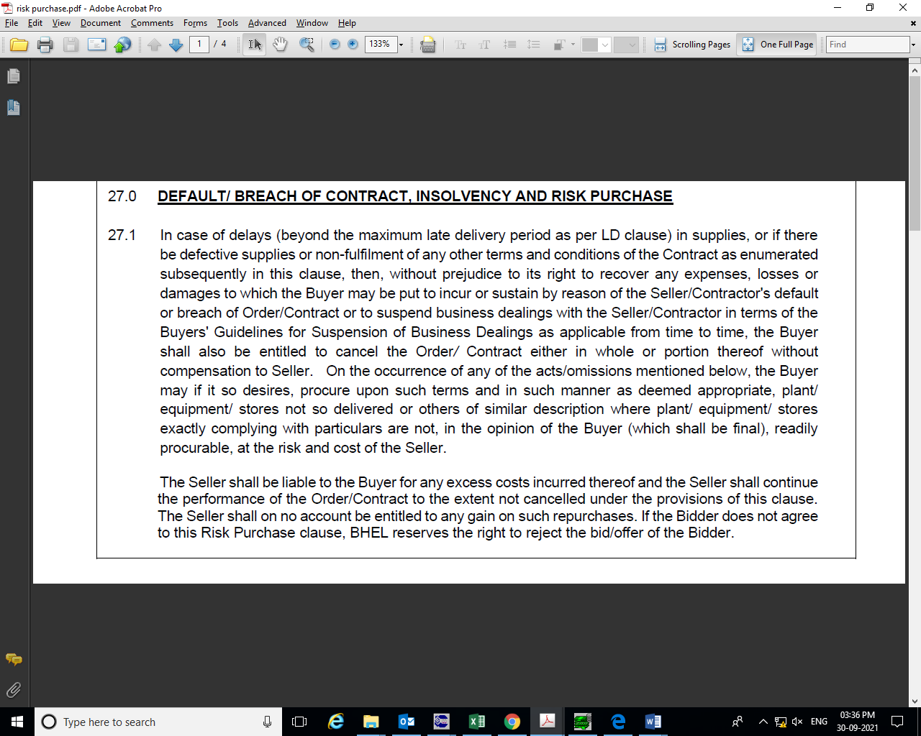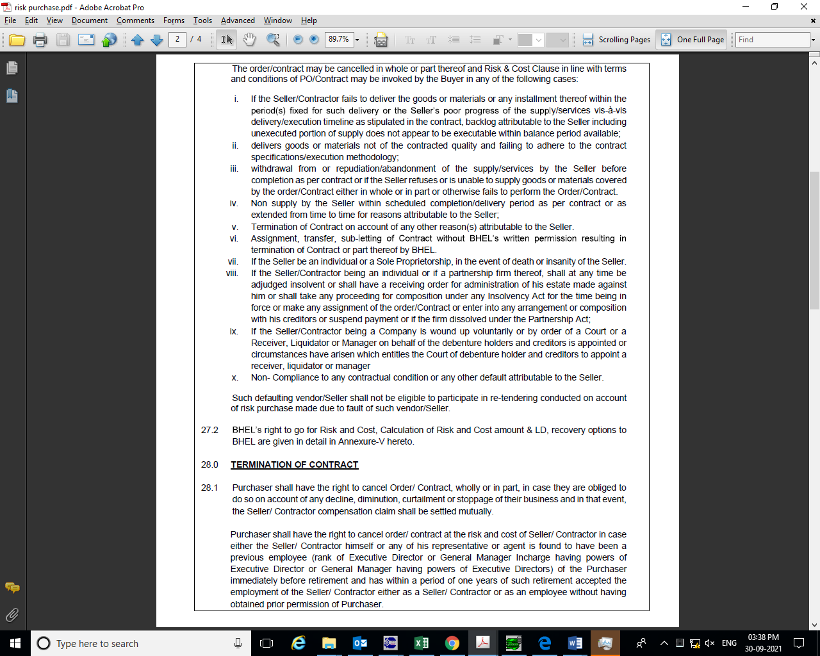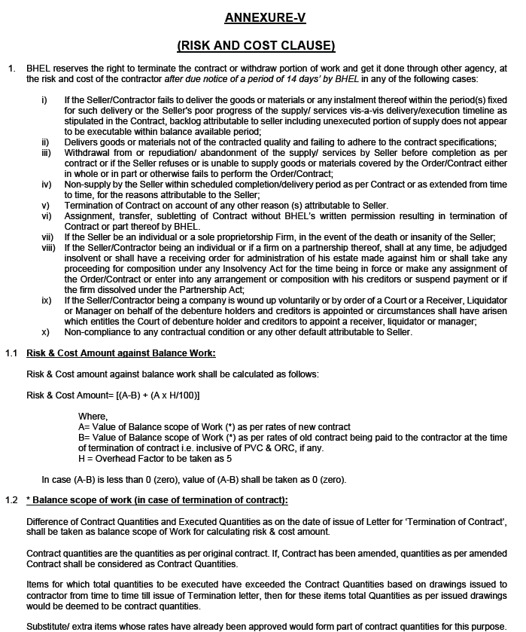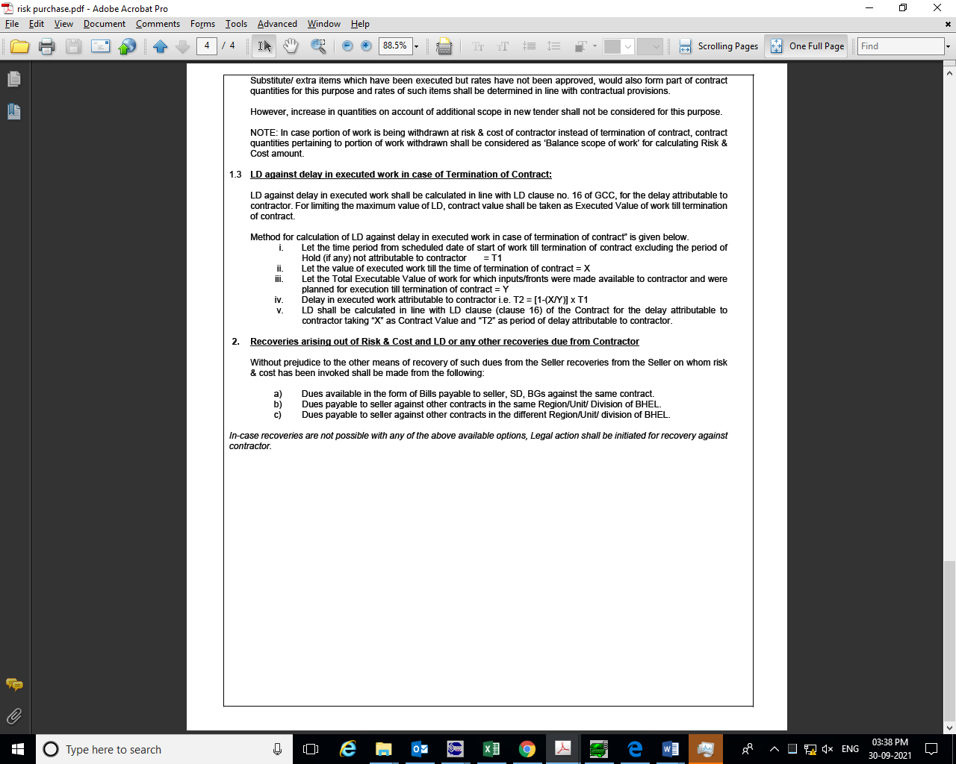

2X660 MW Udangudi Project
ME Bellows
GeM Bid No. GEM/2022/B/2229897 dated 02.06.2022
Letter head of Company

Ref………………………………………. Date………………………….

To,
Bharat Heavy Electricals Limited
PEM, PPEI Building, Plot No 25,
Sector ‐16A, Noida (U.P)‐201301

Subject: ‐ DECLARATION REGARDING LAND BORDER

Reference: GeM Bid No. GEM/2022/B/2229897 dated 02.06.2022
Name of Package: ME Bellows

Dear Sir,
This has reference to:-

1. Offer for Supply of ME Bellows for 2X660 MW Udangudi Project against GEM Tender No. GEM/2022/B/2229897 dated 02.06.2022
2. Order dated 23.07.2020 reg. restriction under rule 144 (xi)of GFR issued by Ministry of Finance, Department of Expenditure Public Procurement Division.

I have read the clause regarding restriction on procurement from a bidder of a country which shares a land border with India. I hereby certify that M/s ………………….., is not from such a country and is eligible to be considered.

Thanking you,

Yours truly

…………………………. ((highest competent authority at your end (i.e. Owner, partner, CMD, Director etc.))

…………………………… (firm name)
2X660 MW Udangudi Project
ME Bellows
GeM Bid No. GEM/2022/B/2229897 dated 02.06.2022

Letter head of Company

Ref………………………………………. Date………………………….

To,
Bharat Heavy Electricals Limited
PEM, PPEI Building, Plot No 25,
Sector ‐16A, Noida (U.P)‐201301

Subject: ‐ Certification regarding local content

Reference: GeM Bid No. GEM/2022/B/2229897 dated 02.06.2022
Name of Package: ME Bellows

Dear Sir,
We hereby certify that items offered by us of ME Bellows for 2X660 MW Udangudi Project
meets the requirement of minimum local content in line with GeM NIT clause no. 10.9 and Public Procurement (Preference to Make in India), Order 2017 dated‐15.06.2017, 28.05.2018 & 29.05.2019, 04.06.20 & 16.09.20.

Minimum Local content=…………………. %

We further confirm that details of location at which the local value addition is made will be our registered works at …………………………………………………………………......................................... (complete address of the works)

Yours truly
…………………………. (authorized signatory of company)
…………………………… (firm name)

Annexure-A to Delivery Schedule of ME Bellows for 2X660 MW Udangudi Project
Sl. No. | BHEL Drawing No | Drawing Title | Primary/Secondary | Drg Sch for Vendors
1 | PE-V0-XXX-100-M171 | GA DRGS FOR ME BELLOWS | Primary | R-0 within 14 days from PO & subsequent revisions incorporating all the BHEL comments within 10 days of comments received from BHEL.
2 | PE-QP-XXX-100-M021 | QP FOR ME BELLOWS | Primary
3 | PE-V0-XXX-100-M173 | AXIAL SPRING RATE TEST PROCEDURE FOR M.E. BELLOWS | Secondary
4 | PE-V0-XXX-100-M172 | TYPE TEST PROCEDURE/REPORT FOR M.E. BELLOWS | Secondary
Delivery: Within Six (06) months, from date of CAT-1 approval of Primary drawing/documents OR BHEL manufacturing clearance whichever is later subjected to drawing/document submission/re-submission schedule as stipulated, in case of any delay in submission/re-submission of Primary drawing/documents, then same shall be reduced from the given delivery period.
Note:
a. The end period specified is for completion of the deliveries. Deliveries to start progressively so as to meet the completion schedule.
b. The delivery conditions specified are for contractual LD purposes, however BHEL may ask for early deliveries without any compensation thereof.
c. Non-applicable drawings shall be decided during bid evaluation.
d. Wherever schedule of drawings/documents submission / re-submission is stipulated in the Technical Specifications, same shall be superseded by delivery specified in NIT.
e. Vendor to start manufacturing activities only after obtaining specific manufacturing clearance from BHEL Purchase group.
f. Delivery shall be completed as per the terms mentioned above and LD shall be applicable in case of delay beyond the above-mentioned delivery terms.

