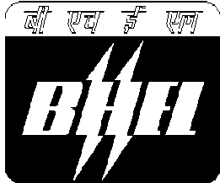  An ISO 9001  Company | Bharat Heavy Electricals Limited  (High Pressure Boiler Plant)  Tiruchirappalli – 620014, _{TAMIL NADU, INDIA}

TITLE: CORRIGENDUM FOR DUE DATE  EXTENSION (NIT_84373) | Phone: +91 431 2577427/ 5636  Email : subramanian.s@bhel.in, sonu@bhel.in

GeM Portal Bid Number & Date GEM/2024/B/5241463 Dt. 02.08.2024 | Due date for submission of quotation 13/08/2024
You are requested to quote the GeM Portal Bid Number & Date and due date in all your correspondences.
This is only a request for quotation and not an order
CORRIGENDUM-1

Details of Corrigendum
Due date for submission of offers has been extended from 13.08.2024 to 20.08.2024
All other terms and conditions as published in the GeM portal against Bid number: GEM/2024/B/5241463 remains unaltered.

Offers should be submitted before 14:00 hours on the due date. Technical bid will be opened after 14:30 hours on the due date. | Yours faithfully,  For Bharat Heavy Electricals Limited  MANAGER/MM/CPSP & WC  Ph: 0431- 2575636/ 7427,  Email: sonu@bhel.in, subramanian.s@bhel.in ,

