For schedule no. 32 : Drawing Uploaded through corrigendum on 21.11.2022
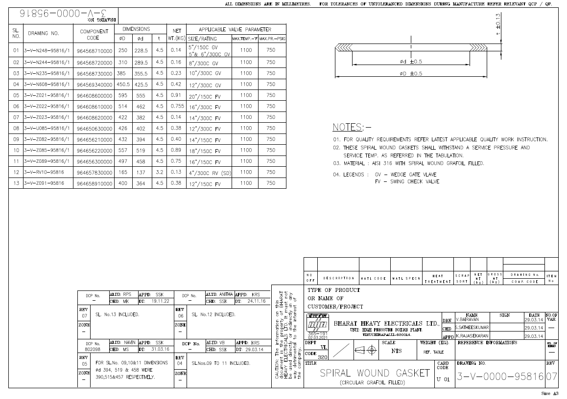
For schedule no. 2 : Drawing Uploaded through corrigendum on 16.11.2022
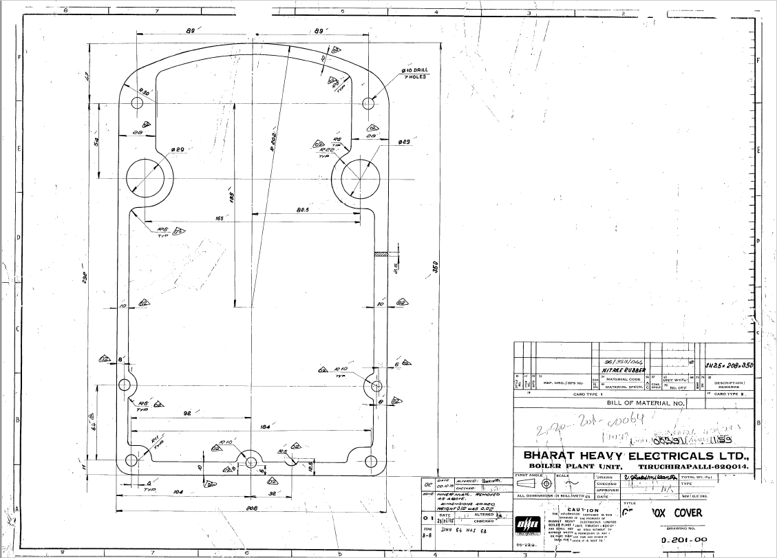

For schedule no. 3 : Drawing Uploaded through corrigendum on 16.11.2022
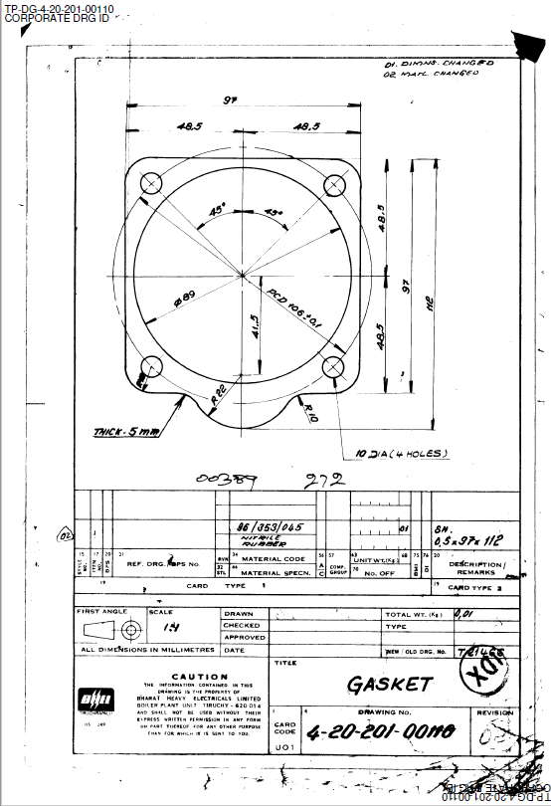
For schedule no. 4 : Drawing Uploaded through corrigendum on 16.11.2022
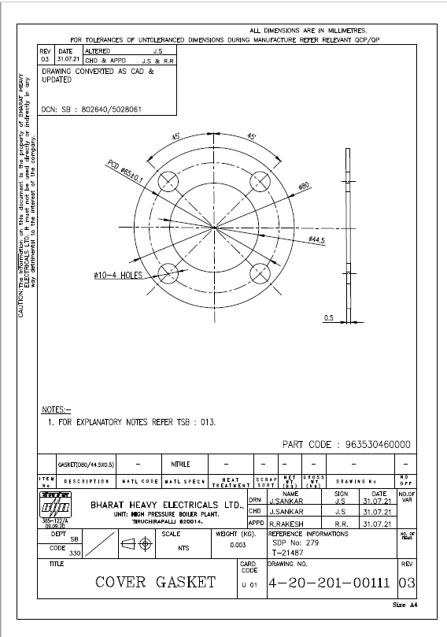
For schedule no. 5 : Drawing Uploaded through corrigendum on 16.11.2022
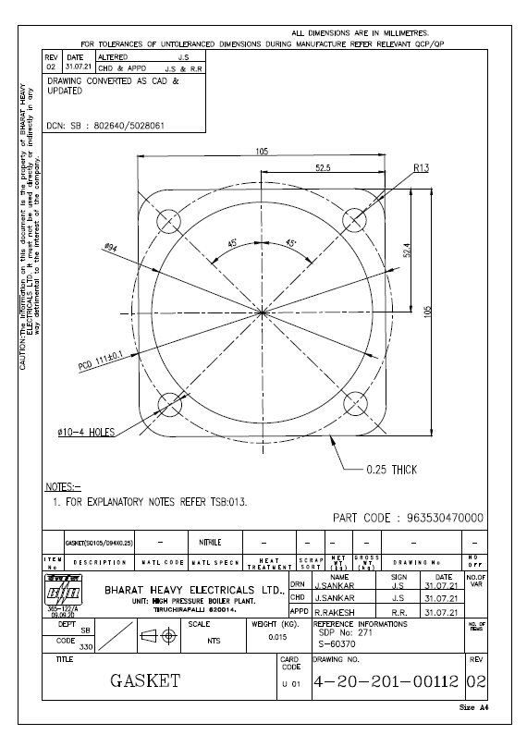
For schedule no. 7 : Drawing Uploaded through corrigendum on 16.11.2022
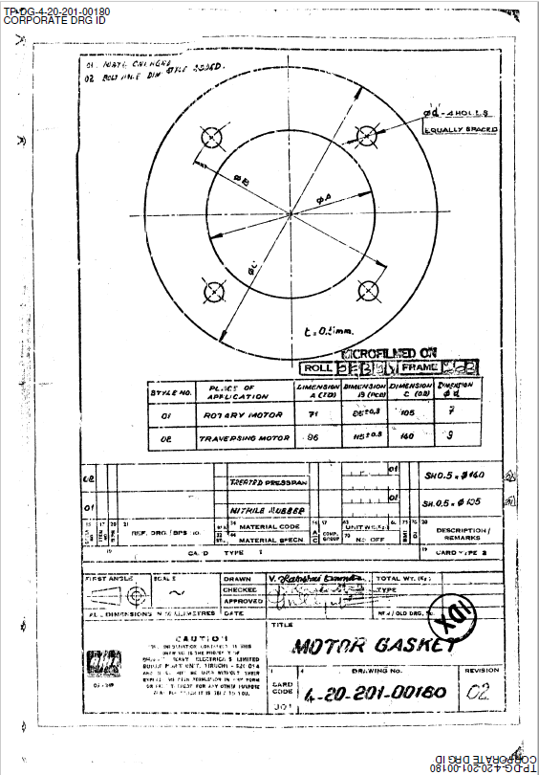
For schedule no. 8 : Drawing Uploaded through corrigendum on 16.11.2022
